Formatting Data-Driven Reports

in Microsoft Word

Introduction
This guide explains how to prepare a clear, consistent, and professional data-driven report in Microsoft Word. The primary focus is not on quality writing, but on formatting and framing results of analysis. While there is some initial cost in learning to properly format a Word document, mastering these habits will save you time throughout your University and professional career.

Define your audience
Before drafting, identify the intended reader and decide what that reader already knows. Students are often habituated to writing for an audience of one: their professor. Their goal becomes proving that they have mastered the material. A report requires a different attitude. The goal is to give the reader useful information with as little friction as possible.

Structure of the report
A common instinct is to structure reports in the same order as the work was done: data acquisition, cleaning, methods, results, and interpretation. That order records the analyst’s effort, but it does not match the reader’s priorities.
A reasonable structure for a report is given in Table 1. This is meant only as a general guide. In short reports, these sections might only be a paragraph. In longer reports, they can be multiple pages.
Table 1: Recommended structure of report
Component | Purpose
Answer | State the main finding in plain language.
Question | Explain what was asked and why the answer matters.
Data | Identify the source, coverage, units, exclusions, and important gaps.
Method | Describe the calculation in ordinary language and provide enough detail for reproduction.
Results | Present the numbers, tables, and figures that support the answer.
Interpretation and limits | Explain what the result means and what the analysis cannot establish.
Sources | Provide enough information for another person to locate the data and supporting material.

Document Structure and Word Styles

Numbered Sections and Subsections
For long reports, use numbered sections. In shorter reports, unnumbered sections often make the document less cluttered. Use Word’s heading styles to title your sections: Heading 1 for each major section, Heading 2 for each subsection, and Heading 3 only when a third level is genuinely necessary. Avoid going deeper than a sub-subsection. If you need another division, use an unnumbered heading instead.
If using numbered sections, the heading styles should be linked to a multilevel list so that Word creates numbers such as 2, 2.1, and 2.1.1 automatically. This makes life so much easier. When you add a new section in the middle of your report, all the section numbers will automatically update.
To view all your sections you can open the Navigation Pane.

Paragraphs, Spacing, and Pasting
Use paragraph styles rather than repeated direct formatting. A formal report may use an unindented paragraph immediately after a heading, followed by paragraphs with a 0.5-inch first-line indent and no extra blank line between paragraphs. The exact convention matters less than applying one convention consistently throughout the document.
Do not press Enter repeatedly to create space before a heading or to move text to a new page. Control vertical space through the paragraph style, and use a page break when a new page is required. Apply “Keep with next” to headings so that a heading is not stranded at the bottom of a page.
When bringing text from another file or website, use Keep Text Only or Paste Special, then apply the appropriate style. This prevents imported fonts, spacing, numbering, and hidden style definitions from disrupting the document. Paste figures, equations, and tables separately and verify each object after pasting.

Figures

Quality, Consistency, and Placement
Readers find it jarring when figures in the same report look as though they came from different sources. For example, when one graph is made in Excel, another is made from R, and a third is copied from a website. To make a professional report, use one visual system throughout: create all figures in the same software program, such as Excel or R, and apply consistent fonts, label sizes, and colours to all your figures. If you want to use a chart found online, download or reconstruct the raw data and recreate the figure in your own statistical program—do not include screenshots of figures from other websites.
Export or paste figures from the source program at high quality. Use SVG or EMF for vector graphics when available, and use a suitably high-resolution PNG for raster images. Do not enlarge a small image, because scaling cannot restore missing detail.
It is often preferable to embed figures in a single-cell table. When using multiple panels you can embed them in a 2x1 or 2x2 table.

Labelling, and Captions
Put captions below figures using Insert Caption. Always include the source. Some authors include the source in the caption itself; I prefer to place sources in a smaller note below the figure. The important point is to choose one convention and apply it consistently.
Introduce every figure before it appears, as I am doing here with Figure 1. When referring to a figure in the body of the report, use Word’s cross-reference feature rather than typing the figure number manually. As with section numbering, cross-references automatically update when you add, delete, or move figures.
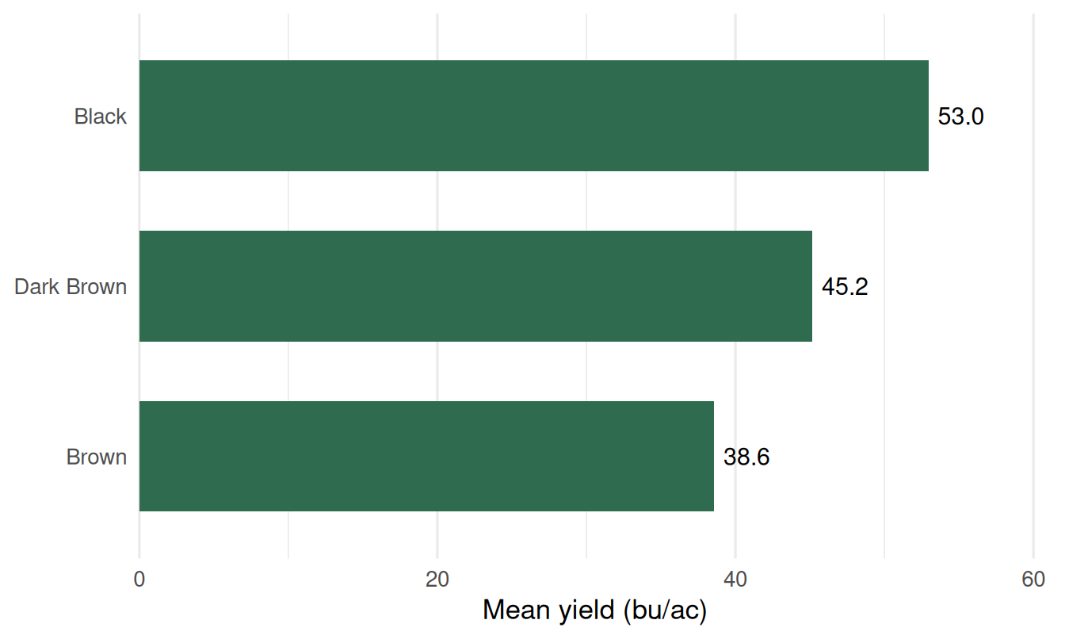
Figure 1: Mean wheat yield by soil zone, 2025.
Source: Agricultural Data Analytics, “Writing a Report.”

Tables

Alignment, Rules, and Pagination
Some general rules for table formatting:
- Fit every table within the page margins without shrinking the text.
- If a table is too large to fit on the page consider reformatting the table or breaking it into two tables.
- Try to avoid landscape tables, as they make the reader’s life difficult.
- Left-align columns that contain words and right-align columns that contain numbers, including their headings.
- Try to keep columns the same width (except for the first column). Use Table Properties to set column widths – this is much more precise than using your mouse.
- Use horizontal lines at the top and bottom of tables, and after the column headings. Views differ on whether horizontal lines are needed after every row. For small tables, too many lines add clutter. For large tables, light row rules or subtle alternating row shading can help readers follow values across columns, but use these devices only when the table is large enough to justify them.
- Avoid vertical lines in almost all tables. Instead, ensure there is enough white space between columns for the reader to distinguish values easily.
- Use Insert caption to caption your table.
- Mention every table in the body before or near its location and use a cross-reference rather than a manually typed number.
- Do not insert the table itself in the middle of a sentence.
- Keep explanatory notes and source information directly below the table and distinguish those notes from ordinary document footnotes.
- Introduce every table before it appears, identify what it contains, and state which values support the discussion.
- Include only the rows and columns needed for the report.
- Never paste pictures of tables – always include them as Word formatted tables.
- It is generally best to keep tables on the same page instead of letting them break across pages. Do this through table and paragraph settings rather than by manually adjusting the document at the end. Select the table, then use Paragraph > Line and Page Breaks > Keep with next. Then, with the table selected, go to Table Layout > Properties > Row and clear Allow row to break across pages.

Table 2 is an example of a table that is formatted according to these principles.

Table 2: Example of clearly formatted table
Category | Group A | Group B | Unit
Measure 1 | 12.4 | 15.1 | units
Measure 2 | 9.8 | 11.6 | units
Measure 3 | — | 7.3 | units
Note: Define units, symbols, and the data source when they are not obvious from the title and headings.

Equations and Symbols

Equation Formatting
In some reports you may need to include equations. For a general audience, try to avoid equations. For a more specialized audience, equations may be necessary.
- Use Word’s built-in equation editor through Insert > Equation. Create subscripts, superscripts, fractions, and mathematical symbols in the equation editor rather than approximating them with ordinary text. Use the same mathematical formatting for a symbol when it appears in running text and in a displayed equation.
- Place an important displayed equation on its own line, rather than within text. Number equations only when the text needs to refer to them, using sequential numbers at the right margin: (1), (2), and so on. Insert references with the cross-reference tool so that numbers remain correct after revisions.
- Define every variable, subscript, superscript, and unit immediately before or after the equation. Treat the equation as part of the surrounding sentence and punctuate it accordingly. Do not end a paragraph or section with an equation that the text has not explained.

Methods, Sources, and Supporting Material

Acknowledging Artificial Intelligence
Always acknowledge the use of artificial intelligence (AI). Follow any requirements for AI use and reporting that are specific to the course or professional body. Verify all AI-assisted text, data, analysis, and citations before submission.

Appendices and Computer Code
Use appendices only for supporting material that would interrupt the main discussion. Place them after the references, label them Appendix A, Appendix B, and so on, and refer to each appendix in the body. Treat each appendix as a section with its own descriptive title.
If you are asked to submit code with your submission, it is usually best to provide it in a separate file. Ensure that the code is readable. If there is more than one code file, include a README file so the reader can understand how the files fit together. The code should be well commented and should include only the commands needed to generate the results shown in the report.

References
Cite all sources used in the report and provide a complete reference list. Every source cited in the text must appear in the reference list, and every entry in the reference list must be cited in the text.
For reports that use several sources, use a reference manager such as Zotero or Mendeley. Learning one of these programs requires some effort initially, but it will save time and improve accuracy throughout your university career.
You do not need to cite common knowledge, including standard formulas and definitions for familiar statistical measures such as the mean, median, and standard deviation. Much of the general material taught in this course falls into this category.

Final Review and Submission

Language and Field Checks
Complete a final language review with Word Editor and a careful human read-through. Check names, numbers, terminology, and citations separately. If permitted, use multiple AI models to proofread your report. Ask for specific feedback on the report and for broader feedback on your writing habits. Relying solely on AI to fix mistakes will make you a worse writer; using AI to identify and correct your habits can make you a better one.

Word to PDF
Most professional documents are provided as PDFs because a PDF preserves margins, page breaks, figures, tables, and other formatting as intended. In Word, choose Print > Export as PDF. Then open the exported file and inspect every page at a readable zoom, paying particular attention to symbols, graphics, captions, and page numbers. Note that some courses may still require submission as a Word document because instructors often prefer to make inline comments.

Many of the principles in this guide were adapted from guidelines prepared for departmental graduate students by my colleague Tristan Skolrud. ChatGPT and Microsoft Copilot were used to support brainstorming and editing. The author reviewed and approved the final content.

