E-Learning Facilitator Manual

Important: If you are the only person who will be studying the courses and, therefore, do not have multiple Learners for whom you need to setup profiles, there is no need for you to consult this manual.
If you are the only Learner involved, you are all ready to go. Please login with the Customer ID and Password you were issued upon purchase and click on the “My Content” tab to start taking your courses!

Last updated

April 15, 2013

 For Questions About My E-Learning Account: Email OnLineTraining@employersgroup.com. Please provide your Customer ID when communicating with us to expedite the process. Please keep your Customer ID and Facilitator Password confidential and in a safe place.

Table of Contents
Welcome and License Information: Administrative Access 1
(Terms of License & Use, Administrative Walk Thru Orientation)

Assessments and Certificates of Completion 1

Bulk Upload of Learners of Learner Profiles 2

Facilitator Log In Info
Where to Sign In: 3
Info Page Tab: Account Info (Expiration date, Customer ID & Password, etc) 4
My Content Tab: Courses Available to Facilitators 4
More Content Tab: How To Purchase Additional Courses 4
Administration Tab: Reports, Learner Assignment 4
Sign Off Tab 4

Facilitator Services (under Administration tab) 5
My Profile 5
Add a Learner: How to Set Up A Learner Profile & Assign Training 5
Learner Report (lists all Learners) 9
(Edit Learner Profiles, Deactivate or Delete a Learner) 8
Programs Purchased & Assigned: Remaining Balance 16

Tracking Learner Progress:
Completion and InCompletion Reports (account wide) 10
Learner Report Card (Per Individual Learner) 11
(Print Certificates of Completion)
Activity Report 14
Assessment Report 15

To Print a Learner’s Certificate of Completion 12

Signing Off 16

Email Alerts and Log In Reminders
(How to Enable/Disable for your whole account and/or a single Learner) 17

To Resend a Learner’s Email Alert 18

Sample Learner Access Instructions / Manual Log In Info
(For use when email alerts are not available for Learners) 19

Tips for Learners:
How Learners print a certificate after passing an assessment 19
How Learners review answers after taking an assessment 19
Module bookmarking for Learners 19

Tips for Facilitators:
How to edit a Learner profile 20
How to deactivate a learner who is no longer with the company 20
Deleting Learners 20

Common FAQ
Can I reassign a course to another learner?
Can I turn off the reminder notices? 20
How do I purchase more training courses?
Are there discounts available for bulk purchases?

Welcome
Welcome to Employers Group E-Learning Learning Management System. As the Facilitator of this web-based service, you can:

- Set up access for individual Learners to the course(s) available in your account
- Produce a variety of reports to monitor Learner activity including certificates of completion, and
- Take the purchased course(s) yourself at no additional charge (just click My Content after you login).
- Purchase additional courses directly from your existing account.

Terms of License (Account): Your account is active for one year (365 days) from date of purchase. To renew your account, additional courses will need to be purchased to extend the term of your account or an administrative access extension may be purchased. Contact OnLineTraining@employersgroup.com for more information.

Administrative Walk Thru Orientation: Available for a nominal fee. Contact OnLineTraining@employersgroup.com

Purchasing Additional Training Courses: Once you have purchased a license, you can add training seats to your account at any time by making an online payment through the “More Content” tab – See Page 7. Once purchased, the seats will be made available in your account for immediate assignment and can be viewed when you go to “Add a Learner”. If you have any questions, please contact OnLineTraining@employersgroup.com.

Tip: To see the balance of courses remaining in your account’s inventory at any time, run the “Programs Purchased and Assigned Report”.

Important: Exams and Certificates of Completion from the Learner’s Perspective:
Many e-learning courses include a final exam/assessment. A final exam may be accessed through an examination link or may be embedded on the last page of the module and accessed by clicking an in-module “Test” button. Each Learner is given 3 attempts (may vary by course) to pass the exam. Please note that in-module exams accessed from a Quiz button do not track on the system. If you are not sure about whether or not an assessment is tracked, contact OnLineTraining@employersgroup.com with your Customer ID and Password to see if the assessments in your course(s) will be tracked.

Passing Score: 80% or higher in most cases is considered a passing grade.

Once an exam is passed, it can no longer be accessed or reviewed. Launching the assessment and viewing the questions counts as an attempt, even if no answers were chosen and/or submitted.

How Learners can print certificates after passing the exam:
- Click from the My Content tab screen. The certificate button can also be accessed from the status panel (which is launched by clicking “Completed” to the left of the certificate button on the main My Content screen). In some cases, Learners can also print certificates from their Report Card.

To Review Assessment Answers as a Learner:
Learners can only review their test results prior to printing out their certificate and/or exiting the assessment window. Once you’ve exited the assessment window and the certificate is printed, the results are no longer available for review.

To Reset an Exam for a Learner:
If a Learner does not pass the exam in 3 attempts and needs a reset, please contact OnLineTraining@employersgroup.com.

To Print a Learner’s Certificate of Completion:
Access the Learner’s results in the “Learner Report Card” to print his/her certificate. Please see page 10.

Bulk Upload of Learner Data for Automatic Creation of Learner Profiles
For purchases of thirty (30) or more E-learning courses, a one time courtesy bulk upload is available. To arrange for a bulk upload, please email OnLineTraining@employersgroup.com for a Bulk Upload Template. For purchases less than thirty (30), a nominal fee will be applied for the bulk upload. Contact us for more info.

The spreadsheet should contain 5 columns in the following order:
- Password (must be a unique identifier) created by the Facilitator. No two learners should have the same passwords. It can be an employee number or email address, and must be at least 4 characters in length, using only English alphabet, numbers and the following characters: underscore, period, short dash or the @ symbol. Do NOT embed any of these reserved words into the password: "ALTER DROP DELETE INSERT UPDATE”. Do NOT include any spaces in the Password. Passwords are not case sensitive.
- Learner(s) first name.
- Learner(s) last name.
- Learner(s) email address (used for sending email notifications to Learners). Do not include any spaces in the email address. Leave blank if no email is available.
- Course title(s) to be assigned to the Learner.
Sample Spreadsheet

Note: Column headings must be presented as shown below; they must appear in the specified order for the upload to be completed.

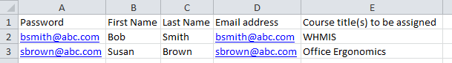

Signing In / Accessing Your Account as the Facilitator
To sign in as the Facilitator of the e-learning site:

- Open your Web browser. Go to: http://vubiz.com/Lakewood/

- Turn off any pop-up blockers that may be active in your browser. To disable pop-up blockers, please see http://vubiz.com/v5/Public/BrowserIssues.htm or contact your Internal IT department for assistance on how to disable.

- Type in the Customer ID and Password that were issued to you at the end of the transaction.
- Click “GO”.

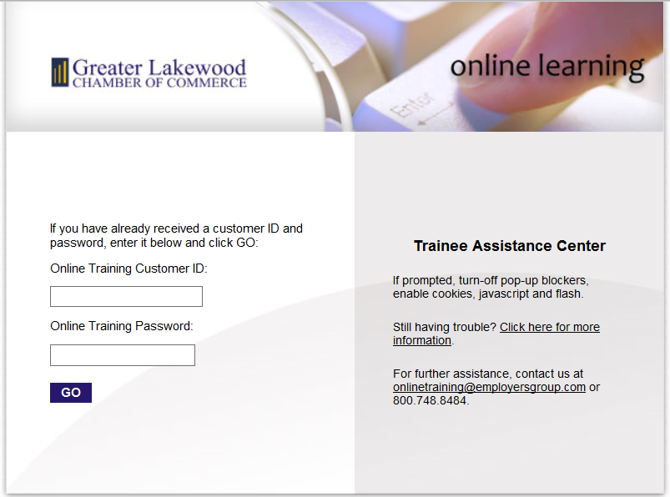

After signing in, a new screen will appear. At the top of this screen, you will see 5 tabs:

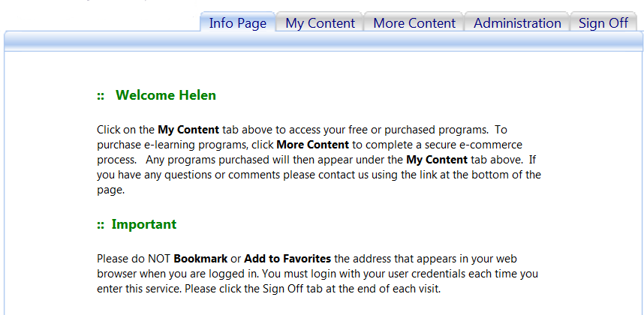

Info Page
The Info Page contains general information and tips on using the service, including your E-Learning Account Customer ID, Password, Account Expiration Date, etc.

My Content
This is the tab from which courses are accessed. Click description to see details of the course, or a module within a course.

To access a module, click on the Launch button.

More Content
Use this tab to purchase additional courses. This will require a credit card to complete the transaction. Once purchased, the seats will be made available in your account and can be viewed when you go to the “Add a Learner” tab and can be assigned to Learners immediately.

Administration
To access the Facilitator Services, click on the Administration Tab on the Learning Management System. There are various features and reports available to manage and monitor the Learners in your account. You can set up a new learner profile, edit existing profiles, run a Learner Report Card, print certificates of completion, etc.

Sign Off
Click on this tab to log out of the e-learning platform.

Facilitator Services / Account Administrator
To begin setting up your Learners in your Multiple-Learner account, click on the tab. The various features and reports available under the Administration Tab are:

My Profile (Your personal information)
Add a Learner (Setup a new Learner)
Learner Report (Lists all of your Learners and their login details)
Learner Report Card
Activity Report (Detailed reports on learner training activity)
Assessment Report
Programs Purchased and Assigned (Check your account’s training inventory)
Completion Status Report - Online Version
Completion Status Report - CSV Download (Summaries of account-wide training completions)
InCompletion Report - CSV Download

My Profile
My Profile is where information on you, the Facilitator, can be viewed and edited – your password, first and last name and email address.

The Facilitator is provided with one (1) complimentary access to the purchased course(s) at no additional charge. For example, if 10 course seats have been purchased for Harassment, then the facilitator will receive a complimentary access to the same course. The access is good for a one time use only. Changes in Facilitators does not provide a 2nd complimentary access.

To access the complimentary Facilitator courses, click on the My Content tab to take the course(s).

How to Add a Learner / Assign Courses
Important: To send out notification emails to learners when you assign training, activate the feature on your account BEFORE adding your Learners. See page 14 for details on activating the email alert feature (available on all accounts). Emails will originate from OnLineTraining@employersgroup.com

Email Alert System. To set up the email alert function for your entire E-Learning Account, click on the Enable Button to turn on the system. Click on the Enable button first, then proceed to set up the learner profile for your trainees.

To Turn OFF the Email Alert System for your entire account, including future reminder notices, click on the Disabled Button.

Emails are scheduled to go out to all active learners biweekly from date of assignment up until the assigned courses are completed. The frequency of the emails cannot be altered.

The account in the example below has the email feature Enabled, hence, the Disable button appears.

Before a Learner can begin taking a course, the Facilitator must set up a Learner profile (see below) and assign one or more course seats to the profile. Note that each course title corresponds to a program number such as P1176EN, so the system identifies a course seat as a program.
When you click “Add a Learner” from the Administration tab, you will be brought to the screen below.

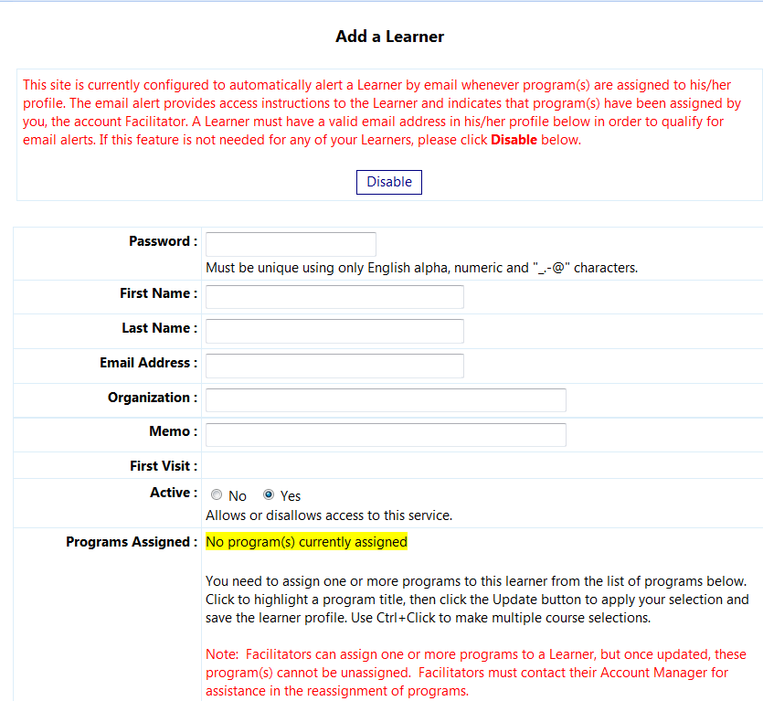

Note: The program assigned field in the screen shot above indicates that no programs (courses) has been assigned yet.

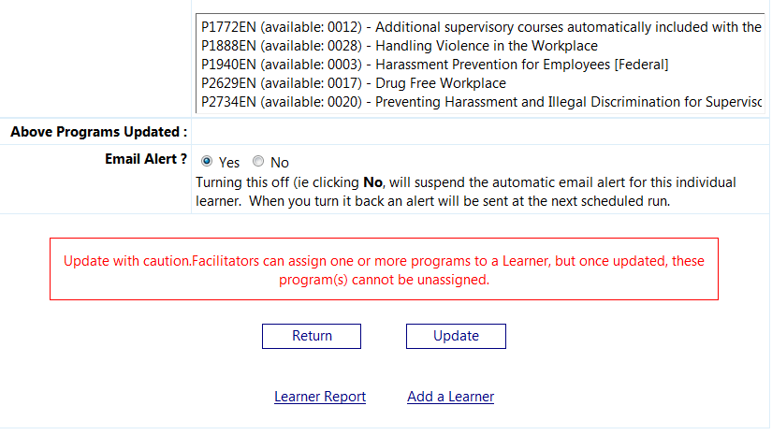

To set up a Learner and assign a course seat (program) to his profile:
- Enter a UNIQUE password (no two trainees should have the same password). Minimum of 4 characters (no spaces).
- Enter the First Name and Last Name of the Learner.
- Enter the Learner's email address (mandatory if using email alerts). Leave blank if no email is available (learners without emails will not receive an email with their log in info).
- Beside Active, click the Yes radio button to allow access to the system. If a learner needs to be denied access, click on the No radio button to deactivate the password and deactivate their access. This is set to Yes by default.
- From the list of courses “available”, assign one or more course seats (programs) to the Learner by clicking on a course title to highlight it. (You can assign 2 or more course seats to a Learner by holding down the ‘Ctrl’ key while simultaneously clicking on the course titles to be assigned.)

- Confirm that all information you have entered is correct and then press Update to complete the process and attach the assigned course(s) to the Learner profile.

After each Learner has been setup, you will be brought to the Learner Report screen (below) that lists the Facilitator and the Learners.
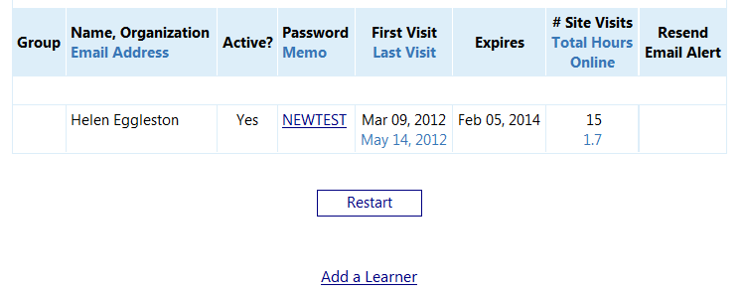
From this screen, click “Add a Learner” to create a learner profile for the next Learner. This can be done for as many learners based upon course purchased.
By clicking "Restart", you can:
- Confirm that all Learners are created properly
- Create reports based on the parameters you set – see “Learner Report” below.

Example of a successful Learner assignment will include the course assingment. Learner profile will display the following:

A Learner who was not properly assigned a course, will receive a message stating: “There are no programs available” upon logging in.

To verify if the course has been correctly assigned, run the Learner Report or the Programs Purchased & Assigned Report.

Notes:
- Each course assignment will reduce the number of available courses.
- Once a course seat (program) is assigned to a Learner profile, it cannot be unassigned and it is removed from the list of courses that can be assigned to that Learner.
- Once all the courses have been exhausted and assigned to learners, the course title will disappear altogether from the list of available programs.
- You can only assign a course that you’ve already purchased.

Edit a Learner’s Profile: Once a Learner has a profile setup, you may wish to edit their profile (e.g. change in email address or typo in spelling their name). To access a learner’s profile, run the Learner Report and locate the Learner in the list. Click the Learner’s password in the Password column to open and edit his/her profile, make the changes needed and then click Update.

Deactivating A Learner : Choose the “No” toggle beside Active in the Learner profile, then click Update.


Deleting A Learner: Facilitators cannot delete a Learner from the database (you may deactivate them – see below). To delete a learner, please contact OnLineTraining@employersgroup.com

Learner Report
The Learner Report lists all Learners in your account. Simply click on the Learner Report link from the Administration tab to see the following options in running the Learner Report.

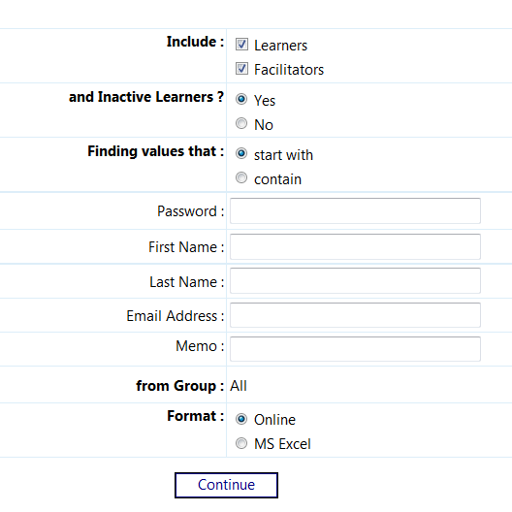

To produce the Learner Report, choose from one or all of the following parameters:

Include – Determine whether you wish to include Facilitators or Learners only.
Include Inactive Learners -- Determine whether you wish to include inactive Learners or just active Learners.
Finding Values That – This enables you to list only learners whose Password, First Name, Last Name or Email Address either start with or contain specific values.
Format – Choose to view the report Online or in MS Excel format.
Click "Continue" to get the following output online.
Completion and InCompletion Reports

At a glance, these account-wide summary reports tell you the status of all training completions for all courses you have assigned, ever. Scores and time spent are not included.

Completion Status Report

The report is available online as a PDF and is also downloadable to Excel. The report lists programs in numerical order and within programs, Learners are listed alphabetically by last name.

The report is a comprehensive list of all Learners who have been assigned a training program in your account. Therefore, if you have assigned a Learner a program, they will appear on this report for the program in question.

A blank that appears in the Completed column indicates that a passing score has not yet been achieved. Otherwise, a date in the completed column indicates the date of completion (i.e. achievement of a passing score). The excel output is as follows:

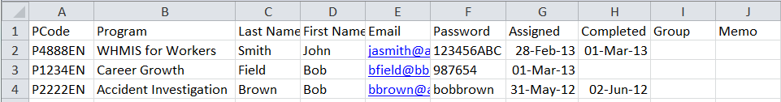

InCompletion Report – CSV Download:

The report lists only programs that are not completed for all programs assigned to your Learners. Therefore, it is your “delinquent” report.

The CSV output is as follows:

Learner Report Card:

The Learner Report Card provides detailed information on activity (time spent and assessment scores) for each Learner. If the Learner has not accessed any training courses during the time period, the particular program will not appear on the details for that Learner.

The report lists all modules in multi-module programs, unlike the Activity and Assessment Reports, that only list modules accessed.

The first screen below is where you choose the parameters with which you want to run the Learner Report Card. Choose your parameters, then click Next.

The date fields can be left blank or enter a date range manually or use the calendar icon to choose dates from a calendar. Click to start with the first date on file and to end at today’s date.

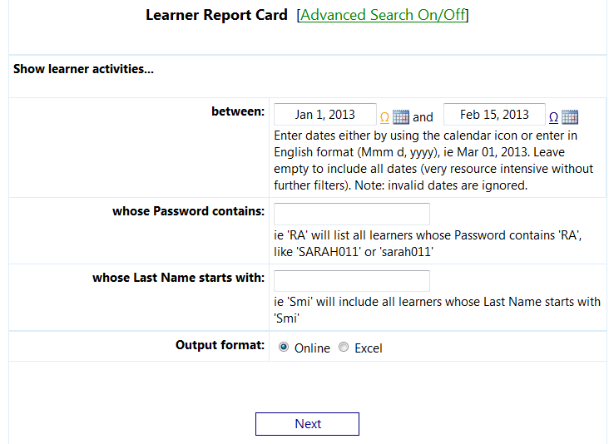

For further options, click [Advanced Search On/Off]

Additional parameters with which you may choose to selectively run the report include:
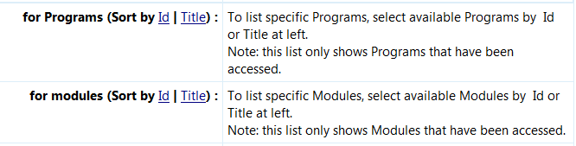

The online report that is generated is in the following format:

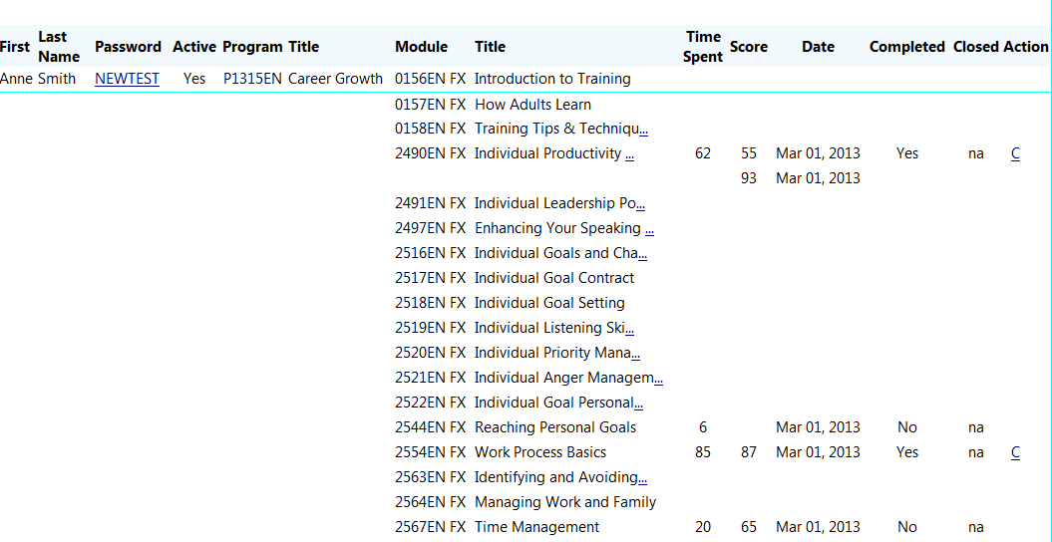

You can enter the Learner's profile by clicking on his/her Password. Note that any changes made to a profile will not be reflected on this report unless it is restarted.

Time Spent: The total time in minutes spent reviewing a module or taking an assessment.

Assessment Scores: The latest score appears first, followed by previous attempts. Passing rate is 80% or higher (for most exams).

Completed: A "Yes" indicates that an assessment was passed or courses were completed by the Learner and/or an acknowledgement button was clicked to trigger a module completion.

Closed: Not Applicable.

Certificates of Completion: Click "C" to generate the Learner’s certificate for a completed module.

Click “D” in the Action column to see further details of learner activity, if available.

The full value of truncated green fields ending in "..." can be shown when you mouse over the field.

NOTE: Learners can only review their test results prior to printing out their certificate and/or exiting the training.

How to Print a Learner’s Certificate of Completion:

Click "C" to generate the Learner’s certificate.
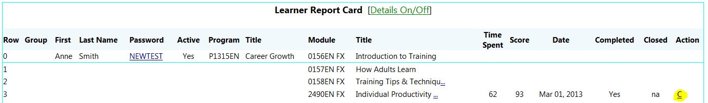

Sample Certificate :

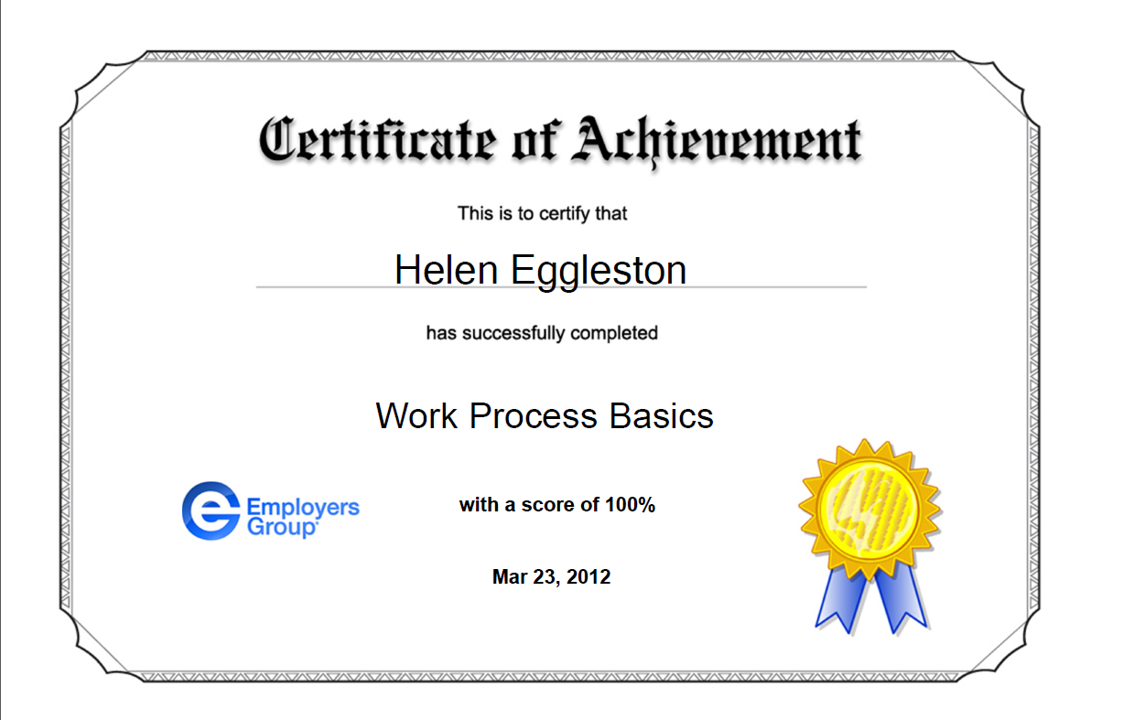

Activity Report
This report, sorted by last name, shows the total time spent during ALL date ranges (hours: min: secs) and any scores achieved on any assessments (within the ranges chosen).

You may choose to run the Activity Report with the options below, or leave the options on default to get all data:
Learners: “Active Learners Only” or “All Learners”
Scores: “Highest Score Only” or “All Scores”
Modules: Insert a module number or click the icon to open up the module selector.
Score: Insert a score of a certain value and choose the “greater than or equal to” or the “less than or equal to operator”.
Find Learners that: Choose “Start With” or “Contain” specific values including Password, First or Last Name, email address or memo field information.

Click the dropdown to see options:

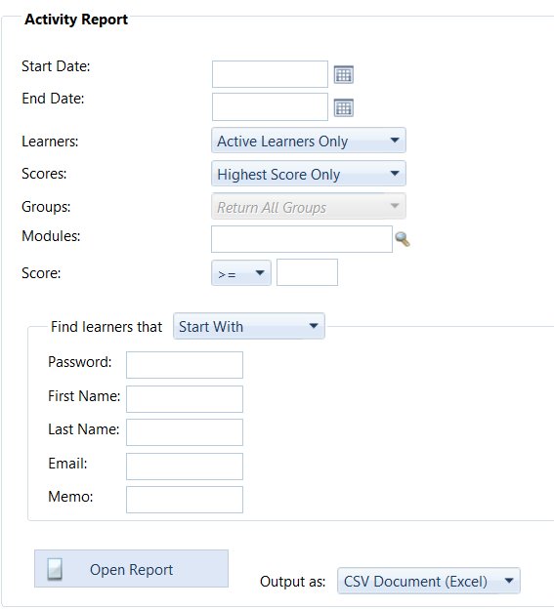

Output Options:
Choose from the dropdown on the right which report format to run (CSV/Excel, PDF or Online), then click “Open Report”.

Sample Excel output:

Assessment Report
This report, sorted by last name, shows scores achieved on assessments within the range chosen.

You can choose to run the Assessment Report with the options below, or leave options on default to get all data:
Learners: “Active Learners Only” or “All Learners”
Scores: “Highest Score Only” or “All Scores”
Modules: Insert a module number or click the icon to open up the module selector.
Score: Insert a score of a certain value and choose the “greater than or equal to” or the “less than or equal to operator”.
Find Learners that: Choose “Start With” or “Contain” specific values including Password, First or Last Name, email address or memo field information.

Click a dropdown to see options:
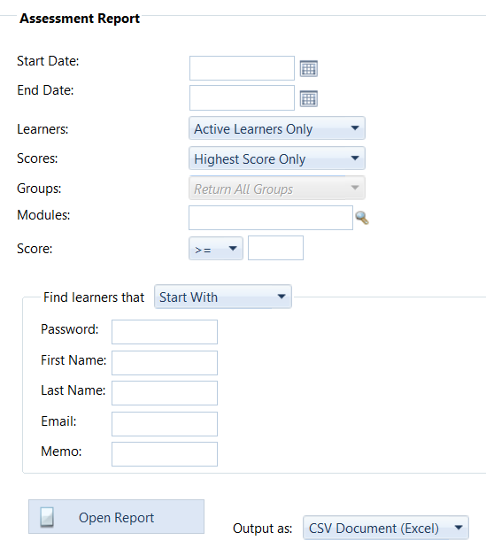

Output Options:
Choose from the dropdown on the right which report format to run (CSV/Excel, PDF or Online), then click “Open Report”.

Sample Excel output:

Programs Purchased and Assigned Report / To View Remaining Course Balances

Summarizes what programs have been purchased, to whom they have been assigned to, and the balance remaining in the E-Learning account.

The report can be generated online or downloaded to Excel.

Mouse-over the program number to see the course title.
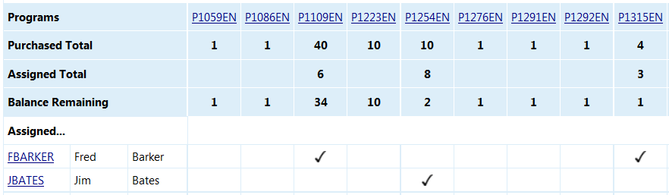

Signing Off
To log out of the current session, click the Sign Off tab at the top of the screen. You may start a new session at any time by following the instructions given in the "Signing In" section of this document.

Learner Email Alerts
Enable the Email Alert System account-wide under the Administration Tab by clicking on either My Profile or Add a Learner. This will prompt the system to send Learners bi-weekly emails containing their log in info and instructions on how to access the training up until the completion of the course. You can enable or disable the feature for your entire account anytime with this toggle.

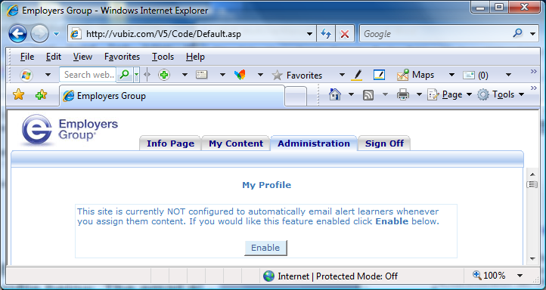

Sample Learner Email Alert:
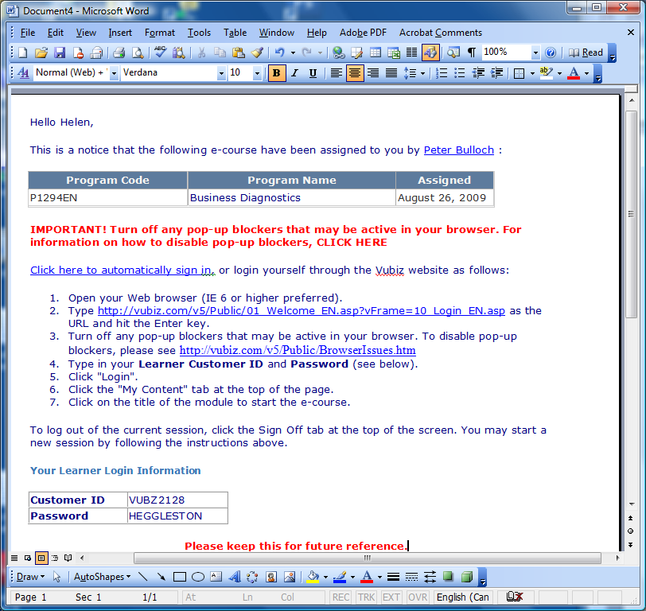

To turn off the email reminder notices for an individual Learner:
You can also override the alert feature for a specific Learner. Access his/her profile in the Learner Report, set the alert toggle to “No”, then click Update to save the change.

To Resend a Learner’s Email Alert (Access Under Learner Report)

A Learner may have misplaced the email alert that was triggered when you first assigned the program to his profile. Or you may have entered an incorrect email address to the Learner’s Profile and if so, please verify the email under the Learner Profile and update accordingly before resending.

To resend the log in email, go to Learner Report, select the learner and click the “Resend” button that appears to the far right of the Learner’s name. (To get to the Learner Report in the screen shot below, from the Administration tab, choose Learner report, then hit Continue.)

NOTE: The Resend button will ONLY appear beside the name of a Learner who has at least one program assigned to his/her profile, who has an email address in the email address field on his/her profile and whose profile is Active for email alerts.

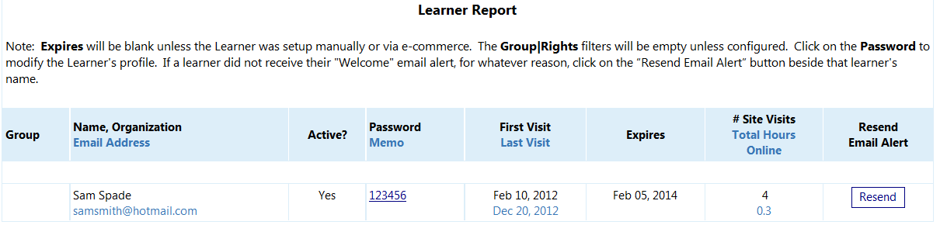

Sample Learner Access Instructions for Manual Log Ins from Website (No Emails)
For those Learners not receiving their Log In Info via the email alert feature, they can access their training courses using the below instructions.

Note: All Learners will share the same Customer ID. Only the passwords will be unique.

Login Instructions

To log into the e-learning course, please follow these steps:

- Open your Web browser and go to: http://vubiz.com/ChAccess/Lakewood/

- Turn off any pop-up blockers that may be active in your browser. To disable pop-up blockers, please see http://vubiz.com/v5/Public/BrowserIssues.htm or contact your internal IT Department for assistance.
- Enter your Customer ID and Password.
- Click “Go”.
- Click on the My Content tab and click on the title of the training course you wish to access.
- To log out of the current session, click the Sign Off tab at the top of the screen. You may start a new session at any time by following the instructions above.

Tips for Learners:

How Learners can print certificates after passing an assessment:
Click from the My Content tab screen. The certificate button can also be accessed from the status panel (which is launched by clicking “Completed” to the left of the certificate button on the main My Content screen). In some cases, Learners can also print certificates from their Report Card.

How Learners Review Answers After Taking an Assessment:
Learners can only review their assessment results prior to printing out their certificate and/or exiting the assessment window. Once the certificate is printed, the results are no longer available.

Bookmarking
Learners are able to log in and off and resume the training at their own pace. When a Learner closes a module, his/her progress is saved. The next time the module is launched, the module will bookmark to the highest page reached in previous sessions. This auto-bookmarking can be overridden with the bookmark icon on any given page.

Tips for Facilitators:

Edit a Learner’s Profile: Once a Learner has a profile setup, you may wish to edit their profile (e.g. change in email address or typo in spelling their name). To access a learner profile, run the Learner Report and locate the Learner in the list. Click the Learner’s password in the Password column to open and edit his/her profile, then click Update.

Deactivating A Learner : Choose the “No” toggle beside Active in the Learner profile, then click Update.

Deleting A Learner: Facilitators cannot delete a Learner from the database (you may deactivate them – see below). To delete a learner, please contact OnLineTraining@employersgroup.com

Common FAQ
Can I reassign a course to another learner?
Yes. A course may be reassigned if the original learner has not accessed the training. Once it has been accessed, it’s considered used and cannot be reassigned as the record of the original learner needs to be maintained, regardless of whether they have completed the course.

Can I turn off the reminder notices?
Yes. You may turn off the reminder notices. Please note that by doing so, you will be turning off the email notices for all learners as the entire account will be turned off.
How do I purchase more training courses?
Additional courses may be purchased from the “More Content” Tab once you’ve accessed your online account as the Account Facilitator. A credit care is required to complete the purchase.

Are there discounts available for bulk purchases?
Yes. See the multi-license volume discount available at www.myEGLearn.com under the Multi-Learner Discount.

