# Changing the Channel Master Password for a Parent Account

Last Updated: Mar 8, 2018

The following is an overview of how to change the current channel master password for all existing parent accounts as well as defining it for any future “children” accounts that are created.

Navigate to <https://learn.vubiz.com/portal>

Enter the current channel master password and click NEXT:

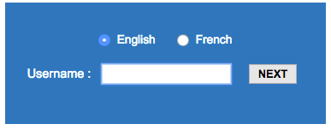

Enter the Customer ID for the desired parent account and click NEXT:

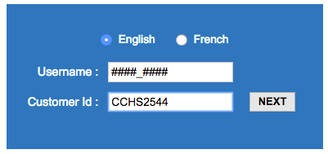

Once logged into the portal, mouse over the menu in the top left corner to expose the Manager Services > Channel Manager Password option and click it:

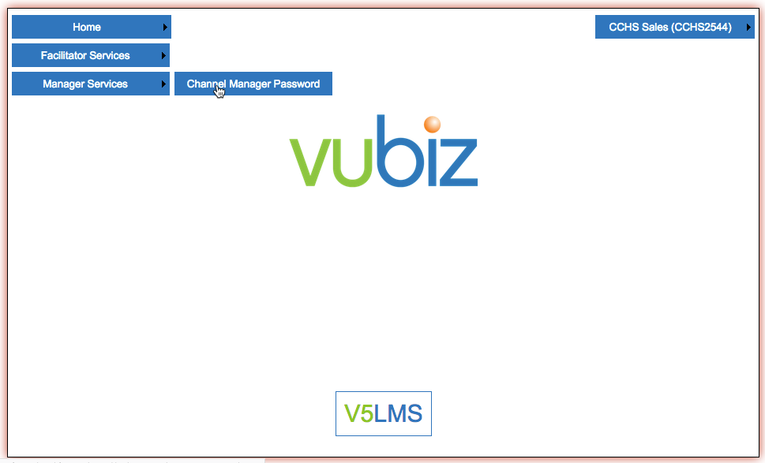

Once the utility opens, enter the current manager password as well as the desired, new password. Please note the password prefix must remain the same (i.e. “VUBZ_”) and the available characters are A-Z 0-9 ! * - _ and is case insensitive:

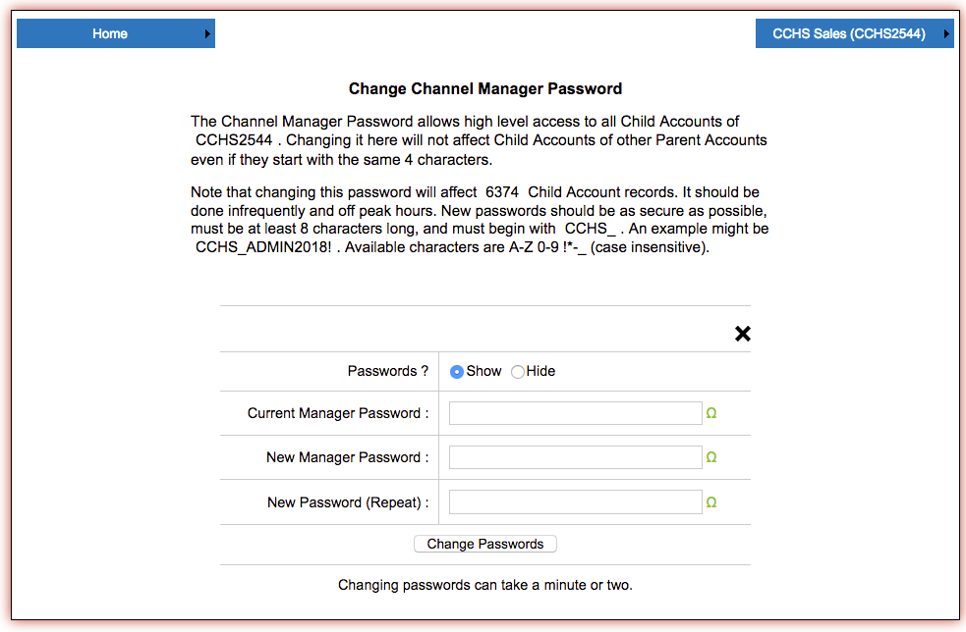

The number of accounts being changed is indicated in the first line of the second paragraph. It may take a few seconds to run the process and please use this utility in off hours if at all possible.