# Ecommerce, Extending/Reducing Expiry Dates

Last updated: Mar 27, 2019

* This web service can either extend an ecommerce transaction’s expiry date to a set number of days from today (ie by specifying # days) or set it to yesterday to effectively expire the transaction (ie by specifying -1 days);
* It requires the Customer Guid, Learner Id (**of the purchaser**), Program Id plus the Number of Days to extend the expiry date from **today!** Note it does **not** add days to the existing expiry date;
* The web service will act on the latest purchased transaction of the specified learner and program; Example:
* Specifying 30 days will extend the Expiry Date to 30 days from today;
* Specifying -1 days will set the Expiry Date to yesterday signifying the transaction has expired;
* <https://stagingweb.vubiz.com/vubizWs/v8server.asmx?op=EcomExtend> (remove “stagingWeb” when running live);
* Web Service parameters:
  1. Customer Guid: provided by Vubiz which defines the Account;
  2. User Id: the user/purchaser must be “active” in the above Account;
  3. Program Id: ie P1234FR;
  4. Number of days: ie 30 (from today) or -1 (set expires date to yesterday); can be plus or minus 365 days;
  5. Returns one of three responses;
     + “inv account” – if the Customer Guid is not valid;
     + “inv ecom transaction” – if there is no ecom transaction;
     + “expires mmm dd, yyyy” – if transaction was successfully extended (or reduced); shows new expires date

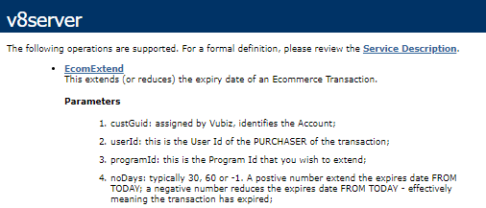

Typical successful response:

