# Portal Styling

* Site is published on staging as /portal
* It is pure .net using MS components (bit of a pain)
* This is the folder structure
* 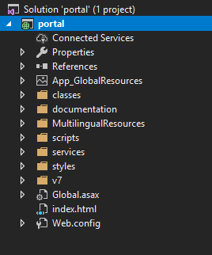
* All the “.aspx” pages are in the V7 folder:
* 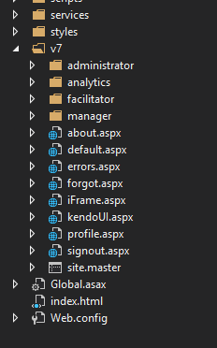
* All styles are in styles/css folder:
* 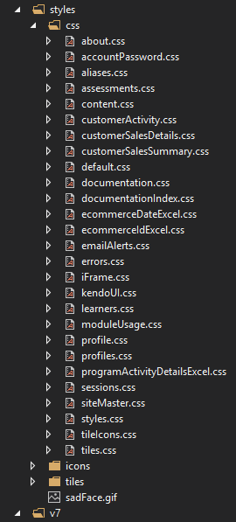
* There is a common CSS called “styles.css”, this is contained in the siteMaster and available to every page/app
* Almost every .aspx file has a corresponding css file of the same name
* Credentials to test at http://stagingweb.vubiz.com/portal
  + Username: VUV5_ADM
  + Customer Id: VUBZ5678
* This will bring up a series of tiles:
* 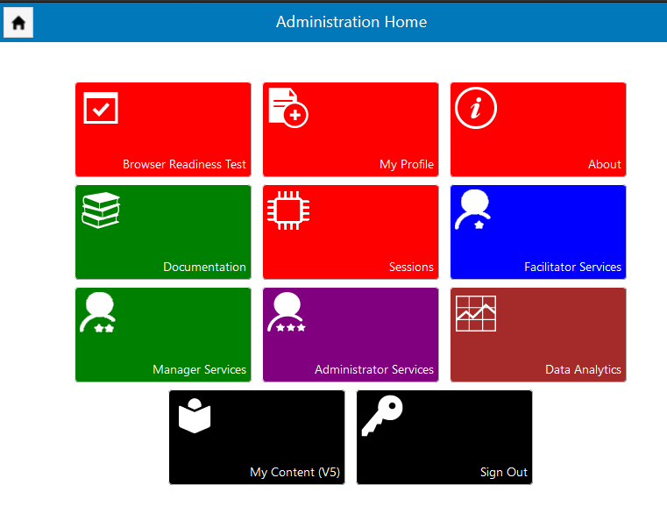
* These tiles have their own CSS (tiles.css)
* However the color of the tiles is database driven – you can change these as you see fit but the system is as follows:
  + RED are apps for the user
  + BLUE for facilitators
  + GREEN is managers
  + PURPLE for administrators
  + BLACK will leave Portal
* To change any, simply tell me to change RED to POOH or whatever color you prefer.
* If, for example you click on Facilitator Service then all tiles are the color of the parent (Blue in this case):
* 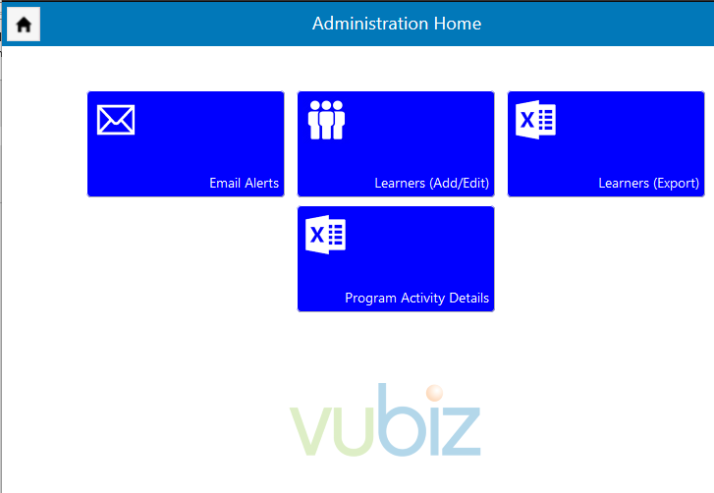
* Typically the logo of the customer is at the bottom of any “tile” page
* The “home” icon at the top left will put you back to the home tile sets.
* The color of the login page plus the header/footers are the Vubiz blue
* If you click on the “Learners (Add/Edit)” tile you will see a typical page:
* 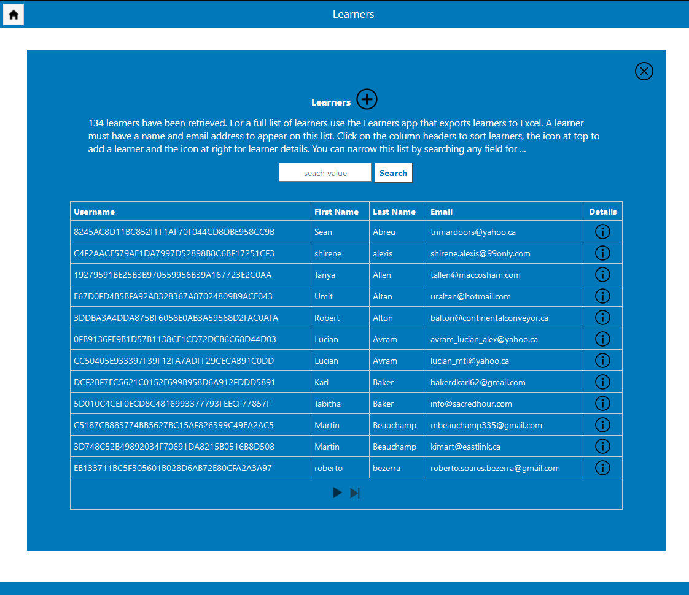
* All pages use.net components (typically tables).
* I try and use icons for navigation (similar my V8 app)
* Data is framed in a Vubiz blue div (easy to change)
* It will not be easy to set this up on your local computer but if you’d like to do that, I can help. Probably easier to just FTP/copy css files to staging.
* Shall we create a copy of /portal called /portal2 which you can use?
* This way we do not muddy up the current version.
* If so, please try and live in the css folder only.
* Also note that I am working on this site regularly so it will NOT be static.
* I can, if you like, let you know of any new or modified pages as I move forward.
* So, each page will contain a link like this:

<link href="/portal/styles/css/about.min.css" rel="stylesheet" />

* If you need any changes to any aspx page (add classes, etc) it’s best if you have me do that, then you can continue to do your thing in css.