# V5 Translation

Last updated: Dec 10, 2020

* V5 translation is a separately run V5 app that reads all pages in the /v5/Source folder and “translates” them with the same page into the /v5/Code folder.
* This app does not require any specific credentials, you simply run it on the server in question, ie: http://localhost/V5/translationengine1.asp
* The app will then read each file look for “tagged” phrases that can be translated.
* There are 3 types of tagged phrase depending on what type of file type they are in.
  1. **html** phrases format: <br><!--[[-->Phrase to be translated.<!--]]-->
  2. **vb** script phrases, ie: vMsg="<!--{{-->Phrase to be translated.<!--}}-->"
  3. **javascript** phrases, ie: var vPhrase1 = "/*--{[--*/Phrase to be translated./*--]}--*/"
* Processing of these phrases can be best viewed in TranslationEnging2.asp.
* It is important to watch for unnecessary embedded leading/trailing spaces.
* Each of the above tags must be entered in the page as a set of tags. Before translation occurs this service will check that there are no odd number of tags in the page, and if there is, it will return an error
* Tags are maintained in a SQL table Phra in the V5_Vubz DB:  
    
  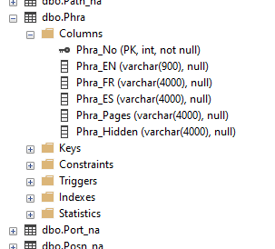
* Note this service/table is only used in V5, not in V8 or Portal (which has its own translation service as part of dot net.
* Each phrase is translated/created with a unique integer value:

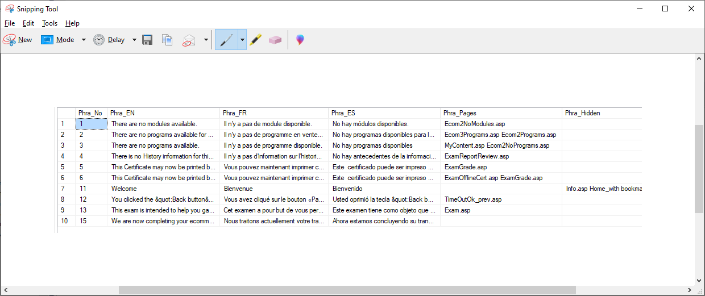

* For example, the phrase “Welcome” is in the Phra table and has the original English (Phra_EN) as well as the French (Phra_FR) and Spanish (Phra_ES) version. (Spanish is no longer used and the values in the Phra table are not current).
* To get the French values of phrases, we make a list of Phrases that need translation, ideally with a snippet of where/how this phrase is used, and send that to our translation guru.
* The guru will typically return the file with the FR version beside the EN.
* We now need to physically add the FR version into the Phra table beside the appropriate EN phrase.
* Now, when we translate one or more pages and we find a source tag that needs translation, the service will look into the Phra table for that phrase, ie “Welcome” and return the FR “Bienvenue”.
* If that phrase does not exist, ie is new, then it will create a new entry for that phrase in the Phra table and return a pseudo FR value such as “FR – Welcome”, implying we need to have this phrase translated and entered into the Phra table.
* Summing up: when you are ready to translate any new or modified phrase, you go here on the server in question:  
  <http://localhost/V5/translationengine1.asp>
* This will appear:  
  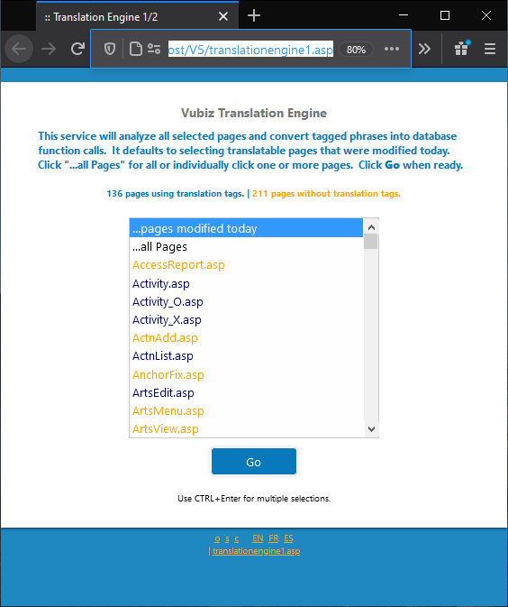
* You can use the default, which is to translate “…pages modified today” or you can selected “…all Pages” (typically unnecessary) or, if you are translating a page you might have modified yesterday (for example) then you can select that specific page.
* Then click “Go”.
* If there are no pages requiring translation it will render:  
  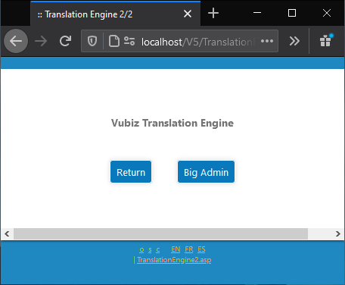
* If pages were translated then those will be listed above.
* You can now run V5 in FR, for example, and check that your phrases were properly translated.