Elec 4700

The Physics and Modeling of Advanced Devices and Technologies

Monte - Carlo Modeling of Electron Transport

Submitted By: Peter Al-Ahmar

Student Number: 100961570

Date Submitted: March 21st 2019

**Introduction**

The following assignment involves modeling electron motion in a semiconductor device. The device is sized at 200nm vertically and horizontally. The experiment conducted in matlab modelled the motion of the electrons using the Monte-Carlo technique. Random numbers were used to estimate the values of thermal velocity, average temperature, mean free time and the mean free path. Finally, an enhancement was added to the experiment and the plots of electron density and the average temperature were found. The enhancements that were added were 2 rectangular blocks in the top and bottom of the semi-conductor. The following report shows the techniques used and the results obtained from the experiment.

**Electron Modeling**

The thermal velocity was first calculated using equation 1 below. An assumed temperature was given to be 300 K. Thermal velocity is the velocity of an electron particle would have if its kinetic energy was the same as the average energy of the system

$V_{th}=\sqrt{kT/m}$ (1)

k is the Boltsman Constant

T is temperature

M is t he effective mass of the electron

As seen in figure 1 below, the plot is a sample of the electron flow.

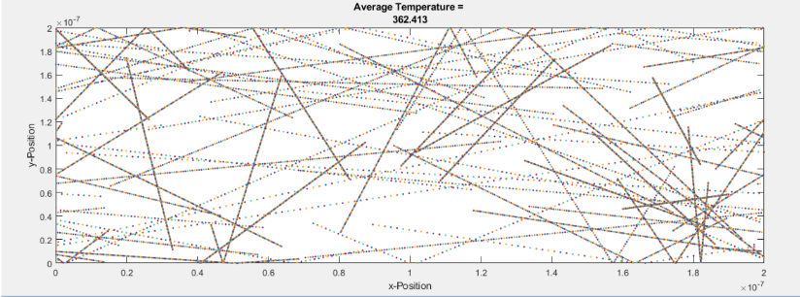

Figure 1: Sample particle Trajectories [1]

Figure 2 below shows the temperature plot against time with scattering implemented in the experiment.

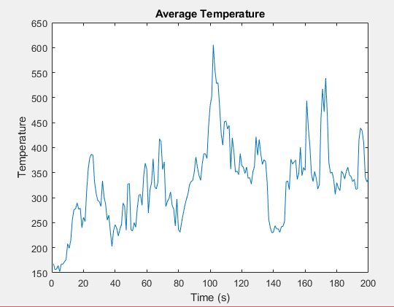

Figure 2: Temperature vs Time

**Collision with Mean Free Path (MFP)**

Random velocities were assigned to each particle. A velocity in the x and y direction were given to each electron from a distribution. The velocities were then multiplied by a standard deviation. The standard deviation is the thermal velocity divided by the square root of 2. Next the probability of scattering was calculated. The scattering was first checked to make sure that it would occur then a random velocity was assigned.

The mean free time was given as 0.2ps, therefore the mean free path can be calculated by multiplying the mean free time by the thermal velocity. As seen in equation 2 below, the mean free path was calculated to be 2.65 x 10^-12

$MeanFP=0.2x13.2= 2.65x10^-12$ (2)

The average temperature fluctuated however it stayed around 300K. It increased and decreased but returned to around 300K. As can be seen in figure 5 below.

The histogram of the thermal velocities can be seen in figure 3 below.

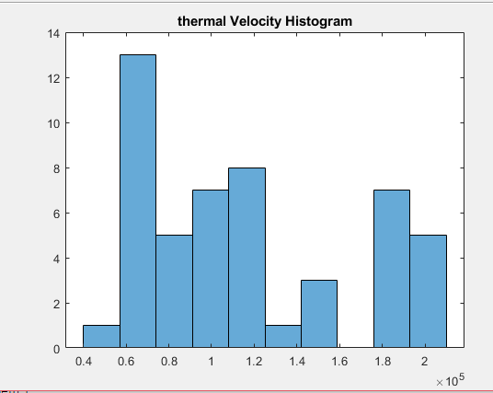

Figure 3: Electron Thermal Velocity Histogram

The figure below shows a sample particle trajectory with scattering.

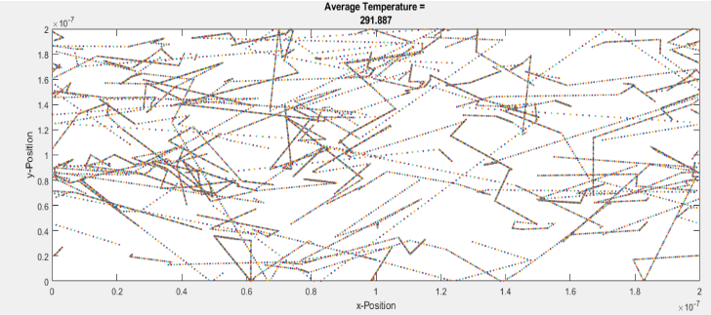

Figure 4: Sample particle trajectory with scattering [1]

Figure 5 below shows the average temperature over time.

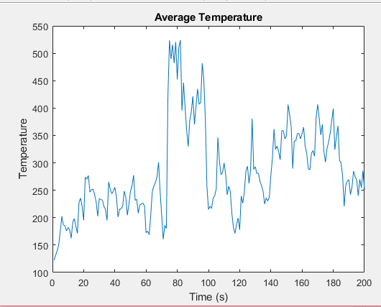

Figure 5: Temperature plot over time, the temperature hovers around 300K

**Enhancements**

Bottlenecks were added to the boundaries of the semi-conductor. The boundaries on the x plane were from 0.85 times of half the width and 1.15 times from half of the width. The y boundaries were from a third of the length and 2 thirds. This created the region in semi-conductor. The electron particles were assigned a random velocity after contacting the boundaries of the diffusive material.

The 2-D plot of the particle trajectories can be seen in figure 6 below.

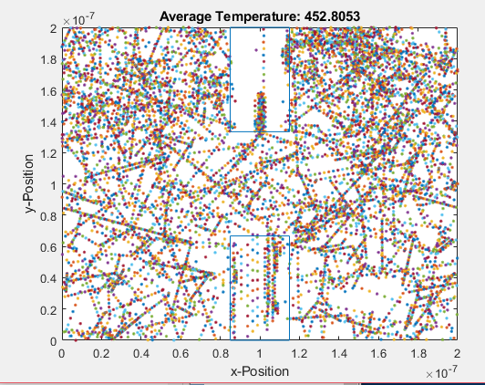

Figure 6: Plot of the 2-D trajectories with “Bottle-neck”

The Electron Density map can be seen below in figure 7.

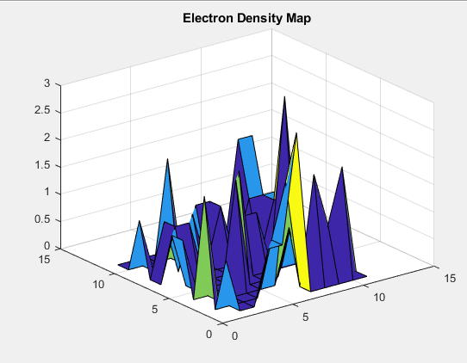

Figure 7: Electron Density Map

The Temperature Map can be seen in figure 8 below.

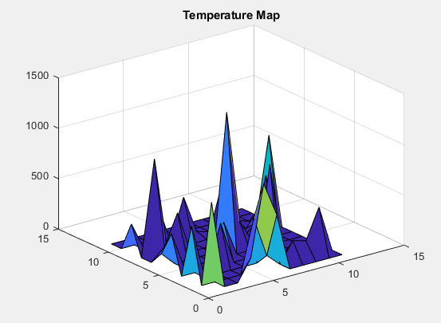

Figure 8: Temperature Map

**Conclusion**

To conclude, the experiment was not as successful as I would have hoped. The matlab code was hard to come up with and I know the result was not as correct as I would have wanted it to be, due to the leaks that occurred after adding the bottle-necks.

**References**

[1] Due to not knowing about the report and completing the code and not knowing about taking snippets of the figures on the way. I have used a colleagues 2 graphs for reference on how the plots were meant to turn up.