Elec 4700

The Physics and Modeling of Advanced Devices and Technologies

Finite Difference Method

Submitted By: Peter Al-Ahmar

Student Number: 100961570

Date Submitted: March 21st , 2019

**Introduction**

The experiment was divided into 2 parts, the first used the finite difference method to solve for electrostatic potential in a region with boundary conditions and the second used the same method to solve for current flow with boundary conditions and added bottleneck. Current was calculated in the device and the behaviour of the current.

**Finite Difference Method with Boundary Conditions**

The first case was tested, and the voltage increased from 0V to Vo which was set to 1V. It increased linearly and the plot can be seen below. Figure 1 and 2 determine the spy of the G-matrix and the voltage model for fixed boundary conditions respectively.

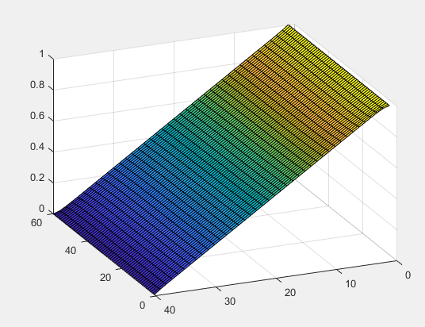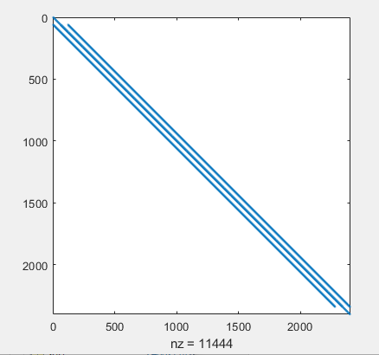

Figure 2: Voltage model with fixed Boundary Conditions on 2 sides

Figure 1: Spy for the G-matrix

Next a model was derived using the meshing method, figure 3 below shows the result obtained in matlab.

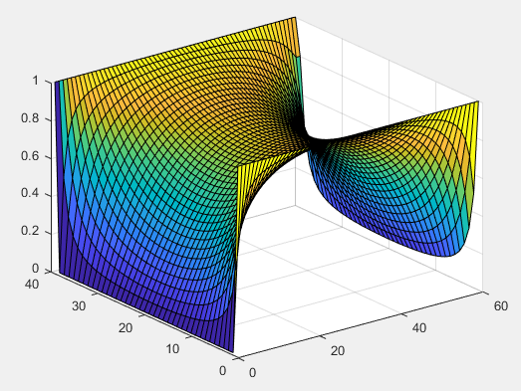

Figure 3: Using numerical solution with fixed Boundary Conditions on all sides

Figure 4 uses the analytical approach and the result can be seen below.

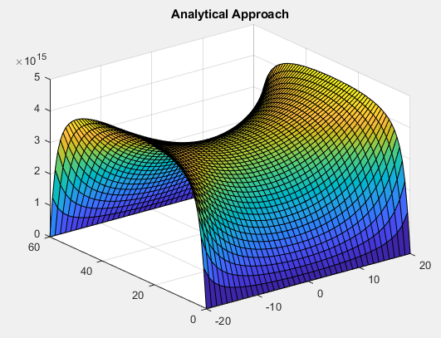

Figure 4: The analytical solution with a fixed Boundary Condition on all sides

**Finite Difference Method with Boundary Conditions and Bottle-necks**

The current flow is the sum of the magnitude of current along the line connecting the contacts. Multiplying the voltage matrix with the conductivity matrix results in the current matrix. The conductivity map is seen in figure 5 below. The mesh size of 120 and 80 is set for the length and width of the rectangular region. The current flow was determined to be 2.75 x 10^-6 A.

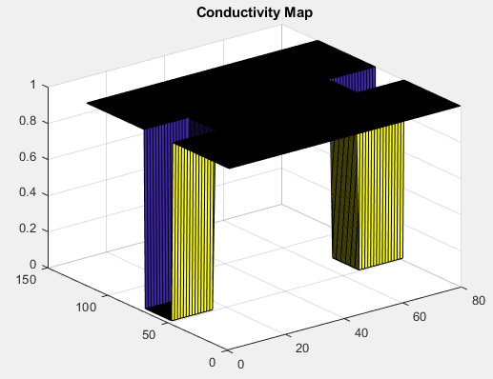

Figure 5: The conductivity map on a rectangular region

The voltage decreased after contacting the bottle-neck from 1V to 0V. Figure 5 shows the plot of the voltage map with a bottleneck. There is some voltage left over but is later goes down to 0V as seen below.

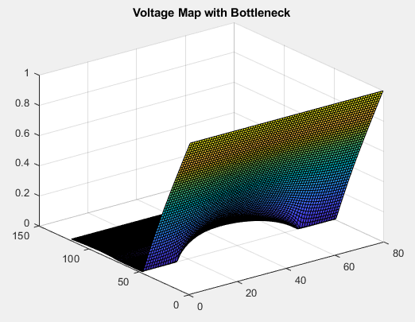

Figure 6: Voltage Map with Bottle-necks Added

Next the electric fields were found in both the x and y direction. This was accomplished by determining the gradient of the voltage map matrix and using the quiver function to plot them. Both the x and y electric field directions can be seen in figure 7 and 8 respectively.

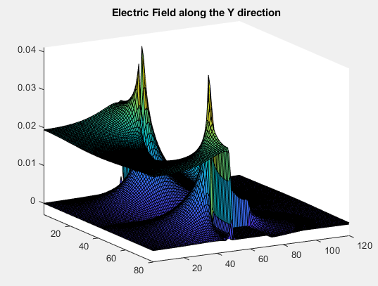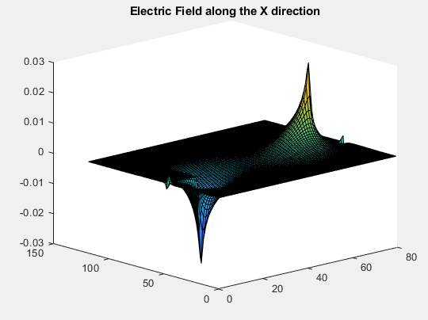

Figure 8: Electric field in Y-Direction

Figure 7: Electric field in X-Direction

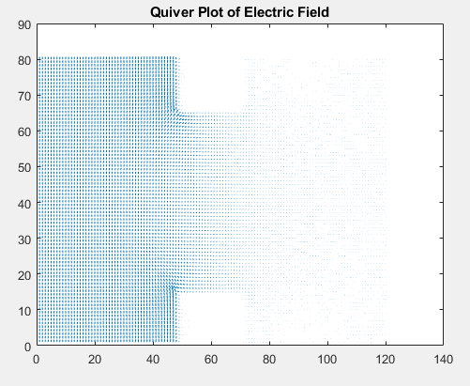 Next the quiver plot of current density and the electric field were determined using the quiver function, below the current density can be seen.

Figure 9: Quiver Plot Electric Field

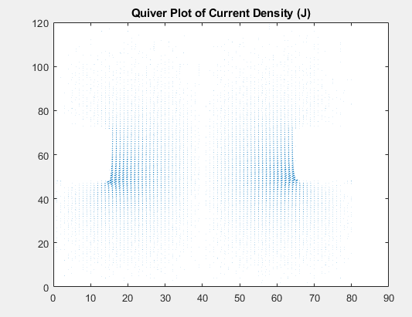

Figure 8: Quiver Plot Current Density

The magnitude of the current density was determined by using the surface function on the magnitude of the current density. Figure 10 below shows the magnitude of the current density.

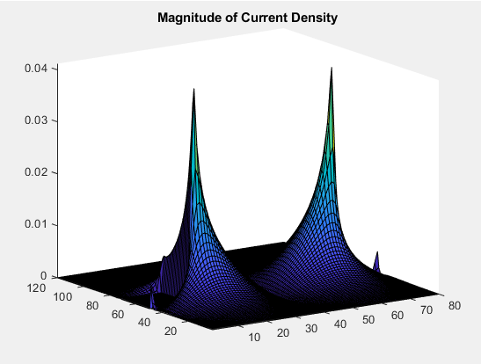

Figure 10: Magnitude of Current Density

As the conductivity of the material increases, so will the current through the material. The increase will be linear. This can be determined using Maxwell’s Equation. Since there the electric current density is proportional to conductivity, if conductivity increases so will the current.

**Conclusion**

To conclude, the voltage models were obtained successfully. The numerical solution appeared to be more accurate and was obtained successfully. The analytical solution approach had the correct shape, but the voltages were varying from the numerical solution. The second part of the experiment yielded in correct graphs and as expected. During the experiments the reason for the errors that I was obtaining was due to the order in which the Boundary conditions were typed out, when that was fixed, the code compiled with no errors. Finally, due to knowing Maxwell’s equation, the current density will increase linearly as the conductivity of the material increases.