Elec 4700

The Physics and Modeling of Advanced Devices and Technologies

Monte – Carlo/Finite Difference Method

Submitted By: Peter Al-Ahmar

Student Number: 100961570

Date Submitted: March 26 2019

**Introduction**

Combining the Monte-Carlo technique that was done in the first assignment and the finite difference method that was done in the next assignment. First the Monte-Carlo simulation was completed after a voltage was applied and the electron field was examined. Next, the finite difference method to calculate the electric field applied on the Monte-Carlo method and finally, applying the electric field to the first simulation.

**Monte-Carlo Simulation**

The electric field was first calculated, by dividing the voltage applied (0.1V) by the distance(200x10^-9). The electric field is measured to be 500,000 V/m.

Next the force is calculated by multiplying the charge by the electric field. The force is calculated to be 8 x 10^-14.

Finally, the current was calculated by using equation 1 below.

$I=n*A*v*Q$ (1)

Where,

I: Current

n: the number of particles

A: Area of the conductor

v: Drift velocity

Q is the charge of the particle (constant)

The plots are generated below, the number of particles chosen was7 from the 5000 particles in the experiment, in order to observe the results clearly. Figure 1 below shows the sample trajectory of 7 particles.

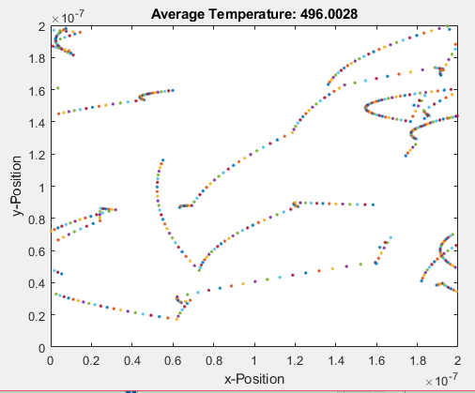

Figure 1: Particles Trajectory Path

The average temperature of the particles after 1000 iterations can be seen in figure 2 below, and the Average Current plot can be seen in figure 3 below.

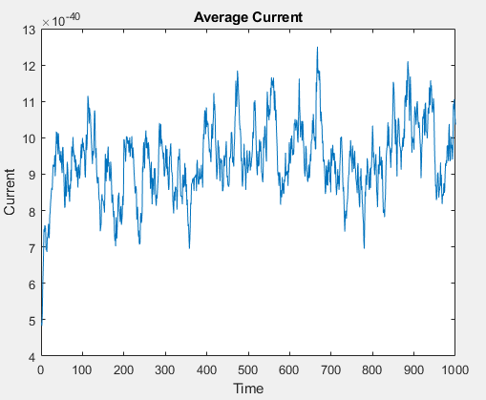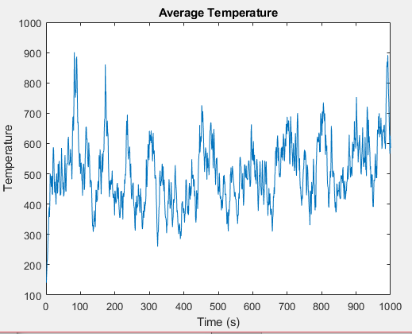

Figure 2: Average Temperature over time Figure 3: Average Current over time

Next the electron density map and the temperature map were then plotted using surf in matlab. The electron density map and the temperature map can be seen in figure 4 and 5 respectively below.

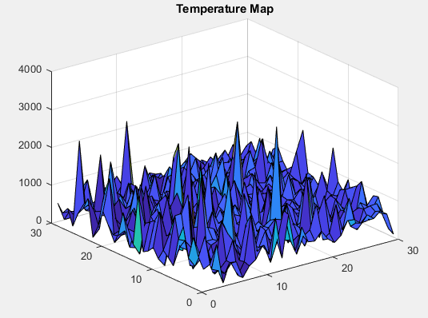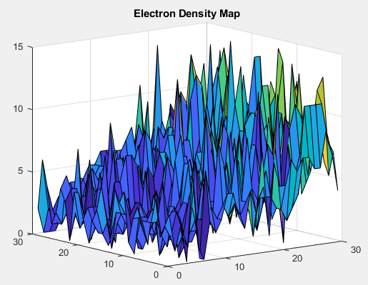

Figure 5: Temperature Map

Figure 4: Electron Density Map

**Finite Difference Method**

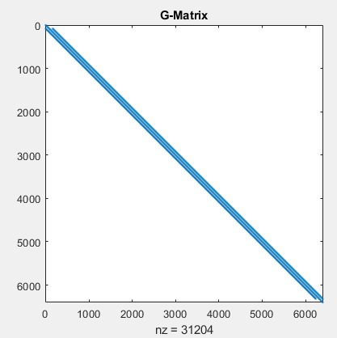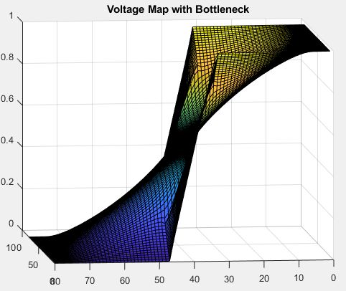The following part involves calculating a voltage and electric field using the finite difference method. Figure 6 is the G-matrix that was created from the finite difference method. Next, figure 7 below is the voltage map with the bottle-necks present, finally figure 8 below is the electric field resulted from the quiver function.

Figure 6: Finite Difference G- Matrix Figure 7: Voltage Map with Bottleneck

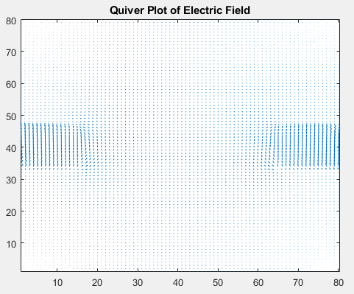

Figure 8: Quiver Plot of Electric Field

**Monte-Carlo Simulation and Finite Difference Method**

Finally, the following experiment dealt with using the first simulation created and combining it with the electric field achieved in the second simulation. The result can be seen in the figure below. The figure below shows the bottlenecks that were created earlier and the reaction the particles had with an electric field present.

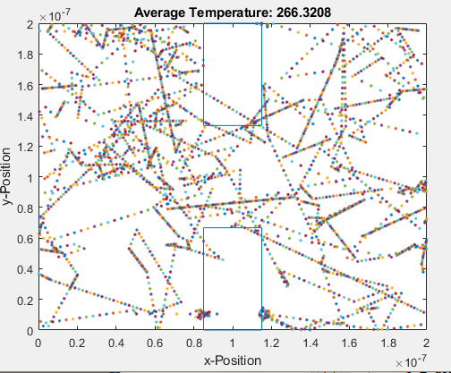

Figure 9: 2-D- Seven Particle sample after 1000 iterations

The electron density map can be seen in figure 10 below. Due to the electric field, the electrons cannot escape, the plot below depicts that.

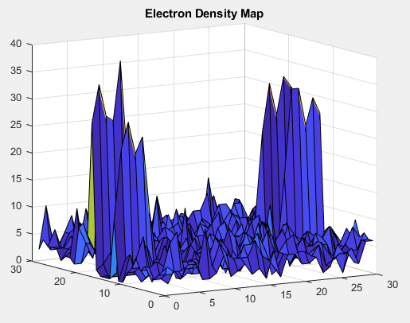

Figure 10: Electron Density Map

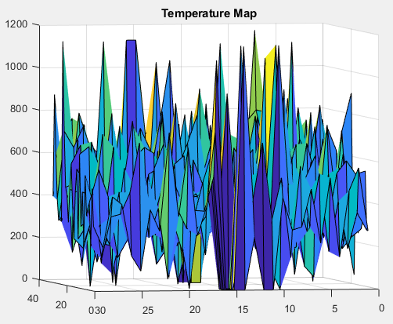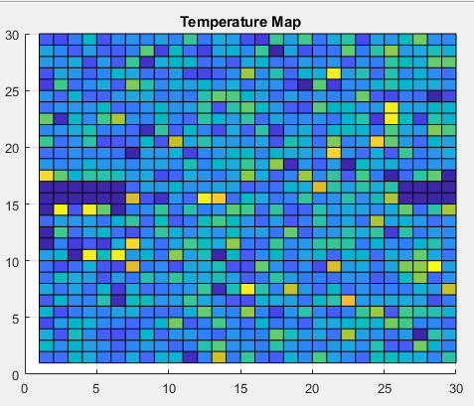Finally, the temperature plot is created. Figure 11 below shows the temperature plot of the Monte-Carlo Simulation and Finite Difference Method.

Figure 11: Top view of Temperature Map Figure 11: Side View of Temperature Map

There is an increased in temperature in the insulated part. This is due to the electric field pushing the electrons towards the insulated areas and the electrons bouncing off them. With the repeated movement of the electrons in such a dense area, the temperature increases resulting in the plots above.

Next step of the experiment is increasing the mesh used in calculating the temperature and the density. This will yield in a more accurate reading and will generate a more accurate plot of the electrons.

**Conclusion**

There are some leaks into the bottlenecks that were added, this is due to my own lack of knowledge in implanting a better and more efficient method in matlab. The first section of the experiment worked well. This was seen by the electron curved movement. Next, the voltage was modelled correctly, and the electric field was found. Lastly, the temperature and density maps had 2 focus points, and that was expected due to the electric field and the insulated areas acting upon the electrons.