Modelling Bidirectional Transport

This is a model of particles (can be molecular motors, vehicles ect) move along a **bundle** of oriented **tracks**. Take molecular motion as an example. Each **track** represents microtubules (MTs) formed from certain cMTOCs (minus ends of MTs). A **unit** in a track represents tubulin dimer in a MT where molecular motors can bind to.

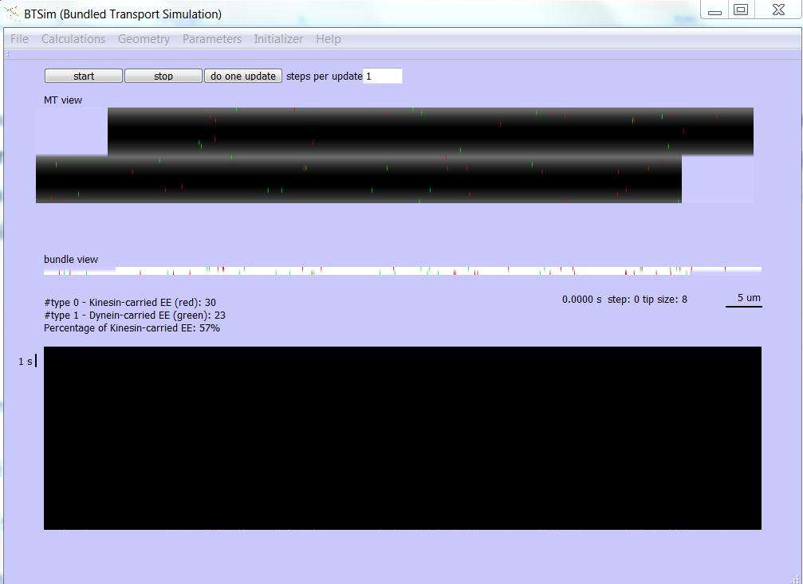

If no particles are shown, use ‘Parameters’ menu to give particle number.

[Initialize](Initializer.docx): initial the state of particles in the bundle.

[Parameters](parameter.docx): set and view the parameters in the model

[Geometry](geometry.docx): set and view the display of tracks, microtubule ends, blockages etc. in the model

[Calculations](Calculations.docx): do the calculation of time averaged state

[File](File.docx): save data and images.