LiveTimer
The classroom timer that follows your students.
There are plenty of countdown timers. But the moment a student closes their laptop to grab coffee, the timer vanishes. LiveTimer puts the countdown on their phone instead — scan a QR code, and the timer travels with them.

No app to install. No account to create. Students join by scanning the screen or typing four characters. The timer is live in seconds.
Zero Friction  Scan a QR code or type a class code. Done. | Timer Library  Save your presets. Load in one click. | Duration or Target  Set a countdown or an end time. Add time live.

LiveTimer — Built for virtual instruction

Your Command Center
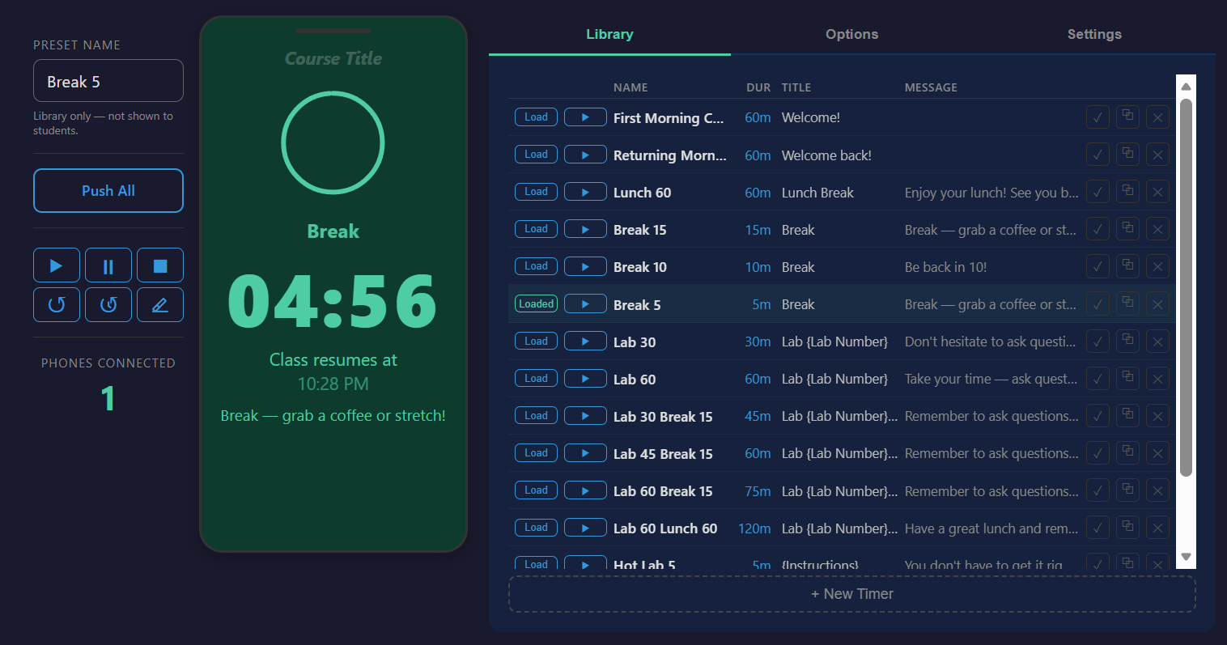 | Everything revolves around a phone-shaped preview in the center of your screen. What you configure is what your students see — live, in real time.  Your timer library sits to the right: every break, lab, and exercise saved as a one-click preset.
Setting the Time
Dial in hours and minutes, or pick a target end time. Need to extend a running lab? Add time without stopping the countdown.  The popup floats over your workspace so you can see the timer underneath. | 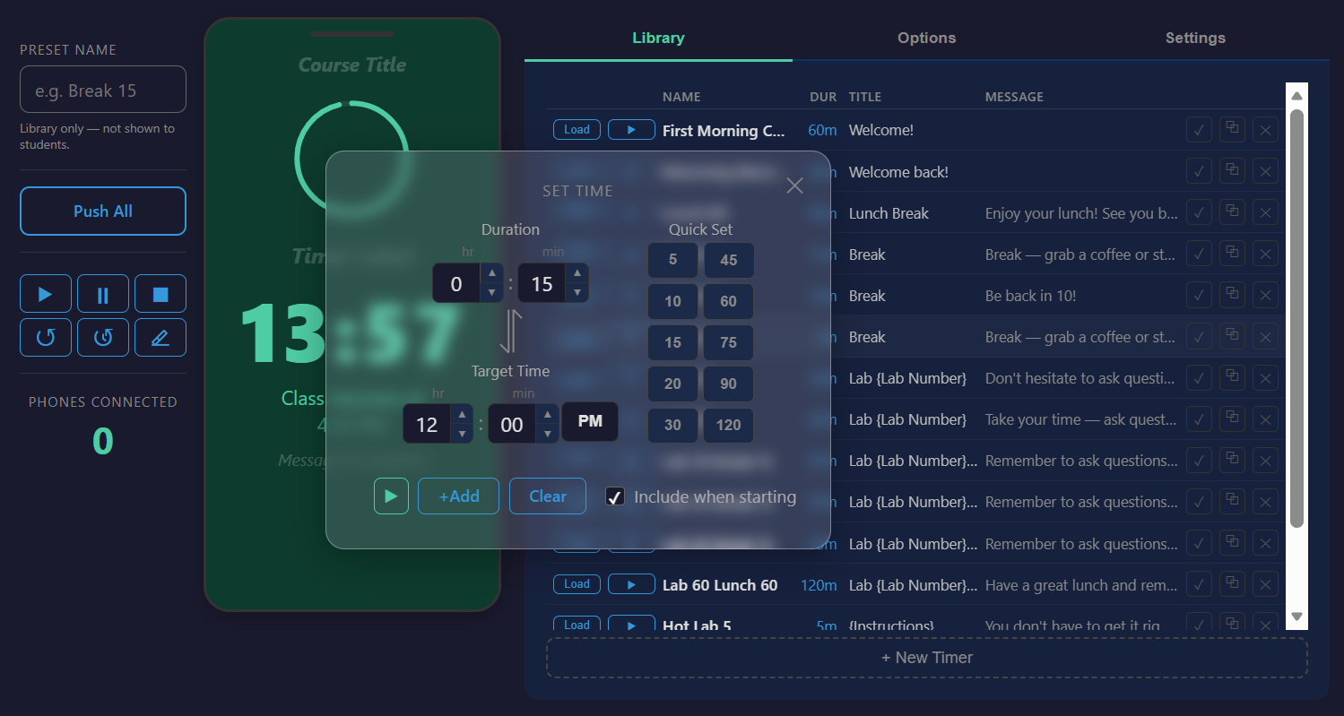
While the Timer Runs
• Push text updates to students without restarting the countdown.
• OBS display modes: transparent background and clock-only options for stream overlays.
• Course title persists across all timers — set it once for the day.
• Class codes keep your session private. Regenerate anytime.
LiveTimer — Built for virtual instruction

Every Screen, Every Student
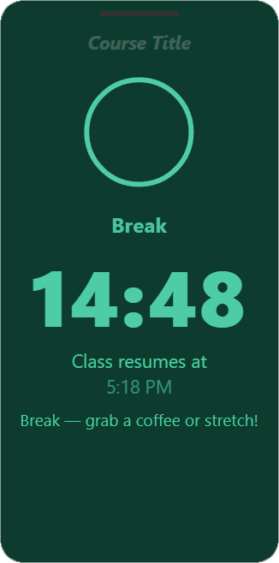 | LiveTimer works on anything with a browser — phones, tablets, laptops, projected displays. The same countdown, synced in real time.  The large screen shows the timer with a QR corner for latecomers. The phone view is streamlined for small screens. Students don’t need Zoom open to see what’s counting down.


The Colors Tell the Story
Green means go. Yellow means heads up. Orange means wrap it up. Red means time’s up. No one needs to ask — the answer is in the color.
 |  | 
Plenty of time | Heads up | Almost done

That’s LiveTimer.
Lightweight. Fast. No accounts, no installs, no training required.
your-livetimer-url.com
LiveTimer — Built for virtual instruction

