LiveTimer
The classroom timer that follows your students.

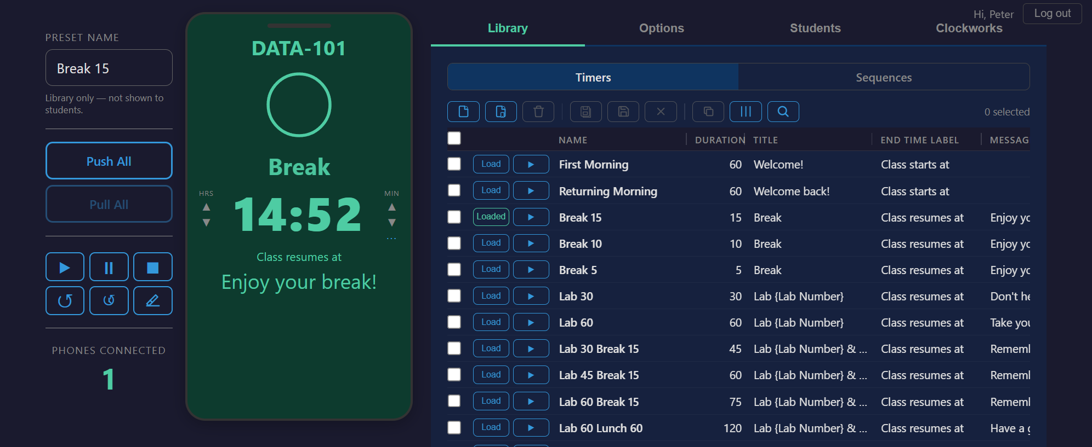

There are plenty of countdown timers. But the moment a student closes their laptop to grab coffee, the timer vanishes. LiveTimer puts the countdown on their phone — scan a QR code, and the timer travels with them.
No app to install. No account to create. Students join by scanning the screen or typing four characters. The timer is live in seconds.
LiveTimer is packed with features, but you don’t have to use them all. Start with a simple countdown — that’s all most people need on day one. When you’re ready for sequences, check-ins, or OBS integration, they’re there waiting. Use what you need, ignore the rest.
Zero Friction  Scan a QR code or type a 4-character class code. No app, no account, no install. | Runs Anywhere  Phones, tablets, laptops, projected displays — if it has a browser, it works. | Always in Sync  Every screen shows the same countdown, updated in real time via WebSockets.
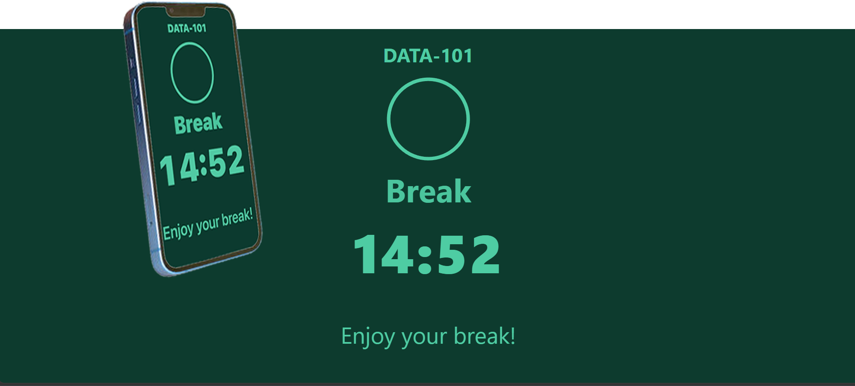

Everything you need. Nothing you don’t.
The instructor panel is built around a live phone preview — what you edit is what your students see, in real time. Course title, timer label, messages — just click and type.
Timer Library
Save every break, lab, and exercise as a one-click preset. Organize them in a full-width grid with inline editing, batch operations, and one-click loading. Your library syncs to the cloud and backs up automatically.
Set Time Your Way
Dial hours and minutes with quick spinners, or pick a target end time (“Back at 2:15”). Need to extend a running lab? Add time without stopping the countdown. The duration popup floats over your workspace so the timer stays visible underneath.
Sequences
Chain timers together into a sequence — lecture, then break, then lab — and run them hands-free. Drag to reorder steps. Skip ahead or stop early. A progress badge tracks where you are so students always know what’s next.
Intuitive Interface
The phone mockup at the center of your screen is both preview and control surface. Edit any field directly on the mockup and it pushes live to students. Transport controls, library, and settings are always one click away. If you can see it, you can change it.
[Screenshot: Instructor panel with phone mockup, library grid, and duration popup]

While the timer runs, so do you.
Live Text Updates
Push announcements to every student’s phone without stopping the countdown. Change the label or message and it appears instantly — no refresh needed.
Student Check-In
Turn on check-in and students can tap “Working on it” or “Done” right from their phone. You see a live status board: who’s still working, who’s finished, who hasn’t started. Reset the board with one click when the next activity begins.
Color States
The colors tell the story — green means go, yellow means heads up, orange means wrap it up, red means time’s up. No one needs to ask how much time is left. The answer is on their screen.
OBS & Stream Integration
Teaching on Zoom? LiveTimer has display modes built for streaming: transparent backgrounds for overlays, clock-only mode for minimal screen real estate, and a dedicated QR-code page you can drop into any OBS scene. Browser source dimensions auto-scale — no fuzzy text.

Green  Plenty of time.  Relax and work. | Yellow / Orange  Heads up.  Start wrapping up. | Red  Time’s up.  Return to class.

Built for teams, not just one instructor.
Multi-Instructor Support
Each instructor gets their own workspace — separate library, timers, class codes, and sequences. Students connect to the right instructor automatically. An admin panel manages the roster. No cross-contamination, no conflicts.
Private Sessions
Class codes keep your session private. Four characters, no ambiguous letters. Regenerate anytime — every connected student disconnects and must re-enter. Project the QR code for easy joins; revoke access just as easily.
No IT Burden
LiveTimer is a web app — nothing to install on student machines, no MDM policies to configure, no plugins to whitelist. Works on personal phones, school Chromebooks, and everything in between. Students scan and they’re in.

Lightweight  No accounts. No installs.  No training required. | Fast  Timer is live in seconds.  Updates arrive instantly. | Intuitive  What you see is what students see.  Edit anything, push it live.
your-livetimer-url.com
Try it free. Run your first timer in under a minute.

