Table of Contents

Ogma Library — User Manual
Field | Value
Product | Ogma Library (development snapshot, grand-plan Phases 00–18)
Document | User Manual
Owner | Chwezi Core Systems
Author | Peter Bamuhigire, Lead Consultant, Chwezi Core
Version | 2.0
Date | 2026-07-06
Status | Draft for owner sign-off
Audience | Readers, researchers, collectors, students, teachers, school administrators
Standards | ISO/IEC/IEEE 26514 (user documentation)
Ogma Library is a local-first desktop application that turns a folder of PDF files into a managed, searchable personal library — and, in classroom mode, into a shared school e-library. By default it transmits nothing off your device; every off-device action is opt-in, previewed, and reversible.
Screenshot note: the images in this manual are captured from the development build running against a synthetic test collection (hence titles like "The Bright Chronicle 4") and from the pseudolocale test build. They show real, working screens; production screenshots on a real collection will replace them at Phase 22 packaging. No screenshot of the 3D shelf or the settings surface exists in artifacts/screenshots/ yet — tracking item DOC-IMG-1 in the release-notes known-limitations list.

1. Getting Started

1.1 First Run: Choose Your Library Folder
Ogma requires no account, no internet connection, and no configuration beyond one choice: the folder that holds your PDFs.
- Launch Ogma Library.
- On the welcome screen, click Choose library folder.
- Select the top-level folder containing your PDFs (subfolders are included automatically).
- Ogma begins scanning in the background. You can browse books as soon as they appear — you do not need to wait for the scan to finish.
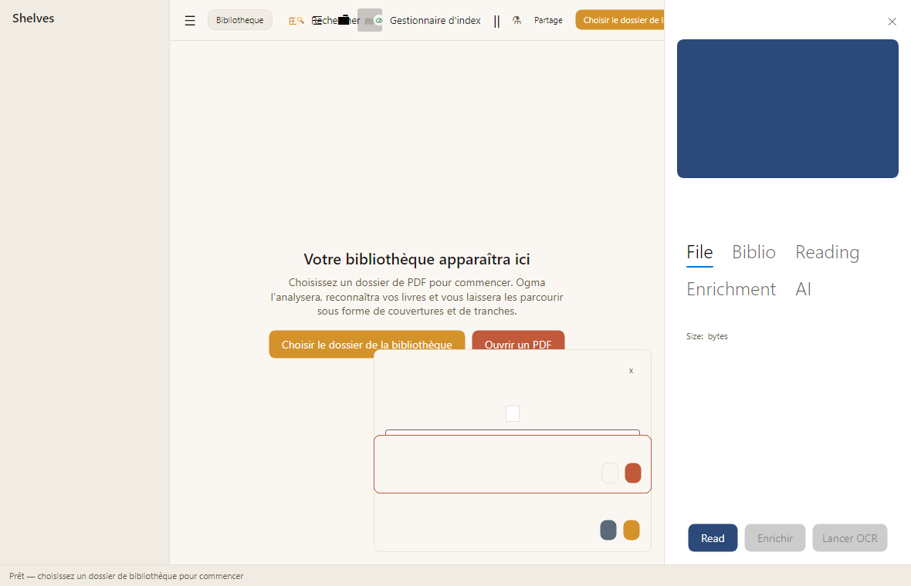
The screenshot above shows the first-run state in French: the interface language is switchable between English and French at runtime (Settings, Language), with Spanish, Italian, and German planned for launch.
To open a single PDF without creating a library, click Open a PDF instead.

1.2 What Scanning Does
Scanning discovers every PDF under your root folder, assigns each file a stable identity (relative path plus content hash), and generates covers and spine images in background jobs. Because identity follows content, renaming or moving a file does not lose its shelves, notes, or reading progress; deleting a file marks the book unavailable but preserves everything you added. Re-scans are incremental: unchanged files are skipped.
To re-scan at any time: open the menu and choose Rescan library. To exclude folders (for example a _drafts subfolder), add them to the excluded list in Settings before rescanning.

2. Browsing Your Library

2.1 Grid, List, Directory, and 3D Shelf
Four views show the same catalogue; a book opened from any view lands in the same detail panel and reader.
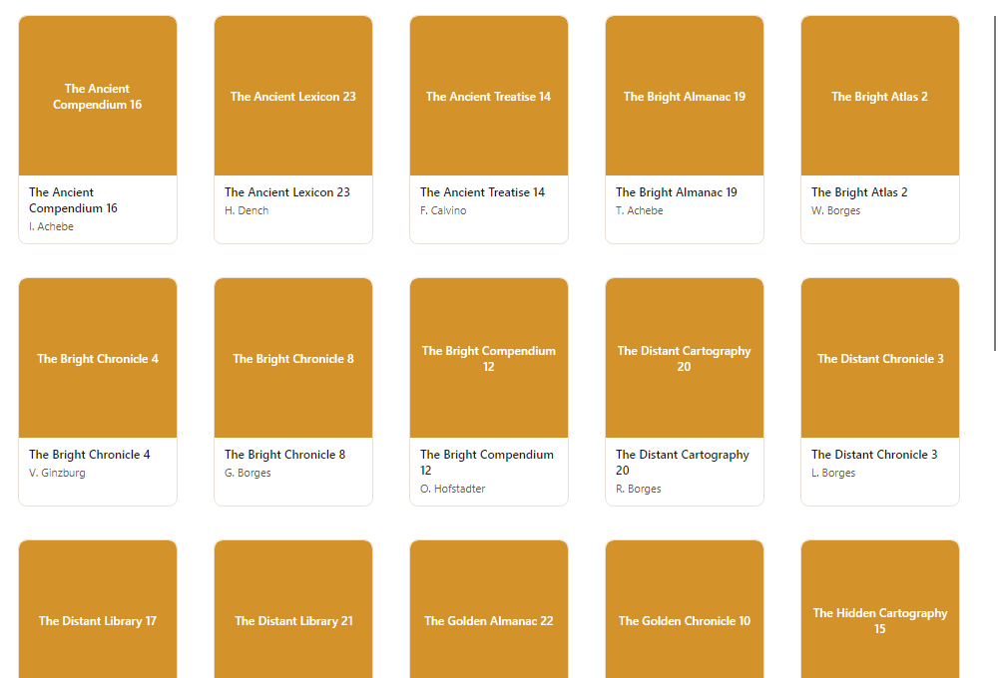
- Grid — cover-first browsing; best for visual recognition.
- List — dense rows with title, author, and status; best for large collections.
- Directory — mirrors your folder structure.
- 3D shelf — a spatial bookshelf rendered with real spine textures; hover to inspect, click to open. The 3D shelf is a browsing aid, never a gate: everything reachable in 3D is equally reachable in grid and list, including by keyboard.
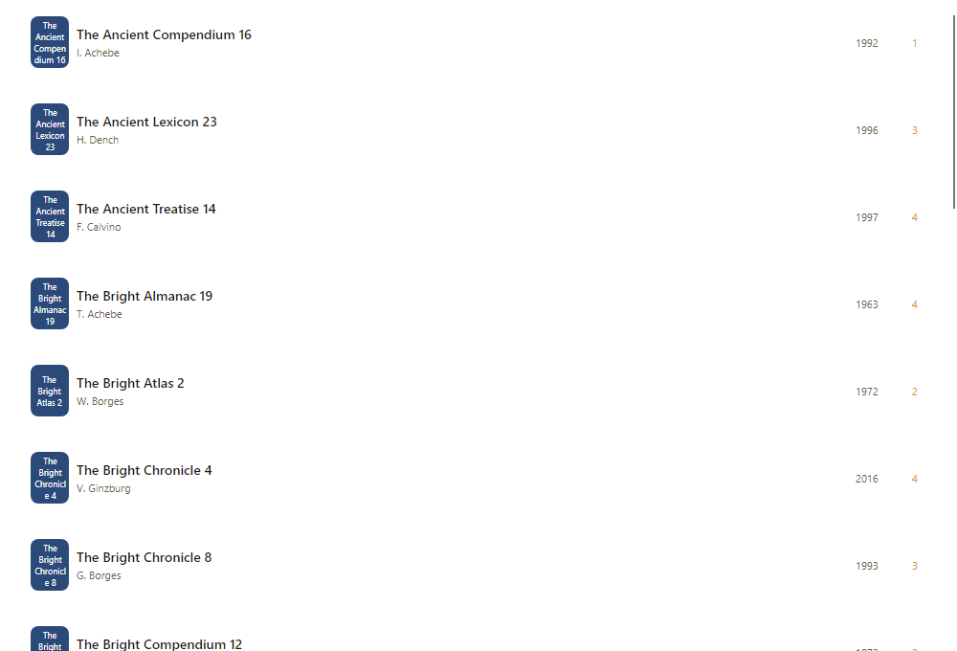

2.2 Sorting, Filtering, and Shelves
- Open the Filters bar above the catalogue.
- Combine filters (title, author, year, status, rating, tag, shelf, availability); results are the intersection of all active filters.
- Click Clear all to return to the full catalogue.
Shelves are virtual: a book can sit on several shelves at once, independent of its folder. Create a shelf from the left sidebar, then add books from the detail panel or by bulk edit. Smart shelves are saved filters that maintain their own membership — for example "Currently reading" or "Missing metadata".
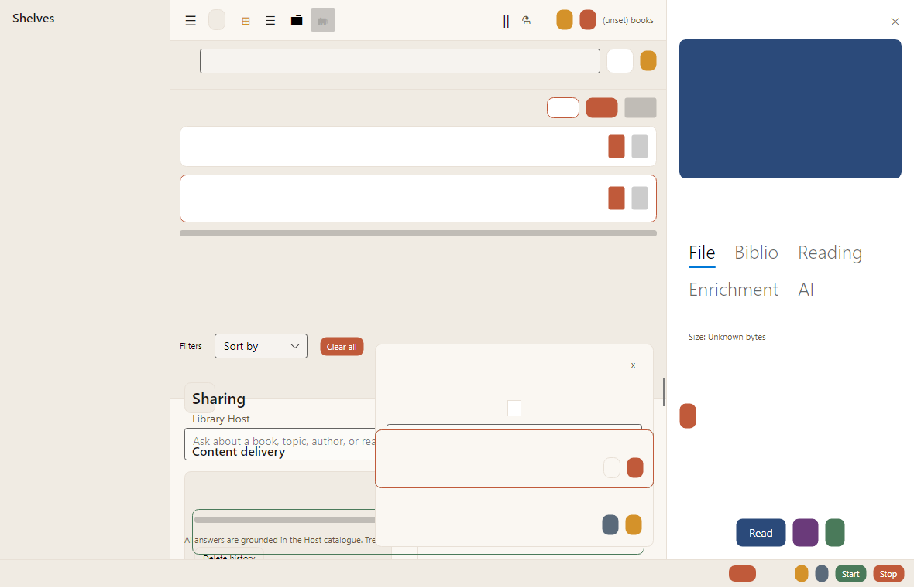

2.3 The Book Detail Panel
Select any book to open its detail panel (right side), organised into File, Biblio, Reading, Enrichment, and AI tabs. From here you can read, edit metadata, run enrichment, or start OCR for scanned books.

2.4 Repairing Metadata
- In the detail panel, open the Enrichment tab and click Enrich.
- Ogma detects ISBNs (from the filename, embedded metadata, and first pages) and looks them up in Google Books and Open Library.
- Review each proposed field: accept, reject, or edit. Your manual edits always win over provider values.
- Optional write-back to the PDF file happens only after your confirmation, with an automatic backup, a field-by-field diff, and a verify-and-restore safety net. A failed write-back leaves your original untouched.

3. Reading and Annotating

3.1 Reading
Open a book from any view. Ogma resumes at your last position automatically. Navigation: first/previous/next/last page, jump-to-page, and back/forward history, all available from the keyboard. Zoom modes (fit width, fit page, fixed percentage) and display modes (single page, two-page spread, continuous scroll) persist per book. Full-screen mode hides everything but the page; press Escape to exit.
Password-protected PDFs prompt once for the password with your consent; the credential is held in your operating system's credential store, never in the catalogue database.

3.2 Bookmarks, Highlights, Notes, Layers, and Reading Memory
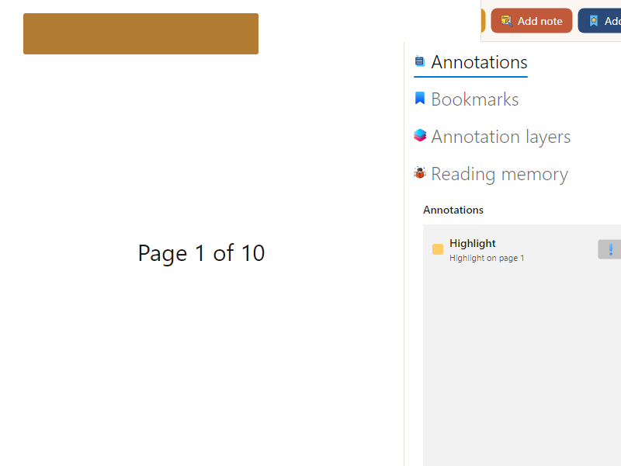
- Select text and click Add note (or the highlight action) to annotate.
- Use the side panel tabs to manage Annotations, Bookmarks, Annotation layers, and Reading memory.
- Assign annotations to named layers (for example "thesis", "quotes", "to-verify") and show or hide layers independently.
- Reading memory records, per book, why you opened it, what you highlighted, and how it ended (finished, abandoned, saved for later).
Annotations live in Ogma's local database and reload exactly where you left them. They are never written into your PDF files.

3.3 Citations and Research Export
Select a passage and choose Copy citation to get a citation card carrying title, author, page, and the selected text. Export selected books, annotations, and citation cards to BibTeX, RIS, CSL JSON, or a Markdown digest from the catalogue's export menu.

3.4 Searching Inside a Document
Press the in-document search shortcut, type a phrase, and Ogma highlights matches and lists the matching pages. For scanned (image-only) books, run Launch OCR from the detail panel first; OCR runs as a background job and its results are marked as OCR-derived in search.

4. Searching the Whole Library
Type in the search box to search metadata as you type. Submit a query to search full text, notes, tags, descriptions, and tables of contents. Every result explains where it matched — title, author, a note, a page of text, or a semantic match — so you can trust why it appeared. Semantic search understands natural-language intent ("that book about cities and memory") using embeddings that are computed locally.
The Index Manager (Settings, Index) shows what is indexed, what is pending OCR, what failed, and how large the index is, with Rebuild index and Erase embeddings controls.
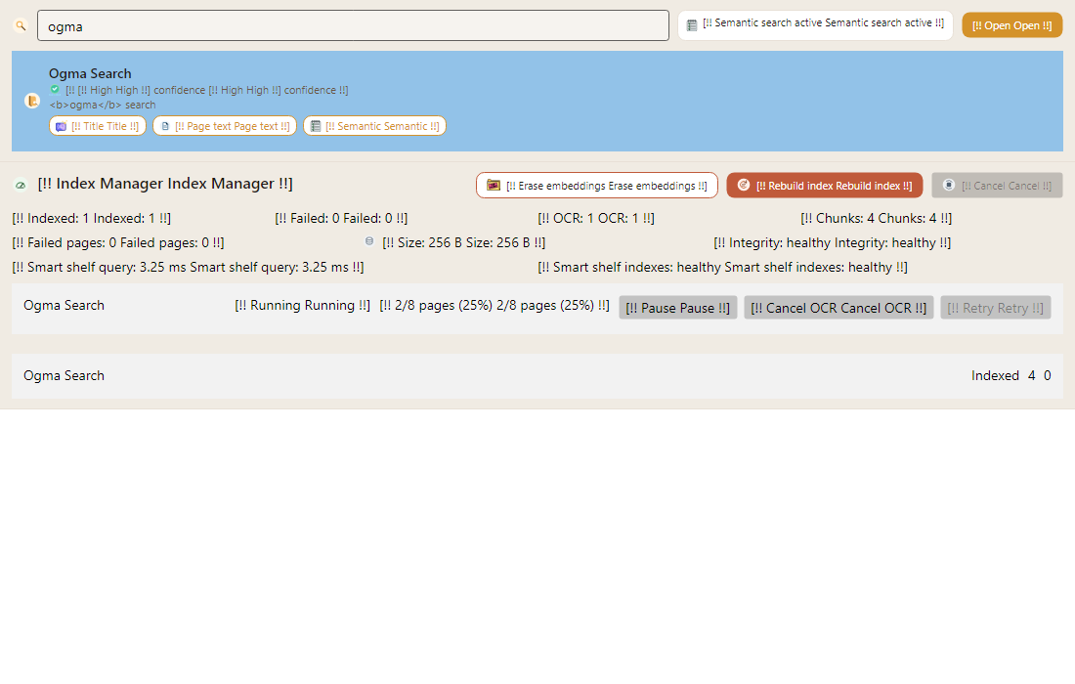
The screenshot above is from the pseudolocale build (text wrapped in [!! … !!]), which the team uses to prove that no interface string is hard-coded; your build shows plain English or French.

5. The AI Reading Advisor and Your Privacy

5.1 Privacy Tiers
AI in Ogma is optional and disabled by default. When you enable it, you choose one of four privacy tiers:
Tier | Name | What can leave your device
0 | Offline | Nothing. AI features are off. This is the default.
1 | Metadata-only | Titles, authors, tags, categories, descriptions, and your notes — never document content. Default for any cloud use.
2 | Content-aware | Selected document excerpts, only after an explicit per-library or per-query opt-in.
3 | Local AI | Nothing. A local model (Ollama) runs on your machine.
Before any off-device call, Ogma shows a payload preview: the exact data, the exact fields, and the destination provider. Nothing is sent until you confirm that preview.

5.2 Using the Advisor
- Enable AI in Settings and pick a provider (OpenAI, Anthropic-compatible, DeepSeek-compatible, or local Ollama). Keys are stored in your OS credential store.
- Ask for recommendations in your own words. Each recommendation card states why it matched, what supported the match, and a confidence level — drawn from your collection, not the internet.
- Generate a reading plan to get a sequenced path through your books with a rationale, estimated difficulty, and checkpoints per step.
The evidence-cited answer mode (ask a question, get an answer citing book and page) is planned for a later release and is not in this build.

5.3 The Privacy Center
The Privacy Center (Settings, Privacy) lists your provider keys, your recent AI calls with their exact payloads and privacy tiers, and delete controls for query history and embeddings, plus an audit-log export. Every off-device transmission, tier change, and credential change is auditable there.

6. The Library Health Dashboard
Open Library Health to audit your collection.
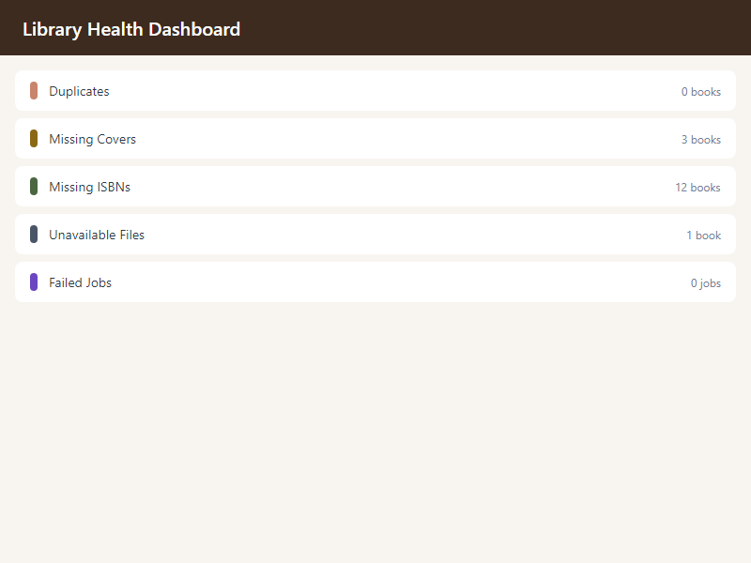
Each row (duplicates, missing covers, missing ISBNs, unavailable files, failed jobs) shows a count and opens the affected books with a remediation action — for example, running enrichment on the 12 books missing ISBNs, or locating the 1 unavailable file.

7. Classroom Mode for Students
If your school runs an Ogma library host, you can read the shared collection from any computer on the school network.

7.1 Joining a Classroom Library
- Choose Join a library and either pick the discovered host or scan the QR join code / enter the join link your teacher gives you.
- On first connection, Ogma shows the host's certificate fingerprint; your enrollment confirms it, and any later change to the host's identity is blocked until re-approved.
- Sign in to your personal profile. Your reading progress, bookmarks, and notes belong to your profile alone — other students cannot see them.

7.2 Reading, Searching, and AI in the Classroom
- Books stream from the host; you never need to copy the whole file. Recently read books stay in a size-limited offline cache so a network drop does not interrupt you mid-chapter.
- Search runs against the host's index with the same match explanations as personal search.
- Smart search (AI) goes through your school's account, not your own. Before anything leaves the school's network, you see the privacy-tier label and the exact payload. The school default sends metadata only — never book content — unless your school administrator has explicitly enabled more.
- You can delete your own AI query history at any time (Settings, Privacy).
If your enrollment is revoked, you lose access to the shared library at your next connection, but the notes you made stay on your machine.

8. Host Mode and School Administration Basics
This section is for teachers and administrators. Host mode is off by default on every install; nothing listens on the network until you enable it.

8.1 Enabling Host Mode
- Open Sharing, then Library Host, and switch host mode on. The action is confirmed, audited, and reversible.
- Ogma provisions a TLS certificate and advertises the host on the local network (mDNS). Clients see the certificate fingerprint on first connection.
- Publish the folders and shelves you want shared. Only published content is ever visible or enumerable to clients — unpublished books do not exist as far as clients are concerned.
- Generate join codes (QR) for your students and teachers.

8.2 Managing People and Sessions
Enroll, edit, and revoke student and teacher profiles from the admin console. Active client sessions can be listed, limited, and revoked. Every connection, stream, and denial is written to the host activity log, which you can export.

8.3 Managed AI for the Classroom
- Store your school's AI key on the host; it lives in the host's OS credential store and is never sent to any client.
- All student AI queries route through the host's gateway under your policy: the class default is metadata-only, and content-aware analysis requires your explicit opt-in.
- Set per-student and per-class quotas and per-student rate limits; the admin dashboard shows usage, cost, and quota utilisation.
- Students can delete their own AI history; you can purge all student AI history for the institution.
The data-protection posture of classroom mode — including how students' (minors') reading and AI-query data is protected — is documented in the project's Data Protection Impact Assessment (09-governance-compliance/03-dpia/). Teacher dashboards are aggregate by design; per-student visibility is disclosed to the students it covers.

9. Troubleshooting
Symptom | Cause | Resolution
A book shows as unavailable | Its file was moved outside the library root or deleted | Restore or relocate the file, then rescan; your notes and progress are intact either way
A scanned book returns no search hits | It has no text layer and has not been OCR-processed | Open the detail panel and click Launch OCR; hits appear when the job completes, marked OCR-derived
The AI panel is greyed out | AI is disabled (Tier 0) or no provider is configured | Enable AI in Settings and select a provider, or leave it off — no reading feature depends on it
A classroom client cannot connect | Host offline, enrollment revoked, or changed host certificate | Check host status with the administrator; re-approve the fingerprint if the host was legitimately reinstalled
A metadata write-back reports failure | The PDF is locked, read-only, or malformed | The original file is untouched by design; review the failure detail and retry after unlocking the file
Search feels stale after a big import | The index has not caught up | Open the Index Manager and check progress, or run Rebuild index

10. Getting Help
- In-app help is planned (FR-UX-006) and not yet in this build; this manual and the FAQ (faq.md) are the current references.
- Support: Chwezi Core Systems — chwezicore.com.

phase: "08" document: Installation Guide

Ogma Library — Installation Guide
Field | Value
Product | Ogma Library (development snapshot, grand-plan Phases 00–18)
Document | Installation Guide
Owner | Chwezi Core Systems
Author | Peter Bamuhigire, Lead Consultant, Chwezi Core
Version | 2.0
Date | 2026-07-06
Status | Draft for owner sign-off
Audience | Technically capable early users, school IT staff, contributors
Standards | ISO/IEC/IEEE 26514 (user documentation)
Honesty note: packaged installers (Velopack direct download, MSIX/Microsoft Store, notarized DMG/Mac App Store) are grand-plan Phase 22 scope and do not exist yet — there is no packaging configuration in the repository. Until Phase 22 ships, the only supported installation is building from source. This guide describes that path truthfully rather than documenting installers that are not built.

1. System Requirements
Requirement | Minimum (matches reference machine W-REF-01 / M-REF-01)
Operating system | Windows 10 22H2 or later; macOS 13.6 or later
CPU / RAM | 4-core CPU, 8 GB RAM
Storage | SSD recommended; allow roughly 1–3 GB of sidecar space (covers, thumbnails, extracted text, index) per 2,000 books, in addition to your PDFs
Display | 1920×1080 or better
WebView | Windows: WebView2 Runtime (usually preinstalled on Windows 10/11); macOS: WKWebView (built in)
Network | None required. Internet is needed only for optional metadata lookups and optional cloud AI

2. Prerequisites (from-source install)
- .NET 10 SDK — install from dotnet.microsoft.com; verify with dotnet --version (must report 10.x).
- Git — verify with git --version.
- Windows only: WebView2 Runtime if not already present (required by the 3D shelf).
- Optional: Ollama if you want local AI (Tier 3) or local embeddings — any recent release; verify with ollama --version.
- Optional: an API key for OpenAI, an Anthropic-compatible provider, or a DeepSeek-compatible provider if you want cloud AI. Not required for any core feature.

3. Installation Steps (Windows and macOS)
- Clone the repository:
git clone <repository URL> Ogma-Library
cd Ogma-Library
- Build (warnings are errors; a clean build is the expected state):
dotnet build OgmaLibrary.sln -c Release
- Run the desktop application:
dotnet run --project src/OgmaLibrary.App -c Release
The catalogue database and sidecar assets are created on first run next to your chosen library folder and in the per-user application-data directory; no administrator rights are needed.

4. Configuration
- All configuration is in-app (Settings): language (English/French), theme (light/dark/system), excluded folders, AI provider and privacy tier, index options.
- AI provider keys are stored in the operating system credential store (Windows Credential Manager / macOS Keychain), never in files you could accidentally commit or copy.
- Classroom host mode is off by default and is enabled only from Sharing, Library Host (see the User Manual §8).

5. Post-Installation Verification
- Launch the app; the welcome screen appears within seconds on reference-class hardware (the formal cold-start budget NFR-OGMA-001 is ≤ 3 s at P95, verified at Phase 20).
- Choose a folder containing at least one PDF; the book appears in the catalogue while scanning continues.
- Open the book; a page renders and the reader resumes position after close/reopen.
- Optional full check: run the test suite — dotnet test OgmaLibrary.sln — all tests pass on a healthy checkout (616 test facts/theories as of this snapshot).

6. Upgrading
Until packaged auto-update ships (Phase 22, signed and reversible per the packaging decision ADR-0009), upgrading is git pull followed by a rebuild. Database schema migrations run automatically and are designed to be idempotent and backed up; your catalogue, annotations, and settings are preserved across upgrades.

7. Uninstallation
- Delete the cloned repository folder.
- Delete the per-user application-data directory if you want to remove the catalogue database, sidecar assets, and settings. Your PDF files are never touched: Ogma augments your folder, it does not move or convert your books.
- Remove any stored provider keys from the OS credential store (Windows Credential Manager / macOS Keychain, entries prefixed with the application name).

8. Common Issues and Solutions
Issue | Cause | Solution
dotnet build fails on SDK version | .NET SDK older than 10 | Install the .NET 10 SDK and re-run dotnet --version
3D shelf tab is blank (Windows) | WebView2 Runtime missing | Install the WebView2 Runtime and restart the app; grid and list views work regardless
Local AI features unavailable | Ollama not installed or not running | Install and start Ollama, then re-select the local provider in Settings — or use Tier 0/1 instead
Build warnings treated as errors after local edits | The solution builds with warnings-as-errors by design | Fix the warning; do not disable the setting
macOS blocks the unsigned dev build | Code signing and notarization arrive with Phase 22 | Right-click, Open for a from-source development build; packaged notarized builds will remove this step

phase: "08" document: FAQ

Ogma Library — Frequently Asked Questions
Field | Value
Product | Ogma Library (development snapshot, grand-plan Phases 00–18)
Document | FAQ
Owner | Chwezi Core Systems
Author | Peter Bamuhigire, Lead Consultant, Chwezi Core
Version | 2.0
Date | 2026-07-06
Status | Draft for owner sign-off

General
Q1: What is Ogma Library?
A local-first desktop application that turns a folder of PDFs into a managed, searchable library: covers and shelves (including a 3D shelf), reading progress and annotations, metadata repair, full-text and semantic search, an optional AI reading advisor, and an optional classroom mode that shares a collection over a school network. See the User Manual (user-manual.md) for procedures.
Q2: Does Ogma change or move my PDF files?
No. Your files stay where they are, in their original format. The catalogue database augments your folder; it never replaces it. The only operation that touches a PDF is optional metadata write-back, which runs only after your confirmation, creates a backup first, shows a field diff, verifies the result, and restores the original on any failure.
Q3: Does Ogma work offline?
Yes — offline is the normal state. Reading, browsing, annotation, metadata editing, search, and local AI (via Ollama) all work without internet. Only two features ever use the network, both opt-in: external metadata lookups (Google Books, Open Library) and cloud AI.

Privacy and Data
Q4: What data leaves my device?
Nothing, by default. Ogma's default privacy tier is Offline and the default install transmits 0 bytes. If you opt into cloud AI or metadata lookups, a minimised payload is shown to you in a preview — exact content, exact fields, destination provider — and is sent only after you confirm it. The Privacy Center lists every past call with its exact payload.
Q5: Where are my AI provider keys stored?
In your operating system's credential store (Windows Credential Manager or macOS Keychain) — never in the catalogue database, configuration files, exports, or backups. Removing a provider deletes its stored key.
Q6: Can I delete what the AI has stored?
Yes. You can delete AI query history and derived embeddings for one document or the whole library in a single operation, and the Privacy Center surfaces your provider's own deletion mechanism for anything sent off-device. You can also disable retention entirely.
Q7: Will my documents be used to train AI models?
The provider no-training flag defaults to opt-out. Enabling training would require a separate, explicit opt-in, independent of enabling the feature itself.

AI Features
Q8: Do I need an AI subscription or key to use Ogma?
No. AI is fully optional and disabled by default; no core feature depends on it. If you want AI, you can run it entirely locally with Ollama (no key, no cloud), or bring a key for OpenAI, an Anthropic-compatible provider, or a DeepSeek-compatible provider.
Q9: What does the AI actually do?
It recommends books from your own collection — with an explanation and a confidence level per recommendation — and generates reading plans (sequence, rationale, difficulty, checkpoints). A question-answering mode that cites book and page is planned but not in this build.
Q10: How do I know what a cloud AI call will cost?
Each cloud call displays a model-usage and cost estimate, and the school/admin dashboard (in classroom mode) totals usage and cost against quotas.

Classroom Mode
Q11: How do students join a school library?
The school administrator enables host mode and hands out QR join codes or join links. A student picks the discovered host (or scans the code), confirms the host's certificate fingerprint on first connection, and signs into a personal profile. See User Manual §7.
Q12: Can my teacher see what I read and write?
Your notes, bookmarks, and progress are private to your profile — other students can never see them. Teachers see class-level aggregate dashboards; any per-student visibility is disclosed to the students it covers rather than collected covertly. Your AI query history is yours to delete.
Q13: Does classroom AI expose students' book content to a cloud provider?
Not by default. Student AI queries route through the school's host under the school's key, and the class default tier is metadata-only — book content is never included unless the school administrator explicitly opts the class into content-aware mode, and every student still sees the payload preview before anything is sent.
Q14: What happens if the school network or host goes down mid-lesson?
Recently read books remain available from the client's size-limited offline cache, the client shows its offline state, and reading state re-syncs when the host returns. A host outage never destroys a student's local notes.

Installation and Licensing
Q15: How do I install Ogma today?
By building from source with the .NET 10 SDK — see installation-guide.md. Packaged installers (direct download, Microsoft Store, Mac App Store) are Phase 22 scope and are not yet available. Linux support of the classroom client secret storage exists in code, but Windows and macOS are the supported desktop targets.
Q16: What will Ogma cost?
The working pricing hypothesis is a one-time license (no subscription) with an optional annual update plan, plus separate education licensing for classroom hosts and seats. Final pricing is an open owner decision; nothing in this FAQ is a price commitment.
Q17: Which languages does the interface support?
English and French are complete and switchable at runtime in this build. Spanish, Italian, and German complete the launch scope (grand-plan Phase 21).

phase: "08" document: Release Notes

Ogma Library — Release Notes, v0.x Development Snapshot
Field | Value
Product | Ogma Library
Release | v0.x development snapshot (grand-plan Phases 00–18; not a public release)
Snapshot date | 2026-07-06 (codebase last commit 2026-06-03)
Owner | Chwezi Core Systems
Author | Peter Bamuhigire, Lead Consultant, Chwezi Core
Document version | 2.0 — Draft for owner sign-off
This snapshot documents what the codebase at C:\wamp64\www\Ogma-Library actually delivers as of the Phases 00–18 build (294 commits, 2026-05-30 to 2026-06-03, 616 passing test facts/theories). It is a development snapshot, not a public release: packaging, signing, and store distribution are Phase 22 scope. Identifier note: this project uses module-scoped requirement identifiers (FR-LIB-001 and similar) rather than flat FR-001-style numbering; every identifier below traces to the baselined inventory in _context/features.md.

Highlights
A complete local-first PDF library — scanning, catalogue, metadata repair, reader with durable annotations, full-text and semantic search, a privacy-tiered AI advisor, and a 3D shelf — plus the full classroom stack: LAN host mode, per-student classroom clients, and school-administered managed AI.

Delivered Features by Module

Library setup and scanning (FR-LIB-001 through FR-LIB-007)
Root selection with rescan; recursive discovery with exclusions; stable identity via path plus content hash so renames re-match; unavailable files preserved with all user data; background thumbnail/spine generation with visible, retryable failures; incremental rescan; scan health report.

Catalogue browsing (FR-CAT-001 through FR-CAT-006)
Grid, list, directory, and 3D shelf views over one catalogue; combinable, clearable sort and filter; virtual shelves with multi-membership; full metadata inspector; previewed, undoable bulk edit; smart shelves. Not included: the Work/Edition duplicate-grouping model (FR-CAT-007).

Metadata enrichment (FR-META-001 through FR-META-008)
ISBN detection, normalisation, and ranking; Google Books and Open Library lookups with source, timestamp, and confidence; reviewable confidence merge; field-level provenance; reversible PDF write-back (backup, diff, verify, restore); rate-limited batch enrichment; metadata quality score; library health dashboard.

PDF reader and annotations (FR-READ-001 through FR-READ-011, FR-READ-013 through FR-READ-015)
Open/resume, full navigation with history, zoom and display modes with persistence, full-screen, in-document search, bookmarks, durable highlights and notes, password-protected PDFs via the OS credential flow, background OCR (Tesseract) with OCR-derived labelling, citation capture, citation/research export (BibTeX, RIS, CSL JSON, Markdown digest), reading memory, and annotation layers.

Search and indexing (FR-SEARCH-001 through FR-SEARCH-006)
Type-ahead metadata search; FTS5 full-text index over text, notes, tags, descriptions, and tables of contents; match-location explanations; semantic search on local embeddings; hybrid ranking; index manager with rebuild and erase-embeddings controls.

AI advisor and privacy (FR-AI-001 through FR-AI-007, FR-AI-009 through FR-AI-011)
Complete disable (default); provider choice — OpenAI, Anthropic-compatible, DeepSeek-compatible, Ollama — behind one gateway; explained, confidence-rated recommendations; metadata-only default with payload preview; content-aware opt-in with privacy labels; local embeddings; reading plans; local query history with deletion and retention controls; per-call usage and cost estimates; Privacy Center with exact-payload call log and audit export.

LAN host mode (FR-LAN-001 through FR-LAN-010)
Opt-in host (no listener by default), TLS catalogue and range-request PDF streaming with path validation, mDNS discovery, certificate provisioning with trust-on-first-use fingerprints, per-profile credentials and QR join codes, session management, non-destructive degradation, publish-scope enforcement, exportable activity audit.

Classroom client (FR-CLIENT-001 through FR-CLIENT-013)
Host discovery and connection, per-student private profiles, roles (student/teacher/administrator), streamed reading, bounded offline cache with purge, reading-state sync with per-field conflict rules, host-index search with explanations, student privacy isolation, enrollment/revocation semantics, strict read-only access to host content, host-outage degradation, aggregate-only teacher dashboards with disclosed visibility, entitlements.

School administration and managed AI (FR-ADMIN-001 through FR-ADMIN-013)
Folder publish/unpublish, shared shelves, profile management, school AI keys in the host OS credential store (never sent to clients), host-routed student AI queries, metadata-only class default with admin-gated content-aware mode, student payload preview, per-student and per-class quotas, per-student rate limits, usage/cost/quota dashboard, host-catalogue-cited classroom answers, student self-deletion of AI history, institution-wide AI-history purge.

Platform and quality
.NET 10 solution with warnings-as-errors and XML docs; architecture tests enforcing inward dependencies and the single network-egress chokepoint; English and French interface resources with pseudolocale tests; golden-corpus test harness; AI evaluation harness; 10 EF Core migrations up to the Phase 18 school-admin schema.

Known Limitations
- Split view (FR-READ-012) is not implemented — you cannot yet read two documents or two locations side by side.
- The evidence-cited AI answer mode (FR-AI-008) is not implemented — the advisor recommends and plans, but does not answer questions with citations. Its classroom counterpart surface depends on it.
- The Work/Edition model (FR-CAT-007), command palette (FR-UX-003), and in-app help (FR-UX-006) are not implemented.
- Grand-plan Phases 19–23 are outstanding: security hardening (including optional at-rest encryption), formal performance acceptance on reference hardware (all current performance numbers are trend-only), the WCAG 2.2 AA audit, Spanish/Italian/German localization, packaging/signing/store submission, and beta/launch operations.
- Premium icon procurement is open; placeholder and stock icons are in use (release blocker by policy).
- No production screenshots exist for the 3D shelf or settings surfaces (tracking item DOC-IMG-1); manual screenshots come from the development build on a synthetic corpus.
- EF Core 9.x runs on net10.0 with mixed extension-package versions pending the alignment decision recorded as ADR-0014.

Compatibility
Platform | Status
Windows 10 22H2+ | Supported (from-source build); reference machine W-REF-01
macOS 13.6+ | Supported (from-source build); reference machine M-REF-01; unsigned until Phase 22
Linux | Not a supported desktop target; classroom-client secret storage code exists

Upgrade and Migration Notes
No public releases precede this snapshot, so there is no user migration. Database migrations from any earlier development checkout run automatically, idempotently, and with backup.

