Collection delay and cash timing
Synthetic research note / Four-period operating cash bridge
SYNTHETIC TEST DATA - internal output-format demonstration

Finding
With billings and cash costs held constant, longer collection delays deepen the temporary cash trough. In this artificial four-period example, the largest scenario gap is 20 SCU beyond the assumed 100 SCU buffer. The numbers demonstrate timing arithmetic only.
The result is conditional on the input fixture. It does not establish a customer, market, revenue-recognition rule, financing source, accounting basis, tax treatment or rollout decision.

Scenario comparison
Scenario | Lag | Billings | Cash trough | Need | Gap | Ending AR
No lag | 0 | 400 | 0 | 0 | 0 | 0
One-period lag | 1 | 400 | -60 | 60 | 0 | 100
Two-period lag | 2 | 400 | -120 | 120 | 20 | 200
1 SCU is a synthetic cash unit. Ending receivables equal total fixture billings less receipts within the four periods; this is not an accounting receivables balance.

Buffer gap by collection delay
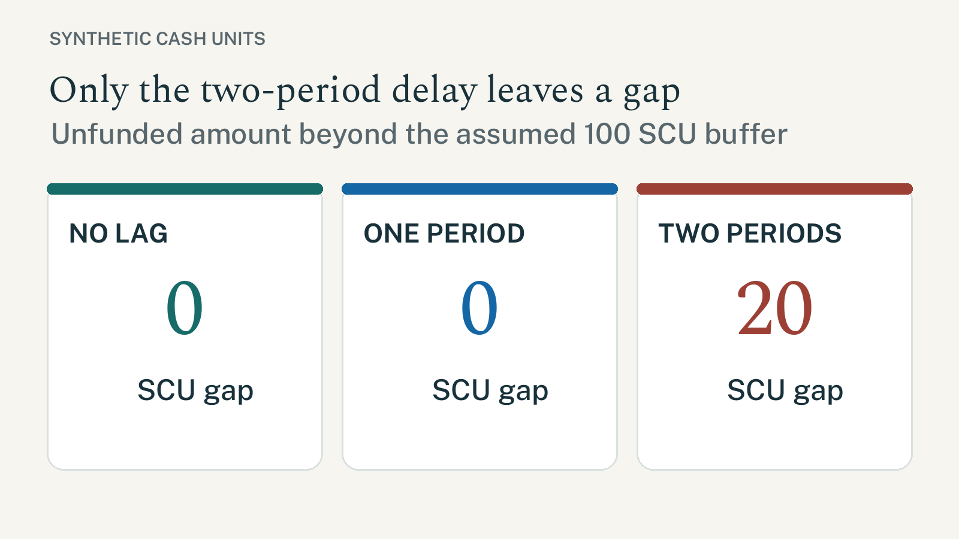
Figure 1. Scenario comparison of unfunded gaps beyond the assumed buffer.
Source: P13-SYNTHETIC-CASH-TIMING-FIXTURE (synthetic fixture; 2026-09-27).

Reperformance detail
The next table is intentionally long enough to exercise row continuity and repeated headers across a page boundary. Every value traces to the one synthetic fixture; calculations are reproduced in the editable workbook.
Scenario | Period | Billings | Receipts | Cash costs | Closing cash
No lag | 1 | 100 | 100 | 60 | 40
No lag | 2 | 100 | 100 | 60 | 80
No lag | 3 | 100 | 100 | 60 | 120
No lag | 4 | 100 | 100 | 60 | 160
One-period lag | 1 | 100 | 0 | 60 | -60
One-period lag | 2 | 100 | 100 | 60 | -20
One-period lag | 3 | 100 | 100 | 60 | 20
One-period lag | 4 | 100 | 100 | 60 | 60
Two-period lag | 1 | 100 | 0 | 60 | -60
Two-period lag | 2 | 100 | 0 | 60 | -120
Two-period lag | 3 | 100 | 100 | 60 | -80
Two-period lag | 4 | 100 | 100 | 60 | -40
Source: synthetic fixture only. No source transaction, accounting period or report balance is represented.

Inputs and interpretation
Item | Value | Interpretation / limit
Billings / cash costs | 100 / 60 SCU per period | Artificial inputs; held constant across all scenarios.
Opening cash / buffer | 0 / 100 SCU | The buffer is assumed; it is not committed funding.
Horizon / collection | 4 periods / 100% | Simplifying test assumptions; credit risk is not modelled.
Reporting framework | Not selected | No entity-specific financial statements are produced.
Revenue / tax | NOT ASSESSED | No recognition, tax rate or statutory treatment is included.
Source / date | P13-SYNTHETIC-CASH-TIMING-FIXTURE / 2026-09-27 | Synthetic fixture; date is not an effective date for law or policy.
Reconciliation / approval | Arithmetic only / none | No subledger, control account, report, Controller or tax sign-off was supplied.
Translation / portability | French sample / local PDF | Translation review, font embedding and recipient-machine proof remain NOT ASSESSED.

Bilingual disclosure sample
Illustrative scenario only; these figures do not describe a customer or forecast.
Scénario illustratif uniquement ; ces chiffres ne décrivent pas un client ni une prévision. (French layout sample; translation not reviewed.)

Countercase and next evidence
A longer delay matters only if the inputs and decision horizon are representative. The same gap can disappear with opening liquidity, lower costs, partial collections or a different horizon. None of those alternatives was tested here.
Before a real decision, obtain an approved transaction and reporting scope, trace source-event timing, confirm available funding, and have the accountable finance reviewer reperform the calculation. Do not convert this example into a forecast or funding recommendation.

