Collection delay and cash timing
Synthetic research note / Four-period operating cash bridge
SYNTHETIC TEST DATA - internal output-format demonstration

Finding
With billings and cash costs held constant, longer collection delays deepen the temporary cash trough. In this artificial four-period example, the two-period delay creates a 45 SCU gap beyond the assumed 75 SCU buffer. The numbers demonstrate timing arithmetic only.
The result is conditional on the input fixture. It does not establish a customer, market, revenue-recognition rule, financing source, accounting basis, tax treatment or rollout decision.

Scenario comparison
Scenario | Lag | Billings | Cash trough | Need | Gap | Ending AR
No lag | 0 | 400 | 0 | 0 | 0 | 0
One-period lag | 1 | 400 | -60 | 60 | 0 | 100
Two-period lag | 2 | 400 | -120 | 120 | 45 | 200
1 SCU is a synthetic cash unit. Ending receivables equal total fixture billings less receipts within the four periods; this is not an accounting receivables balance.

Buffer gap by collection delay
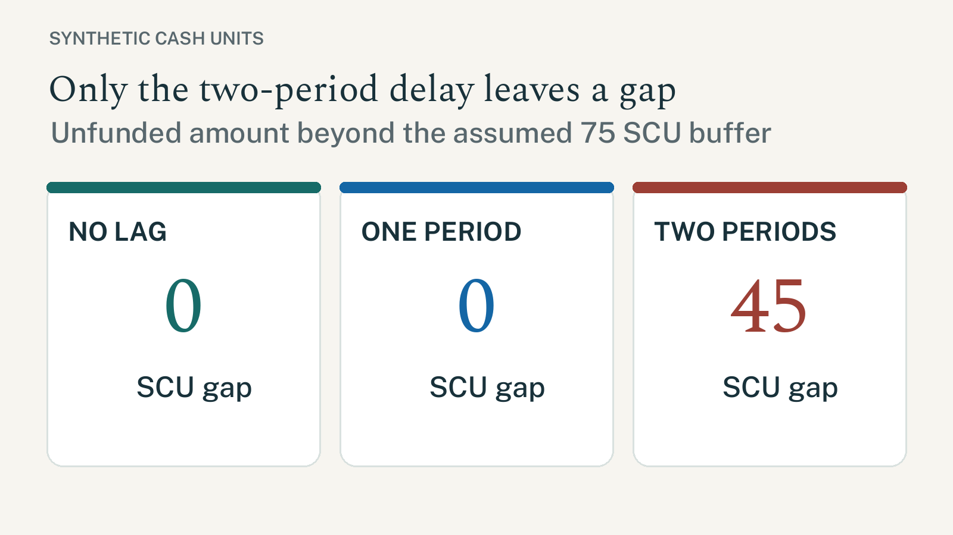
Figure 1. Only the two-period delay leaves a gap beyond the assumed buffer.
Source: P13-SYNTHETIC-CASH-TIMING-FIXTURE (synthetic fixture; 2026-09-27).

Reperformance detail
The next table is intentionally long enough to exercise row continuity and repeated headers across a page boundary. Every value traces to the one synthetic fixture; calculations are reproduced in the editable workbook.
Scenario | Period | Billings | Receipts | Cash costs | Closing cash
No lag | 1 | 100 | 100 | 60 | 40
No lag | 2 | 100 | 100 | 60 | 80
No lag | 3 | 100 | 100 | 60 | 120
No lag | 4 | 100 | 100 | 60 | 160
One-period lag | 1 | 100 | 0 | 60 | -60
One-period lag | 2 | 100 | 100 | 60 | -20
One-period lag | 3 | 100 | 100 | 60 | 20
One-period lag | 4 | 100 | 100 | 60 | 60
Two-period lag | 1 | 100 | 0 | 60 | -60
Two-period lag | 2 | 100 | 0 | 60 | -120
Two-period lag | 3 | 100 | 100 | 60 | -80
Two-period lag | 4 | 100 | 100 | 60 | -40
Source: synthetic fixture only. No source transaction, accounting period or report balance is represented.

Inputs and interpretation
Item | Value | Interpretation / limit
Billings / cash costs | 100 / 60 SCU per period | Artificial inputs; held constant across all scenarios.
Opening cash / buffer | 0 / 75 SCU | The buffer is assumed; it is not committed funding.
Horizon / collection | 4 periods / 100% | Simplifying test assumptions; credit risk is not modelled.
Reporting framework | Not selected | No entity-specific financial statements are produced.
Revenue / tax | NOT ASSESSED | No recognition, tax rate or statutory treatment is included.
Source / date | P13-SYNTHETIC-CASH-TIMING-FIXTURE / 2026-09-27 | Synthetic fixture; date is not an effective date for law or policy.
Reconciliation / approval | Arithmetic only / none | No subledger, control account, report, Controller or tax sign-off was supplied.
Translation / portability | French sample / local PDF | Translation review, font embedding and recipient-machine proof remain NOT ASSESSED.

Bilingual disclosure sample
Illustrative scenario only; these figures do not describe a customer or forecast.
Scénario illustratif uniquement ; ces chiffres ne décrivent pas un client ni une prévision. (French layout sample; translation not reviewed.)

Countercase and next evidence
A longer delay matters only if the inputs and decision horizon are representative. The same gap can disappear with opening liquidity, lower costs, partial collections or a different horizon. None of those alternatives was tested here.
Before a real decision, obtain an approved transaction and reporting scope, trace source-event timing, confirm available funding, and have the accountable finance reviewer reperform the calculation. Do not convert this example into a forecast or funding recommendation.

