Table of Contents

Technical Approach and Methodology (synthetic sample)
This is a fictional sample built for M10-13-T02 evidence. It is not a client deliverable.

Solution context
The proposed system sits inside the client organisation and exchanges data with three external services.
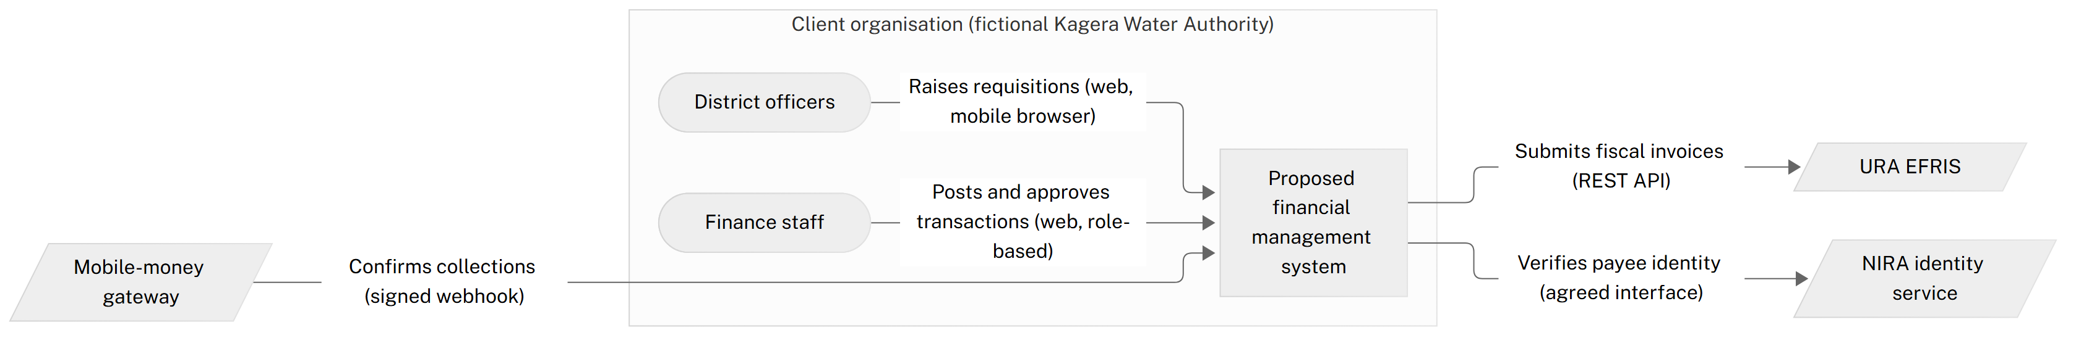
Figure 1 — Proposed solution context

Delivery workflow
Delivery follows the ERP sequence in the methodology skill: each phase closes with a finance-owner approval gate before the next begins.
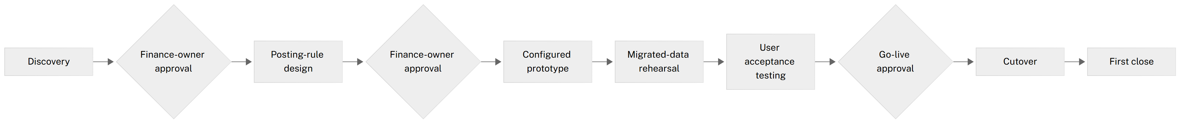
Figure 2 — Delivery workflow and approval gates
Figure numbering, captions and alt text are applied at build time.

