What could be the previous line of this code
b : 20
var o = {
var a = {};
a = 5,
a : 5
c : 5,

What could be the line right after this code
b : 20
var o = {
a = 5,
a : 5
}

See this code :
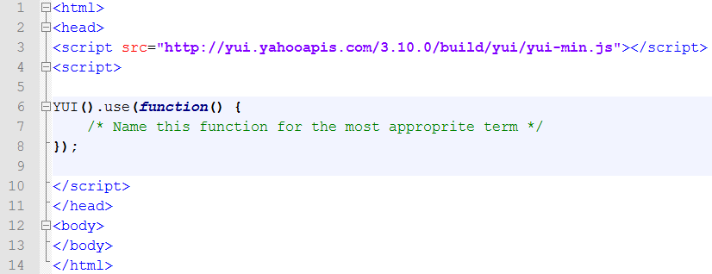
Name the “function() { ….. }” with the most appropriate term
function
object
callback
closure
inner function
asynchronous callback

Write the output of this code:
[1.1,2.2,3.3,4.4].map(Math.round)

Write the output of this code:
[1.1,2.2,3.3,4.4].map(Math.max)

Explain the real output in the previous task!

Write the output of this code:
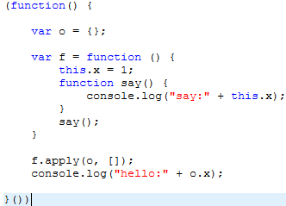

Write the output of this code:
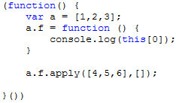

What is the one-line of JS code (in place of //?) which outputs “g” into the console and uses the code below (you are not allowed to write 'console.log'):
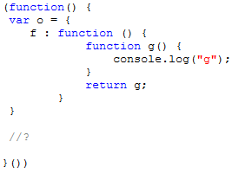

What will be the output if you write f(); in place of //1, //2, //3 but only one at a time?
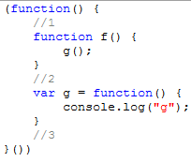
//1:
//2:
//3:

