Use Math.max with an array!
var a = [1, 2, 3];
var max = YOUR_CODE_HERE

What are the mistakes here?
An excerpt from liferay-portal-src-6.1.10-ee-ga1\portal-web\docroot\html\taglib\ui\social_bookmark\plusone.jsp
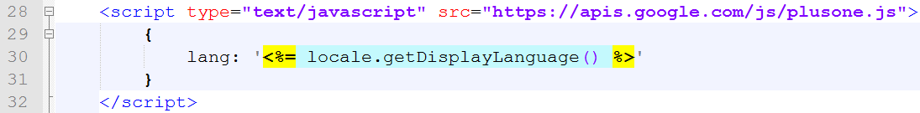
There are at least two big mistakes here. You do not need to know liferay nor google plusone, only JavaScript to point to these two misuses of JavaScript/html tags.
Hint: JSP code is OK, so text between <% and %> is good.
Misuse 1:
Misuse 2:

Try to find out what are the output values. After guessing, try it in js console:
Value | guess | try
[] + []
[] + {}
{} + []
{} + {}
Array(10).toString()
Array(10).join("x")
Array(10).join("x"+1)
Array(10).join("x"-1)
Thank you for @garybernhardt, “A lightning talk by Gary Bernhardt from CodeMash 2012 “ wat, www.destroyallsoftware.com

Fill in the w3school js test and write down all the bad questions/answers here
http://www.w3schools.com/quiztest/quiztest.asp?qtest=JavaScript

