Health vs. Price: How to Be a Smart Grocery Shopper
What Open Food Facts and Open Prices reveal about U.S. packaged groceries
BA780 · Cohort B · Team 2 (B02) · Final deliverable
Audience: everyday grocery shoppers, especially those on a budget who have been told that eating well costs more.
Goal: turn open data into a few simple rules for paying less while eating better, with price at the centre of every decision.
Data
- Open Food Facts product database, U.S. products (off_products_us.csv, rebuilt with B02-Data-Pull-v2.ipynb)
- Open Prices, U.S. stores (off_prices_us.csv)
- Open Food Facts food-group taxonomy (food_groups.json)
All three are open data (ODbL 1.0) and free to download. Our copies are in the team Drive (BA780 Team 2/Codebase/input_data/).
Contents:
- Executive summary
- Problem and hypotheses
- Data and cleaning
- Theme 1: know your aisle
- Theme 2: the greener choice
- Theme 3: healthy doesn’t cost more
- Theme 4: know what you pay for
- Theme 5: shop the store, not just the shelf
- The smart-shopper playbook
- Risks
- Limitations
- Challenges
- Next steps: a gamified swap app
- References
- GenAI disclosure

Executive summary
The belief we tested: “eating healthy is expensive.” We matched 988,445 U.S. products from Open Food Facts with 39,725 shelf prices from Open Prices (85% of them from California, mostly Bay Area stores) and compared prices per 100 g within the same aisle, the way a shopper actually chooses.
What we found: in the stores we could measure, healthy food is not what costs more. Shoppers overpay for brands, packaging, and energy-dense treats, not for nutrition.
- Per 100 g, Nutri-Score A/B products cost 17% less than D/E products in the same aisle, and no aisle shows a significant health premium.
- The healthiest aisles (legumes, vegetables, milk and yogurt, plain cereals, fruit) are also the cheapest, at about $1 per 100 g. Chocolate, biscuits, nuts, and cheese cost $2.30-6.
- Store brands cost 42% less per 100 g than national brands in the same aisle, and are healthier in 10 of 14 aisles.
- The same product varies by a median of 14% between the cheapest and dearest store.
- Low-impact (greener) products are healthier and cost no more (7% less per 100 g).
The smart-shopper rules
- Read the price per 100 g, not the package price.
- Swap down a grade, not up in price. For 89% of D/E products, our prototype finds a healthier, cheaper, similar product in the same aisle.
- Try the store brand first.
- Know your store. The same item can be 10% cheaper or dearer depending on where you buy it.
- Don’t let promotion tags steer the cart. They cluster in the snack and sweet aisles.
Next step: a gamified swap app built on Open Prices. You scan a product, see whether it is a good price for its aisle, get a healthier and cheaper swap, and earn points. Every price tag you photograph also grows the open price data the app relies on.

1. Problem and hypotheses
The shopper’s question: can I eat healthier without paying more, and where does my grocery money actually go?
Why it matters: budget-conscious shoppers are told that healthy food costs more, so many stop trying. If that belief is wrong, or only true in a few aisles, shoppers can eat better and save money at the same time.
Each theme tests one or two hypotheses, each with the direction we expected and the shopping decision it informs.
Theme | # | Hypothesis (expected direction) | Test | Shopping decision it informs
1 | H1 | The aisle (food group) explains more of a product’s Nutri-Score than its brand | R², food group vs brand | Where to compare products
1 | H2 | Aisles with more ultra-processed products have fewer Nutri-Score A/B products | Spearman correlation across food groups | Which aisles need the most care
2 | H3 | In the same aisle, low-impact products (Green A/B) are more often Nutri-Score A/B than high-impact ones (D-F) | % A/B difference per aisle; price ratio | Whether the greener choice is also the healthy, affordable one
3 | H4 | In the same aisle, Nutri-Score A/B products cost more per 100 g than D/E products | Price ratio with 95% CI, 30+ products per side | Whether a healthier swap costs extra
4 | H5 | In the same aisle, less-processed products (NOVA 1-3) cost more per 100 g than ultra-processed ones | Price ratio with 95% CI | Whether avoiding ultra-processed food costs extra
4 | H6 | Organic products cost more per 100 g but are not healthier | Price ratio; % A/B gap | Whether organic is worth it
5 | H7 | Store brands cost less per 100 g than national brands, with no worse Nutri-Score | Price ratio; % A/B gap | Store brand or national brand
5 | H8 | Ultra-processed products are on promotion more often, even in the same store and aisle | % on promotion, same store and aisle | How much to trust promotion tags
Scope of the price results: Themes 3-5 use prices from a small number of mostly Bay Area stores. They describe those stores, not U.S. prices as a whole (see Limitations).

2. Data and cleaning

2.1 Setup and loading
products: (988447, 18)
prices: (42822, 48)
food groups: 91

2.2 Cleaning
Products: barcodes padded to 13 digits, placeholders such as “unknown” set to missing, impossible nutrient values removed, official food-group names attached, and package sizes outside 20 g to 5 kg dropped. Prices: barcode prices in USD only, duplicate price tags removed, regular (pre-discount) price used, and non-grocery prices removed.
clean products: 988445
clean price observations: 39725 for 26573 barcodes
from California: 85%
from the top contributor: 93%

2.3 Joining products and prices
86.1% of priced barcodes match a product
priced products: 22882
with price per 100 g: 9858
86% of priced barcodes match a product. Package size is known for 43% of priced products, which limits the per-100 g analyses to about 10,000 products (and 5,752 foods with a food group).

Theme 1. Know your aisle: it decides most of what you get
A price comparison only makes sense between products a shopper would actually swap. So first: what is in the data, what does each aisle look like, and does the aisle or the brand decide how healthy a product is?

Data funnel and description
Table 1. Data funnel
Stage | Rule | Rows | % of clean catalog
Products file (v2 pull) | U.S.-tagged products + any barcode with a U.S…. | 988447 | –
Clean product catalog | unique barcodes, placeholders removed | 988445 | 100.0
with an official food group | food_groups_tags | 290927 | 29.4
with a Nutri-Score | grade A-E | 384579 | 38.9
with a NOVA group | 1-4 | 393852 | 39.8
with a Green-Score | grade A-F | 55386 | 5.6
with a package size | 20 g - 5 kg | 179715 | 18.2
Aisle analysis set (Themes 1-2) | foods, groups with 2,000+ products | 234005 | 23.7
Price observations (raw) | Open Prices, U.S. stores | 42822 | –
Clean price observations | barcode, USD, regular price, $0.10-$100 | 39725 | –
Priced products in the catalog | barcode join | 22882 | 2.3
with price per 100 g | package size known | 9858 | 1.0
Price analysis set (Themes 3-5) | foods with price per 100 g + food group | 5752 | 0.6
with a Nutri-Score |  | 4994 | 0.5
The official food group is the main bottleneck: 29% of products have one, because most products have no category at all. Prices exist for 2.3% of the catalog, and with both a package size and a food group only 0.6% (5,752 foods) are left for the price analysis.
Table 2. How complete is each variable? (% of rows that are not missing)
 | catalog % | priced products %
food_group | 29.0 | 52.0
nutriscore | 39.0 | 57.0
nova_group | 40.0 | 70.0
green_score | 6.0 | 28.0
is_organic | 18.0 | 55.0
size_g_ml | 18.0 | 43.0
energy-kcal_100g | 84.0 | 87.0
sugars_100g | 79.0 | 83.0
fat_100g | 84.0 | 87.0
proteins_100g | 85.0 | 88.0
fiber_100g | 68.0 | 72.0
salt_100g | 79.0 | 84.0
Nutri-Score share: {'A': 0.14, 'B': 0.11, 'C': 0.19, 'D': 0.24, 'E': 0.32}
NOVA share: {1.0: 0.1, 2.0: 0.03, 3.0: 0.17, 4.0: 0.7}
median price: $5.99 per package, $1.97 per 100 g
 | size g ml | energy-kcal 100g | sugars 100g | fat 100g | proteins 100g | fiber 100g | salt 100g
count | 179715.0 | 832837.0 | 781828.0 | 834507.0 | 840295.0 | 667438.0 | 776879.0
mean | 382.9 | 260.1 | 14.0 | 12.2 | 9.7 | 3.2 | 1.4
std | 455.4 | 186.3 | 20.1 | 16.5 | 12.9 | 6.2 | 4.8
min | 20.0 | 0.0 | 0.0 | 0.0 | 0.0 | 0.0 | 0.0
25% | 113.4 | 97.0 | 0.7 | 0.0 | 0.8 | 0.0 | 0.1
50% | 283.5 | 250.0 | 4.2 | 5.8 | 6.0 | 1.2 | 0.6
75% | 453.6 | 393.0 | 20.0 | 18.4 | 13.6 | 3.6 | 1.4
max | 5000.0 | 900.0 | 100.0 | 100.0 | 100.0 | 100.0 | 100.0
Priced products are better documented than the catalog as a whole (Nutri-Score 57% vs 39%), most likely because people photograph popular, well-known products in stores. The Green-Score covers only 6% of the catalog. The typical priced product costs $5.99 per package and $1.97 per 100 g.
The catalog leans unhealthy: 56% of products with a Nutri-Score are D or E, and 70% of products with a NOVA group are ultra-processed. Nutrients are right-skewed (sugar: mean 15.7 g, median 4.8 g per 100 g in foods), so we use medians and geometric means rather than plain averages.
Table 3. Checking the product aisles coverage (level-1 food groups)
food group l1 | products | with nutriscore | pct A B | pct ultra processed | median kcal | median sugar g | median salt g | pct of products | pct nutriscore
Sugary snacks | 61717 | 53996 | 2.1 | 86.9 | 400.0 | 40.9 | 0.4 | 21.2 | 87.5
Beverages | 47118 | 39856 | 32.8 | 74.6 | 33.0 | 5.0 | 0.0 | 16.2 | 84.6
Cereals and potatoes | 36397 | 32387 | 40.8 | 56.7 | 350.9 | 3.6 | 0.8 | 12.5 | 89.0
Fats and sauces | 35113 | 31323 | 22.9 | 54.4 | 175.4 | 3.6 | 1.2 | 12.1 | 89.2
Milk and dairy products | 26737 | 25032 | 23.7 | 62.4 | 219.5 | 4.4 | 0.5 | 9.2 | 93.6
Composite foods | 26385 | 25088 | 20.4 | 83.4 | 206.0 | 2.3 | 1.2 | 9.1 | 95.1
Fish, Meat, Eggs | 23644 | 21534 | 39.3 | 63.1 | 164.7 | 0.0 | 1.4 | 8.1 | 91.1
Fruits and vegetables | 21807 | 18996 | 77.8 | 21.6 | 50.0 | 4.0 | 0.1 | 7.5 | 87.1
Salty snacks | 9673 | 8537 | 15.3 | 48.9 | 500.0 | 3.5 | 1.3 | 3.3 | 88.3
Alcoholic beverages | 2173 | 7 | 28.6 | 66.0 | 52.0 | 0.6 | 0.1 | 0.7 | 0.3
Baby foods and milks | 163 | 0 | – | 36.2 | 70.8 | 9.6 | 0.0 | 0.1 | 0.0
Sugary snacks are the largest aisle (21% of products with a food group) and the least healthy (2% A/B, 87% ultra-processed). Fruits and vegetables are the opposite (78% A/B, 22% ultra-processed).

The Nutri-Score mix in each aisle
% Nutri-Score A or B: {'Pizza pies and quiches': 1.0, 'Biscuits and cakes': 2.0, 'Sweets': 3.0, 'Appetizers': 4.0, 'Cheese': 4.0, 'Processed meat': 5.0, 'Dressings and sauces': 17.0, 'Breakfast cereals': 18.0, 'Bread': 21.0, 'Sandwiches': 23.0, 'One-dish meals': 28.0, 'Meat': 38.0, 'Fats': 42.0, 'Nuts': 48.0, 'Milk and yogurt': 51.0, 'Cereals': 52.0, 'Fish and seafood': 68.0, 'Fruits': 73.0, 'Legumes': 75.0, 'Fruits and vegetables': 84.0, 'Vegetables': 85.0, 'Eggs': 93.0}
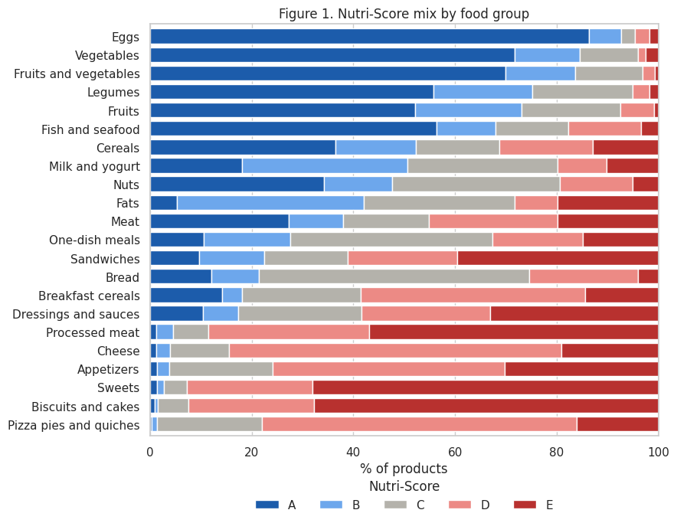
Figure 1. Nutri-Score mix inside each food group
How healthy is each aisle?
Takeaway: The aisle mostly decides how healthy a product is: 93% of eggs and 85% of vegetables score A/B, while about 90% of biscuits, sweets and processed meat score D/E. So the real choice is usually a one-grade swap within an aisle, not a jump from E to A. The aisles with the widest spread (meat, nuts, cereals, ready meals) are where reading the label makes the biggest difference.

H1: the aisle matters more than the brand
660 brands, 85172 products
R² food group = 0.40 | R² brand = 0.29
Supported. Among 660 brands that sell in 3+ aisles (85,172 products), the aisle explains 40% of the variation in Nutri-Score and the brand 29%. A “healthy” brand does not make its cookies healthy.

H2: more ultra-processing, fewer healthy grades
Spearman rho = -0.77 (p = 0.0000, 22 food groups)
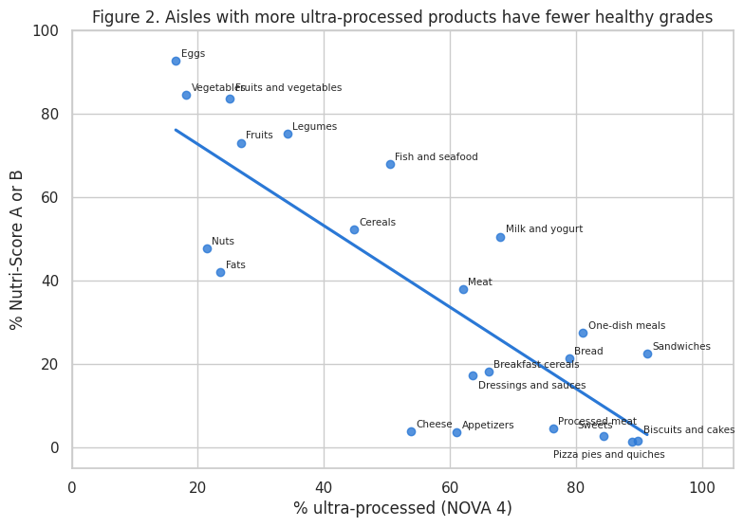
Figure 2. The more ultra-processed an aisle, the fewer healthy products it has
Do aisles with more ultra-processed food have fewer healthy products?
Takeaway: Processing and nutrition move together: the more ultra-processed an aisle is, the fewer healthy products it has (rho = -0.77). The exceptions show that the two measures capture different things. Flavored yogurts are ultra-processed but still score well, while nuts and oils are barely processed but held back by fat. Shoppers need both labels, not one.

Theme 2. The greener choice: healthier, and no more expensive
Only 6% of products have a Green-Score (45,481 have both scores), so this theme uses every product with both scores. The price check at the end uses the priced foods.
products with both scores: 45481
impact
Low impact (Green A/B) 39.0
Medium (Green C) 14.2
High impact (Green D-F) 30.2
dtype: float64
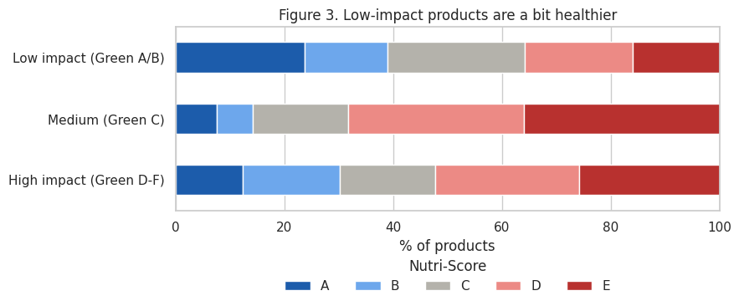
Figure 3. Low-impact products are only slightly healthier across the whole store
Are low-impact products healthier overall?
Takeaway: Low-impact products are only slightly healthier (39% score A/B vs 30% for high-impact), and medium-impact products are the least healthy (14%). Therefore, Green-Score alone is a weak signal of health, so we should compare products within the same food group next to explore more meanigful links.
products pct_healthy pct_green
food_group
Bread 2159 25.4 97.8
Appetizers 3567 4.0 90.2
Vegetables 1426 84.9 86.4
Milk and yogurt 7769 57.0 82.7
Fruits 950 71.1 73.7
Sweets 3005 6.6 69.8
Legumes 1503 70.8 69.0
Dressings and sauces 3570 14.0 58.3
One-dish meals 654 46.4 38.4
Cereals 1718 69.7 33.5
Eggs 1634 92.7 30.9
Biscuits and cakes 4381 1.9 13.4
Breakfast cereals 3787 18.2 12.5
Meat 952 45.0 8.9
Fats 2148 76.5 2.5
Processed meat 409 4.9 1.5
Fish and seafood 1069 65.5 1.3
Nuts 864 49.1 0.7
Cheese 3743 5.1 0.4
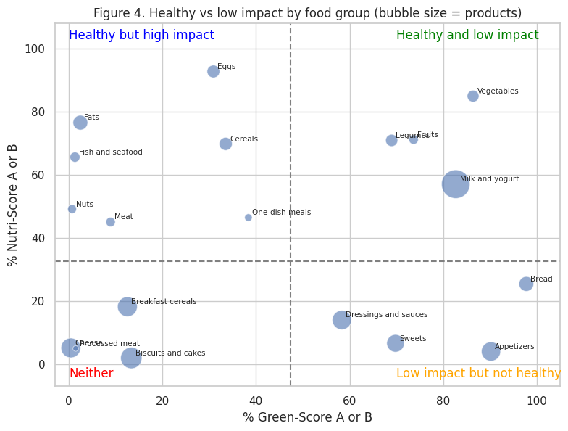
Figure 4. Healthy vs low impact, one dot per food group (only includes groups with 300+ Green-Scored foods)
Which food groups are both healthy and low-impact?
Takeaway: Health and the environment agree for: vegetables, legumes, fruits and milk/yogurt. But the link conflicts with the following categories that are healthy bad have high impact on the environment: eggs, fats, fish, meat, nuts and cereals. Pairing “healthy” and “green” advice works in some aisles but would mislead shoppers in others, so designation should be done carefully.

H3: inside an aisle, is the greener product also the healthier one?
food group | products | rho | p_value
Processed meat | 344.00 | -0.16 | 0.00
Fats | 1937.00 | -0.12 | 0.00
Cereals | 1143.00 | -0.03 | 0.35
Eggs | 1324.00 | -0.00 | 0.99
Nuts | 772.00 | 0.00 | 0.93
Sweets | 2248.00 | 0.04 | 0.09
Meat | 758.00 | 0.04 | 0.29
Cheese | 3298.00 | 0.09 | 0.00
Fruits | 595.00 | 0.10 | 0.01
Fish and seafood | 920.00 | 0.13 | 0.00
One-dish meals | 526.00 | 0.17 | 0.00
Appetizers | 3181.00 | 0.19 | 0.00
Vegetables | 1103.00 | 0.24 | 0.00
Milk and yogurt | 7271.00 | 0.25 | 0.00
Dressings and sauces | 2881.00 | 0.26 | 0.00
Bread | 1922.00 | 0.27 | 0.00
Biscuits and cakes | 4016.00 | 0.28 | 0.00
Breakfast cereals | 3318.00 | 0.29 | 0.00
Legumes | 1296.00 | 0.47 | 0.00
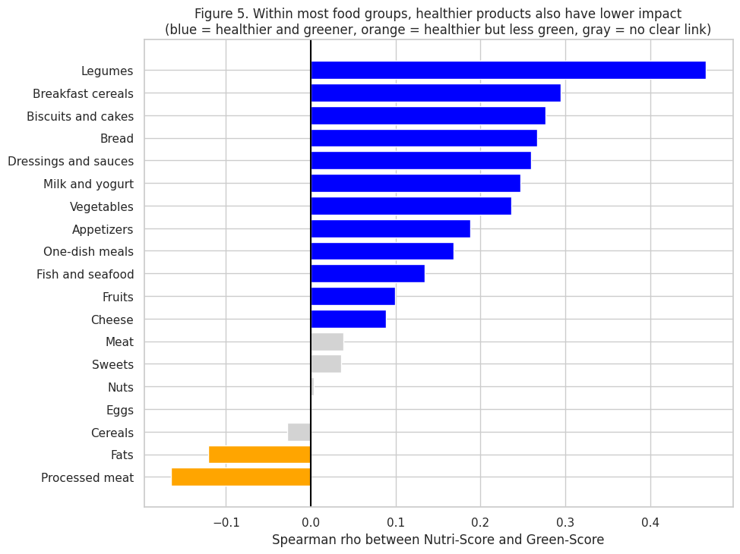
Figure 5. Inside each food group, are the healthier products also the greener ones?
Within each food group, is the healthier product also the greener one?
Takeaway:
In 12 of 19 food groups, healthier products also have lower impact, most strongly for legumes (rho 0.47). Five groups (cereals, eggs, nuts, sweets and meat) show no clear link, and only processed meat and fats go the other way.
food group | products | healthy_low | healthy_high | gap
Cereals (rice, grains) | 1042.0 | 57.9 | 79.7 | -21.8
Eggs | 1295.0 | 91.6 | 93.7 | -2.1
Sweets | 1960.0 | 6.6 | 5.3 | 1.3
Biscuits and cakes | 2432.0 | 5.1 | 0.6 | 4.5
Milk and yogurt | 7214.0 | 59.6 | 43.5 | 16.1
Dressings and sauces | 2603.0 | 20.1 | 2.6 | 17.5
One-dish meals | 474.0 | 66.7 | 40.1 | 26.6
Breakfast cereals | 2632.0 | 60.4 | 11.7 | 48.7
Legumes | 1288.0 | 89.4 | 29.7 | 59.7
Average gap: 17.6
Positive groups: 7 out of 9
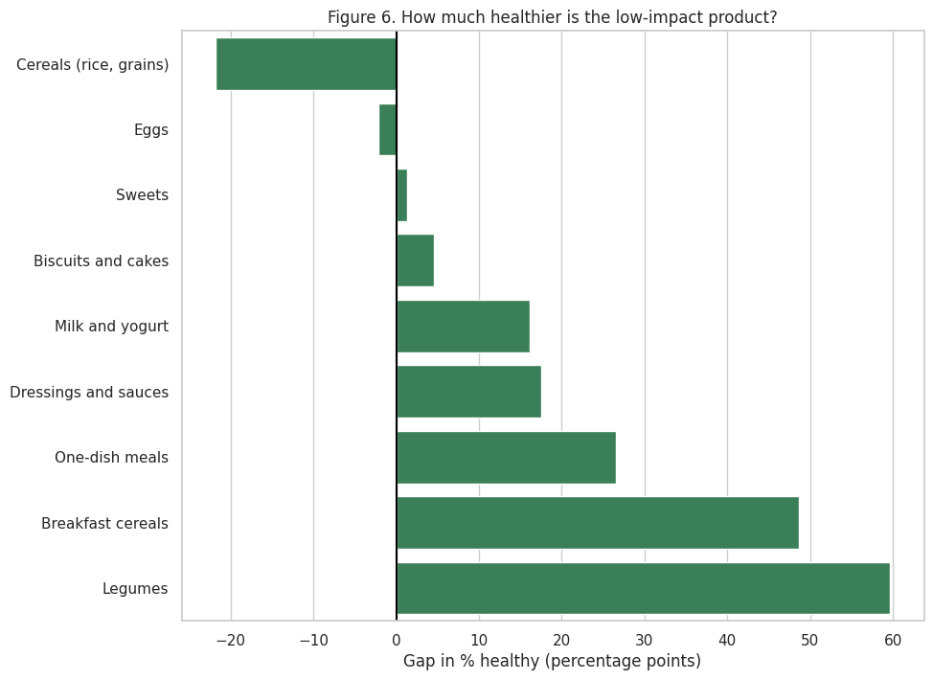
Figure 6. In the same food group, how much more often is the low-impact product Nutri-Score A/B?
low-impact vs high-impact, same food group: 0.93x per 100 g (95% CI 0.88-0.99), 1520 vs 1399 products
Takeaway: Picking the low-impact product raises the chance it’s healthy by about 18 percentage points on average (positive in 7 of 9 food groups), with the biggest gains in legumes (+60) and breakfast cereals (+49). It reverses for rice and grains (-22) and makes almost no difference for eggs, so the greener product is a good shortcut to the healthier one in most aisles, but not all.
And it does not cost more: low-impact products cost 0.93× what high-impact products cost per 100 g in the same aisle (95% CI 0.88-0.99).
Smart-shopper takeaway: the greener option is usually healthier and slightly cheaper. The exceptions are eggs and rice, where the healthy choice is not the low-impact one.

Theme 3. Healthy doesn’t cost more: swap within the aisle
This is the centre of the project. From here on, prices are per 100 g, for foods with a known package size and food group (5,752 products). Drinks are left out because tea bags, juice, and water are not comparable per 100 g.
Caveat: the price data is crowd-sourced, 85% from California, and 93% from one contributor. It covers 0.6% of the catalog. The results describe these (mostly Bay Area) stores and are not national price estimates. We use them to compare products within the same aisle, not to state what groceries cost.
food group | catalog | priced | representation
Sandwiches | 2.20 | 0.80 | 0.36
Fruits and vegetables | 1.23 | 0.45 | 0.37
Pizza pies and quiches | 2.05 | 1.13 | 0.55
Sweets | 10.79 | 7.89 | 0.73
Fish and seafood | 2.21 | 1.72 | 0.78
Cheese | 4.67 | 3.69 | 0.79
Bread | 3.61 | 3.34 | 0.92
Processed meat | 2.78 | 2.89 | 1.04
Vegetables | 3.80 | 3.96 | 1.04
Biscuits and cakes | 9.81 | 10.71 | 1.09
Milk and yogurt | 3.82 | 4.52 | 1.18
Fats | 2.63 | 3.18 | 1.21
Meat | 2.35 | 2.94 | 1.25
Cereals | 5.92 | 7.48 | 1.26
Fruits | 2.07 | 2.87 | 1.39
Dressings and sauces | 9.44 | 13.42 | 1.42
Appetizers | 2.13 | 3.48 | 1.63
One-dish meals | 4.82 | 8.40 | 1.74
Legumes | 1.20 | 2.52 | 2.10
Breakfast cereals | 1.32 | 4.36 | 3.31
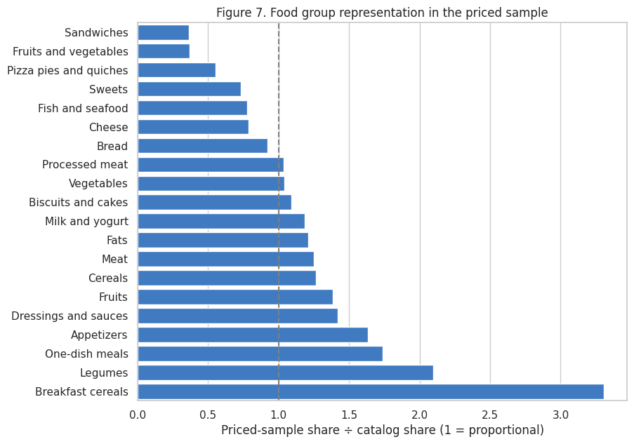
Figure 7. Is each food group over- or under-represented in the priced sample?
Do the priced products represent the full catalog?
Takeaway: The priced sample mostly mirrors the catalog, but it leans toward ready meals and appetizers (1.6×) and away from sandwiches, sweets, cheese and fish (0.3–0.7×), reflecting where our main contributor shopped. Comparing overall averages would be misleading, so every price comparison after this is made within the same food group.
22 food groups | Spearman rho (% A/B vs price per 100 g) = -0.60, p = 0.00
food group | products | median price 100g | pct ab | aisle type
Chocolate products | 154 | 5.99 | 0.00 | Mostly C-E
Fish and seafood | 99 | 3.46 | 55.43 | Mostly Nutri-Score A/B
Biscuits and cakes | 616 | 2.80 | 1.88 | Mostly C-E
Nuts | 87 | 2.51 | 47.56 | Mostly C-E
Fats | 183 | 2.47 | 39.38 | Mostly C-E
Sweets | 454 | 2.42 | 7.55 | Mostly C-E
Processed meat | 166 | 2.35 | 5.96 | Mostly C-E
Cheese | 212 | 2.31 | 4.89 | Mostly C-E
Appetizers | 200 | 2.22 | 3.19 | Mostly C-E
Meat | 169 | 2.11 | 27.56 | Mostly C-E
Pizza pies and quiches | 65 | 2.04 | 3.08 | Mostly C-E
Breakfast cereals | 251 | 1.76 | 23.71 | Mostly C-E
Ice cream | 111 | 1.67 | 8.26 | Mostly C-E
Potatoes | 70 | 1.55 | 20.00 | Mostly C-E
Dressings and sauces | 772 | 1.44 | 17.27 | Mostly C-E
One-dish meals | 483 | 1.41 | 33.18 | Mostly C-E
Bread | 192 | 1.36 | 36.63 | Mostly C-E
Fruits | 165 | 1.23 | 88.89 | Mostly Nutri-Score A/B
Cereals | 430 | 1.22 | 62.17 | Mostly Nutri-Score A/B
Milk and yogurt | 260 | 1.05 | 57.31 | Mostly Nutri-Score A/B
Vegetables | 228 | 1.04 | 80.00 | Mostly Nutri-Score A/B
Legumes | 145 | 0.91 | 58.06 | Mostly Nutri-Score A/B
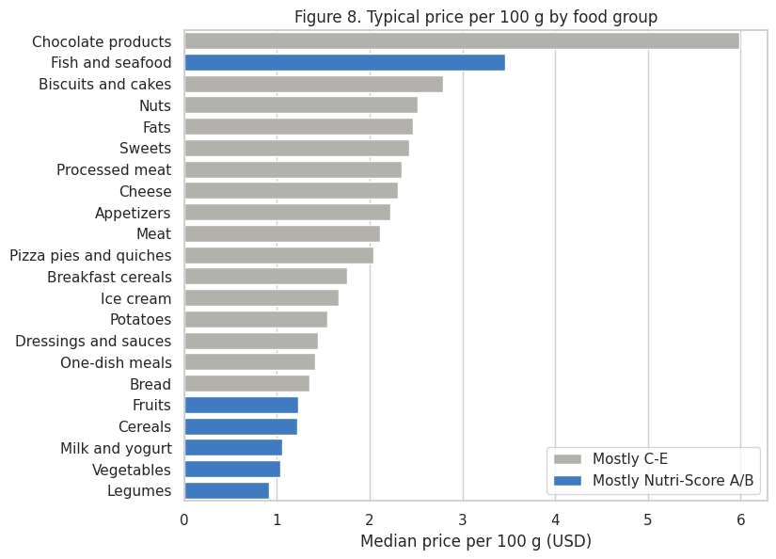
Figure 8. Are the healthier aisles the more expensive ones? (median price per 100 g by food group)
Are the healthier aisles more expensive?
Takeaway: Across the store, healthy food is the cheap food. Legumes, vegetables, milk, cereals and fruits cost about $1 per 100 g, while chocolate, biscuits, nuts and cheese cost $2.30–6, and aisles with more A/B products are cheaper (rho = -0.60). The belief that healthy eating is expensive likely comes from comparing per package or per item, not per 100 g.

H4: inside an aisle, do A/B products cost more than D/E products?
food group | n ab | n de | ratio | ci low | ci high | p | p adj
Cereals | 189 | 69 | 0.481 | 0.394 | 0.588 | 0.000 | 0.000
One-dish meals | 146 | 98 | 0.647 | 0.543 | 0.769 | 0.000 | 0.000
Dressings and sauces | 114 | 384 | 0.663 | 0.557 | 0.788 | 0.000 | 0.000
Meat | 43 | 83 | 0.729 | 0.527 | 1.009 | 0.057 | 0.113
Bread | 63 | 41 | 0.774 | 0.545 | 1.099 | 0.150 | 0.240
Breakfast cereals | 55 | 115 | 0.829 | 0.609 | 1.128 | 0.228 | 0.261
Milk and yogurt | 145 | 33 | 0.882 | 0.669 | 1.162 | 0.365 | 0.365
Fats | 63 | 56 | 1.150 | 0.915 | 1.445 | 0.229 | 0.261
all food groups together: A/B costs 0.83x D/E per 100 g (95% CI 0.79-0.88)
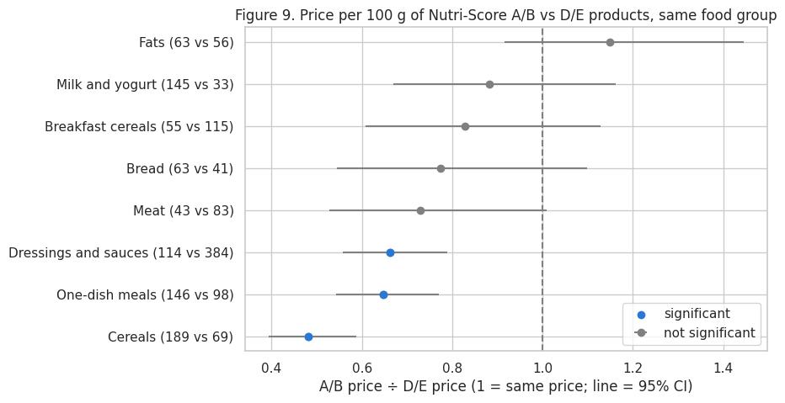
Figure 9 (H4). Inside a food group, do Nutri-Score A/B products cost more per 100 g than D/E products?
Within an aisle, do A/B products cost more than D/E products?
Takeaway: Even within the same aisle, the healthier product costs less: A/B products cost 0.83× what D/E products cost per 100 g. The savings are biggest where D/E products are convenience versions of a staple, like plain rice and pasta vs noodle kits (0.48×). No aisle shows a health premium, so “swap down a grade” is advice that saves money rather than costing it.

Theme 4. What shoppers pay for
These are relative prices, not actual dollar prices. A price index of 100 is the comparison baseline. A value of 115 means 15% higher than that baseline. Figures 10 and 11 compare products using their food-group-adjusted price index. Figure 12 shows comparisons separately by food group.
We use simple charts with labeled axes and the same two main colors throughout.

H5: Does avoiding ultra-processed food cost more?
Question: When we compare products within the same food groups, are less-processed foods generally more expensive?
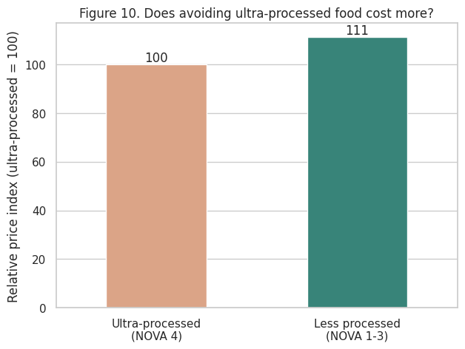
Figure 10. Per package, less-processed food costs about 11% more
Less-processed price difference: +11.2%
95% confidence interval: +8.9% to +13.6%
Does avoiding ultra-processed food cost more?
Takeaway: Per package, less-processed products cost about 11% more than ultra-processed products in the same food group (95% CI 9–14%). This is a package price, so it mixes up the price of the food with the size of the pack, and less-processed staples like plain milk or rice often come in bigger packs. Avoiding ultra-processed food can raise the bill at the checkout, but comparing price per 100 g (Figure 9) is the fairer test of whether the food itself costs more.

Which nutrients do shoppers pay for?
Nutrient | Price difference
Salt | -7.5
Sugar | -3.2
Protein | 5.1
Calories | 10.7
Fat | 12.7
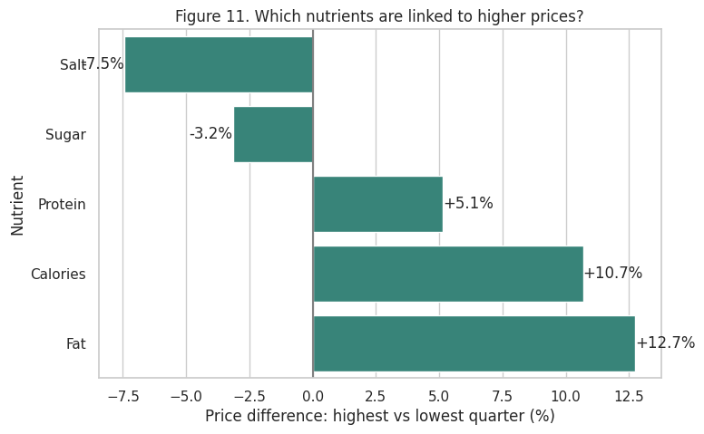
Figure 11. Fattier, calorie-dense products cost more; sugary and salty ones cost less
Which nutrients are linked to higher prices?
Takeaway: Within the same food group, the fattiest and most calorie-dense products cost more per package (fat +13%, calories +11%, protein +5%), while sugary and salty products cost less (sugar −3%, salt −8%). Shoppers pay a little more for richer, more filling foods, but nothing extra for sugar or salt. Cheap sugary and salty products can make less healthy choices look like better value.

H6: Does the organic price premium vary by food group?
food group | n organic | n regular | organic index
Dressings and sauces | 130 | 1378 | 103.9
Sweets | 54 | 868 | 112.0
Fruits | 71 | 217 | 113.7
Vegetables | 83 | 447 | 115.1
Cereals | 68 | 619 | 121.5
Unsweetened beverages | 100 | 476 | 134.2
Milk and yogurt | 73 | 484 | 145.9
Fats | 56 | 365 | 154.0
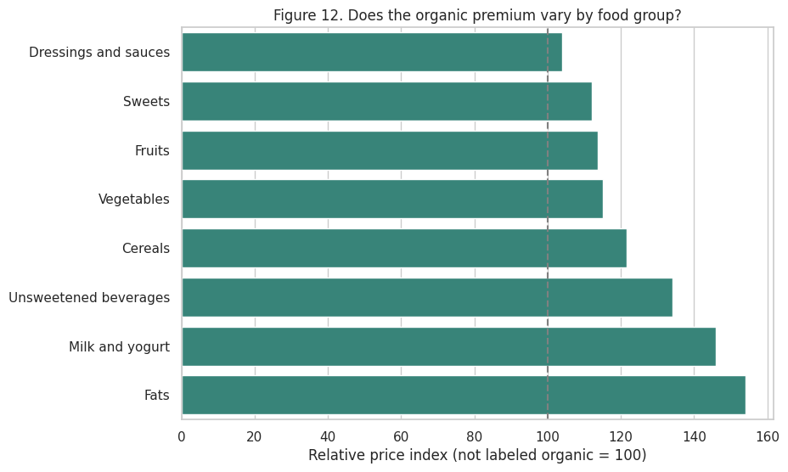
Figure 12 (H6). Organic price premium by food group
Overall organic price difference: +18.3%
95% confidence interval: +14.5% to +22.4%
Does the organic premium vary by food group?
Takeaway: Organic products cost about 18% more per package than non-organic products in the same food group (95% CI 15–22%), and the premium varies a lot by aisle. It’s small for sauces (+4%) and sweets (+12%), but large for milk and yogurt (+46%) and fats (+54%). Organic is a real premium in these stores, so shoppers on a budget should pick their organic buys aisle by aisle, starting where the premium is smallest.
Conclusion: Paying more for organic products does not automatically mean better nutritional quality. Shoppers should compare the price difference within each food group and check nutrition labels before deciding whether the extra cost is worthwhile.

Theme 5. Shop the store, not just the shelf
The biggest savings we found come from which version and which store, not from which food.

H7: store brands vs national brands
store-brand products: 655
median package size (g): store brands 453.59237 | national brands 340.1942775
price vs national brands in the same group: 0.58x (95% CI 0.54-0.61)
store brands have +10.8 pp more Nutri-Score A/B (13 groups, more A/B in 9 of them)
and -22.8 pp ultra-processed (11 groups)
food group | n_store | n_national | ratio | ci_low | ci_high | p | q
Legumes | 34.00 | 111.00 | 0.54 | 0.44 | 0.67 | 0.00 | 0.00
Dressings and sauces | 60.00 | 712.00 | 0.57 | 0.50 | 0.65 | 0.00 | 0.00
Cheese | 50.00 | 162.00 | 0.69 | 0.60 | 0.79 | 0.00 | 0.00
Vegetables | 63.00 | 165.00 | 0.70 | 0.60 | 0.82 | 0.00 | 0.00
Bread | 20.00 | 172.00 | 0.74 | 0.59 | 0.92 | 0.01 | 0.02
Cereals | 57.00 | 373.00 | 0.75 | 0.64 | 0.89 | 0.00 | 0.00
One-dish meals | 32.00 | 451.00 | 0.79 | 0.66 | 0.94 | 0.01 | 0.02
Fruits | 42.00 | 123.00 | 0.83 | 0.68 | 1.00 | 0.05 | 0.09
Eggs | 25.00 | 23.00 | 0.85 | 0.62 | 1.18 | 0.32 | 0.41
Sweets | 30.00 | 424.00 | 0.91 | 0.73 | 1.14 | 0.41 | 0.48
Nuts | 38.00 | 49.00 | 0.96 | 0.78 | 1.19 | 0.71 | 0.71
Biscuits and cakes | 21.00 | 595.00 | 1.06 | 0.78 | 1.43 | 0.70 | 0.71
Fats | 27.00 | 156.00 | 1.14 | 0.89 | 1.46 | 0.30 | 0.41
Milk and yogurt | 25.00 | 235.00 | 1.17 | 0.99 | 1.39 | 0.07 | 0.11
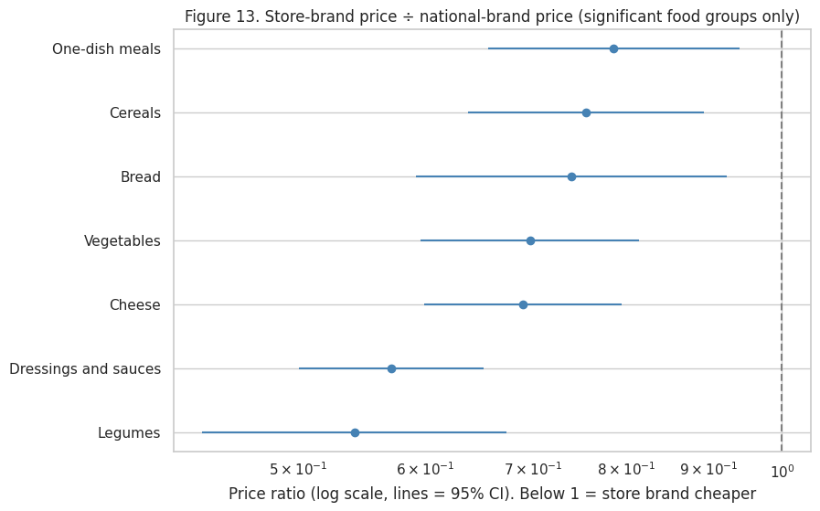
Figure 13 (H7). Store brands vs national brands in the same food group
Are store brands cheaper than national brands, and are they worse for you?
Takeaway: Store brands are the biggest saving we found: 0.58× the price of national brands per 100 g in the same aisle, while being healthier (11 points more A/B, 23 points less ultra-processed). Part of the gap is bigger packs and plainer products, which is good news for shoppers rather than a catch. Trying the store brand first is the single easiest rule to follow.

Same product, different store
Products priced at 2+ stores: 4323
Priciest vs cheapest store, median product: 1.14x
A quarter of products: 1.29x or more
store | products | store_index
Smart & Final extra! | 307.000 | 0.892
FoodMaxx | 240.000 | 0.895
Target | 186.000 | 0.924
Whole Foods Market | 1090.000 | 0.974
Ava’s Market and Deli | 244.000 | 0.975
Sprouts Farmers Market | 371.000 | 1.003
Nob Hill Foods | 1794.00 | 1.01
Safeway | 2919.000 | 1.016
Dumbo Market | 423.000 | 1.017
Walgreens | 195.000 | 1.032
Morton Williams | 150.000 | 1.045
Draeger’s | 697.000 | 1.083
Mollie Stone’s | 173.000 | 1.097
Lucky | 169.000 | 1.106
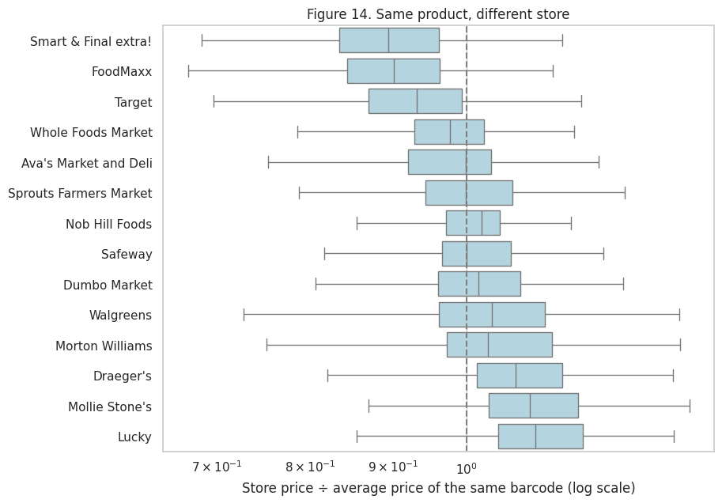
Figure 14. The same product (same barcode) at different stores
Does the same product cost more at some stores?
Takeaway: The same barcode varies 14% between the cheapest and priciest store for the median product, and 29% or more for a quarter of products. Smart & Final and FoodMaxx are about 11% below average, while Whole Foods is slightly below average for identical items: its expensive reputation comes from what it stocks, not what it charges. Where you do the big weekly shop matters as much as what you buy.

H8: are ultra-processed products promoted more?
store | 1.0 | 2.0 | 3.0 | 4.0
Draeger’s | 1.0 | 11.5 | 11.3 | 10.1
Nob Hill Foods | 38.5 | 51.9 | 55.8 | 64.4
Safeway | 43.2 | 52.4 | 43.9 | 56.5
Whole Foods Market | 26.8 | 33.1 | 38.6 | 36.8
Average discount when on promotion, by NOVA group (%):
{1.0: 23.5, 2.0: 20.7, 3.0: 23.6, 4.0: 23.8}
Same store and food group: ultra-processed products are on promotion +2.4 pp more often (95% CI +0.6 to +4.2)
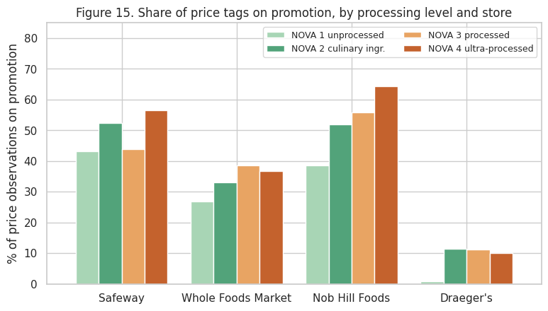
Figure 15 (H8). How often are products on promotion, by processing level?
Are ultra-processed products on promotion more often?
Takeaway: Ultra-processed products look heavily promoted (64% vs 39% of price tags at Nob Hill), but most of that is because snack and sweet aisles are promoted more overall. Within the same store and aisle, the gap shrinks to +2.4 points: small but real. Discounts are the same size (about 24%) at every processing level, so a sale tag in the snack aisle is a nudge toward the aisle, not a better deal.
Not supported once the aisle is held fixed.
At Nob Hill and Safeway, ultra-processed products carry promotion tags more often (64% vs 39% for NOVA 1 at Nob Hill). But within the same store and aisle, the difference is small and not significant (+2.2 pp, CI −1.8 to +6.1), and goes the other way in about half of the pairs. Promotions follow the aisle: snack and sweet aisles are promoted heavily, and those aisles are mostly ultra-processed.
Smart-shopper takeaway:
- Reach for the store brand first.
- Do the big shop at a cheaper store.
- Treat a sale tag in the snack aisle as a nudge, not a saving.

The smart-shopper playbook (conclusions)
# | Rule | Evidence from this project | What it is worth | How sure we are
1 | Compare within the aisle | The aisle explains more of the Nutri-Score than the brand (R² 0.40 vs 0.29) | Sets up every rule below | High (85,172 products)
2 | Read the price per 100 g | Package price hides size; store brands come in bigger packs (454 g vs 340 g) | Makes the savings below visible | High
3 | Swap down a grade, not up in price | A/B costs 0.83× D/E per 100 g in the same aisle; no aisle shows a health premium | About 17% less per 100 g | Medium (local prices)
4 | Buy plain staples; pay for quality only in treats | Less processing is cheaper in milk/yogurt, cereals, and breakfast cereals, and dearer in fats, chocolate, and biscuits | 37-57% less in staples | Medium
5 | Choose the greener option | +18 pp more A/B; 0.93× the price per 100 g | About 7% less, and healthier | Medium (Green-Score covers 6%)
6 | Try the store brand first | 0.58× per 100 g; more A/B in 10 of 14 aisles | About 42% less per 100 g (part is pack size) | Medium-high
7 | Know your store | Median 14% gap for the same barcode across stores | 8-11% at the cheaper stores | Medium (Bay Area stores)
8 | Don’t follow sale tags into the snack aisle | Promotions follow the aisle, not the product’s health | Avoids impulse spending | Low-medium (not significant within aisle)
Bottom line for shoppers: in the stores we could measure, eating better is mostly a matter of how you compare, not how much you spend.

Risks
Risks for a shopper following these rules, or for an app that gives this advice:
- Price per 100 g favours big packs. A larger pack is only cheaper if you finish it, so waste can cancel the saving.
- Cheap per 100 g can mislead. Sugary and dry products look cheap per 100 g (Theme 4), so price should never be the only signal.
- Nutri-Score has blind spots. It is calculated per 100 g, not per portion, and it does not cover additives, so a recommended swap is a better choice, not necessarily a perfect one.
- Prices go stale. Shelf prices and promotions change weekly, so advice based on old prices can be wrong at the shelf.
- Bad swaps erode trust. Matching by category tags can suggest products that are not real substitutes (e.g. crackers for cookies). A few poor suggestions could make shoppers ignore the good ones.
- Gaming and privacy. If an app rewards price uploads, some users may upload fake prices to earn points. Receipts and store locations are also personal data.

Limitations
- Local, concentrated price data: 85% of price observations are from California and 93% from one contributor, so results describe these stores, not U.S. prices.
- Small priced sample: 5,752 foods have both a price per 100 g and a food group (0.6% of the catalog), and package size is known for only 43% of priced products.
- Coarse matching: comparisons are within official food groups, which still mix different products (e.g. milk gallons and yogurt cups in “Milk and yogurt”). Part of each gap may be product mix rather than a true price difference.
- Approximate flags: store brands are identified by brand name, and organic status by label tags (missing for 82% of products).
- Scores are not missing at random: popular, well-documented products are more likely to have a Nutri-Score, Green-Score, and price.
- Associations, not causes: we show which products cost more, not why. Brand, packaging, and store strategy all play a part.

Challenges
- No second price region. Commercial price APIs and scanner data cost money, and scraping retailer websites breaks their terms of use, so we stayed with Open Prices and kept every price claim to within-aisle comparisons.
- Package size. The first data pull had no package size. The v2 pull added it, but some sizes were clearly wrong (e.g. “1 g” of peanut butter for $24), so we kept sizes between 20 g and 5 kg and prices between $0.05 and $50 per 100 g.
- Categories. Each product’s category list starts with a very broad parent, so the first category was useless for grouping. We switched to the official Open Food Facts food groups.
- Messy crowd-sourced fields. Barcodes lost leading zeros when read as numbers, placeholders such as “unknown” looked like real values, and some nutrients were impossible (over 100 g per 100 g).
- Downloading the data. Hugging Face returned HTTP 429 (too many requests) when we streamed the parquet files, so the pull notebook downloads them once and reads them locally.

Next steps: a gamified swap app built on Open Prices
The rules above only help if shoppers can use them at the shelf, in a few seconds. Our next step is a phone app (SmartCart) that turns this notebook into instant, personal advice, and turns shoppers into contributors to the open price data it runs on.
What the shopper sees
Feature | What it does | Rule it applies
Scan and price check | Scan a barcode and see the price per 100 g, rated against the aisle median (e.g. “1.2× the aisle average”) | 1, 2
Better swap | Up to 3 similar products in the same aisle that are healthier and cheaper per 100 g | 3, 4, 5, 6
Store tip | “Seen for $X less at Store Y” for the same barcode | 7
Sale-tag check | Flags promotions on D/E or ultra-processed products | 8
Points and streaks | Points for every swap (more for bigger health gains and savings), weekly savings total, streaks, and badges such as “Store-brand scout” or “Aisle swapper” | Keeps the habit going
Price hunter | Points for photographing price tags, which go into Open Prices | Fixes our biggest data limitation
What runs in the backend
Layer | What it does | Built from
Data | Nightly import of Open Food Facts products and Open Prices observations | Our pull notebook
Cleaning | Barcode fixes, regular prices, package sizes, price per 100 g | Section 2 of this notebook
Price index | Aisle medians and each product’s price index; store index for the same barcode | Themes 3 and 5
Swap engine | Same aisle, better Nutri-Score, lower price per 100 g, similar categories; ranked by points | Prototype below
Feedback loop | Swaps accepted or rejected improve the matching; new price photos are checked against recent prices before they count | Protects against bad swaps and fake prices
How we would measure success: share of scans that get a swap, swap acceptance rate, dollars saved per shopper per week, change in the average Nutri-Score of scanned baskets, and new prices contributed per user.

Prototype: the swap engine on our data
Scanned: Cinnamon Toast Crunch (General Mills) | Breakfast cereals | Nutri-Score C
Price: $2.05 per 100 g = 1.2x the aisle median ($1.76)
product name | brand | nutriscore | price 100g | saving pct | similarity | points
Shredded Wheat | Post | A | 1.37 | 33.33 | 1.00 | 37.0
Fiber One Cereal | Fiber One | B | 1.53 | 25.55 | 1.00 | 23.0
Bite-size shredded wheat | Winco foods | A | 0.46 | 77.39 | 0.86 | 59.0
Quick Cooking Hot Wheat Cereal | Malt-O-Meal | A | 0.75 | 63.27 | 0.86 | 52.0
Organic Bare Multigrain Cereal With Flax | Better Oats | A | 0.74 | 63.77 | 0.86 | 52.0
The app finds at least one similar, healthier and cheaper swap for 89% of Nutri-Score D/E products (2241 of 2521)
For a box of Cinnamon Toast Crunch at $2.05 per 100 g (1.2× the breakfast-cereal median), the prototype suggests Post Shredded Wheat (A, 33% cheaper per 100 g) and Fiber One (B, 26% cheaper). Across the price set, it finds at least one healthier, cheaper, similar swap for 89% of Nutri-Score D/E products. The category tags are coarse, so some suggestions are not real substitutes. Better product matching is the first thing to improve before a real launch.
Other next steps
- More prices, more places: the team scans prices at Boston stores into Open Prices, which gives a second region at no cost and joins automatically by barcode.
- Better matching: use finer categories and product names to pair true substitutes, and compare price per serving as well as per 100 g.
- Test with shoppers: a small pilot (e.g. 20 students over 4 weeks) to measure swap acceptance and savings before building the full app.

References
- Open Food Facts. Product database (food.parquet). Hugging Face, https://huggingface.co/datasets/openfoodfacts/product-database. ODbL 1.0.
- Open Food Facts. Open Prices. Hugging Face, https://huggingface.co/datasets/openfoodfacts/open-prices. ODbL 1.0.
- Open Food Facts. Food-group taxonomy, https://github.com/openfoodfacts/openfoodfacts-server/tree/main/taxonomies.
- Santé publique France. Nutri-Score, https://www.santepubliquefrance.fr/en/nutri-score.
- Monteiro, C. A., et al. (2019). Ultra-processed foods: what they are and how to identify them. Public Health Nutrition, 22(5), 936-941.
- Open Food Facts. Green-Score (formerly Eco-Score), https://world.openfoodfacts.org/green-score.
- Benjamini, Y., & Hochberg, Y. (1995). Controlling the false discovery rate. Journal of the Royal Statistical Society B, 57(1), 289-300.

GenAI Disclosure
We used Claude (Anthropic), ChatGPT (OpenAI), Codex, and Gemini as coding, debugging, and writing assistants.
AI helped us understand code structure, explore unfamiliar analytical methods and chart types, and generate initial drafts that we reviewed, adapted, and customized for our datasets and research questions.

Where we used it?
Data pull: Claude helped write the original code to download Hugging Face data using DuckDB (B02-Data-Pull-v2.ipynb).
Cleaning and chart code: AI provided guidance on code structure and initial drafts for cleaning and visualizations, particularly unfamiliar chart types. We adapted the drafts to our datasets, refined their appearance, and added analytical layers.
Theme 1 (Aashna): Used claude to troubleshoot and explore alternative approaches to refine visualizations. I reviewed and adapted suggestions to improve the presentation of findings while retaining responsibility for the analysis.
Theme 2 (Gauri): Claude provided initial code structures for unfamiliar chart types, helping Gauri construct graphs that were subsequently iterated on and adapted to our project, datasets, and analysis. AI also helped troubleshoot cluttered or unclear visualizations, improve their presentation, and refine insights and conclusions to align with the notebook’s narrative. Selected changes included A+B totals on Figure 3, quadrant labels on Figure 4, significance-based coloring on Figure 5, and a gap bar chart on Figure 6.
Theme 3 (Peter): Peter used Claude and Codex to brainstorm analytical questions, discuss possible interpretations of data patterns, and get feedback on charts and analytical approaches. AI also helped debug and refine selected code, improve visualizations, explain Python syntax, and improve the clarity and grammar of team-written drafts. Suggestions were reviewed and discussed with the team rather than used to generate the entire notebook or make final decisions.
Theme 4 (Dhruv): ChatGPT assisted with Python coding, debugging, and improving the visual presentation of Figures 10–12, which examined food processing, nutrient content, and organic price premiums. AI also helped refine key takeaways and conclusions, which were reviewed and incorporated into the team’s final analysis.
Theme 5 (Alex): Claude helped fix minor visualization details and suggest ways to communicate the main ideas more clearly. During integration into the main notebook, Gemini helped Alex identify errors and troubleshoot solutions.

Writing, analysis, and app prototype:
AI explained code and concepts such as .T, ax.text, Spearman’s rho, and weighted averages; suggested hypothesis framing, figure questions, and takeaways; flagged inconsistencies with the rubric and cell outputs; and provided an initial code draft for the swap-app prototype.

What we decided ourselves?
We determined our research questions, hypotheses, analytical approach, and results to report. We selected which AI suggestions to keep or reject, adapted the code and visualizations, and made all final decisions about interpretations and conclusions.

How we checked the AI output
Re-ran the notebook to verify reported numbers and confirmed Theme 2’s revised code matched the original results.
Investigated surprising findings by examining actual products, including unexpected cereal classifications and ultra-processed fats.
Reviewed extreme price-per-100 g values before setting cut-offs and evaluated swap suggestions for weak matches.
Compared findings against group medians and counts and reviewed AI-generated code and writing as a team.

