|  |
| --- |
| Job Portfolio  **Xiao Ping Cai (Peter Cai)** |
| Certifications   1. Virtualization    1. VCP-Cloud (VMware Certified Professional Cloud)    2. VCP5-DCV (VMware Certified Professional 5 - Data Center Virtualization)    3. VCP5-DT (VMware Certified Professional 5 - Desktop ) 2. Data Center    1. CCNA Data Center (Cisco Certified Network Associate Data Center)    2. Cisco Data Center UF Support Specialist    3. Cisco Data Center Unified Computing Design Specialist    4. Cisco Unified Computing Technology Design Specialist    5. Cisco Unified Computing Technology Support Specialist 3. Storage    1. EMCISA (EMC Proven Professional Information Storage Asociate) 4. Network    1. CCNP Certification    2. CCNA Security Certification 5. Server    1. MCSE ( Microsoft Certified Solutions Expert: Windows Server 2012) 6. Developer    1. SCJP (Sun Certified Java Programmer) 7. Telecom    1. Senior Engineer of China Telecom Certificate    2. The 21st – Century Elite of China Telecom Certificate 8. Computer and Communication Networks, Bachelor's Degree 9. Computer Systems Technology – Networking (Co-Op), Advanced Diploma |

|  |
| --- |
|  |

# Virtualization

## VCP-Cloud (VMware Certified Professional Cloud)

## VCP5-DCV (VMware Certified Professional 5 - Data Center Virtualization)

## VCP5-DT (VMware Certified Professional 5 - Desktop)

# Data Center

## CCNA Data Center (Cisco Certified Network Associate Data Center)

## Cisco Data Center UF Support Specialist

## Cisco Data Center Unified Computing Design Specialist

## Cisco Unified Computing Technology Design Specialist t

## Cisco Unified Computing Technology Support Specialist

# Storage

## EMCISA (EMC Proven Professional Information Storage Associate)

# Network

## CCNP (Cisco Certified Networking Professional)

## CCNA Security (Cisco Certified Network Associate Security)

# Server

## MCSE (Microsoft Certified Solutions Expert: Windows Server 2012)

# Developer

## SCJP (Sun Certified Java Programmer)

# Telecom

## Senior Telecom Engineer

## The 21st – Century Elite

# Computer and Communication Networks, Bachelor's Degree

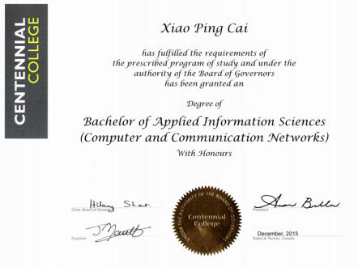

# Computer Systems Technology – Networking (Co-Op), Advanced Diploma

