|  |
| --- |
|  |
| Job Portfolio  **Xiao Ping Cai (Peter Cai)** |
| 1. **Cover Letter** **& Resume** 2. **VCP5-DCV (VMware Certified Professional 5 - Data Center Virtualization)** 3. **VCP5-DT (VMware Certified Professional 5 - Desktop )** 4. **MCSE ( Microsoft Certified Solutions Expert: Windows Server 2012)** 5. **Cisco Unified Computing Technology Design Specialist** 6. **Cisco Unified Computing Technology Support Specialist** 7. **CCNP Certification** 8. **CCNA Security Certification** 9. **SCJP (Sun Certified Java Programmer)** 10. **Computer Systems Technology – Networking (Co-Op), Advanced Diploma** 11. **Senior Engineer of China Telecom Certificate** 12. **The 21st – Century Elite of China Telecom Certificate** |
|  |
|  |
|  |

|  |
| --- |
|  |

1. **Cover Letter & Resume**

Dear HR Manager,

Please accept this letter and the accompanying resume as an application for the position of System Administrator. I have over 10 years’ experience in system administration in Telecom industry. I am a certified Senior Telecom Engineer with a Bachelor of Science Degree and I have certificate in VCP5-DCV (VMware Certified Professional 5 - Data Center Virtualization), VCP5-DT (VMware Certified Professional 5 – Desktop).

Some of my achievements are -

* At RBC, as a Technical Support, I worked on virtualization using VMware; managed the virtual infrastructure using vCenter Server and VI client, also performed vMotion, iSCSI, NAS. I also developed a program to automate produce VMware VMs daily report and transfer to Microsoft SharePoint. This program reduced the time from one hour manual work to seven minutes automatic job every day.
* At China Telecom, as a Senior Network Engineer I attended the project to build a VMware data center. The data center contains core, aggregation and access layers.
* Currently I am attending Centennial College to pursue a Bachelors of Computer Network Degree. Here I have the opportunity to work on the project to build Data Center using VMware DRS, SRM and Cisco UCS technology.

I possess effective team building, excellent communication and interpersonal skills to maintain strong relations with my co-workers and both external and internal customers. I am good at organizing and prioritizing my work to meet the established deadlines. This position seems tailored to my education, experience and career interest. I would welcome the opportunity to meet with you and elaborate on how I could make a substantial contribution to your organization.

I look forward to hearing from you soon and please contact me at 416-839-6065 if you need further information.

Thank you for your consideration.

Regards.

Peter Cai

PETER Cai, VCP5, MCSE, CCNP

230 Oak Street, Toronto, ON M5A 2E2 • Tel: (416)839-6065 • E-mail: petercharles.ca@gmail.com

System Administrator

**PROFILE**

* 10+ years of service provider technical support of enterprise Windows environments with domains, multiple sites and centralized services
* 5+ years of experience implementing complex virtualization solutions using VMware vSphere with clustered storage, with high availability capabilities such as vMotion, fault tolerance and SRM
* MCSE ( Microsoft Certified Solutions Expert: Windows Server 2012)
* VCP5-DCV (VMware Certified Professional 5 - Data Center Virtualization)
* VCP5-DT (VMware Certified Professional 5 - Desktop )
* Cisco Unified Computing Technology Design Specialist
* Developed many programs for continuous improvement in production environment
* Excellent customer facing support experience
* Strong communication skills and the ability to articulate task management, priorities, and issues.
* Technologies: Windows Server, Active Directory design and management, Group Policy customization, VMware vCenter 5.X with SRM/VR, NetApp SAN, Cisco UCS and Flexpod architecture, SharePoint

**PROFESSIONAL Development & CERTIFICATIONS**

* VCP5-DCV (VMware Certified Professional 5 - Data Center Virtualization)
* VCP5-DT (VMware Certified Professional 5 - Desktop )
* MCSE ( Microsoft Certified Solutions Expert: Windows Server 2012)
* Cisco Unified Computing Technology Design Specialist
* Cisco Unified Computing Technology Support Specialist
* CCNP (Cisco Certified Networking Professional)
* CCNA Security (Cisco Certified Network Associate Security)
* SCJP (Sun Certified Java Programmer)
* Certified Senior Telecom Engineer
* The 21st – Century Elite of China Telecom Award

**Professional skills and Expertise**

**Server** IBM Blade Server, Cisco UCS, HP Server

**OS** Windows Server 2012/2008/2003, Linux(Redhat, Fedora, Ubuntu)

**Network** TCP/IP, SMTP, HTTP, SSL, SSH, Router, Switch, Firewalls

**Storage** SAN, FCoE, iSCSI, NAS, Disk Arrays

**Technology**  VMware vSphere, VMware Horizon View, Active Directory, LAMP, NFS, LDAP, SQL,

LDAP, Sysinternals Suite, PowerShell, VBScript, bash, bash, Perl, PHP, Ruby, C#

**PROFESSIONAL EXPERIENCE:**

**Centennial College, Toronto, Bachelor of Computer and Communication Networks program** 2010 – present

* Installed, configured, and managed a Windows Server 2008 Infrastructure with Active Directory Domain Services; installed DHCP server role and fault tolerance using split scope, installed DNS server role and created pointer records.
* Worked in a team to create a VPN network with traffic engineering to connect two customer branches in a test environment.
* Installed, configured, managed Red Hat Enterprise Linux 6; performed DNS server configuration, Apache Web Server configuration, Samba & FTP Server Configuration, Network File System Configuration
* Worked on Enterprise virtualization using VMware; managed the virtual infrastructure using vCenter Server and VI client, also performed vMotion, iSCSI, NAS
* Installed, configured, and managed MS Exchange Server 2013 and Lync Server 2013

**PETER CAI** Ph. 416-839-6065 page 2

**RBC Financial Group, Toronto (coop) Developer** 2011/9-2011/12

* Develop desktop and web application
* Creation of virtual environments for development teams and assisting in troubleshooting day-to-day issues.
* Monitoring network usage and undertaking routine preventative measures.
* Performing OS, database and application administration and provide support

**Project:** Automate VMware VMs daily report

Technologies: VMware vSphere, VMware Horizon View, Windows Server, Active Directory, SQL Server, C#, IIS

**RBC Financial Group, Toronto, Ontario (coop) Technical Support** 2011/1-2011/4

* Maintain Website
* Develop Web sites and applications

**Project:** Automate daily report from Oracle BI to SharePoint

Technologies: IIS, C#, Windows Server, Active Directory, Oracle BI,

**A2AWeb Solution Inc., Toronto, Web Developer** 2008-2009

* Maintain Web hosting and build websites
* Developed Web sites and applications using ASP/C#.

**Project:** Developed Web Applications

Technologies: C#, PHP, Windows Server, IIS, SQL Server

**World Service Cargo, Toronto, Network Administrator** 2009

* Monitoring network usage and undertaking routine preventative measures.
* Troubleshooting network and system issues to resolution and isolating problems using system logs
* Manage security across the environment including user administration and SSL certificate installations
* Performing OS, database and application administration and provide support

**Project**: Enhance Wireless Network Security.

Technologies: TCP/IP, DNS, DHCP, Active Directory, Group Policy, PKI

**China Telecom, China, Senior Network Engineer**  1998-2008

* Monitoring network usage and undertaking routine preventative measures.
* Troubleshooting network and system issues to resolution and isolating problems using system logs
* Managing vendors, including tracking hardware/software issues and driving vendors to resolve issues.
* Manage security across the environment including user administration and SSL certificate installations
* Monitor patches from vendors for hardware and OS and apply pro-actively within assigned environment
* Performing OS, database and application administration and provide second-level support
* Support Architects in the development of the architectural direction and governing policies.
* Establishing necessary testing requirements to evaluate proposed designs and validate technology platforms

**Project**: Build Telecom Data Center

Technologies: VMware vSphere, VMware Horizon View, Windows Server, Active Directory, SQL Server, C#, IIS

**Project**: Internet service network system Extension

Technologies: DNS, DHCP, FTTB (Fiber to the Building) +LAN, ADSL

**EDUCATION**

**Bachelor of Computer and Communication Networks Program**, Centennial College, Toronto 2013-2014

**Advanced Diploma Computer Systems Technology** – **Networking**, Centennial College, Toronto 2011-2012

**Master of Business Administration (MBA**), Hunan University, China 2004-2006

1. **VCP5-DCV (VMware Certified Professional 5 - Data Center Virtualization)  
   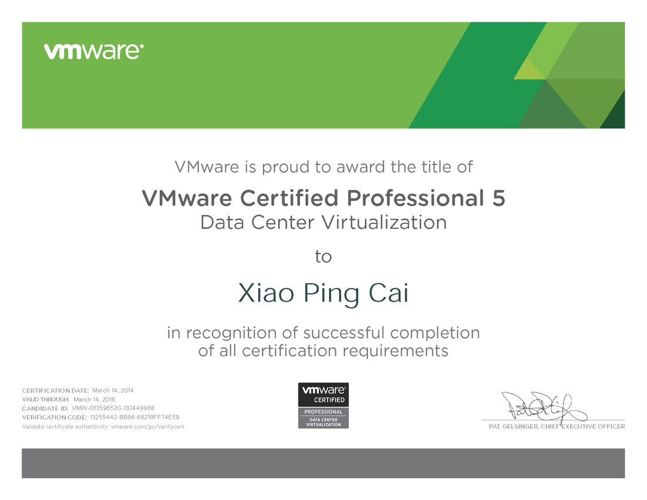**
2. **VCP5-DT (VMware Certified Professional 5 - Desktop )  
   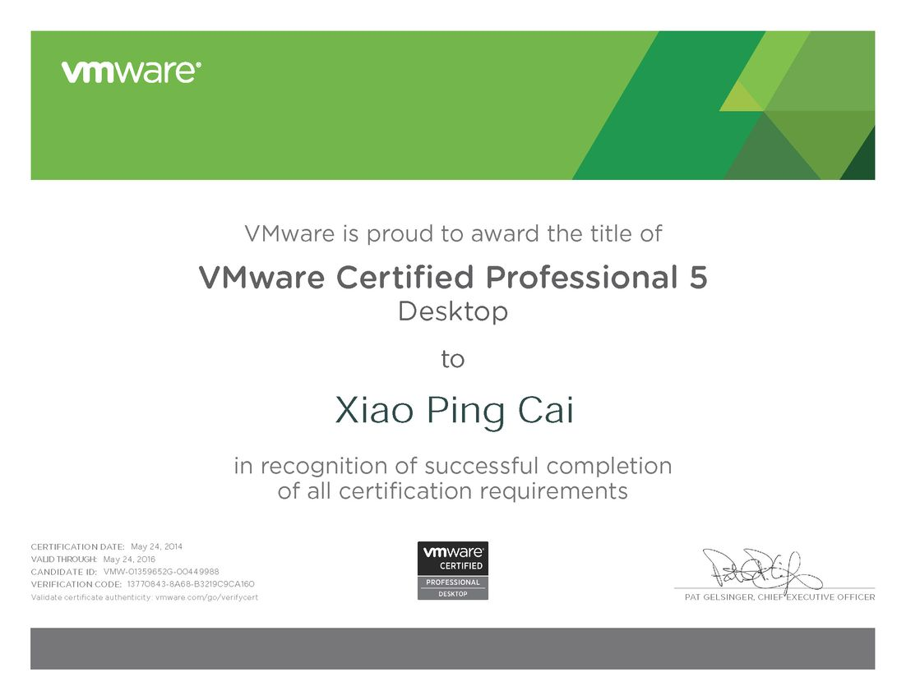**
3. **MCSE ( Microsoft Certified Solutions Expert: Windows Server 2012)  
   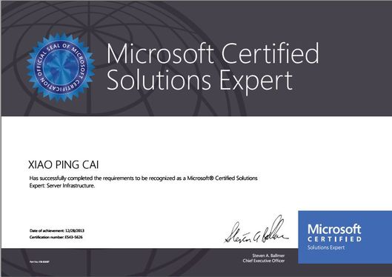**
4. **Cisco Unified Computing Technology Design Specialist  
   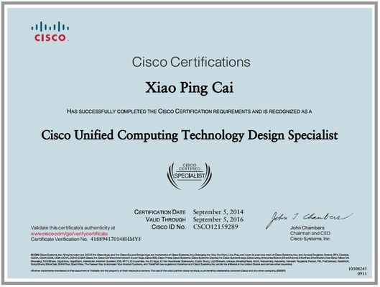**
5. **Cisco Unified Computing Technology Support Specialist  
   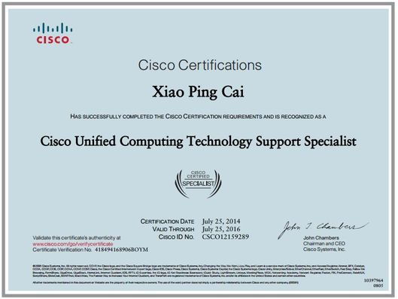**
6. **CCNP Certification  
   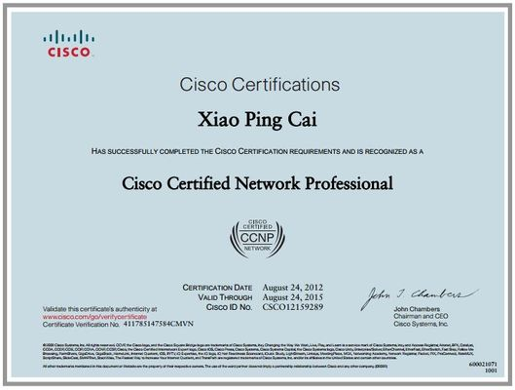**
7. **CCNA Security Certification  
   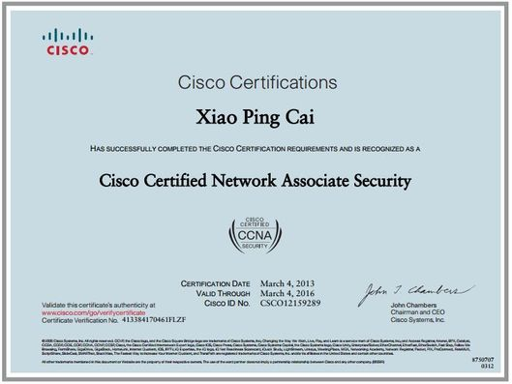**
8. **SCJP (Sun Certified Java Programmer)  
   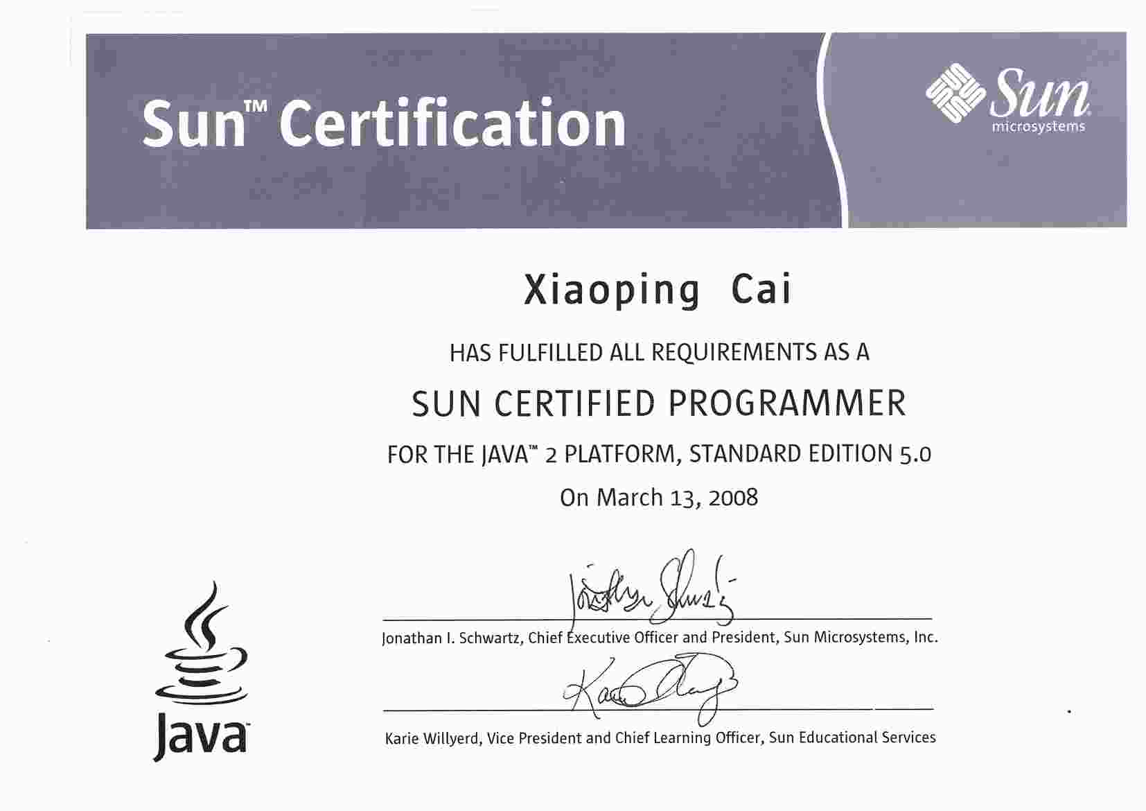**
9. **Computer Systems Technology – Networking (Co-Op), Advanced Diploma**

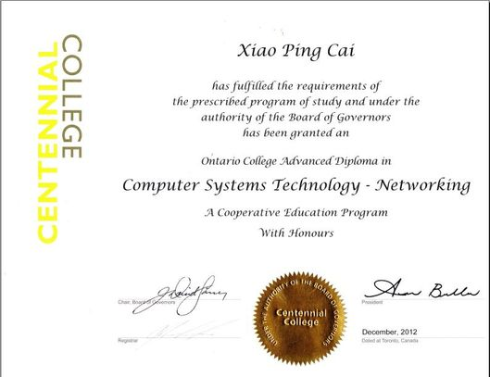

1. **Senior Engineer of China Telecom Certificate  
     
   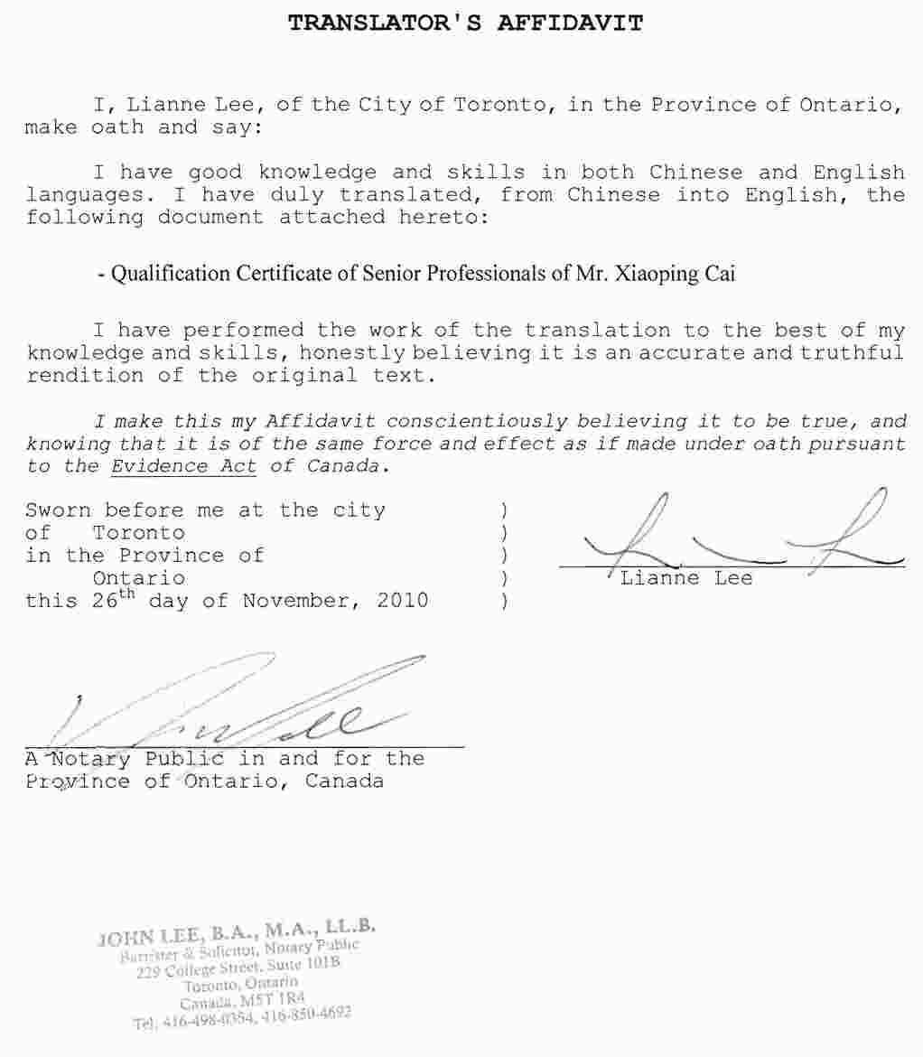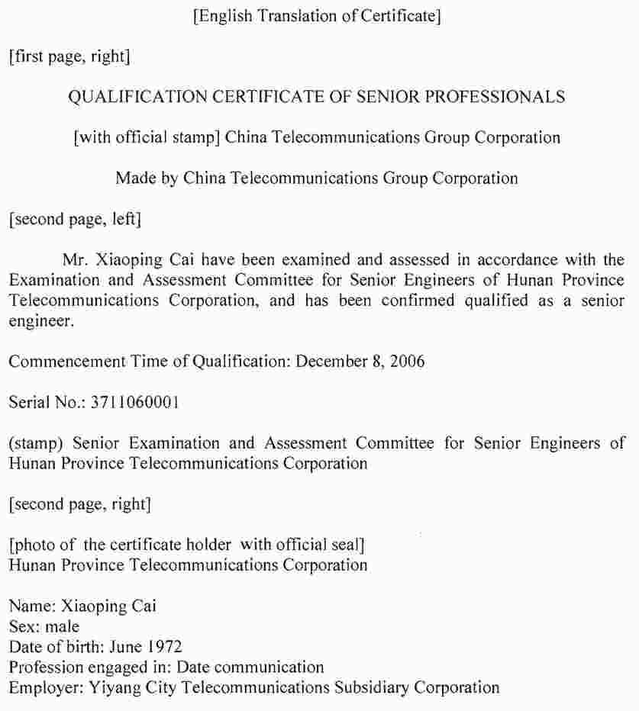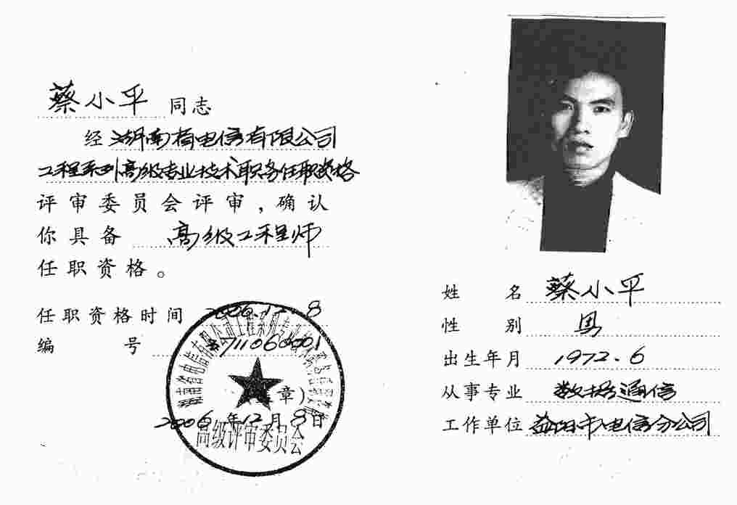**
2. **The 21st – Century Elite of China Telecom Certificate**

