# VCP5-DCV

# 

# VCP5-DT



# MCSE



# CCNP

# CCNA Security

# 

# SCJP

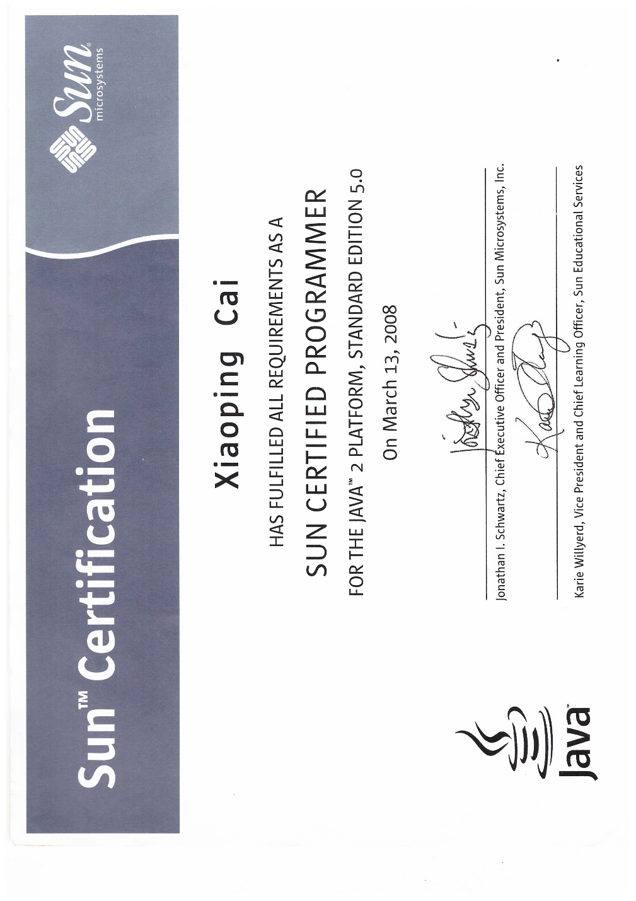

# Computer Systems Technology – Networking (Co-Op)

# Senior Telecom Engineer



 

 