

Portfolio for Systems Administrator

Peter Cai

#1905-230 OAK Street, Toronto, Ontario M5A 2E2

Tel: (416)839-6065 E-mail: [petercharles.ca@gmail.com](mailto:petercharles.ca@gmail.com)

VCP5-DCV 1

VCP5-DT 2

MCSE 3

CCNP 4

CCNA Security 5

SCJP 6

Senior Telecom Engineer 7

Computer Systems Technology – Networking (Co-Op) 10

# VCP5-DCV



# VCP5-DT



# MCSE



# CCNP

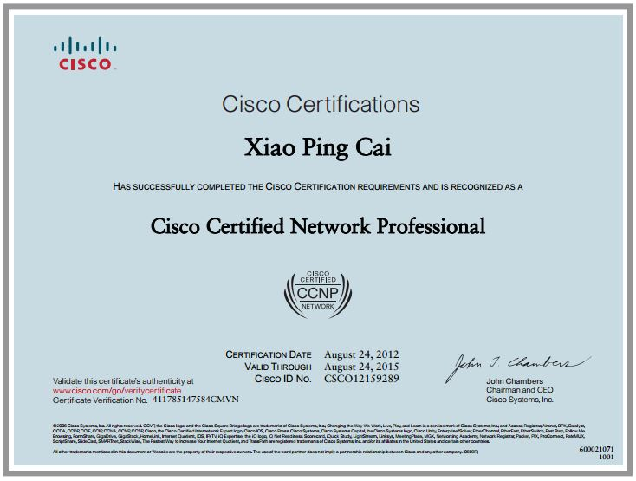

# CCNA Security

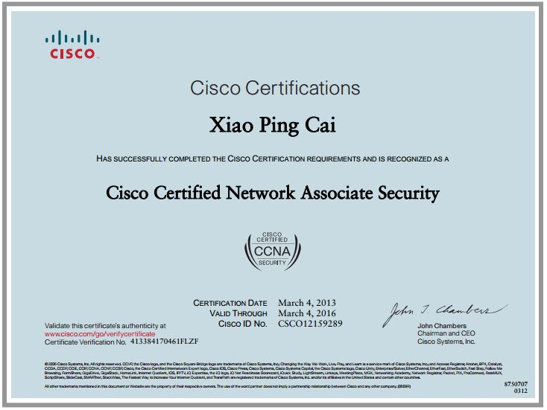

# SCJP

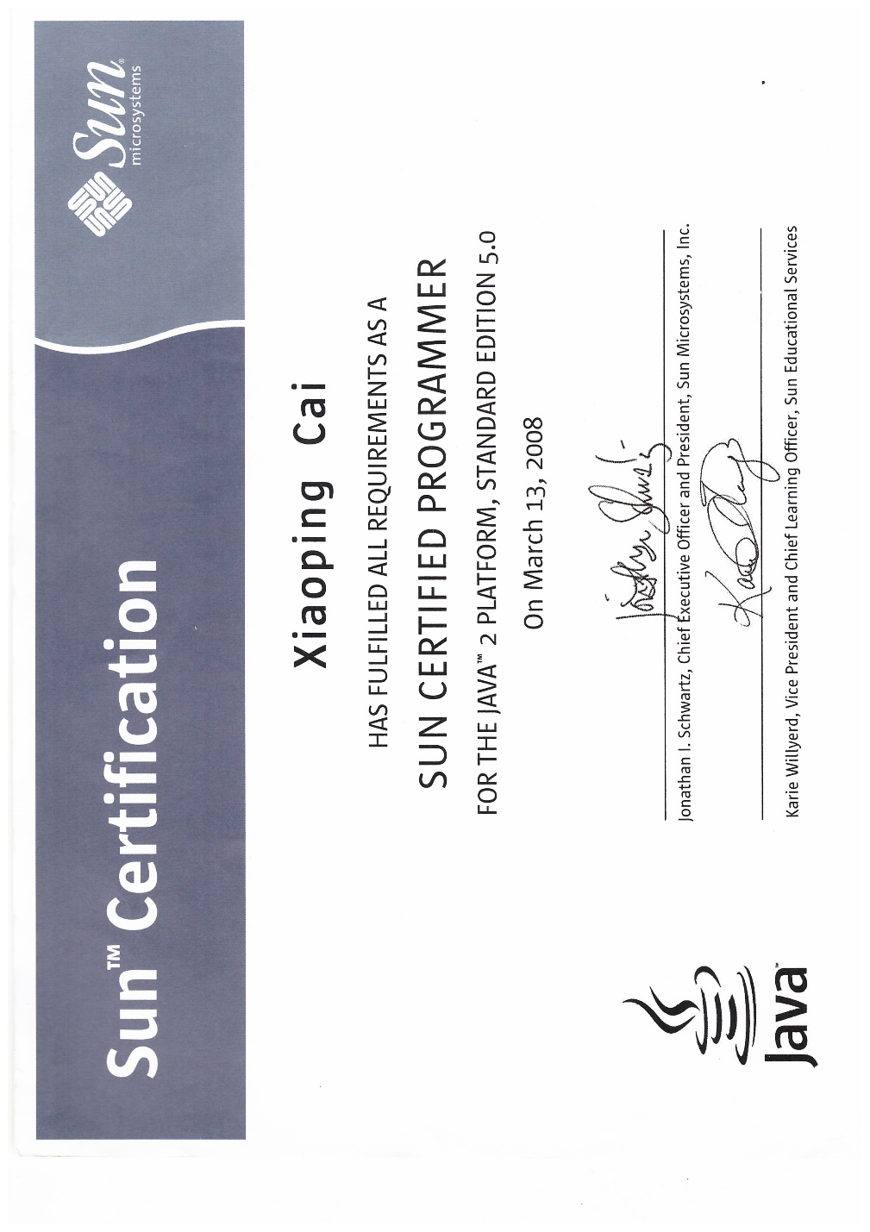

# Senior Telecom Engineer

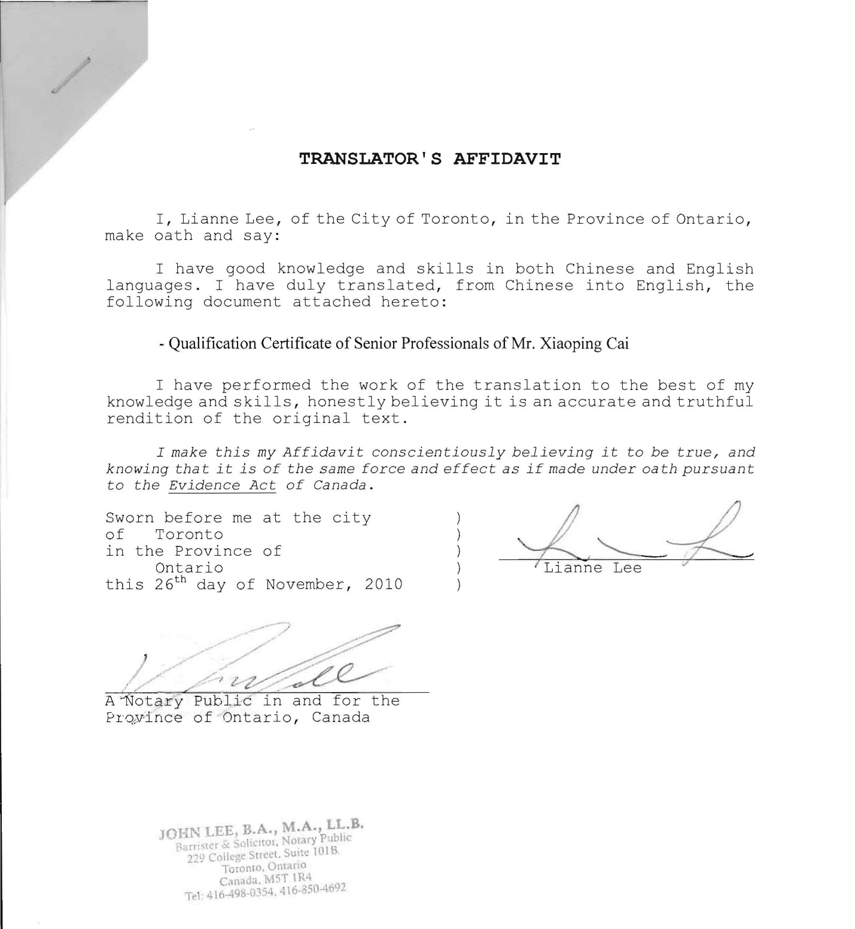

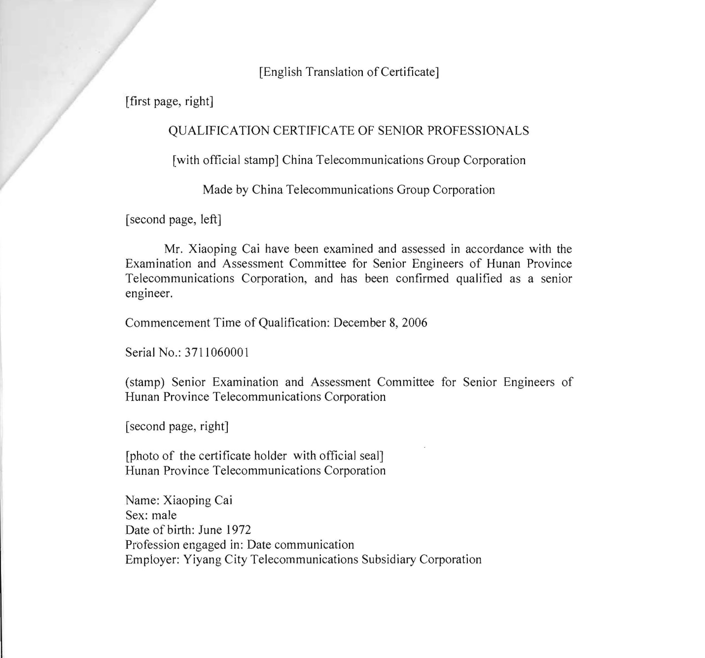

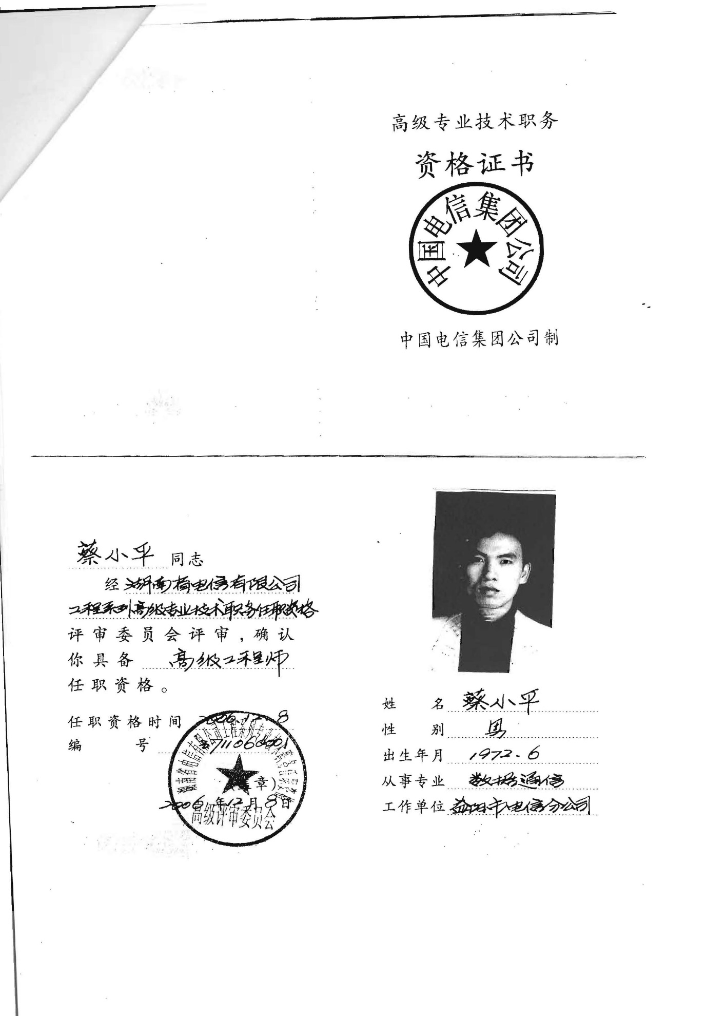

# Computer Systems Technology – Networking (Co-Op)

