### Exploratory Data Analysis Challenge

**Task**

In this exercise, you are given a dataset with claims data. You need to perform an Exploratory Data Analysis and present your results to business users (e.g. interactive dashboard, notebook, or some other tool of your choice).

Business users are interested to see trends and anomalies in the data as well as projections for the upcoming 6 months.

**Note:** Claims are expenses that insurance companies have to pay for medical services provided to patients.

**Dataset**

This dataset is a sampled aggregated data for the period of 2018/01 - 2020/07 (numbers are fictional).

The dataset contains the following columns:

* MONTH - a month claims were lodged
* SERVICE_CATEGORY - a department that provided services to patients
* CLAIM_SPECIALTY - a type of medical services by an official classification system
* PAYER - an insurance company
* PAID_AMOUNT - sum of expenses (claims), $

**Requirements**

* Python 3+
* Open-source libraries
* [Optional] Use Docker

**Hints**

* Kaggle EDA’s as a reference
* Flask / FastAPI / plotly / bokeh / dash / etc.
* Perform any necessary data clean up
* For additional interactivity, you can use filtering data on the fly, pivoting data, etc.

**How to submit**

Please upload the code for this project to GitHub, post a link to your repository below and give instructions on how to set up a local environment and run your code.

### General properties of the dataset

Number of rows: 52152

Minimum date: 201801

Maximum date: 202007

#### Counting the number of payments by month

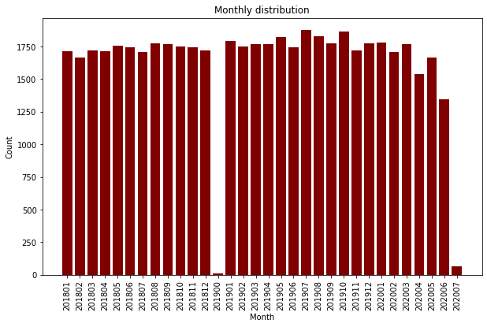

**Warining!** We can see the strange month '201900'. That could be some mistake of writing the data. And we have small amount of payments on '202007'. It seems the month was not ended. We have too small number of payments on these two months so we can just remove them.

Let's compute all different Service categories

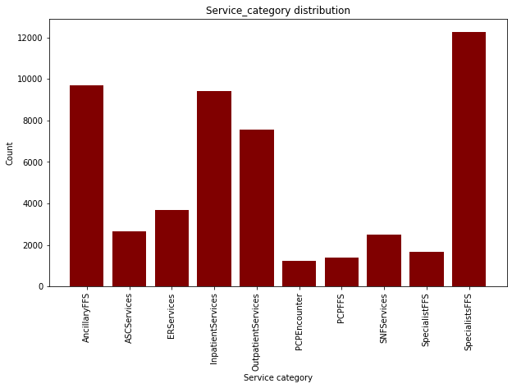

#### Description (from Internet)

* Fee-for-service (FFS) is a payment model in which doctors, hospitals, and medical practices charge separately for each service they perform. In this model, the patient or insurance company is responsible for paying whatever amount the healthcare provider charges for the service.
* Ambulatory Surgical Centers (ASC) Center | CMS
* Ancillary services are supportive or diagnostic measures that supplement and support a primary physician, nurse, or other healthcare provider in treating a patient. Some examples of ancillary services include: Imaging tests (e.g., X-rays, MRI, CT scan, ultrasound) Lab tests. Pharmacies.
* ER (emergency room) - This is probably because the letter E in the hospital setting typically refers to “emergency” (e.g., “ER” for emergency room and “ED” for emergency department).
* A primary care physician (PCP), or primary care provider, is a health care professional who practices general medicine. PCPs are our first stop for medical care. Most PCPs are doctors, but nurse practitioners and physician assistants can sometimes also be PCPs.
* What is an inpatient? In the most basic sense, this term refers to someone admitted to the hospital to stay overnight, whether briefly or for an extended period of time. Physicians keep these patients at the hospital to monitor them more closely.
* With this in mind, what is outpatient care? Also called ambulatory care, this term defines any service or treatment that doesn’t require hospitalization. An annual exam with your primary care physician is an example of outpatient care, but so are emergent cases where the patient leaves the emergency department the same day they arrive. Any appointment at a clinic or specialty facility outside the hospital is considered outpatient care as well.
* Skilled Nursing Facility (SNF) is the full form of SNF medical abbreviation. It’s a rehabilitation center where hospital patients are transferred after leaving the hospital. Seniors usually stay at an SNF for up to 100 days, and licensed medical professionals take care of them while they are there.

Grouping categories. Categories 'SpecialistFFS' and 'SpecialistFFS' seems to be the same category. 'PCPFFS' and 'PCPEncounter' are small categories but as they have the same prefix, we should group them also.

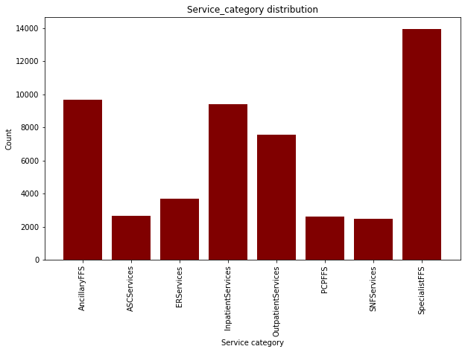

Let's check the data with zero and negative payments.

MONTH SERVICE_CATEGORY CLAIM_SPECIALTY PAYER PAID_AMOUNT  
26 201801 AncillaryFFS Cardiology Payer UN -250  
46 201801 AncillaryFFS Dermatology Payer UN -154  
102 201801 AncillaryFFS Geriatric Medicine Payer UN -201  
103 201801 AncillaryFFS GERIATRICS Payer B -203  
144 201801 AncillaryFFS Internal Medicine Payer UN -530  
... ... ... ... ... ...  
49357 202005 AncillaryFFS Physician Assistant Payer UN -196  
49414 202005 AncillaryFFS Rheumatology Payer UN -1374  
50158 202005 PCPFFS FAMILY PRACTICE Payer CA -245  
50165 202005 PCPFFS GENERAL PRACTICE Payer CA -142  
50172 202005 PCPFFS INTERNAL MEDICINE Payer CA -3412  
  
[318 rows x 5 columns]

Negative payments could be some kind of refund by court order.

Negative payments proportion 0.006106694319622076

Zero payments proportion 0.07385643507316511

Positive payments proportion 0.9200368706072128

#### Preprocessing of Claim Speciality

#### Proportion of nans in Claim speciality 0.004820063755424972

[nan 'ACH' 'Advanced Registered Nurse Prac' 'ADVANCED RN PRACT'  
 'AMBULANCE' 'Ambulance' 'AMBULANCE SERVICE' 'AMBULATORY SURGICAL CENTER'  
 'Ambulatory Transportation Services' 'ANATOM' 'ANESTHESIOLOGY' 'ARNP'  
 'BEHAVIORAL HEALTH COUNSELING' 'CARD ELECTROPHYSIOLO'  
 'CARDIAC ELECTROPHYSIOLOGY' 'CARDIOLOGY' 'Cardiology'  
 'Cardiology/Cardiovascular Disease' 'Cardiovascular Medicine'  
 'CARDIOVASCULAR SURGERY' 'CCS' 'Chiropractic Medicine'  
 'Clinical Medical Laboratory\t' 'Colon and Rectal Surgery'  
 'COMMUNITY MENTAL HEALTH CENTER'  
 'COMMUNITY MENTAL HEALTH CENTER/OTHER REHAB CENTER' 'CONV CARE CLINIC'  
 'COVERING PHYSICIAN' 'CRITICAL ACCESS' 'CSW' 'DEFAULT' 'Dermatology'  
 'DERMATOLOGY' 'DERMATOPATHOLOGY' 'Dermatopathology' 'DIABETES EDUCATOR'  
 'DIAG X-RAY CLINIC' 'DIAGNOSTIC RADIOLOGY' 'Diagnostics' 'DIAL'  
 'DIALYSIS' 'Dialysis' 'DIALYSIS CENTER' 'DISEASE MANAGEMENT'  
 'DME & Medical Supplies, Oxygen Equip & Supplies' 'Doctor of Psychology'  
 'DURABLE MED EQUIPMENT' 'DURABLE MEDICAL EQUIPMENT'  
 'Durable Medical Equipment' 'Durable Medical Supply']  
...

As we can see different records have different format and contain misprints and abbreviations so we should preprocess the field and indicate popular groups by hand

Preprocessed list:

['abulatory surgical center', 'accup', 'ach', 'acupu', 'acupuncturist', 'acute care hospital', 'acute short term hospital', 'addmed', 'addpsy', 'adlmed', 'adolescent medicine', 'advanced heart failure and transplant cardiology', 'advanced registered nurse prac', 'advanced registered nurse practitioner', 'advanced rn pract', 'agencies', 'ahftc', 'allergy', 'allergy immunology', 'ambulance', 'ambulance emergency land', 'ambulance land', 'ambulance service', 'ambulance service provider', 'ambulatory health care', 'ambulatory surgery center', 'ambulatory surgical center', 'ambulatory surgical centers', 'ambulatory surgical facility', 'ambulatory transportation services', 'analytical labs', 'anast', 'anatom', 'anatomic and clinical pathology', 'anatomic path clinical path', 'anatomic pathology', 'anes assist', 'anesthesia', 'anesthesia tee', 'anesthesiologist', 'anesthesiologist assistant', 'anesthesiology', 'anesthesiology pain medicine', 'anesthetist nurse', 'aprn', 'arnp', 'asc', 'audio', 'audiologist', 'audiology']  
...

Making new features from grouped specialities

## Exploring negative data

## Number of rows: 318

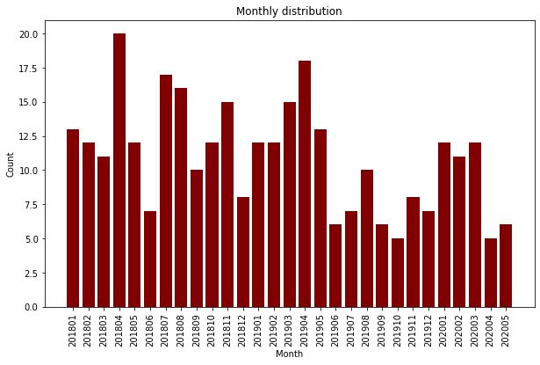

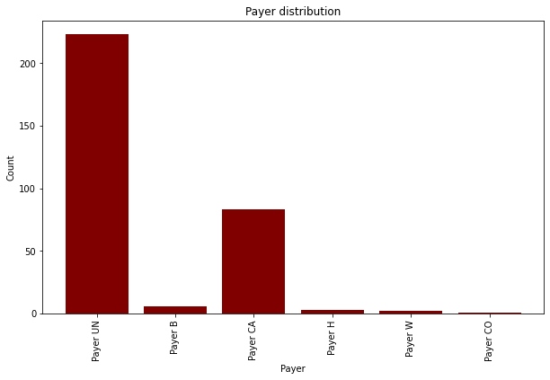

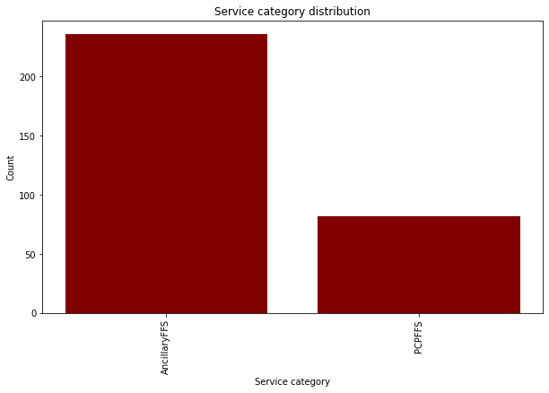

As we can see the most part of there payments belongs to 'Payer NU' and 'Payer CA' and two service categories - 'AncillaryFFS' and 'PCPFFS'

## Exploring null data

## Number of rows: 3846

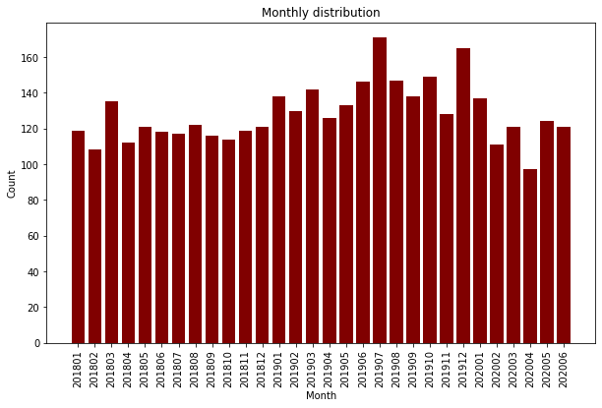

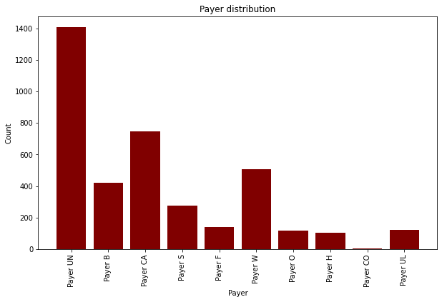

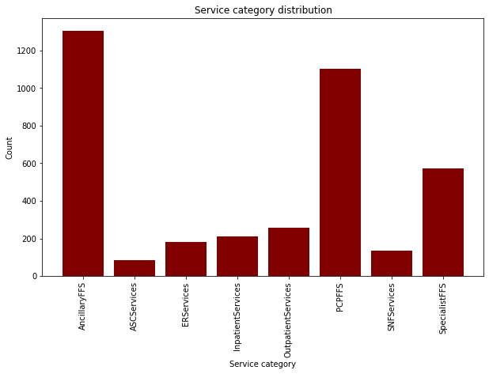

For zero payments one can see variety of companies and Service categories

## Exploring positive data

This is the main part because positive payments if a majority of data (over 92%)

#### Pivot table for number of payments per company per month

count   
MONTH 201801 201802 201803 201804 201805 201806 201807 201808 201809 …   
PAYER   
Payer B 78.0 87.0 85.0 92.0 103.0 110.0 100.0 117.0 104.0 …   
Payer CA 278.0 254.0 265.0 266.0 275.0 272.0 264.0 269.0 256.0 …   
Payer CO 135.0 138.0 148.0 142.0 144.0 124.0 127.0 144.0 151.0 …   
Payer F 291.0 287.0 288.0 290.0 292.0 293.0 279.0 297.0 305.0 …   
Payer H 70.0 62.0 66.0 62.0 64.0 67.0 68.0 72.0 70.0 …   
Payer O 209.0 198.0 205.0 213.0 218.0 216.0 218.0 202.0 210.0 …   
Payer S 161.0 170.0 170.0 169.0 175.0 142.0 136.0 156.0 167.0 …   
Payer UL 0.0 0.0 0.0 0.0 0.0 0.0 0.0 0.0 0.0 …   
Payer UN 134.0 137.0 151.0 145.0 147.0 161.0 141.0 147.0 148.0 …   
Payer W 224.0 211.0 199.0 203.0 208.0 235.0 239.0 233.0 230.0 …

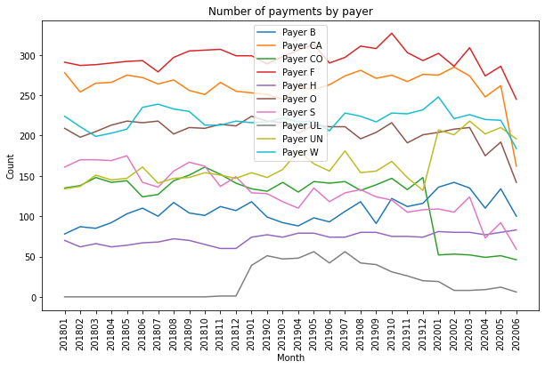

As one can see 'Payer UL' has less transactions than other payers and the first transaction appears on 201811

#### Paid_amount distribution

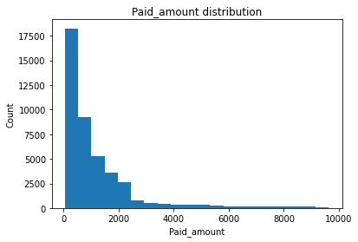

Probably paid_amount has log_normal distribution. Let's check it

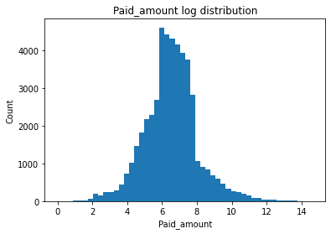

Average of paid_amount: 4042.0415988311415

Standard deviation of paid_amount: 35971.74086297727

Standard deviation of paid_amount without outliers: 1464.6181974158987

In the case when the distribution is log-normal, it's better to use median score instead of average because median is not too sensitive to the outliers

Median paid_amount: 676.0

The median is very close to the average of log-normal distribution

Log-normal average of paid_amount: 683.0967826328668

#### Payer distribution

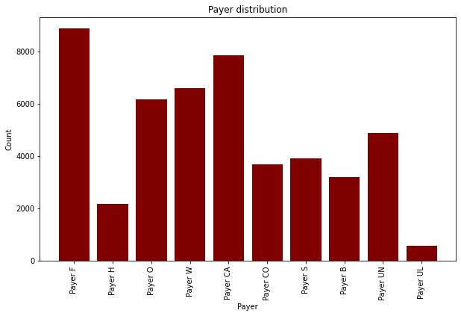

Computing how many different Service categories each payer has

Payer F : 8  
Payer H : 8  
Payer O : 8  
Payer W : 8  
Payer CA : 8  
Payer CO : 8  
Payer S : 8  
Payer B : 8  
Payer UN : 8  
Payer UL : 8

All 10 payers have all categories

### GOODNESS OF FIT Test

Comparing the distribution of service categories by payer to overall distribution

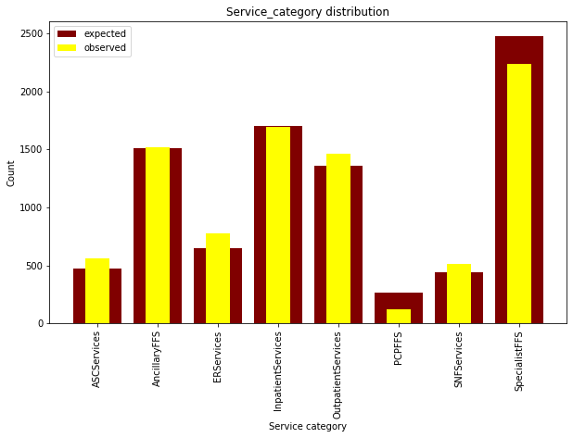

payer: Payer F  
chi_square_test_statistic is : 159.11604550451807  
p_value : 4.922792044589307e-31  
12.591587243743977

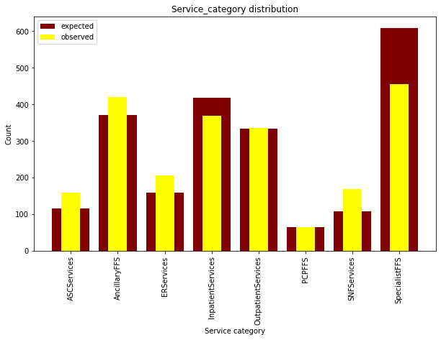

payer: Payer H  
chi_square_test_statistic is : 115.792171352185  
p_value : 5.753410270783393e-22  
12.591587243743977

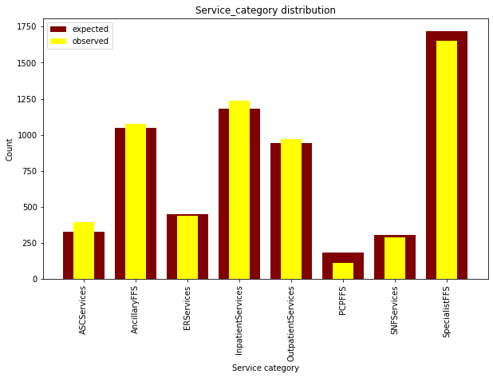

payer: Payer O  
chi_square_test_statistic is : 52.34938375375981  
p_value : 4.982251437196621e-09  
12.591587243743977

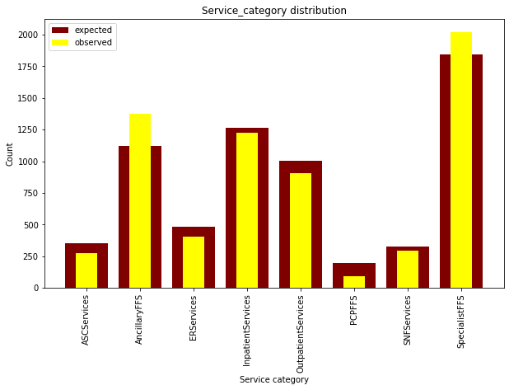

payer: Payer W  
chi_square_test_statistic is : 176.0289455086634  
p_value : 1.3426989397139578e-34  
12.591587243743977

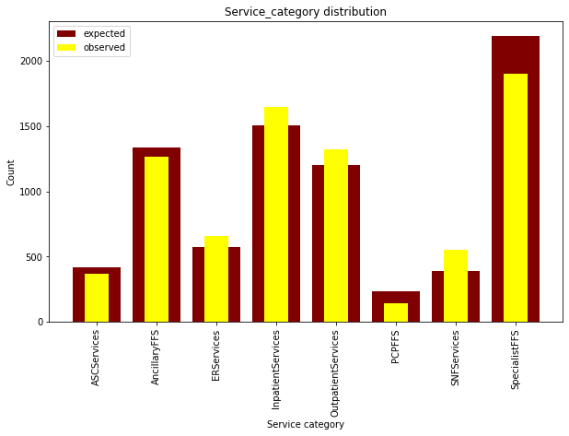

payer: Payer CA  
chi_square_test_statistic is : 197.54232751920188  
p_value : 3.804057411879403e-39  
12.591587243743977

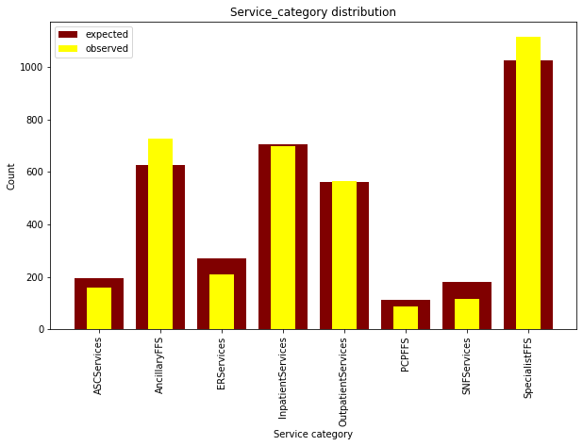

payer: Payer CO  
chi_square_test_statistic is : 74.13116577018542  
p_value : 2.1525009320621745e-13  
12.591587243743977

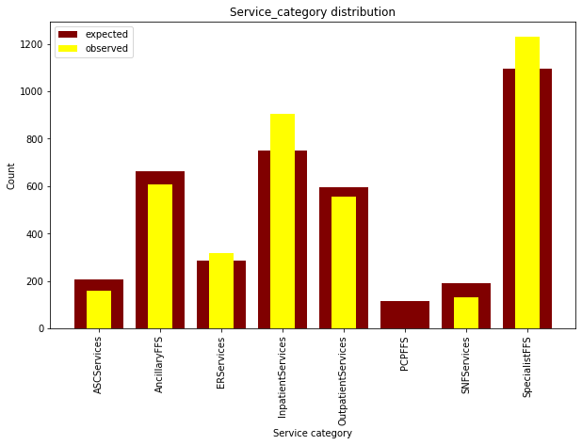

payer: Payer S  
chi_square_test_statistic is : 205.22116354002327  
p_value : 8.990849221299443e-41  
12.591587243743977

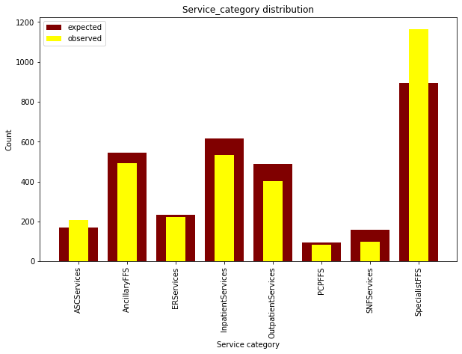

payer: Payer B  
chi_square_test_statistic is : 146.63526282809346  
p_value : 2.0647085595041257e-28  
12.591587243743977

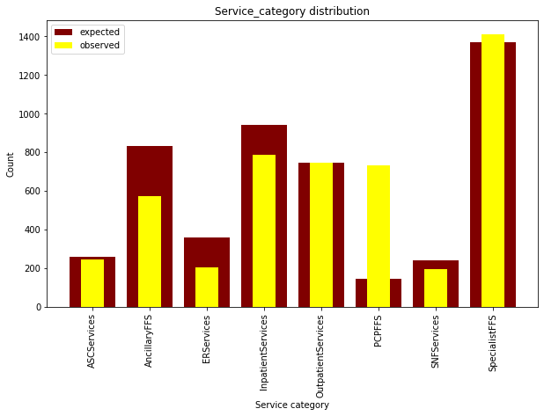

payer: Payer UN  
chi_square_test_statistic is : 2508.030453893707  
p_value : 0.0  
12.591587243743977

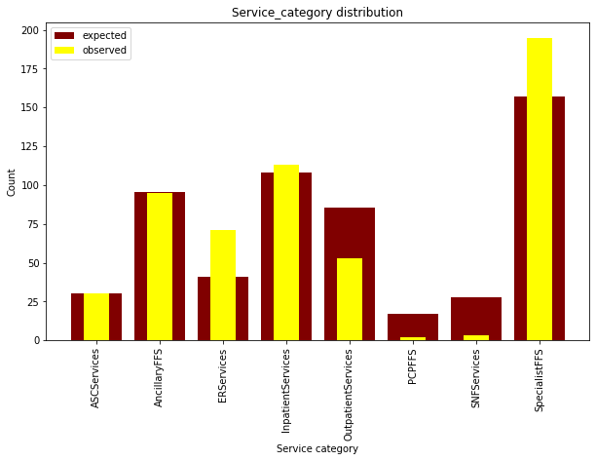

payer: Payer UL  
chi_square_test_statistic is : 78.7670210369333  
p_value : 2.4569468480583376e-14  
12.591587243743977

In each case we have significant difference but the most visible difference is for 'Payer UN' which has unproportional number of PCP payments

### Payment distribution by payer

### Payer: Payer F Number of rows: 8870 Median paid_amount: 1035.0 Mean paid_amount: 9782.131792559188

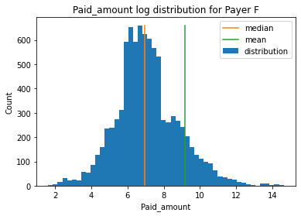

Payer: Payer H  
Number of rows: 2182  
Median paid_amount: 1245.5  
Mean paid_amount: 9956.466086159488

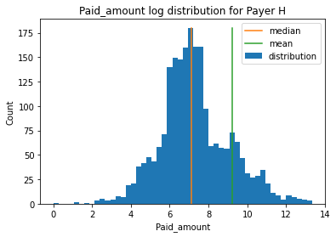

Payer: Payer O  
Number of rows: 6159  
Median paid_amount: 810.0  
Mean paid_amount: 3477.723981165

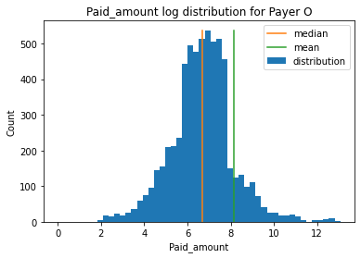

Payer: Payer W  
Number of rows: 6596  
Median paid_amount: 588.0  
Mean paid_amount: 1846.734990903578

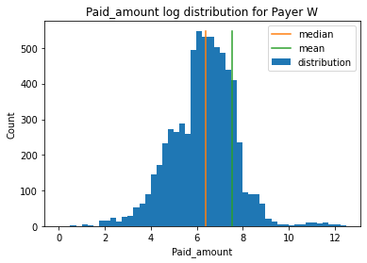

Payer: Payer CA  
Number of rows: 7851  
Median paid_amount: 757.0  
Mean paid_amount: 4291.237804101388

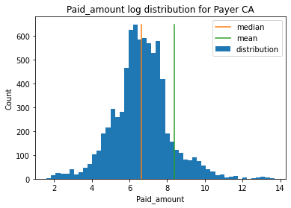

Payer: Payer CO  
Number of rows: 3673  
Median paid_amount: 607.0  
Mean paid_amount: 1380.007078682276

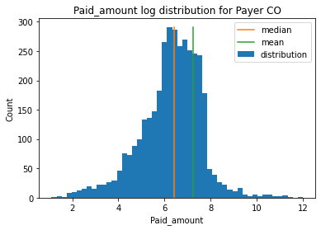

Payer: Payer S  
Number of rows: 3913  
Median paid_amount: 438.0  
Mean paid_amount: 973.8686429849221

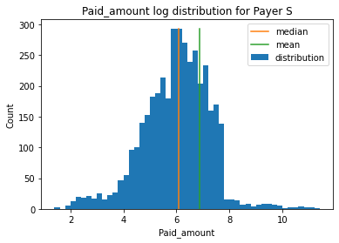

Payer: Payer B  
Number of rows: 3206  
Median paid_amount: 416.0  
Mean paid_amount: 751.426699937617

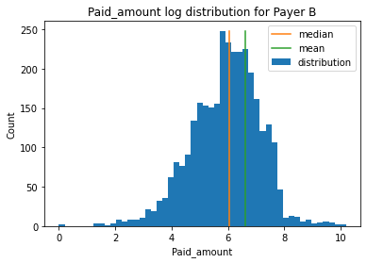

Payer: Payer UN  
Number of rows: 4898  
Median paid_amount: 544.0  
Mean paid_amount: 1280.56472029399

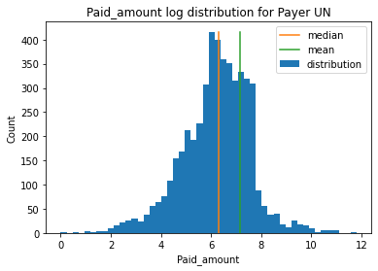

Payer: Payer UL  
Number of rows: 562  
Median paid_amount: 318.5  
Mean paid_amount: 551.6494661921708

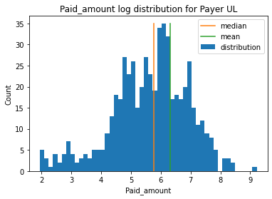

Showing that median is more stable statistic

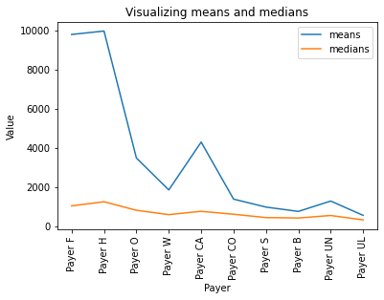

Correlarion between means and medians: 0.9510783412495436  
P-value for correlation coefficient: 2.3618698414366877e-05

### Exploring top-specialities

#### Top categories by count

Speciality Count  
0 surgery 6047  
1 otolaryngology 5490  
2 radiology 3701  
3 cardiology 3119  
4 oncology 2164  
5 general 2150  
6 physical 1954  
7 nurse 1773  
8 internal 1739  
9 urology 1711

surgery -->   
corr_coef: 0.032931277007990596 --> p-value: 0.8628445382422639

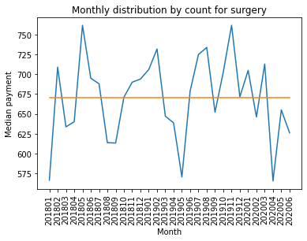

otolaryngology -->   
corr_coef: -0.3872070810381735 --> p-value: 0.03451882284

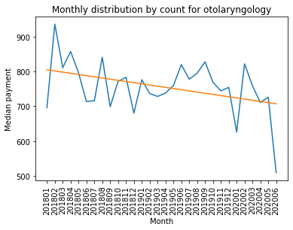

radiology -->   
corr_coef: 0.319460027017729 --> p-value: 0.085282512162

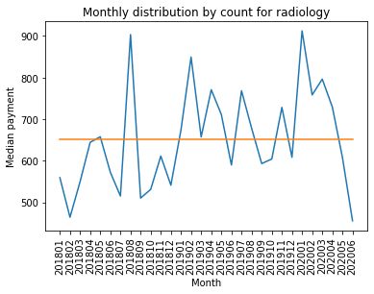

cardiology -->   
corr_coef: 0.09391273122173291 --> p-value: 0.6215762120784231

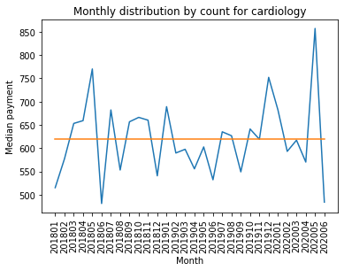

oncology -->   
corr_coef: 0.3956229330988751 --> p-value: 0.030463878999197228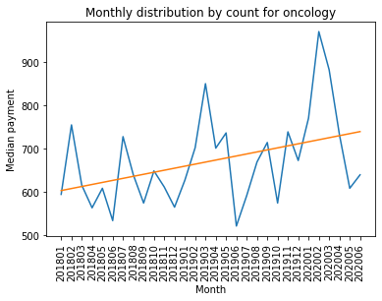

For the top specialities by count we can see the significant (0.05 threshold) trend for:

* otolaryngology (correlation: -0.39, p_value: 0.03)
* oncology (correlation: 0.39, p_value: 0.03)

#### Top categories by paid sum

Speciality Sum_paid  
0 hospital 41863179  
1 otolaryngology 10368734  
2 oncology 9718748  
3 surgery 9039850  
4 radiology 8190466  
5 cardiology 7504275  
6 hematology 6291089  
7 internal 4966067  
8 ambulance service 3664576  
9 nurse 3554506

hospital -->   
corr_coef: 0.45885957745161543 --> p-value: 0.010757221768815231

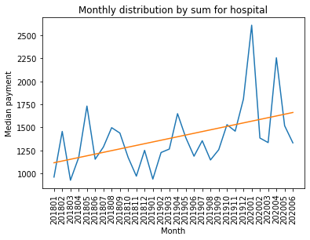

otolaryngology -->   
corr_coef: -0.3872070810381735 --> p-value: 0.03451882284

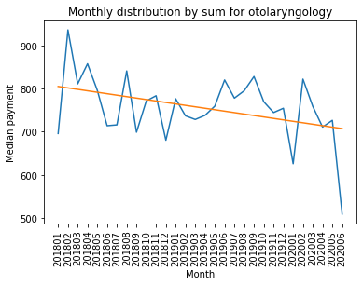

oncology -->   
corr_coef: 0.3956229330988751 --> p-value: 0.030463878999197228

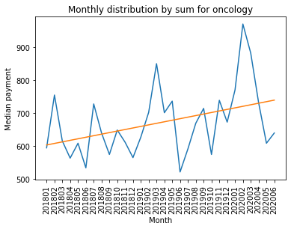

surgery -->   
corr_coef: 0.032931277007990596 --> p-value: 0.8628445382422639

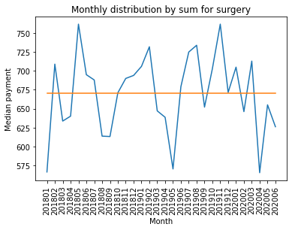

radiology -->   
corr_coef: 0.319460027017729 --> p-value: 0.08528251216296788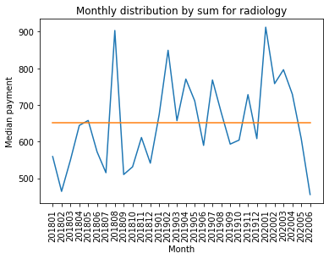

For the top specialities by sum we can see the significant (0.05 threshold) trend for:

* hospital (correlation: 0.46, p_value: 0.01)
* otolaryngology (correlation: -0.39, p_value: 0.03)
* oncology (correlation: 0.40, p_value: 0.03)

#### Top specialities by median

Speciality Median_payment  
0 long term 8759.0  
1 dialysis 6642.0  
2 ambulance service 1846.0  
3 home 1610.0  
4 infusion 1345.5  
5 hospital 1344.5  
6 durable 1147.0  
7 dental 1075.0  
8 dermatology 951.0  
9 gastroenterology 917.0

long term -->   
corr_coef: -0.38852250243749 --> p-value: 0.10019989880254503

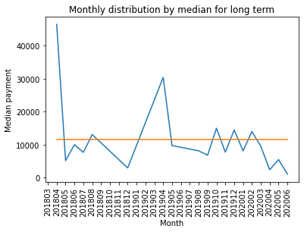

dialysis -->   
corr_coef: 0.11341195049337842 --> p-value: 0.5506954964399359

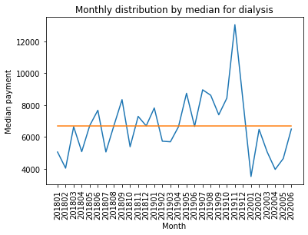

ambulance service -->   
corr_coef: 0.00197792695692095 --> p-value: 0.99172352

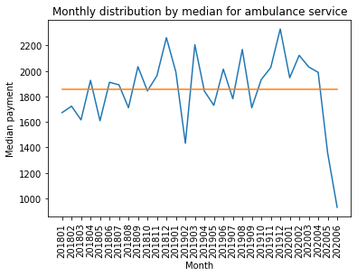

home -->   
corr_coef: -0.6047007937506313 --> p-value: 0.00040090201551917613

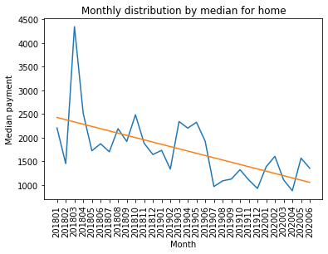

infusion -->   
corr_coef: 0.33621129408152717 --> p-value: 0.06928594951186588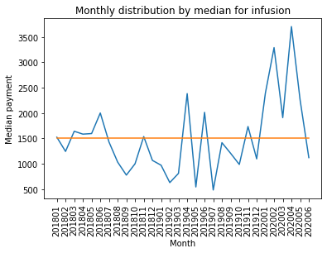

For the top specialities by median payment we can see the significant (0.05 threshold) trend for:

* home (correlation: -0.60, p_value: 0.0004)
* hospital (correlation: 0.46, p_value: 0.01)

**Payment trends for payers**

Payer F -->   
corr_coef: -0.35472418489540486 --> p-value: 0.05442710261042485

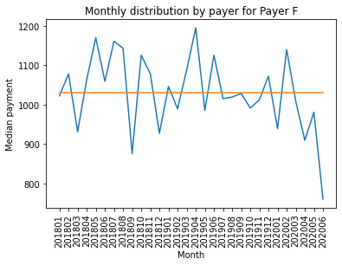

Payer H -->   
corr_coef: 0.1342354948437787 --> p-value: 0.47943758557549215

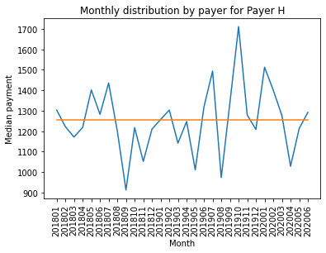

Payer O -->   
corr_coef: -0.5537476680881521 --> p-value: 0.0015006959768256332

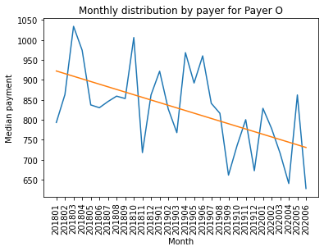

Payer W -->   
corr_coef: -0.1340543304851863 --> p-value: 0.4800362644441857

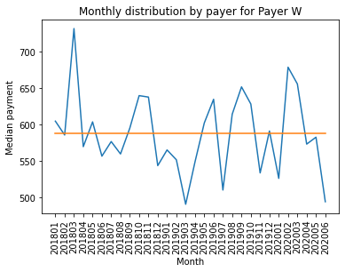

Payer CA -->   
corr_coef: -0.33589995639861936 --> p-value: 0.06956029961543066

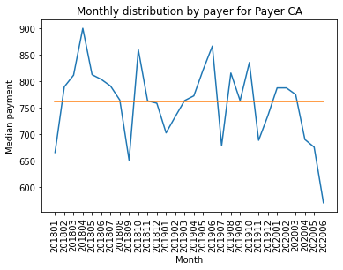

Payer CO -->   
corr_coef: 0.5394459004591824 --> p-value: 0.002095670825129852

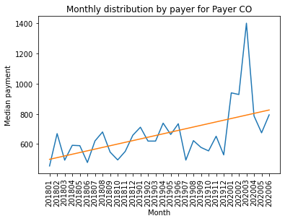

Payer S -->   
corr_coef: -0.4474623809781648 --> p-value: 0.013162094617099218

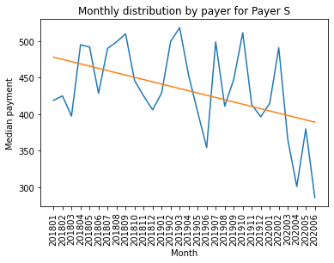

Payer B -->   
corr_coef: 0.44893165150710146 --> p-value: 0.01282889657371473

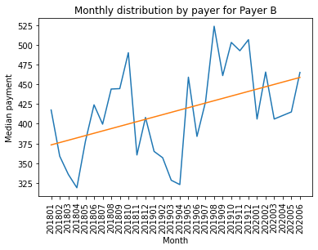  
  
  
  
Payer UN -->   
corr_coef: 0.2846193125394907 --> p-value: 0.12740626211597295

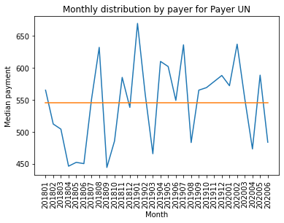

Payer UL -->   
corr_coef: 0.34863808611306984 --> p-value: 0.1319400938083967

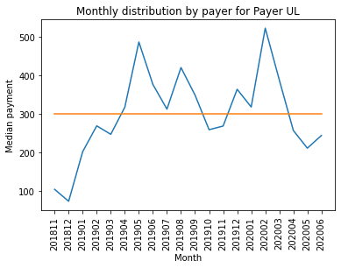

For the top specialities by sum we can see the significant (0.05 threshold) trend for:

* Payer O (correlation: -0.55, p_value: 0.001)
* Payer CO (correlation: 0.54, p_value: 0.002)
* Payer S (correlation: -0.44, p_value: 0.01)
* Payer B (correlation: 0.45, p_value: 0.01)

### Looking most frequent specialities by payer

Payer F: surgery  
Payer H: nurse  
Payer O: surgery  
Payer W: otolaryngology  
Payer CA: surgery  
Payer CO: surgery  
Payer S: otolaryngology  
Payer B: otolaryngology  
Payer UN: surgery  
Payer UL: physical

### Looking most median payment specialities by payer

### Payer F: dialysis Payer H: hospital Payer O: home Payer W: long term Payer CA: hospital Payer CO: durable Payer S: long term Payer B: long term Payer UN: long term Payer UL: audiology

### Looking most frequent specialities goes with surgery

cats sums  
 surgery 6047  
 general 1087  
 vascular 914  
 orthopedic 909  
 thoracic 615  
 cardiology 583  
 plastic surgery 504  
 neurology & neurophysiology 491  
 otolaryngology 392  
 colon & rectal 333

### Looking most frequent concurrence between specialities

ambulance service --> surgery --> 288  
ambulance service --> otolaryngology --> 282  
anatomic --> pathology --> 205  
anesthesia --> nurse --> 264  
cardiology --> vascular --> 634  
cardiology --> otolaryngology --> 602  
cardiology --> interventional --> 602  
cardiology --> surgery --> 583  
cardiology --> physiology --> 412  
cardiology --> thoracic --> 303  
colon & rectal --> surgery --> 333  
critical care --> surgery --> 163  
dental --> otolaryngology --> 437  
diagnostic --> radiology --> 862  
diagnostic --> sleep --> 139  
durable --> otolaryngology --> 185  
family --> nurse --> 196  
gastroenterology --> otolaryngology --> 1077  
general --> surgery --> 1087  
gynecology --> oncology --> 165  
hematology --> oncology --> 758  
interventional --> otolaryngology --> 1155  
interventional --> radiology --> 511  
interventional --> vascular --> 166  
mental --> otolaryngology --> 140  
neurology & neurophysiology --> urology --> 854  
neurology & neurophysiology --> surgery --> 491  
neurology & neurophysiology --> radiology --> 158  
nuclear --> radiology --> 218  
occupational --> therapy --> 118  
oncology --> radiology --> 435  
oncology --> surgery --> 250  
orthopedic --> surgery --> 909  
orthopedic --> prosthetic orthotics --> 218  
orthopedic --> sports --> 136  
otolaryngology --> pain medicine --> 744  
otolaryngology --> radiology --> 556  
otolaryngology --> surgery --> 392  
otolaryngology --> urgent --> 320  
otolaryngology --> vascular --> 166  
otolaryngology --> sleep --> 147  
otolaryngology --> rehabilitation --> 132  
physical --> therapy --> 398  
physical --> rehabilitation --> 370  
plastic surgery --> surgery --> 504  
radiology --> vascular --> 141  
surgery --> vascular --> 914  
surgery --> thoracic --> 615

## Summary

Preprocessing

* Analyzed the structure of the dataset
* Filtered strange rows with not positive payments
* Corrected errors by creating new speciality list and features

Analyzed

* Payers by paid_amount distribution
* Service category distributions by payer
* Payment distributions by payer

Analyzed trends

* Top specialities by count
* Top specialities by sum paid
* Top specialities by median payment
* Median payment by payer by month
* Correlations between specialities

Discovered:

* The data collecting process may have errors
* Service speciality list have overlaps
* Claim speciality list is not structured and have mistypes and missed data
* 'Payer UL' has lowest median paid_amount
* 'Payer H' has highest median paid_amount
* Top-5 specialities by count: surgery, otolaryngology, radiology, cardiology, oncology
* Top-5 specialities by sum: hospital, otolaryngology, oncology, surgery, radiology
* Top-5 specialities by median payment: long term, ambulance service, home, infusion, hospital

For the top specialities by count we can see the significant (0.05 threshold) trend for:

* otolaryngology (correlation: -0.39, p_value: 0.03)
* oncology (correlation: 0.39, p_value: 0.03)

For the top specialities by sum we can see the significant (0.05 threshold) trend for:

* hospital (correlation: 0.46, p_value: 0.01)
* otolaryngology (correlation: -0.39, p_value: 0.03)
* oncology (correlation: 0.40, p_value: 0.03)

For the top categories by median payment we can see the significant (0.05 threshold) trend for:

* home (correlation: -0.60, p_value: 0.0004)
* hospital (correlation: 0.46, p_value: 0.01)

Most frequent categories for payers are

* Payer F: surgery
* Payer H: nurse
* Payer O: surgery
* Payer W: otolaryngology
* Payer CA: surgery
* Payer CO: surgery
* Payer S: otolaryngology
* Payer B: otolaryngology
* Payer UN: surgery
* Payer UL: physical

Most expensive categories for payers are

* Payer F: home
* Payer H: hospital
* Payer O: home
* Payer W: long term
* Payer CA: hospital
* Payer CO: durable
* Payer S: long term
* Payer B: long term
* Payer UN: long term
* Payer UL: audiology

Most frequent categories for surgery are:

* general
* vascular
* orthopedic
* thoracic
* cardiology
* plastic surgery
* neurology & neurophysiology
* otolaryngology
* colon & rectal

Also discovered most frequent correlations between categories

Information could be useful for the Ministry of Health, hospitals as well as for insurance companies