Introduction
Here is a technical documentation about the FME Chart project. In this document, the functionalities, data flows and the components of each class will be described briefly.

Chart Layout
FMenuBar(fmenuBar)
FButtonBar(fbuttonBar)
FTABar(ftaBar)
FTypeBar(fTypebar)

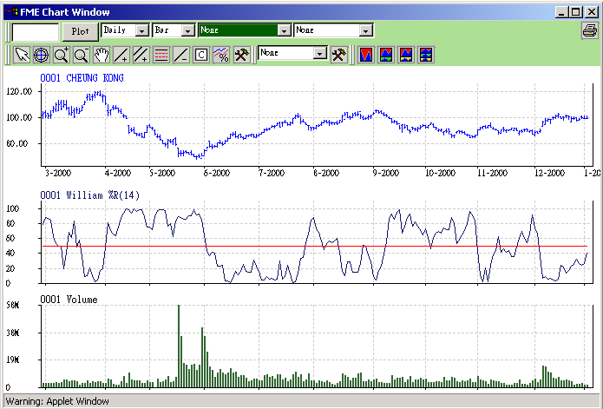
ChartScreen(chartScreen3)
ChartScreen(chartScreen2)
ChartScreen(chartScreen1)
Figure 1: the Chart Layout and the corresponding components.

The ChartScreen class is the main UI components for drawing all kinds of stock charts. It is controlled by the FBars(FMenuBar, FButtonBar, FTABar, FCompareBar and FTypeBar). All of the UI and non-UI components are hosted by FMEChartA.class, which is extended from Panel. By creating the FMEChartA instance and init it correctly (see FMEChartAApplet for initiating), you can place the chart anywhere.

Classes descriptions

Class Name | Descriptions
BasicPrint | A Printable Object that used to print the charts to printer device.
ChartData | It contains a sequence of chart data represent a chart. There are some methods can be invoked to calculate Technical Analysis chart.
ChartScreen | The main UI component that displays the chart given the ChartUIObject which is extended from ChartData. ChartScreen provides all drawing features including zoom, insert line and so on.
ChartSource | It is a data source of ChartData. It requires the web server and generates the chartdata according to the Fcommand object.
ChartSourceListener | Interfaces for the menubar to listen to take the suitable action when the ChartData is received correctly or not. FMenuBar, FcompareBar have implemented it.
CharUIObject | It contains ChartData object and contains UI information about the properties of the display chart currently.
FAction | It is a component of ChartUIObject. FAction contains information about the current drawing events, the inserted line, parallel line, golden partitions and so on.
FBar | It is a base class of FMenuBar, FButtonBar, FTypeBar, FCompareBar and FTypeBar.
FBound | It is a component of ChartUIObject. Fbound contains information about the max and min value of the current display chart.
FButtonBar | A Button Menu handles all of the drawing events.
FCommand | It is a class to ask the ChartSource to download data from web server. When you request a chart, you create a new FCommand object and then add it into ChartSource. ChartSource will download the chartdata according to FCommand object.
FCompareBar | A menu handles all the compare events including “insert a compare line” and “remove a compare line”.
FConfig | A constant class to set the properties of stock charts such as color.
FFormater | A static class includes some general for formatting data.
FlButton | Not used for the time being
FImageButton | A button class which displays image and provide action events.
FLine | A line object represents a line location in a ChartScreen.
FMEChartA | The Main Panel of the FME chart, it hosts all the components of FME chart.
FMEChartAppletA | An example of Applet to host FMEChartA.
FMEChartWindow | A class hosts FMEChartA object in a floating manner.
FMenuBar | A menu handles the requests of intraday, daily, weekly and monthly chart data.
FPoint | A point of a chart data.
FSettingDialog | A window used to set the (MA) moving average chart and bollinger’s band chart.
FTAConfig | It stored the setting parameters of TA charts and MA charts.
FTAMenu | Handles the action of TA charts.
FTAPoint | A point of TA chart, which is generated by ChartData.
FTASettingDialog | The setting dialog of TA charts.
FtypeBBar | A menu to handle the diaplay of ChartScreen1, 2 and 3.
ScreenActionListener | An Interface to handle the events of chart screen change. FButtonBar implements it and used to syn the chart screen 1, 2,3 during zooming.

Receiving chart data from web server
The ChartSource object creates a thread and then downloads the stock data from web server thought CGI interfaces. When a client enters a stock code in the text field of the menu area, menu bar creates a new FCommand object based on the stock code and then add it to the ChartSource. ChartSource downloads the data and creates ChartData object according to the command. Finally, it will call the interface “OnReceivedChartData” of the menu and pass the ChartData to the menu. The menu adds the ChartData to the ChartScreen and instructs the ChartScreen to display it. The data flows are shown as follows:

A user enter a code
Create a FCommand.
Is there FCommand?
Dataload the chart from web server*(1)
Add FCommand to ChartSoure and notify the source.

OnReceivedChartData() or OnReceivedDownloaError().
Get the chartdata and add it to chartScreen.
Sleep()
Yes.
No.
FmenuBar
ChartSource
Figure 2: the process flow of ChartSource

Using FCommand
FCommand object is used to ask the chartSoruce to download stock data from web server. After creating and formatting the FCommand, we add fCommand to the chartSource. There are 4 types of stock client can download and select. They are namely Daily, Weekly, Monthly and Intraday chart. The constructor of the FCommand is:

FCommand(int sCode, int atype, int type, String key, int num, int intervals, boolean fillEmptyPoints, ChartSourceListener re)
Where
aCode – the stock code
atype – the action type, it is reversed and should be TYPE_DOWNLOAD_XXX_CHART
type – the chart type (daily, weekly, monthly or intraday)
key – the name of the chart
num – number of point request to download
intervals – the intervals of the intraday chart it should be 1 or 10;
fillEmptyPoints – If it is true, add enough point at the beginning of chart when there are not enough point received.
Re – chartSourceListener reference, when chartSource received the data, it will invoke the OnReceivedChartData interface of re.

Zoom feature of the ChartScreen
FME Chart supports “Zoom” features. It provides different levels of resolution for the users to watch. When a user selects an area in the screen, ChartScreen calculates and update:
startDisplayIndex: the starting index of the chart needed to display.
endDisplayIndex: the ending index of the chart needed to display.
Once we calculate the new startDisplayIndex and endDisplayIndex. We call Zoom(startIndex, endDisplayIndex) to update the screen. Zoom() performs the following actions:
- Calculate the new resolution – resolution means the number of pixels in each point.
- Call updateBaseScreen to redraw the screen image
- Fire the OnZoomCompleted event to the ChartScreenListener. We implement OnZoomCompleted() in order to synchronise the chartScreen1,2,3.
- plotXXX function will be auto-scale according to the resolution.

Draw charts into base-Image

To display a chart, we use two buffered images in each ChartScreen class and update the images when it is necessary. ChartScreen Class handles all the events and contains all the features for drawing and display. When a new ChartUIObject arrives, we add the chart the specify ChartScreen by calling chartScreen.addChart() function. Then, we call chartScreen.updateBaseImage() to create/update a new buffered image. We call repaint() to draw the image to the screen. Two buffered images are screenImage and allscreenImage. screenImage contains the graphics about the stock chart and TA chart while allscreenImage contains the graphics about inserted line, p-line, golden partition and watch table. When updateBaseImage() is invoked, it does the follows:
- Get all the stock lines, which are added the chartScreen.
- If the chart needs to be recalculated (such as TA chart and compare chart), update the chart data.
- Draw the chart to the screenImage based on the chartType using plotXXX functions.
Remark: The drawing of Faction (insert lines, p-lines and so on) are implement in paint() procedure.

The process of updateBaseScreen() are shown as follows:

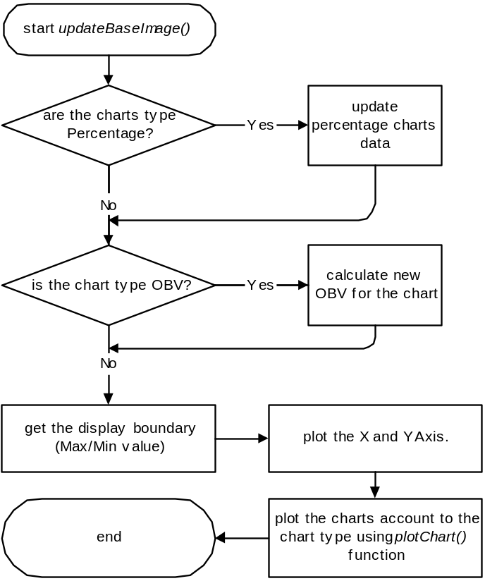
Figure 3: process flow of updateBaseScreen().

Display charts into Screen
When the repaint() is invoked, the screenImage draw into allscreenImage and the line objects (straight line, pline and so on) also draw into allscreenImage. Then, the allscreenImage is a complete image and would be displayed in the screen. The following figure shows the relation among the screenImage, the allscreenImage and the screen.

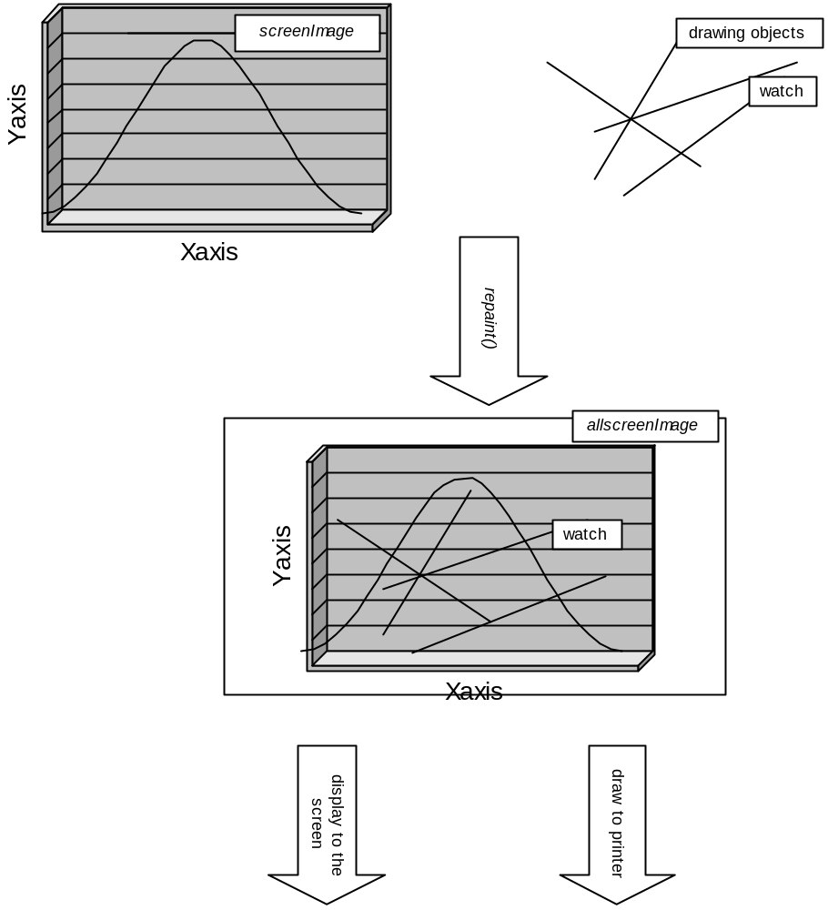
Figure 4: the relation among the screens and buffered image.

Technical Analysis chart

Currently, chartScreen supports 10 types of technical analysis charts listed in the following table:
TA Chart Type | Name
SIMPLEMOVINGAVERAGE | Simple Moving Average
WEIGHTDMOVINGAVERAGE | Weighted Moving Average
EXPONENTIALMOVINGAVERAGE | Exponential Moving Average
BOLLINGERBAND | Bollinger’s Bands
RSI | Relative Strength Index
STC | Stochastics
OBV | On Balance Volume
MACD | Moving Average Convergence Divergence
WilliamR | William %R

Al l of the TA charts are calculated by the function calculateTAChartName(). They are calculated based on the FPoint data sequence. The formula of TA chart is according to the book “Technical Analysis, Economic Digest”.

The following is an example of placing a RSI chart to a chartScreen when the data is arrived.

public void OnReceivedChartData(FCommand fc, ChartData chartData)
{
ChartData mydata = chartData;
ChartUIObject mychart4 = new ChartUIObject(mydata,"TA1Chart");

//set TA chart Type
mychart4.chartType = ChartUIObject.RSI;
mychart4.axisBar = ChartUIObject.LEFT;
mychart4.setVisible(false);

//create RSI data with parameter 14
mychart4.calculateRSI(14);

//add the chart to the chartScreen1
chartScreen1.addChart(mychart4);
chartScreen1.faction.zoomRecords.removeAllElements();
chartScreen1.faction.lineRecords.removeAllElements();

// call the updateBaseImage() implicitly
chartScreen1.zoom();
chartScreen1.repaint();
}

