Contents
Eclipse with HDPI 1
Derby Database 2
ActiveMQ 2
Disruptor 2
Gradle 2

Eclipse with HDPI
To overcome the screen issue on NetBean/Eclipse running on Surface Pro 3, you can
- Go to regedit
- Add key HKEY_LOCAL_MACHINE\SOFTWARE\Microsoft\Windows\CurrentVersion\SideBySide
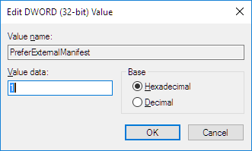
It enables the external manifest of exe.
- Add eclipse.exe.manifest file under the executable folder

Derby Database
JavaDB comes with JDK. You can find it for JDK folder
To start a new server
mkdir db
cd db
DERBY_HOME=/c/DevTools/Java/jdk1.8.0_66/db
java -jar $DERBY_HOME/lib/derbyrun.jar server start
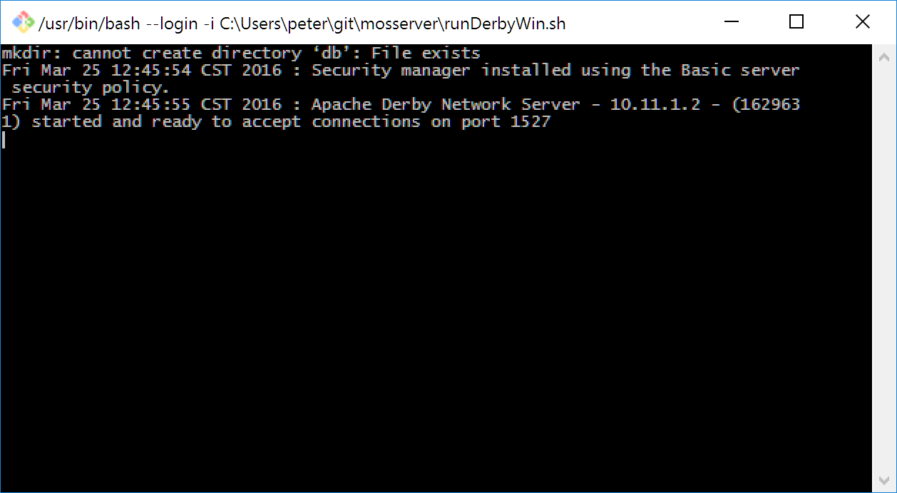
Client Connection:
<property name="javax.persistence.jdbc.url" value='jdbc:derby://localhost:1527/mos;create=true'/>
<property name="javax.persistence.jdbc.driver" value="org.apache.derby.jdbc.ClientDriver"/>

ActiveMQ

Disruptor

Gradle

