Supplementary Information

S.1 Probability Distributions considered
Here, we provide the details of 8 distributions considered in the study. The suitability of these distributions to the incremental magnitude series ($M_{j}$) and the time interval series ($L_{j}$) of record events at each $j^{th}$ grid are evaluated using three approaches as mentioned in Section 3.1. The 8 distributions considered are provided in Table T1 below.
Table T1: List of probability distributions considered along with their abbreviations
Sl. No. | Distribution | Abbreviation
1 | Generalized Extreme Value Distribution | GEV
2 | Generalized Logistic Distribution | GLO
3 | Generalized Normal Distribution | GNO
4 | Generalized Pareto Distribution | GPA
5 | Pearson Type III Distribution | PE3

Also, the quantile $z\left(F\right)$ corresponding to each of the distributions for a probability $F$ is provided below. It is to be noted that here the quantile (or variable) is represented as $z$, however, in this paper, the variables are the incremental magnitudes and the time interval of the record events which are represented as $m$ and $t$ respectively.

Generalized Extreme Value (GEV) Distribution
The GEV distribution finds its application in the analysis of several hydrological data related to extreme events (Martins and Stedinger, 2000). It is a three-parameter distribution with a location ($μ$), scale ($σ$), and shape ($ξ$) parameter. The quantile function of the GEV distribution is given by
 | $z\left(F\right)=\left\{\begin{aligned}μ+\left(\frac{σ}{ξ}\right)\left[1-{\left\{-ln⁡(F)\right\}}^{ξ}\right] for ξ≠0 \\ μ+σln\{-ln(F)\} for ξ=0\end{aligned}\right.$ | (E2)
Further details related to GEV distribution and its parameter estimation are provided in Coles (2001), Hosking & Wallis (1997), and Hosking et al. (1985).

Generalized Logistic (GLO) Distribution
The GLO is a three-parameter distribution with a location ($μ$), scale ($σ$), and shape ($ξ$) parameter which has been used widely in several applications. More details related to GLO distribution can be obtained in Kumar & Manju (2022). The quantile function of the GLO distribution is given by
 | $z\left(F\right)=μ+\left(\frac{σ}{ξ}\right)\left[1-{\left\{(1-F)/F\right\}}^{ξ}\right]$ | (E3)
Details on estimation of the parameter using the L-moments can be obtained from Hosking (1996) and Hosking & Wallis (1997).

Generalized Normal (GNO) Distribution
The GNO is an extended version of the two-parameter normal distribution that combines (i) lognormal (for positive skewness), (ii) reflected lognormal (for negative skewness), and (iii) Normal distribution (for zero skewness). GNO has three parameters which are location ($μ$), scale ($σ$), and shape ($ξ$) of the distribution. The quantile function of the three-parameter GNO does not have an explicit form but can be obtained by inverting the probability or the cumulative distribution function ($F$). The equation provided below demonstrates an indirect way of obtaining the quantile from a GNO distribution.
 | $$F=Φ\left[-ξ^{-1}ln\left\{1-ξ\left(z-μ\right)/σ\right\}\right]$$  $$z\left(F\right)=Φ^{-1}(F)$$ | (E4)
where, $Φ\left(z\right)={(2π)}^{-1/2}\int_{-∞}^{z}{\exp\left({-u}^{2}/2\right)du}$ is the standard Normal cumulative distribution function. Details related to GNO and the estimation of its parameters are provided in Hosking (1996) and Hosking & Wallis (1997).

Generalized Pareto (GPA) Distribution
The GPA distribution finds its application to estimate the magnitude of the excess over a threshold corresponding to a probability ($F$). This distribution is popular to model the peak of the values over a defined threshold which is more popularly known as Peak-Over-Threshold (POT). GPA has three parameters which are location ($μ$), scale ($σ$), and shape ($ξ$) of the distribution. The quantile function of the GPA distribution is given by
 | $$z\left(F\right)=μ+σ\left\{1-(1{-F)}^{ξ}\right\}/ξ$$ | (E6)
The details related to GPA and the estimation of its parameters are provided in Hosking & Wallis (1987), Hosking (1996), and Hosking & Wallis (1997).

Pearson Type III (PE3) Distribution
The PE3 distribution is a combination of Gamma (for positive skewness), reflected Gamma (for negative skewness), and Normal (for zero skewness) distribution. The PE3 is represented by three moments which are: mean ($μ$), standard deviation ($σ$), and skewness ($ξ$). The PE3 has been applied to several hydrological analyses. The quantile function of the PE3 distribution does not have an explicit form, however, it can be obtained indirectly for a corresponding probability ($F$) as given below
 | $F=G\left({\left(z-μ+2σ/ξ\right)}/{\left|\frac{1}{2}σξ\right|},4/{ξ^{2}}\right)$ ; $z\left(F\right)=G^{-1}\left(F\right)$ for $ξ$ > 0  $F=1-G\left({-\left(z-μ+2σ/ξ\right)}/{\left|\frac{1}{2}σξ\right|},4/{ξ^{2}}\right)$ ; $z\left(F\right)=G^{-1}\left(1-F\right)$ for $ξ$ < 0 | (E7)
where, $G\left(z,α\right)={\left\{Γ\left(α\right)\right\}}^{-1}\int_{0}^{z}{u^{α-1}}e^{-u}du$ is the incomplete gamma integral. More details related to PE3 and the estimation of its parameters are provided in Hosking (1996) and Hosking & Wallis (1997).

S.2 Analysis of the joint distribution of variables using copulas
The joint CDF with S-dimensions of variables can be obtained by utilizing the individual univariate distributions as per the Sklar (1959) theorem (Nelsen, 1998) given as
 | $F(z_{1},z_{2},…z_{i}…..z_{s})=C(F_{1}\left(z_{1}\right),F_{2}\left(z_{2}\right),…..F_{i}\left(z_{i}\right)…..F_{s}(z_{s}))$ | (E9)
where, $z_{i}$ is the $i^{th}$ variable and $F_{i}\left(z_{i}\right)$ is the marginal CDF of the variable $z_{i}$.
Here, for each $j^{th}$ grid, the incremental magnitude series ($M_{j}$) and the time interval series ($L_{j}$) are considered simultaneously with S = 2.
Therefore, for S = 2, Equ. E9 reduces to
 | $$F\left(M_{j},L_{j}\right)=C\left(F_{1}\left(M_{j}\right),F_{2}\left(L_{j}\right)\right)$$  $$=C\left(w,v\right)$$ | (E10)
where, $w$ is the CDF of the incremental magnitude series and $v$ is the CDF of the time interval series at $j^{th}$ grid.
The copulas considered in this study are provided in Table T2 below
Table T2: List of copulas considered along with their abbreviations
Sl. No. | Copulas | Abbreviation
1 | Gaussian Copula | Gaussian
2 | Gumble Copula | Gumble
3 | Clayton Copula | Clayton
4 | Frank Copula | Frank

Gaussian Copula
The Gaussian or Normal Copula is a type of Elliptical Copulas where the dependence between the variables is accounted by using a positive matrix. This copula is found to be suitable when the dimensions are high (Renard and Lang, 2007; Shah and Mishra, 2020).
The Gaussian Copula is expressed as:
 | $$C_{G}\left(w,v\right)=Φ_{S}\left(ϕ^{-1}\left(w\right),ϕ^{-1}\left(v\right)\right)$$ | (E11)
where, $ϕ$ is the CDF of standard normal distribution and $Φ_{S}$ is the CDF of multivariate normal distribution with mean zero and covariance matrix $Σ$.

Gumbel Copula
The Gumbel copula is first applied to model the joint distribution of the variables where the marginal follow exponential distribution (Gumbel, 1960). It is one kind of the Archimedean which is expressed as
 | $$C_{GB}\left(w,v\right)=exp\left({-\left[{\left(-\ln{w}\right)}^{θ}+{\left(-\ln{v}\right)}^{θ}\right]}^{\frac{1}{θ}}\right)$$ | (E12)
where, $θ$ is the copula parameter defining the dependence between the variables.

Clayton Copula
Clayton copula is one of the popular kind of copulas from the Archimedean family (Chesneau, 2024). The expression of the Clayton Copula is expressed as
 | $$C_{C}\left(w,v\right)={\left[{\left(w\right)}^{-θ}+{\left(v\right)}^{-θ}-1\right]}^{-\frac{1}{θ}}$$ | (E13)

Frank Copula
The Frank Copula is the minimal information copula (Sukeda and Sei, 2025) that belong to the Archimedean family (Nelsen, 1998). The joint probability of the two variables with their marginal denoted as $w$ and $v$ is given as
 | $$C_{F}\left(w,v\right)=-\frac{1}{θ}ln\left(1+\frac{\left(e^{-θw}-1\right)\left(e^{-θv}-1\right)}{e^{-θ}-1}\right)$$ | (E14)

S.3 Sample time series of the incremental magnitude and the time interval of RB events at a representative site.

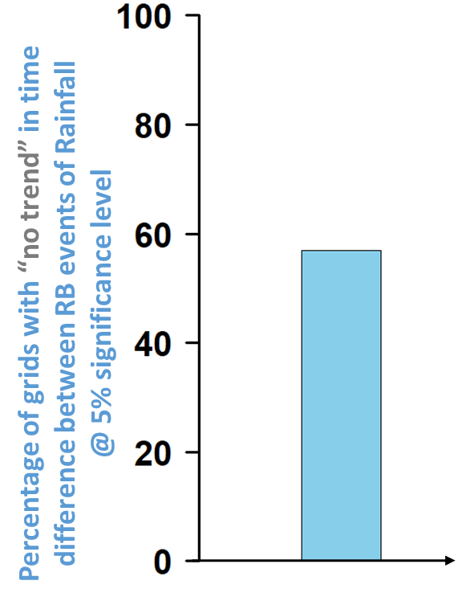
Figure S1 Percentage of sites with no trend in the time interval between the RB events for all the grids considered.

S.4 Boxplot of probability of occurrence of RB events in 10-year time interval
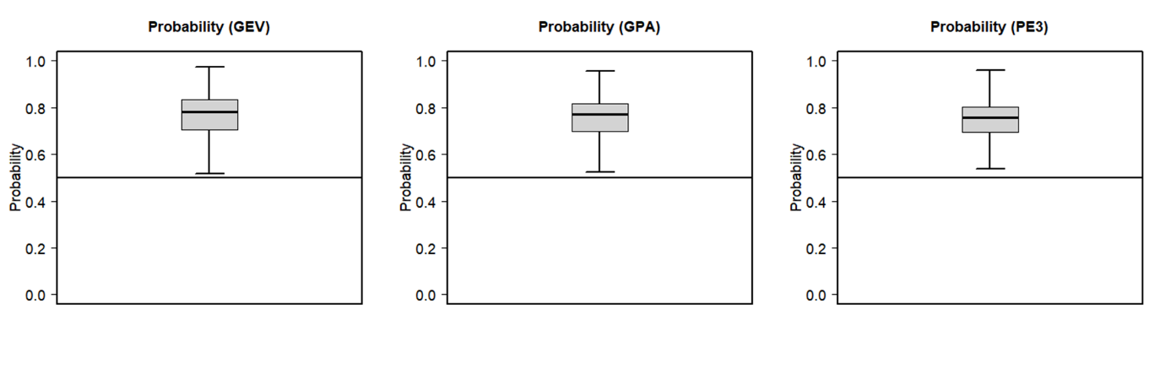
Figure S2 Boxplots of the probability of occurrence of RB events that would occur within ≤ 10-year time interval across all the grids considered in the study obtained using GEV, GPA, and PE3. For >95% of the grids, the probability of RB events is > 0.5.

