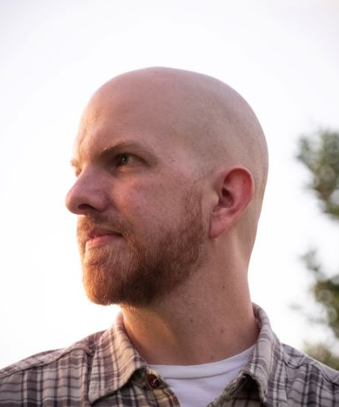

Peter Crabtree

Tampa, Florida, United States peter.crabtree@gmail.com (727) 431-2958  in/peterdcrabtree/  https://petercrabtree.work

SUMMARY

Highly skilled and strategic Software Engineer with a 20-year track record of reliably enhancing system performance, scalability, and security across varied industries. Proven history of leading complex software projects and nurturing cross-functional collaboration. Seeking to leverage deep technical acumen, strategic prowess, and a team-focused mindset to drive technology and delight users.

EXPERIENCE

Production Engineer

Meta/Facebook September 2021 - January 2023, San Francisco, CA

• Assumed leadership of the stalled Corporate Asset Inventory program, establishing strategic direction and setting the groundwork for unifying dozens of disparate Asset Inventory systems and addressing unmet fundamental corporate infrastructure security needs.  
• Formulated a roadmap for a Meta-wide Asset Inventory that minimized costly and difficult deprecation by defining the system of record per asset type; thus promoting a self-service approach, crucially matching Meta's hyper-diverse infrastructure and organizational structure.  
• Held technical workshops disseminating the existing asset inventory tools, improving compliance, enabling teams to use asset data, and allowing for faster ingest into the central asset repository.  
• Displayed robust crisis management skills by providing critical support during the log4j security issue, working with senior security partners to enable discovery of log4j whether in first or third party code.  
• Established team documentation, creating runbooks, on-call duty lists, and unifying existing fragmented documentation.  
• Improved the functionality of the corporate secret access tool by restructuring code and writing associated documentation.  
• Showcased leadership and organizational skills by moderating departmental 'all hands' meetings and ensuring that execs and other speakers stayed on schedule.

VP Engineering

Affinitiv June 2018 - August 2020, Chicago, IL

• Reporting to the CTO, led architecture, IT, infrastructure, and SRE teams.  
• Led $2M infrastructure modernization project, from inception to execution, by setting scope, plan, budgeting, and presenting to CEO for approval.  
• Migrated to new datacenter with 99.99% uptime over migration. Improved compliance and risk posture. The improved system design resulted in reducing datacenter-related downtime events by 80%, eliminated all single points of failure, and reduced datacenter costs by 30%.  
• Implemented Scrum throughout engineering and restructured management, reducing middle management from 4 to 2, shifting responsibility from managers to product owners, and cutting requirements-to-shipped time in half.  
• Established hybrid cloud strategy, leveraging cloud for burst capability and lower storage costs, while utilizing datacenter capacity for lower continuous compute costs.  
• Acted as security lead for OEM contracts, reviewing contract security language, proposing redlines, and liaising with corporate council.  
• Started audit and uplift of enterprise-wide security and established security team.  
• Presented technical stack and architecture as part of successful M&A process.

Principal Engineer

AutoLoop December 2013 - June 2018, Clearwater, FL

• Reporting to the CTO, leading system architecture, software architecture, application platform services.  
• Identified the need for, designed and implemented replacement core network for datacenter, dealt with all aspects including budgetary analysis, vendor selection, hardware installation and configuration.  
• Performed complex, high-risk refactoring of core work distribution system in C#, reducing boilerplate and improving health monitoring, resource measurement and balancing. Saved an estimated 200 hours of developer time / year.

Senior Software Engineer

AutoLoop September 2010 - December 2013, Clearwater, FL

• Performed staged replacement of existing Access-based internal workflow tracking and CRM system, reusing existing SQL backend with new ASP.Net MVC and Entity Framework frontend.  
• Engineered customizable data-based workflow rule engine which allowed continuous and rapid workflow changes during rapid company growth. Shortened workflow changes from 2+ weeks to 30 minutes.  
• Performed all aspects of software development, including user interviews, business analysis, user story prioritization, CI/CD (including zero downtime deployment pipeline), QA, and infrastructure maintenance.  
• Proposed and implemented engineering department conversion from SVN to git.

Lead Developer

EON Systems May 2002 - September 2010, Clearwater, FL

• Developed 200,000-line medical office documentation product, including designing system architecture, UI, database structure, writing application code, installer, build system, and documentation.  
• Fixed vendor ActiveX control’s incompatibility with Visual FoxPro by coding a DLL in C++ which hooks the ActiveX control’s Windows message callback.  
• Prevented client loss by optimizing billing product’s modules with major refactors, resulting in 100X speed improvements in the critical ledger, note-keeping, and main payment areas.  
• Created system to enable proper source control (merges, diffs) of binary, proprietary FoxPro source files by round-tripping to custom text format. Achieved high performance via multithreading and profiled hotspot elimination in Python.  
• Acted as “last tier” troubleshooter for all technical issues, including those of development, IT, and technical support.

SKILLS

Enterprise Architecture

.NET – C# – C++ – Python – Javascript

SQL (MSSQL, Postgres, MySQL) – NoSQL – Git

DevOps – SRE – CI/CD

Cloud – AWS

Networking

Performance Optimization

Complex Troubleshooting

Security

Scaling

User Experience

Scrum/Agile Methodologies

Conflict Resolution

Consensus Building

Mentoring

Blame-free Culture