Building a visit counter
Imagine you are an orange merchant. Every day, you’d bring your baskets of fruit to the nearby farmer market to trade your labor, and coming home selling some of them. At dinner, your family ask you how many oranges you sell, and you yawn with a number you make up 2 seconds ago.

That’s ridiculous! - some may say.

Yet that’s the story of many websites- they lack analytics, or any form of tracking that allows builders to observe their presence on the internet. Tracking sounds vast, but, once you break it down, some main components are incredibly simple and intuitive to build. One of them is an engine to answer the question: “how many people visit my site today?” Knowing that number, you can measure how compelling a piece of content you deliver to your audience, hence craft according to their taste. And that’s exactly what we’re going to build today- a visit counter website.

The ingredients
Let’s work backward from what we need with some questions?
- If I need to show the number of people who visited my site, how can I deliver that number? I probably need to store that data somewhere & return it. Perhaps, I need a backend or at least some form of data to store to & query that constant from. So firstly, I’d need a backend and a database. In that backend, let’s have a [GET] endpoint to return the visit counter.
- When someone visits my site, we gotta bump that counter up? How can we do so? Perhaps, we should have a [POST] endpoint that receive requests and modify our internal counter.
- But, when many people visit our site at the same time, we can have an overloaded number of requests to bump our counter:
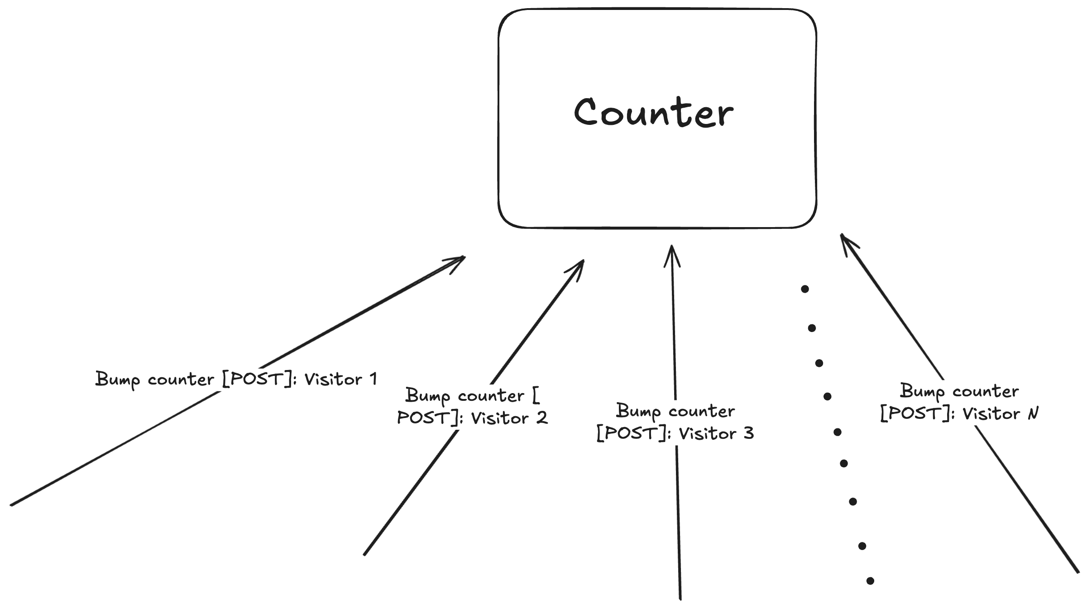
For that overloaded number of requests, our counter value is fetched, then incremented, then saved back to the internal memory, repeatedly. There is where a problem occurs: Because each request is handled by a thread, below the flow, the counter behavior can happen as such:
  - Thread 1 (which handles visitor 1’s request) reads the counter value as 0 (no one has visited the site yet).
  - Thread 2 (which handles visitor 2’s request) also reads the counter value as 0 (this is before the counter is incremented by another thread).
  - Thread 1 bumps the counter to 1.
  - Thread 2 bumps the counter to 1 (since it read the value as 0)
  - Thread 1 saves the counter value of 1 to the database.
  - Thread 2 saves the counter value of 1 to the database.
So now we have a mismatch: a visitor count of 1 for 2 users. What a bummer!
This circumstance is called a race condition, where the order of the requests affects the result. In another universe where Thread 2 only reads after Thread 1 having completed its whole read-increment-write operation, we’ll have a correct count. So, our server <> database architecture must orchestrate requests in a way that let them communicate with each other and avoid reading the false count while there exists a thread that executing the increment & write operations. Internally, modern frameworks and database use lock to handle this multithreading situation (for frameworks that use event-based such as async, they have an acquire/release mechanism though different but aligned with the idea behind multithreading’s lock- only allow one thread/event to run at any moment). The goal of this blog is not to go too deep into multithreading/asynchronism, but the caution behind a race condition reminds us to design our system to handle that potential issue.
- Now we have two main pieces, let’s cook. First, for the database, we can store the count value into a file, a database, or an in-memory storage like a cache. Let’s evaluate each of them:
  - Storing to a file is the most intuitive solution. We have a number representing a count, and we store that number to a text file. Reading and writing to a file are simple. Yet one problem occurs- file I/O doesn’t have multithreading solution out-of-the-box, so we will have to implement one ourselves. Plus, what if instead of a counter, we want to store additional information later. A file can account for that, but searching through a text file & parsing is not ideal as our data grows.
  - The 2nd option is storing to a database. Modern databases are powerful with built-in locking to handle race conditions, plus powerful query capability. However, a database may be overkilled for our v1. We can create a table for our data, but that table will stay one-rowed for a long time- we don’t need to track users yet, we simply want a counter with fast read and fast write. For many performant databases, these operations are rapid, yet we can raise our speed even more.
  - A cache is ideal for our problem at hand

