BIEN 3200: Lab 1

**Introduction to Visual Studio C Compiler**

Peter Dobbs

Lab Section 401

Nicholas Heugel

13 September 2016

**Introduction:**

Many of the students enrolled in this class have not had much experience with programming. This introductory lab serves as a chance for all the students in this class to have the same basic understanding of Visual Studio, Visio, and either Excel, MatLab, or both.

**Methods:**

Data for the total body oxygen consumption (liters/min) and lung volumes and capacities (liters) were collected using a Quark PFT system from COSMED, USA. The trials were performed on normal subjects. This data was then placed in two separate text files, ERGO.txt and SVC.txt. The normal readings for sinus rhythm was simulated, while a Lionheart 1 ECG simulator from Bio-Tek was used to collect the data during ventricular fibrillation. The electrocardiogram data was exported to a text file, ECG.txt.

For the first part of the lab, Excel was used to plot the data contained in both ERGO.txt and SVC.txt, while MatLab was employed to create the comparison plot for the data in ECG.txt. When it became necessary to write a program in C, Microsoft Visual Studio’s C++ compiler was applied to the code written in the Visual Studio IDE. Both debugging and program creation were possible through the use of Visual Studio.

**Results:**

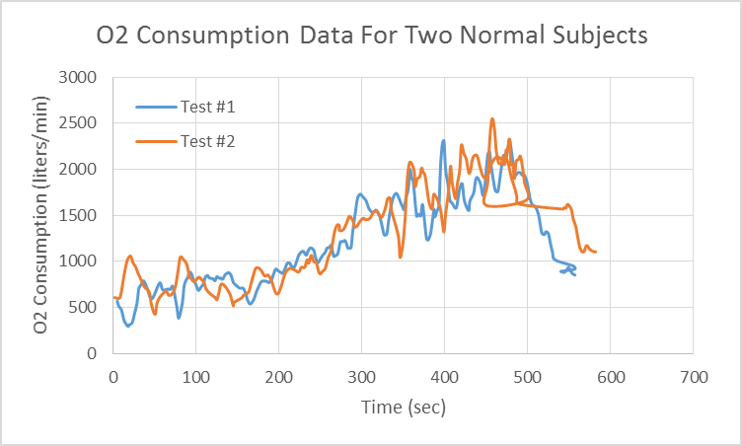

**Figure 1:** Graph produced in Excel of the data held in the ERGO.txt file. The figure shows the comparison of oxygen consumption for two normal subjects in a case study.

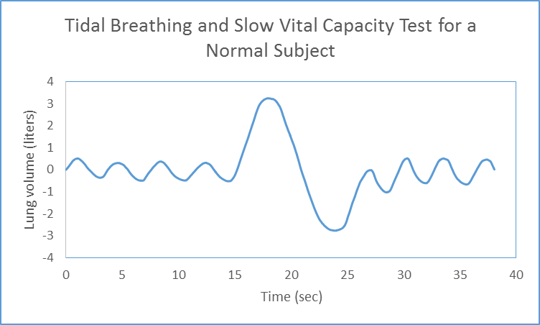

**Figure 2:** Graph produced in Excel of the data held in the SVC.txt file. Displayed in this figure is a set of data for a normal test subject that was asked to breathe normally, take a deep breath, and return to normal breathing.

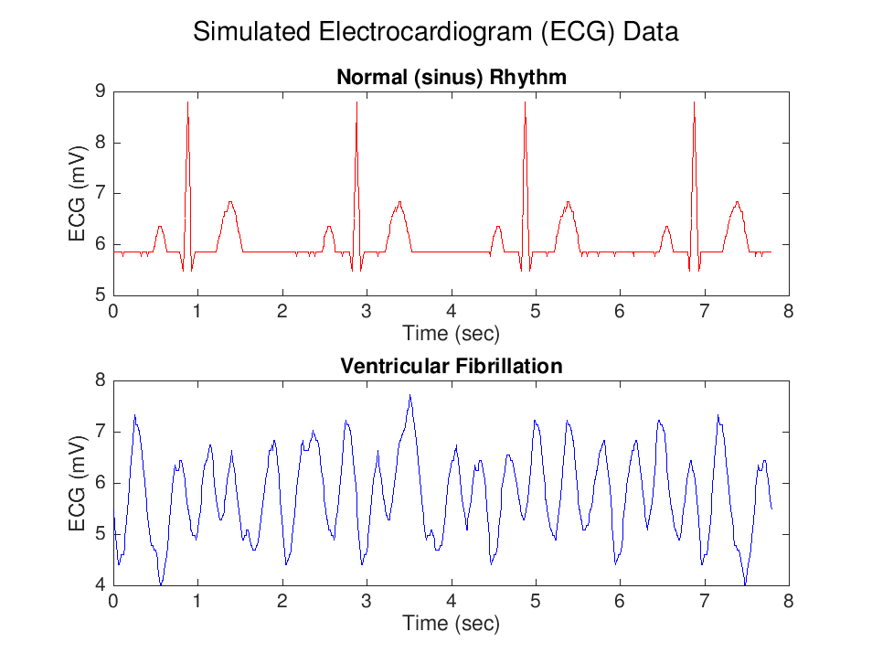

**Figure 3:** Graphs produced in MATLAB that reflect the specifications given in part one of the lab outline. The separate plots show normal heart electrical activity and abnormal heart electrical activity, respectively. Together, a comparison of potential heart malfunctions is displayed.

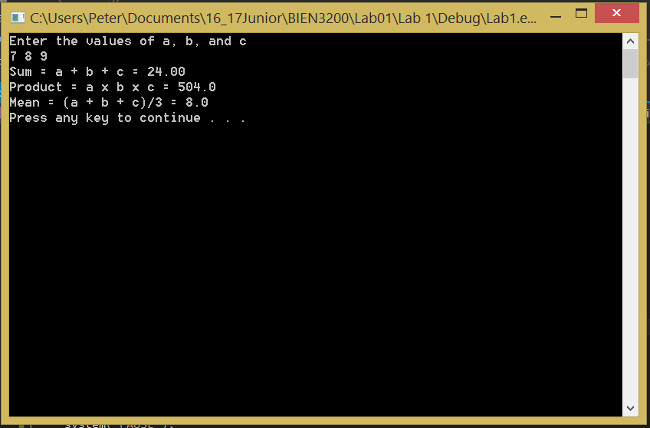

**Figure 4:** Screenshot of results from program written to compute the sum, product, and mean of three input float numbers.

|  |  |
| --- | --- |
| Error-filled program | Corrected |
| Include <stdio.h>;  float main(Void);  {  Int sum, Char, float  /* compute result  Sum = 40 + 36 – 100**2;  /* Display results //  print (“The answer is /n”, sum);  Return Sum; | #include <stdio.h>  float main(void) {  int sum;  //compute result  sum = 40 + 36 - 100 * 2;  //display result  printf("The answer is %i \n", sum);  system("PAUSE");  return sum;  } |

**Figure 5:** diff for corrections to error-filled program.

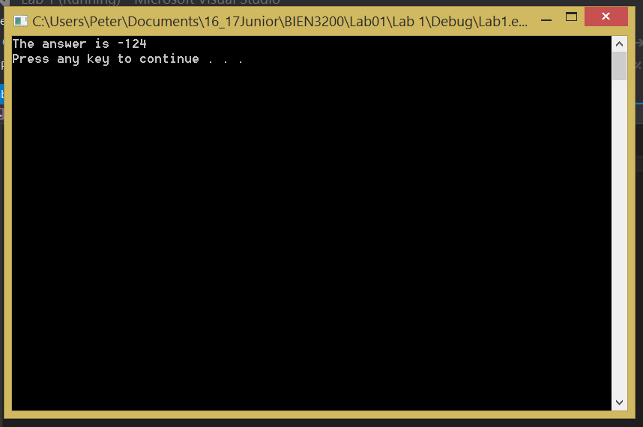

**Figure 6:** Screenshot of results from the corrected program in Part III of the lab handout

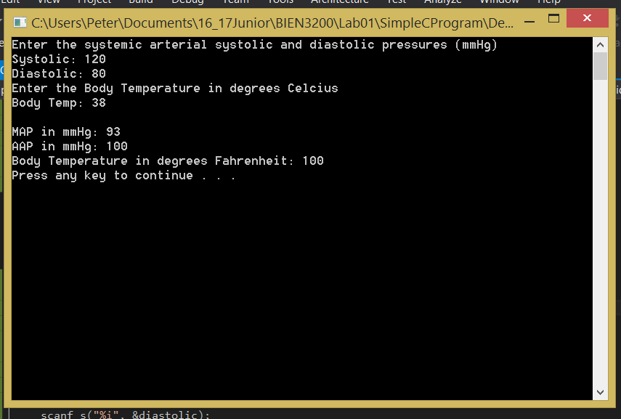

**Figure 7:** Screenshot of results from program that uses input systolic and diastolic pressures and body temperature to compute the mean arterial pressure (MAP) and the arithmetic arterial pressure (AAP) and convert body temperature from degrees Celsius to degrees Fahrenheit.

**Discussion:**

The results of the methods went as planned, with limited problems. The graphs came out as planned, the simple program and corrected code programs both successfully built and ran, and the program built from scratch met expectations. I did experience issues due to my antivirus software, but was able to sort those out quickly.

As a Biocomputing major, an application developer at GasDay, and an avid programmer I already knew how to do most of the work in this lab. It was, however, helpful to refresh my memory and put all the functions and materials in one place for future reference. I have already worked extensively with MatLab and Visual Studio, but I am new to Visio. I wonder, though, why we do not make use of the code maps that Visual Studio provides.

**Conclusion:**

All expectations of the lab were met.

**C Code:**

/*

Peter Dobbs

BIEN 3200 – Section 401

September 6, 2016

Lab 1

Part 2: Corrected code for program that calculates and displays the result

*/

#include <stdio.h>

float main(void) {

int sum;

//compute result

sum = 40 + 36 - 100 * 2;

//display result

printf("The answer is %i \n", sum);

system("PAUSE");

return sum;

}

/*

Peter Dobbs

BIEN 3200 – Section 401

September 6, 2016

Lab 1

Part 4: Program that prompts the user for systolic and diastolic pressures and body temperature, calculates values from the input data and displays the result of the calculations

*/

#include <stdio.h>

int main(void) {

int systolic, diastolic, bodyTemperatureC;

//User Input

// blood pressure

printf("Enter the systemic arterial systolic and diastolic pressures (mmHg)\n");

printf("Systolic: ");

scanf_s("%i", &systolic);

printf("Diastolic: ");

scanf_s("%i", &diastolic);

// body temp

printf("Enter the Body Temperature in degrees Celcius\n");

printf("Body Temp: ");

scanf_s("%i", &bodyTemperatureC);

//Calculate the mean arterial pressure (MAP)

int MAP = diastolic + (systolic - diastolic) / 3;

//Calculate the arithmetic mean arterial pressure (AAP)

int AAP = (systolic + diastolic) / 2;

//Converts Body Temp to Fahrenheit

int bodyTemperatureF = 32 + bodyTemperatureC * 9 / 5;

//Display the results

printf("\nMAP in mmHg: %i", MAP);

printf("\nAAP in mmHg: %i", AAP);

printf("\nBody Temperature in degrees Fahrenheit: %i", bodyTemperatureF);

printf("\n");

system("PAUSE"); //pauses command window for user to view results

return 0;

}

**Flow Charts:**

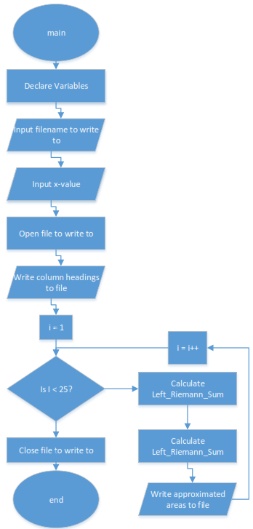

**Figure 8:** Flow chart for the program part two

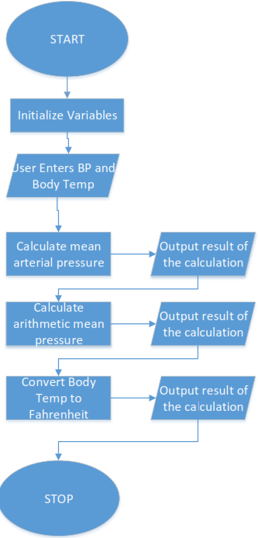

**Figure 9:** Flowchart for program that takes in patient vitals, performs calculations on them, and outputs the results.