Randy McMillan

COP-1220 Programming in C

Programming Project 1

// main.c

// Chapter2PP1

// Created by Randy McMillan on 8/29/13.

#include <stdio.h>

double calculateDistanceTraveled(double beginning, double ending);

double calculateReimbersment(double milesTraveled);

int main(int argc, const char *argv[])

{

double reimbursement = 0.0,

beginning = 0.100,

ending = 0.0,

milesTraveled;

// insert code here...

printf("MILEAGE REIMBERSMENT CALCULATOR\n");

printf("Enter beggining odometer reading=>\n");

scanf("%lf", &beginning);

printf("Enter ending odometer reading=>\n");

scanf("%lf", &ending);

milesTraveled = calculateDistanceTraveled(beginning, ending);

printf("You traveled %lf miles. At $0.35 per mile,\n", milesTraveled);

reimbursement = calculateReimbersment(milesTraveled);

printf("your reimbersment is $ %lf\n", reimbursement);

return 0;

}

double calculateDistanceTraveled(double beginning, double ending)

{

double temp = ending - beginning;

return temp;

}

double calculateReimbersment(double milesTraveled)

{

double tempReimbursment = milesTraveled * 0.35;

return tempReimbursment;

}

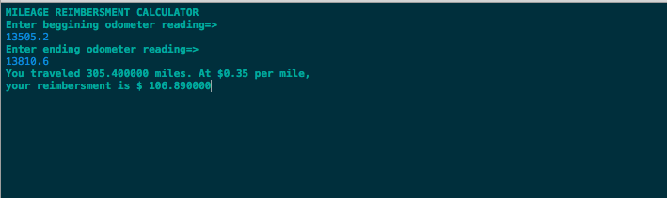

Programming Project 2

//

// main.c

// Chapter2PP4

// Created by Randy McMillan on 8/29/13.

//

#include <stdio.h>

#include <math.h>

#define FIVE_NINTHS 5.0 / 9.0

double returnCelcius(double fahrenheitTemp);

int main(int argc, const char *argv[])

{

int fahrenheit = 0.0;

double celcius = 0.0;

printf("Please enter the tempreature in degrees fahrenheit.\n");

scanf("%i", &fahrenheit);

celcius = returnCelcius(fahrenheit);

printf("%i degrees Fahrenheit is %lf Celsius", fahrenheit, celcius);

return 0;

}

double returnCelcius(double fahrenheitTemp)

{

double temp = (FIVE_NINTHS * (fahrenheitTemp - 32));

// printf("%lf\n", fahrenheitTemp);

return temp;

}

