Randy McMillan
COP-1220 Programming in C

Programming Project # 6

//
// main.c
// Chapt3PP6
//
// Created by Randy McMillan on 9/11/13.
// Copyright (c) 2013 Randy McMillan. All rights reserved.
//

/*
*
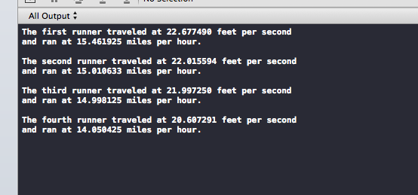
* 6. Four track stars have entered the mile race at the Penn Relays. Write a pro-
* gram that scans in the race time in minutes (minutes) and seconds (seconds) for a runner and computes and displays the speed in feet per second (fps) and in meters per second (mps). (Hints: There are 5,280 feet in one mile, and one kilometer equals 3,282 feet.) Write and call a function that displays instruc- tions to the program user. Run the program for each star’s data.
* Minutes Seconds
* 3 52.83
* 3 59.83
* 4 00.03
* 4 16.22
*
*/

//https://www.google.com/search?client=safari&rls=en&q=feet+per+second+to+mph

#include <stdio.h>
#define feetMile 5280
#define metersMile 1609.34

double calcFPS(int min, double sec);

double calcMPS(int min, double sec);

void printResults(double fps, double mps);

int main(int argc, const char *argv[])
{
int first_min = 3,
second_min = 3,
third_min = 4,
fourth_min = 4;

double first_sec = 52.83,
second_sec = 59.83,
third_sec = 00.03,
fourth_sec = 16.22;

//double minutes = 0,
// seconds = 0;

/*
printf("%i,%i,%i,%i,%f,%f,%f,%f,%f,%f\n\n", first_min,
second_min,
third_min,
fourth_min,
first_sec,
second_sec,
third_sec,
fourth_sec,
minutes,
seconds);
*/

///calc feet per second
printf("The first runner traveled at %f feet per second \n", calcFPS(first_min, first_sec));
///calc meters per second
printf("and ran at %f miles per hour.\n\n", calcMPS(first_min, first_sec));

///calc feet per second
printf("The second runner traveled at %f feet per second \n", calcFPS(second_min, second_sec));
///calc meters per second
printf("and ran at %f miles per hour.\n\n", calcMPS(second_min, second_sec));

///calc feet per second
printf("The third runner traveled at %f feet per second \n", calcFPS(third_min, third_sec));
///calc meters per second
printf("and ran at %f miles per hour.\n\n", calcMPS(third_min, third_sec));

///calc feet per second
printf("The fourth runner traveled at %f feet per second \n", calcFPS(fourth_min, fourth_sec));
///calc meters per second
printf("and ran at %f miles per hour.\n\n", calcMPS(fourth_min, fourth_sec));

return 0;
}

double calcFPS(int min, double sec)
{
double fps = 0;
//15/22
//printf("%f\n", ((min * 60) + sec));
fps = feetMile/((min * 60) + sec);
//printf("%f", fps);
return fps;
}

double calcMPS(int min, double sec)
{
double mps = 0;

double fps = 0;
//15/22
//printf("%f\n", ((min * 60) + sec));
fps = feetMile/((min * 60) + sec);
mps = fps*(15.0/22.0);
//printf("%f", fps);
return mps;
}

void printResults(double fps, double mps) {}

Programming Project # 10
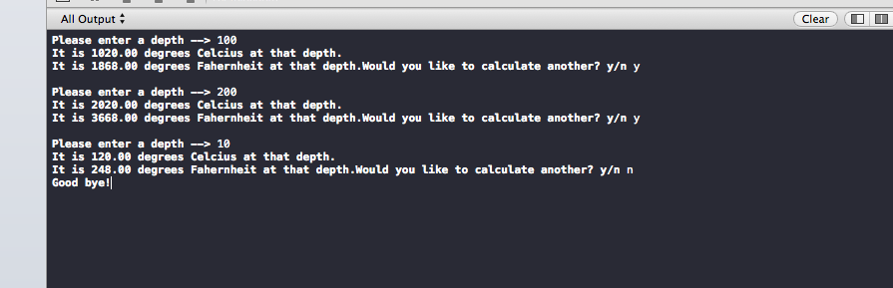

//
// main.c
// Chpt3PP10
//
// Created by Randy McMillan on 9/14/13.
// Copyright (c) 2013 Randy McMillan. All rights reserved.
//

#include <stdio.h>
#include <string.h>

float celcius_at_depth(float depth);
float farenheit(float depth);

void calculate();

int main(int argc, const char * argv[])
{
calculate();
return 0;
}

void calculate(){

printf("Please enter a depth --> ");
float depth = 0;
scanf("%f", &depth);
float celcius = celcius_at_depth(depth);
printf("It is %0.2f degrees Celcius at that depth.\n",celcius);
printf("It is %0.2f degrees Fahernheit at that depth.",farenheit(celcius));
// insert code here...
//printf("Hello, World!\n");

char yesOrNo[100];
printf("Would you like to calculate another? y/n ");
scanf("%s", yesOrNo);

if (strncmp(yesOrNo, "y", 2) == 0) {
printf("\n");
calculate();
}

if (strncmp(yesOrNo, "n", 2) == 0) {
printf("Good bye!");
}
}

float celcius_at_depth(float depth){

float celcius = 10*depth+20;
return celcius;
}

float farenheit(float celcius){

float farenheit = 1.8*celcius+32;
return farenheit;
}

