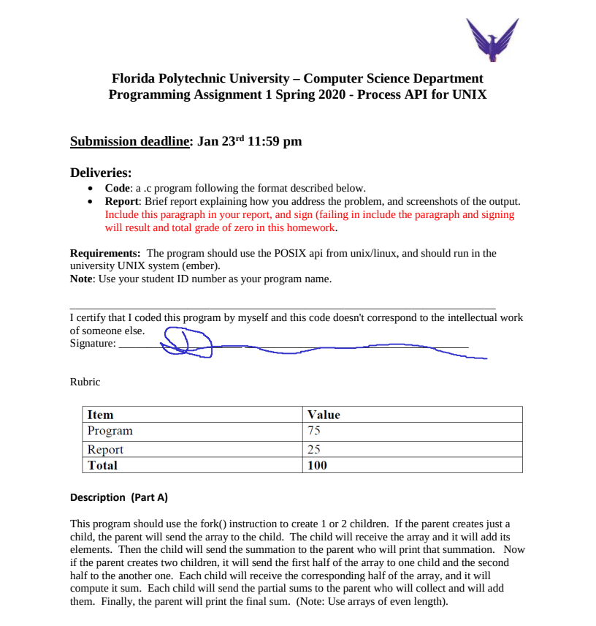
Approach: This program solves the base condition and the enthusiast challenge in the same program. This is achieved by nesting the entire forking logic in a for loop, iterating for every child that needs to be created. The parent, however, sends the data through the constructed pipes before the fork to eliminate an off-by-one error. The parent after the fork only prints (asynchronously) the values sent. When all children complete their computation and submit their result to the parent, the parent computes and prints the sum.
