Appendix A contains the original MATLAB source code.

>> project1
Part 1:
The math below is being done symbolically

transfer_function_s =

(3927*s)/(625*(s^2 + (3927*s)/625 + 8681395487635617/8796093022208))

transfer_function_z =

(125664*(z - 1))/(25*(z + 1)*((125664*(z - 1))/(25*(z + 1)) + (640000*(z - 1)^2)/(z + 1)^2 + 8681395487635617/8796093022208))

big_x =

1105352233542746112*(z - 1)*(z + 1)

big_y =

142059875476061636537*z^2 - 281040906936274219150*z + 139849171008976144313

The difference equation is:
142059875476061634560.000000 y[n] + -281040906936274223104.000000 y[n-1] + 139849171008976142336.000000 y[n-2] = 1105352233542746112.000000 x[n] + -1105352233542746112.000000 x[n-2]

y[n] = 1.978327 y[n-1] - 0.984438 y[n-2] + 0.007781 x[n] - 0.007781 x[n-2]

Alternatively, using the tf and c2d commands:

tf_s =

6.283 s
-------------------
s^2 + 6.283 s + 987

Continuous-time transfer function.

tf_z =

0.007781 z^2 - 0.007781
-----------------------
z^2 - 1.978 z + 0.9844

Sample time: 0.0025 seconds
Discrete-time transfer function.

ans =

logical

1

Part 2:
The roots of the denominator of the discrete transfer function are

y_roots =

0.98916356921498264032497066372084 - 0.07741869137108069695169937597003i
0.98916356921498264032497066372084 + 0.07741869137108069695169937597003i

And is the magnitude of the roots less than 1?

ans =

2×1 logical array

1
1

If all above values are true (==1), then the system is BIBO stable
Part 3:
The amount of time to complete all tasks in seconds is:

completion_time =

7.3000e-04

ans =

logical

1

Part 4:
The maximum sampling frequency (in Hz) is simply the inverse of the total computation time of the difference equation

max_freq =

1.3699e+03

Since the bilinear transform requires a sample period parameter, the entire transform must be recalculated.
Part 5:
A frequency response plot for both transfer functions is being drawn, please wait...

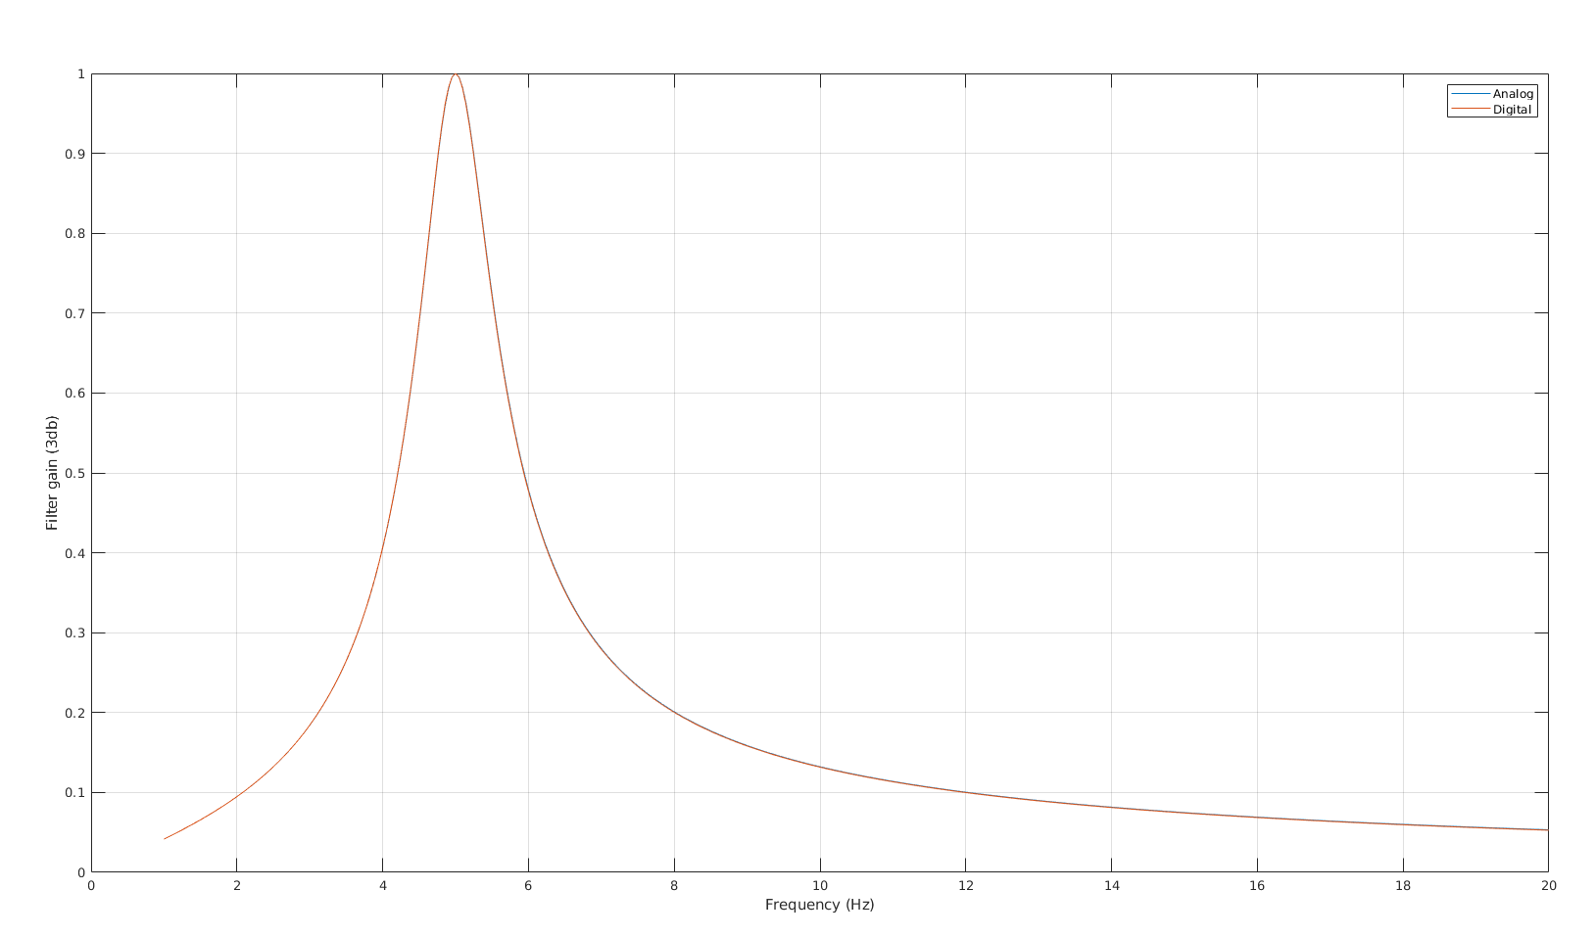

Appendix A:

disp("Part 1:");
syms s z;
sample_freq = 400;
sample_period = 1 / sample_freq;
disp("The math below is being done symbolically");
transfer_function_s = (6.2832*s) / (s^2 + 6.2832*s + 986.9604)
transfer_function_z = subs(transfer_function_s, s, (2/sample_period)*((z-1)/(z+1)))
[big_x, big_y] = numden(transfer_function_z)
y_coeffs = fliplr(coeffs(big_y));
x_coeffs = fliplr(coeffs(expand(big_x)));
fprintf("The difference equation is: %f y[n] + %f y[n-1] + %f y[n-2] = %f x[n] + %f x[n-2]\n", y_coeffs(1),y_coeffs(2),y_coeffs(3),x_coeffs(1),x_coeffs(2))
fprintf("y[n] = - %f y[n-1] - %f y[n-2] + %f x[n] + %f x[n-2]\n", y_coeffs(2)/y_coeffs(1),y_coeffs(3)/y_coeffs(1),x_coeffs(1)/y_coeffs(1),x_coeffs(2)/y_coeffs(1))
%matlab transfer function
disp("Alternatively, using the tf and c2d commands:");
tf_s = tf([6.2832,0],[1,6.2832,986.9604])
tf_z = c2d(tf_s, sample_period, 'tustin') %tustin is another name for bilinear transform
isstable(tf_z)

disp("Part 2:");
disp("The roots of the denominator of the discrete transfer function are");
y_roots = vpa(roots(y_coeffs))
y_roots = abs(y_roots);
disp("And is the magnitude of the roots less than 1?");
logical(y_roots < 1)
disp("If all above values are true (==1), then the system is BIBO stable");

disp("Part 3:");
%read 10us, write 10us, mult 5us, add 1us, overhead 30us
%fast enough?
%3 delays, 4 mults, 3 adds, write, read, and overhead
disp("The amount of time to complete all tasks in seconds is:");
completion_time = (10 + 10 + 5*4 + 3 + 30)*10e-6
logical(completion_time < sample_period)

disp("Part 4:");
%Maximum sampling frequency?
disp("The maximum sampling frequency (in Hz) is simply the inverse of the total computation time of the difference equation");
max_freq = 1/completion_time
disp("Since the bilinear transform requires a sample period parameter, the entire transform must be recalculated.");

disp("Part 5:");
disp("A frequency response plot for both transfer functions is being drawn, please wait...");
%plot comparison of continuous and discrete transfer functions over
%frequency, overlapping
syms f;
freqs = linspace(1,20,sample_freq);
freq_resp_s = abs(subs(transfer_function_s, s, j*2*pi*f));
freq_resp_z = abs(subs(transfer_function_z, z, exp(j*2*pi*f*sample_period)));
plot(freqs, subs(freq_resp_s, f, freqs));
hold on;grid on;
plot(freqs, subs(freq_resp_z, f, freqs));
legend("Analog","Digital");
xlabel("Frequency (Hz)");
ylabel("Filter gain (3db)");

