Parameters:
Capacitor C | 9.05×10⁻⁹
Resistor 1 kΩ | 975.3 Ω
Sense Resistor Red | 9.985 Ω
Sense Resistor Black | 9.929 Ω
Sense Resistor Green | 9.919 Ω
Inductor L | 9.96×10⁻³ H
Frequency f | 10000 Hz
Time t | 0.0001 s
Frequency ω | 62831.8530717959 rad/s
V_{in} | 5

RC Circuit:
Ω | theory | exp | % dev
Xc | -1758.6181557116 | -1897.916386448 | 7.92%
z mag | 852.9174510965 | 897.6660682226 | 5.25%
z theta | -29.0120121462 | -28.44 | 1.97%

A | theory mag | theory theta (deg) | exp mag | exp delay (s) | exp theta (deg) | %dev mag | %dev theta
i_{c} | 0.0028431414 | 90 | 2.634×10⁻³ | -2.470×10⁻⁵ | 91.080 | 7.36% | 1.20%
i_{r} | 0.0051266277 | 0 | 4.815×10⁻³ | 0.000 | 0.000 | 6.08% | 0%
i_{in} | 0.005862232 | 29.0120121462 | 5.570×10⁻³ | -7.900×10⁻⁶ | 28.440 | 4.98% | 1.97%
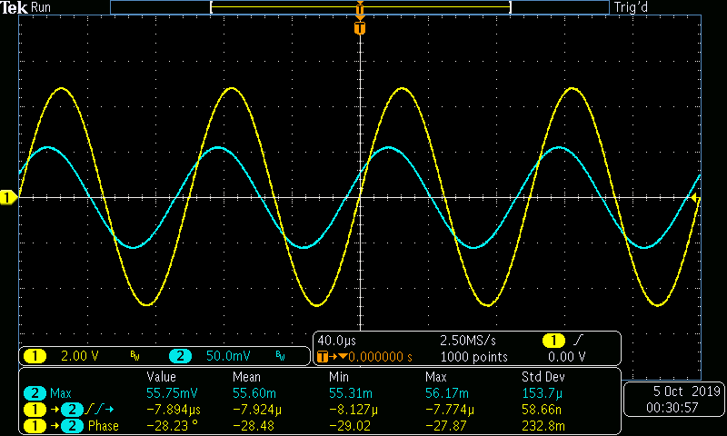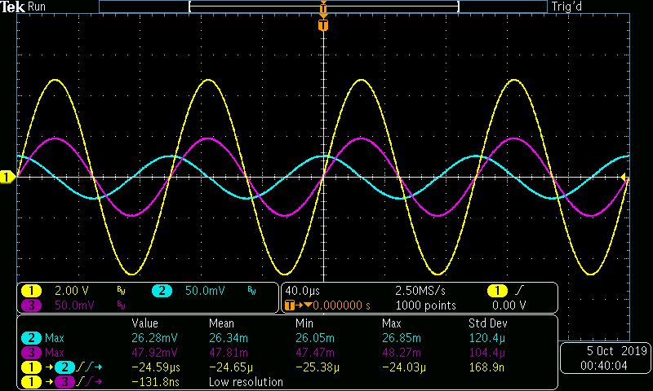
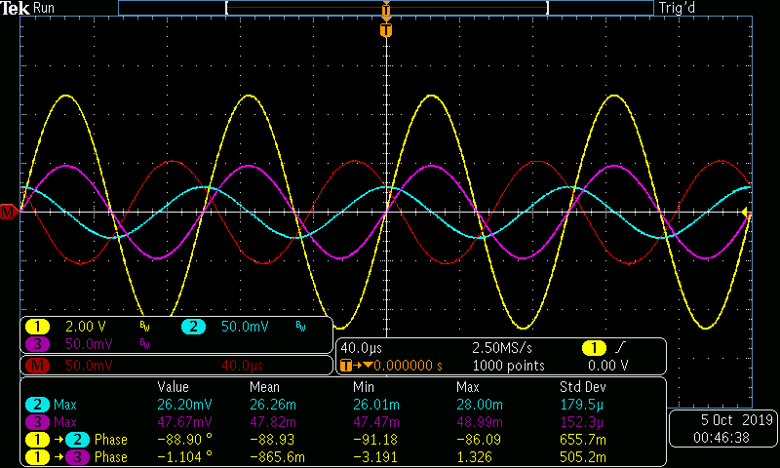

RL Circuit:

Ω | theory | exp | % dev

xl | 625.8052565951 | 651.0196404099 | 4.03%
z mag | 526.7019459512 | 552.1811154059 | 4.84%
z theta | 57.3135729489 | 51.696 | 9.80%

A | theory mag | theory theta | exp mag | exp delay (s) | exp theta (deg) | %dev mag | %dev theta

i_{L} | 0.007989706 | -90 | 7.666×10⁻³ | -7.597×10⁻⁵ | -86.508 | 4.05% | 3.88%
i_{r} | 0.0051266277 | 0 | 4.740×10⁻³ | 0.000 | 0.000 | 7.54% | 0%
i_{in} | 0.009493035 | -57.3135729489 | 9.055×10⁻³ | -8.564×10⁻⁵ | -51.696 | 4.61% | 9.80%
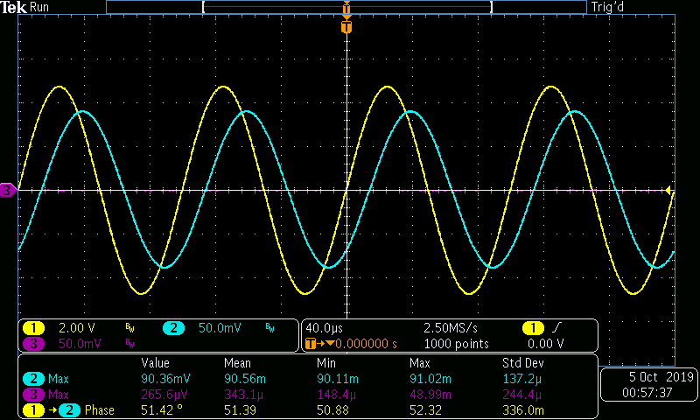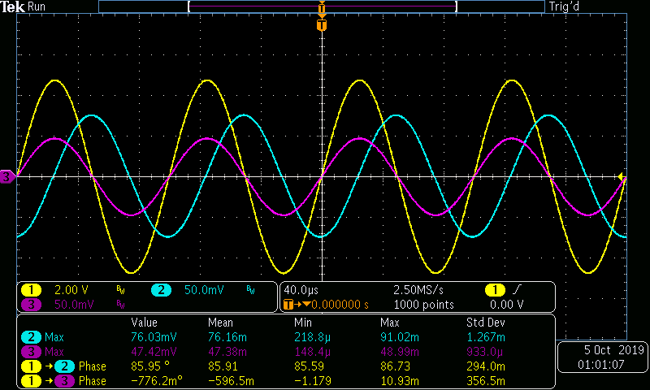
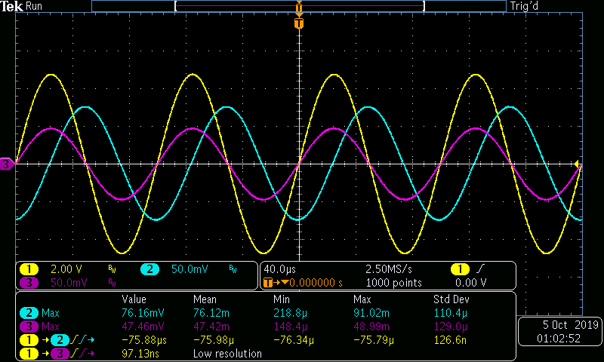

RLC Circuit:

Ω | theory | exp | % dev

xc | -1758.6181557116 | -1914.7388595972 | 8.88%
xl | 625.8052565951 | 647.7491148672 | 3.51%
z mag | 688.3015783482 | 706.9136151562 | 2.70%
z theta | 45.1111923205 | 40.104 | 11.10%

A | theory mag | theory theta | exp mag | exp delay (s) | exp theta (deg) | %dev mag | %dev theta

i_{c} | 0.0028431414 | 90 | 2.611×10⁻³ | -2.525×10⁻⁵ | 90.900 | 8.16% | 1.00%
i_{L} | 0.007989706 | -90 | 7.705×10⁻³ | -7.596×10⁻⁵ | -93.456 | 3.56% | 3.84%
i_{r} | 0.0051266277 | 0 | 4.771×10⁻³ | 0 | 0.000 | 6.94% | 0%
i_{in} | 0.0072642576 | -45.1111923205 | 7.073×10⁻³ | -8.886×10⁻⁵ | -40.104 | 2.63% | 11.10%

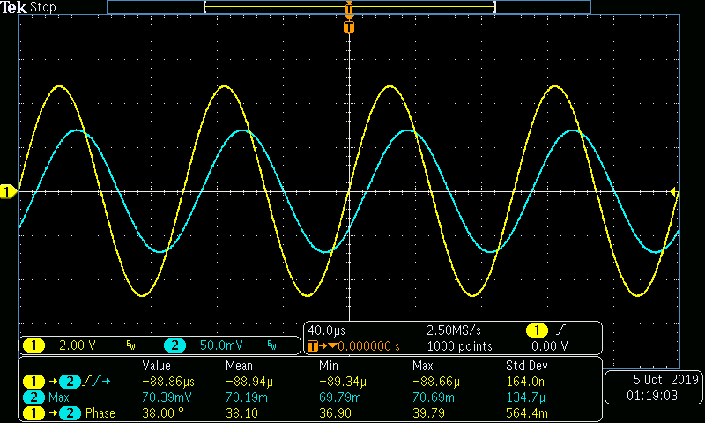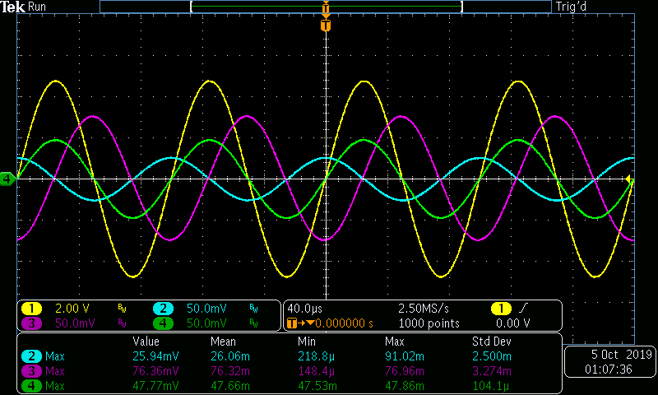
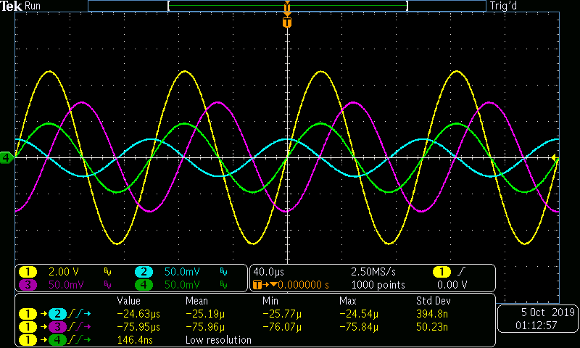
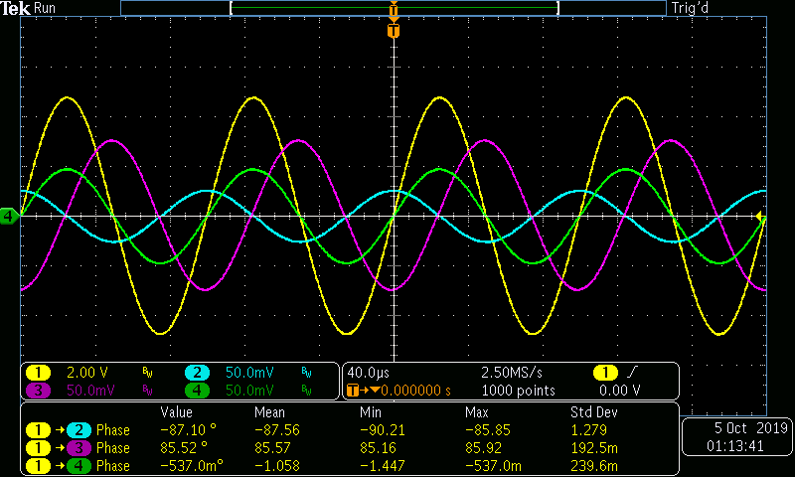

Phasor Plots:
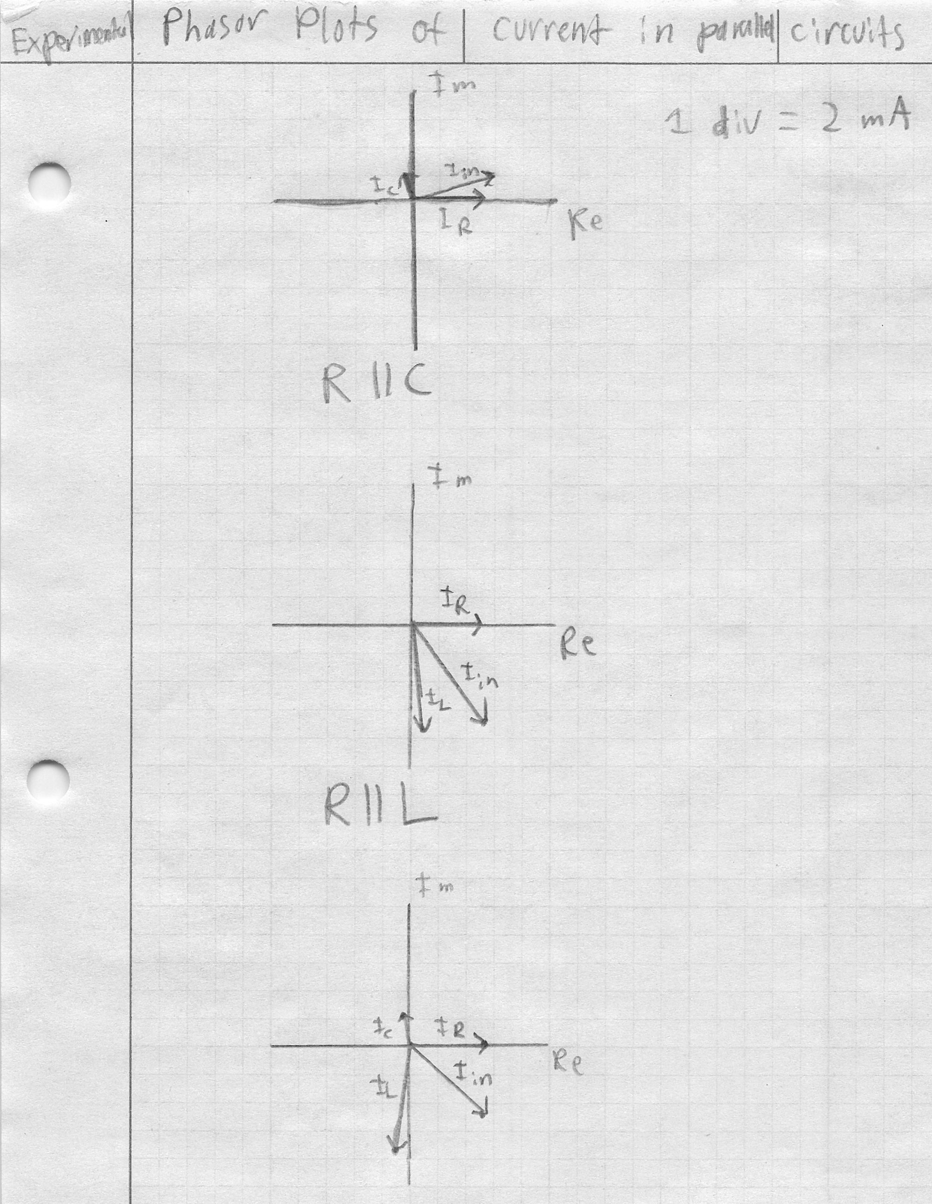
R || L || C

Questions:
- What is the phase relationship between R, L, and C components in a parallel AC circuit?
All components’ current is 90 degrees out of phase from each other (Resistor and inductor, resistor and capacitor) with differing magnitudes.
- Based on measurements, does Kirchhoff’s Current Law apply to the three tested circuits (show work)?
Circuit 1
0.002634∠91.080 + 0.004815∠0 ≈ 0.005570∠28.440 A
-0.00004965+j0.002634 + 0.004815 ≈ 0.00490+j0.002653 A
Circuit 2
0.007666∠-86.508 + 0.004740∠0 ≈ 0.009055∠-51.696 A
0.0004669-j0.007652 + 0.00474 ≈ 0.005613-j0.007106 A
Circuit 3
0.002611∠90.900 + 0.007705∠-93.456 + 0.004771∠0
≈ 0.007073∠-40.104 A
-0.00004101+j0.002611 – 0.0004645-j0.007691 + 0.004771
≈ 0.005410-j0.004556 A
- In general, how would the phasor diagram of Figure 7.1 change if the frequency was raised?
As the frequency is increased, the capacitative reactance decreases. The capacitor current has an inverse relationship with its reactance, so the capacitor current phasor would lengthen towards the value of the source voltage.
- In general, how would the phasor diagram of Figure 7.2 change if the frequency was lowered?
As the frequency is decreased, the inductive reactance decreases, so the inductor current phasor would shorten towards the origin.

