Extra Credit #1: Design and Implementation of a 4-bit Binary Divider by Constant 3
Peter Dranishnikov
U0000005258
EEL3702C Section 04
Professor: Dr. Chandrasekaran Balasumaranian

Introduction:
Division of 2 numbers involves 2 inputs and 2 outputs: the dividend and the divisor as the inputs, and the quotient and the remainder as the outputs. The quotient represents the integer result of the division, whilst the remainder represents the incomplete portion of the division to the next whole quotient. In this design, the divisor is a fixed value of 3, which reduces the domain of the problem to a 4-bit input combinational design and implementation, with 3 bits of quotient output and 2 bits of remainder output, in binary form.

Truth tables:
Decimal: (Note: Divisor is constant set to decimal value 3, binary 0011)
Dividend: | Quotient: | Remainder:
0 | 0 | 0
1 | 0 | 1
2 | 0 | 2
3 | 1 | 0
4 | 1 | 1
5 | 1 | 2
6 | 2 | 0
7 | 2 | 1
8 | 2 | 2
9 | 3 | 0
10 | 3 | 1
11 | 3 | 2
12 | 4 | 0
13 | 4 | 1
14 | 4 | 2
15 | 5 | 0

Binary:
Input/Dividend |  |  |  | Quotient |  |  | Remainder
A | B | C | D | Qa | Qb | Qc | Ra | Rb
0 | 0 | 0 | 0 | 0 | 0 | 0 | 0 | 0
0 | 0 | 0 | 1 | 0 | 0 | 0 | 0 | 1
0 | 0 | 1 | 0 | 0 | 0 | 0 | 1 | 0
0 | 0 | 1 | 1 | 0 | 0 | 1 | 0 | 0
0 | 1 | 0 | 0 | 0 | 0 | 1 | 0 | 1
0 | 1 | 0 | 1 | 0 | 0 | 1 | 1 | 0
0 | 1 | 1 | 0 | 0 | 1 | 0 | 0 | 0
0 | 1 | 1 | 1 | 0 | 1 | 0 | 0 | 1
1 | 0 | 0 | 0 | 0 | 1 | 0 | 1 | 0
1 | 0 | 0 | 1 | 0 | 1 | 1 | 0 | 0
1 | 0 | 1 | 0 | 0 | 1 | 1 | 0 | 1
1 | 0 | 1 | 1 | 0 | 1 | 1 | 1 | 0
1 | 1 | 0 | 0 | 1 | 0 | 0 | 0 | 0
1 | 1 | 0 | 1 | 1 | 0 | 0 | 0 | 1
1 | 1 | 1 | 0 | 1 | 0 | 0 | 1 | 0
1 | 1 | 1 | 1 | 1 | 0 | 1 | 0 | 0

K-maps & Expressions:
Qa = AB
0 | 0 | 0 | 0
0 | 0 | 0 | 0
1 | 1 | 1 | 1
0 | 0 | 0 | 0

Qb = AB’ + A’BC
0 | 0 | 0 | 0
0 | 0 | 1 | 1
0 | 0 | 0 | 0
1 | 1 | 1 | 1

Qc = A’BC’ + B’CD + ACD + AB’D + AB’C
= A’BC’ + CD(A + B’) + AB’(D + C)
0 | 0 | 1 | 0
1 | 1 | 0 | 0
0 | 0 | 1 | 0
0 | 1 | 1 | 1

Ra = A’B’CD’ + A’BC’D + ABCD’ + AB’C’D’ + AB’CD
= CD’(A’B’ + AB) + AB’(C’D’ + CD) + A’BC’D
= CD’(A ⊕ B)’ + AB’(C ⊕ D)’ + A’BC’D
0 | 0 | 0 | 1
0 | 1 | 0 | 0
0 | 0 | 0 | 1
1 | 0 | 1 | 0

Rb = A’B’C’D + A’BC’D’ + A’BCD + ABC’D + AB’CD’
= C’D(A’B’ + AB) + A’B(C’D’ + CD) + AB’CD’
= C’D(A ⊕ B)’ + A’B(C ⊕ D)’ + AB’CD’
0 | 1 | 0 | 0
1 | 0 | 1 | 0
0 | 1 | 0 | 0
0 | 0 | 0 | 1

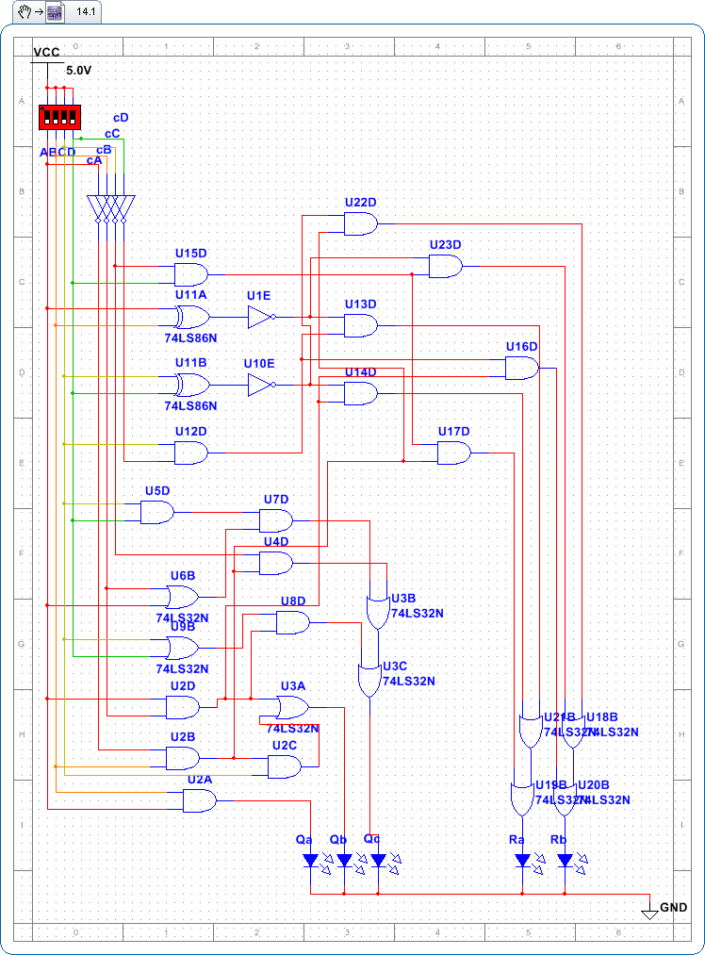
Schematics:

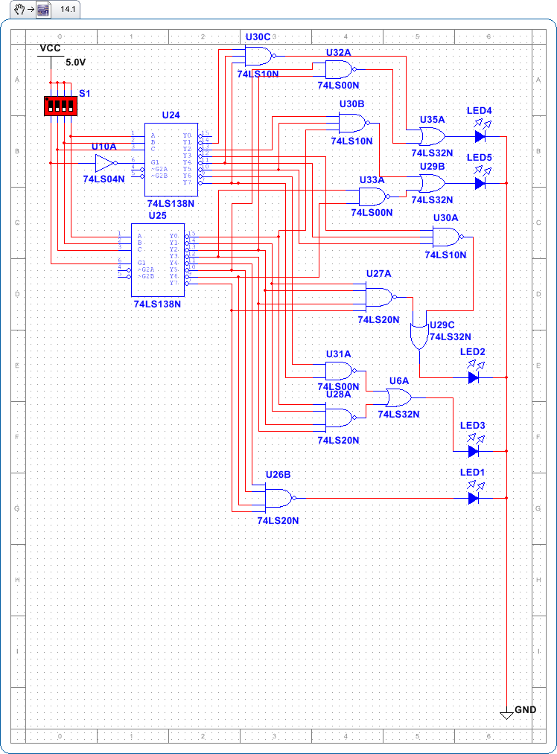

Results and Discussion:
The two designs on the previous pages are a result of an oversight regarding the quantity of basic gates available for use and the required quantity of gates (specifically, AND). Therefore, the design has been modified to use a 4x16 Decoder (with two 3x8 decoders) and select the appropriate minterms with various sized NAND gates. The simulator did not account for the necessary grounding of secondary select on the SN74LS138N chips, which has initially caused trouble in the physical implementation. The implementation works after such corrections have been made.

Conclusion:
A combinational binary divider by a constant is possible to design and implement using decoders and gates.

References
Texas Instruments. (1988, March). SN74LS138. Retrieved from http://www.ti.com/lit/ds/symlink/sn74ls138.pdf
Texas Instruments. (1988, March). SN74LS20. Retrieved from http://www.ti.com/lit/ds/symlink/sn74ls20.pdf
Texas Instruments. (1988, March). SN74LS32. Retrieved from http://www.ti.com/lit/ds/symlink/sn74ls32.pdf
Texas Instruments. (2003, April). SN74LS10. Retrieved from http://www.ti.com/lit/ds/symlink/sn74ls10.pdf

