Experiment 2:
Investigation and Implementation of Boolean Function Using Fundamental TTL Logic Gates
Peter Dranishnikov
U0000005258
EEL3702C: Digital Logic Design
Section 04

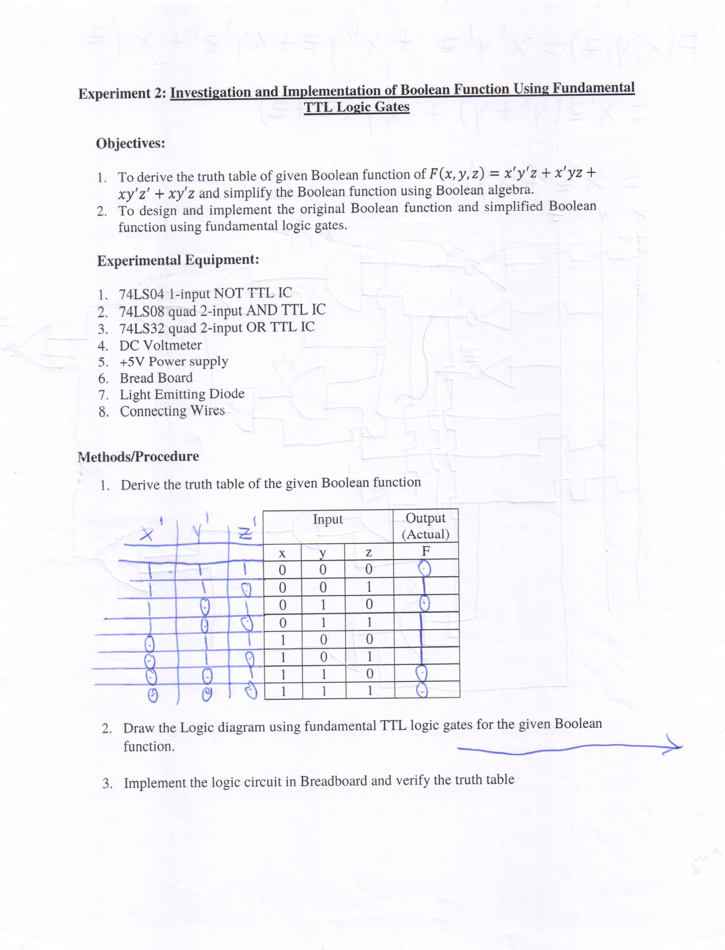
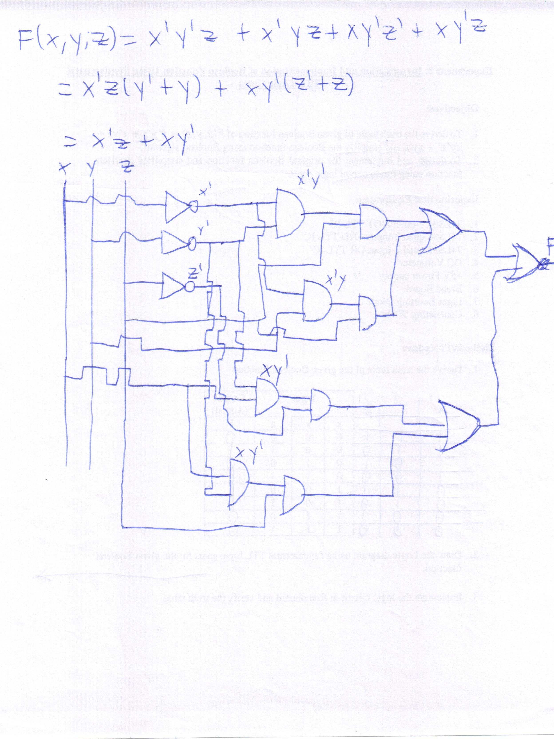
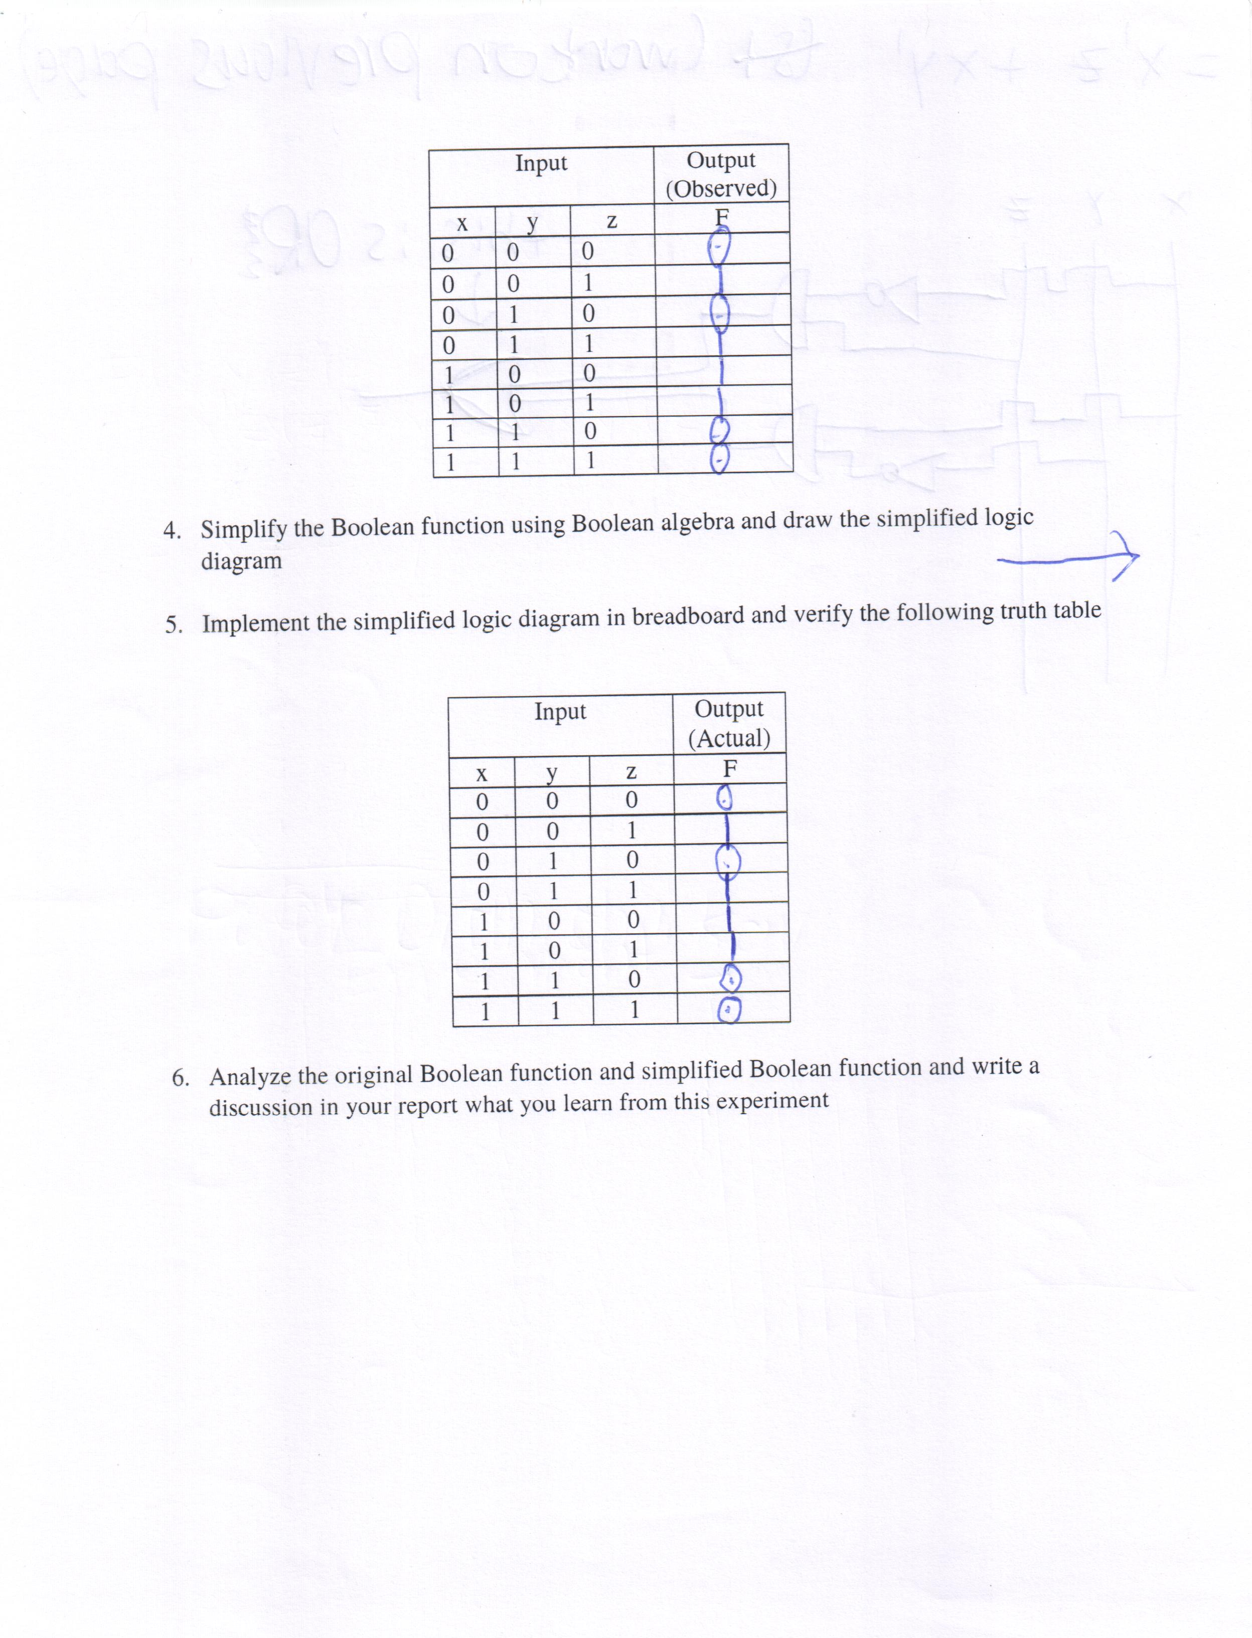
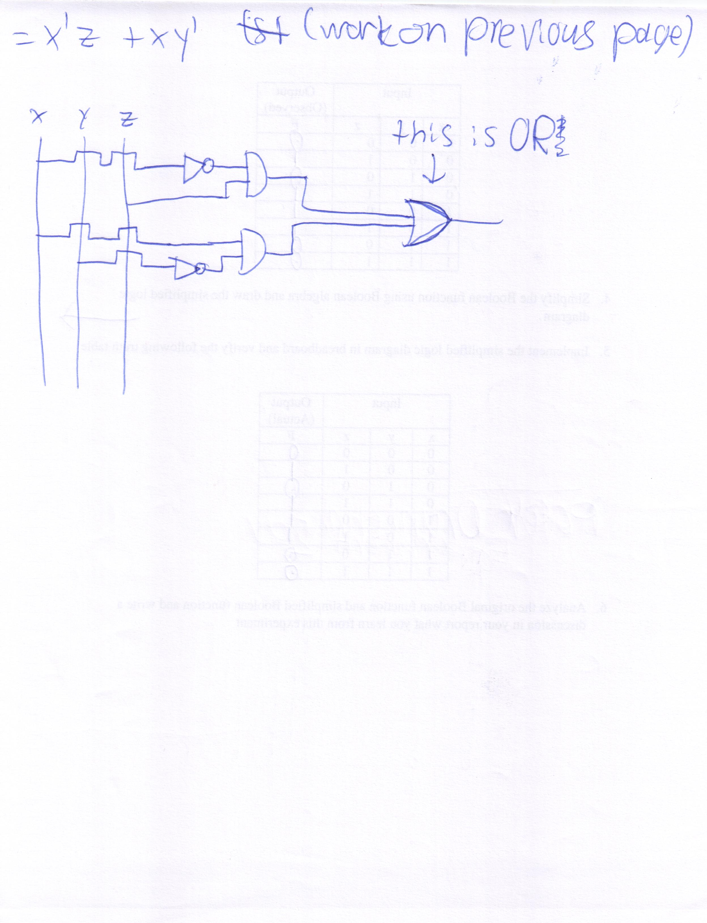
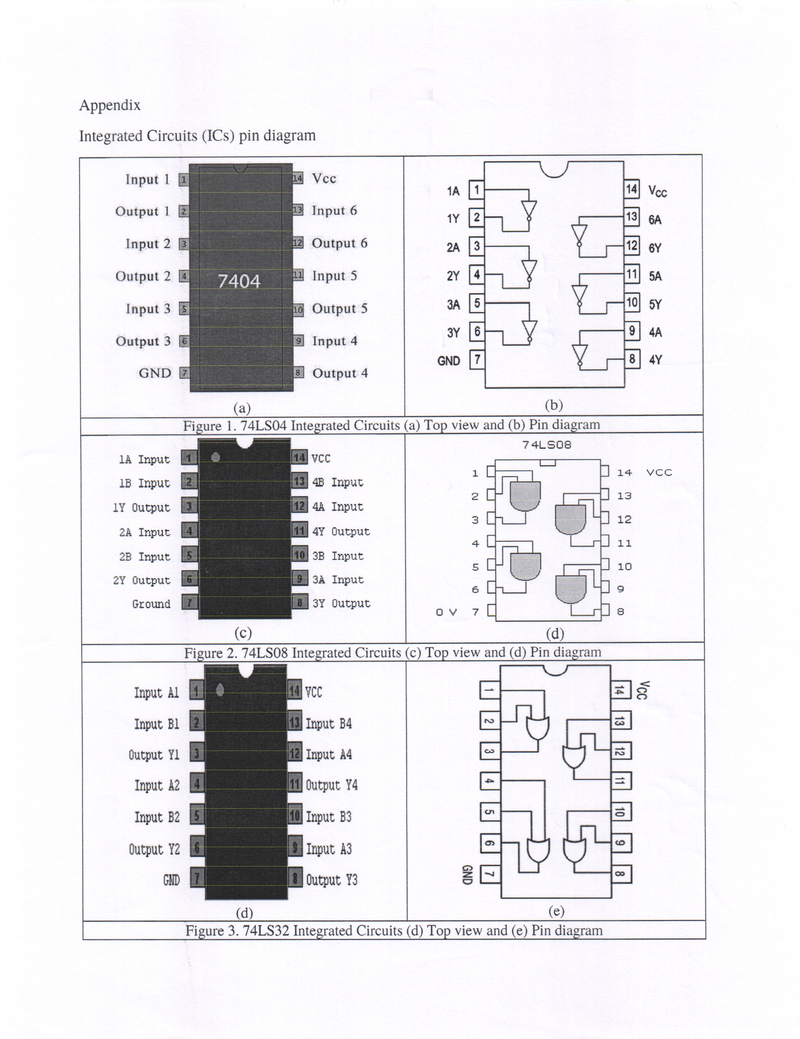
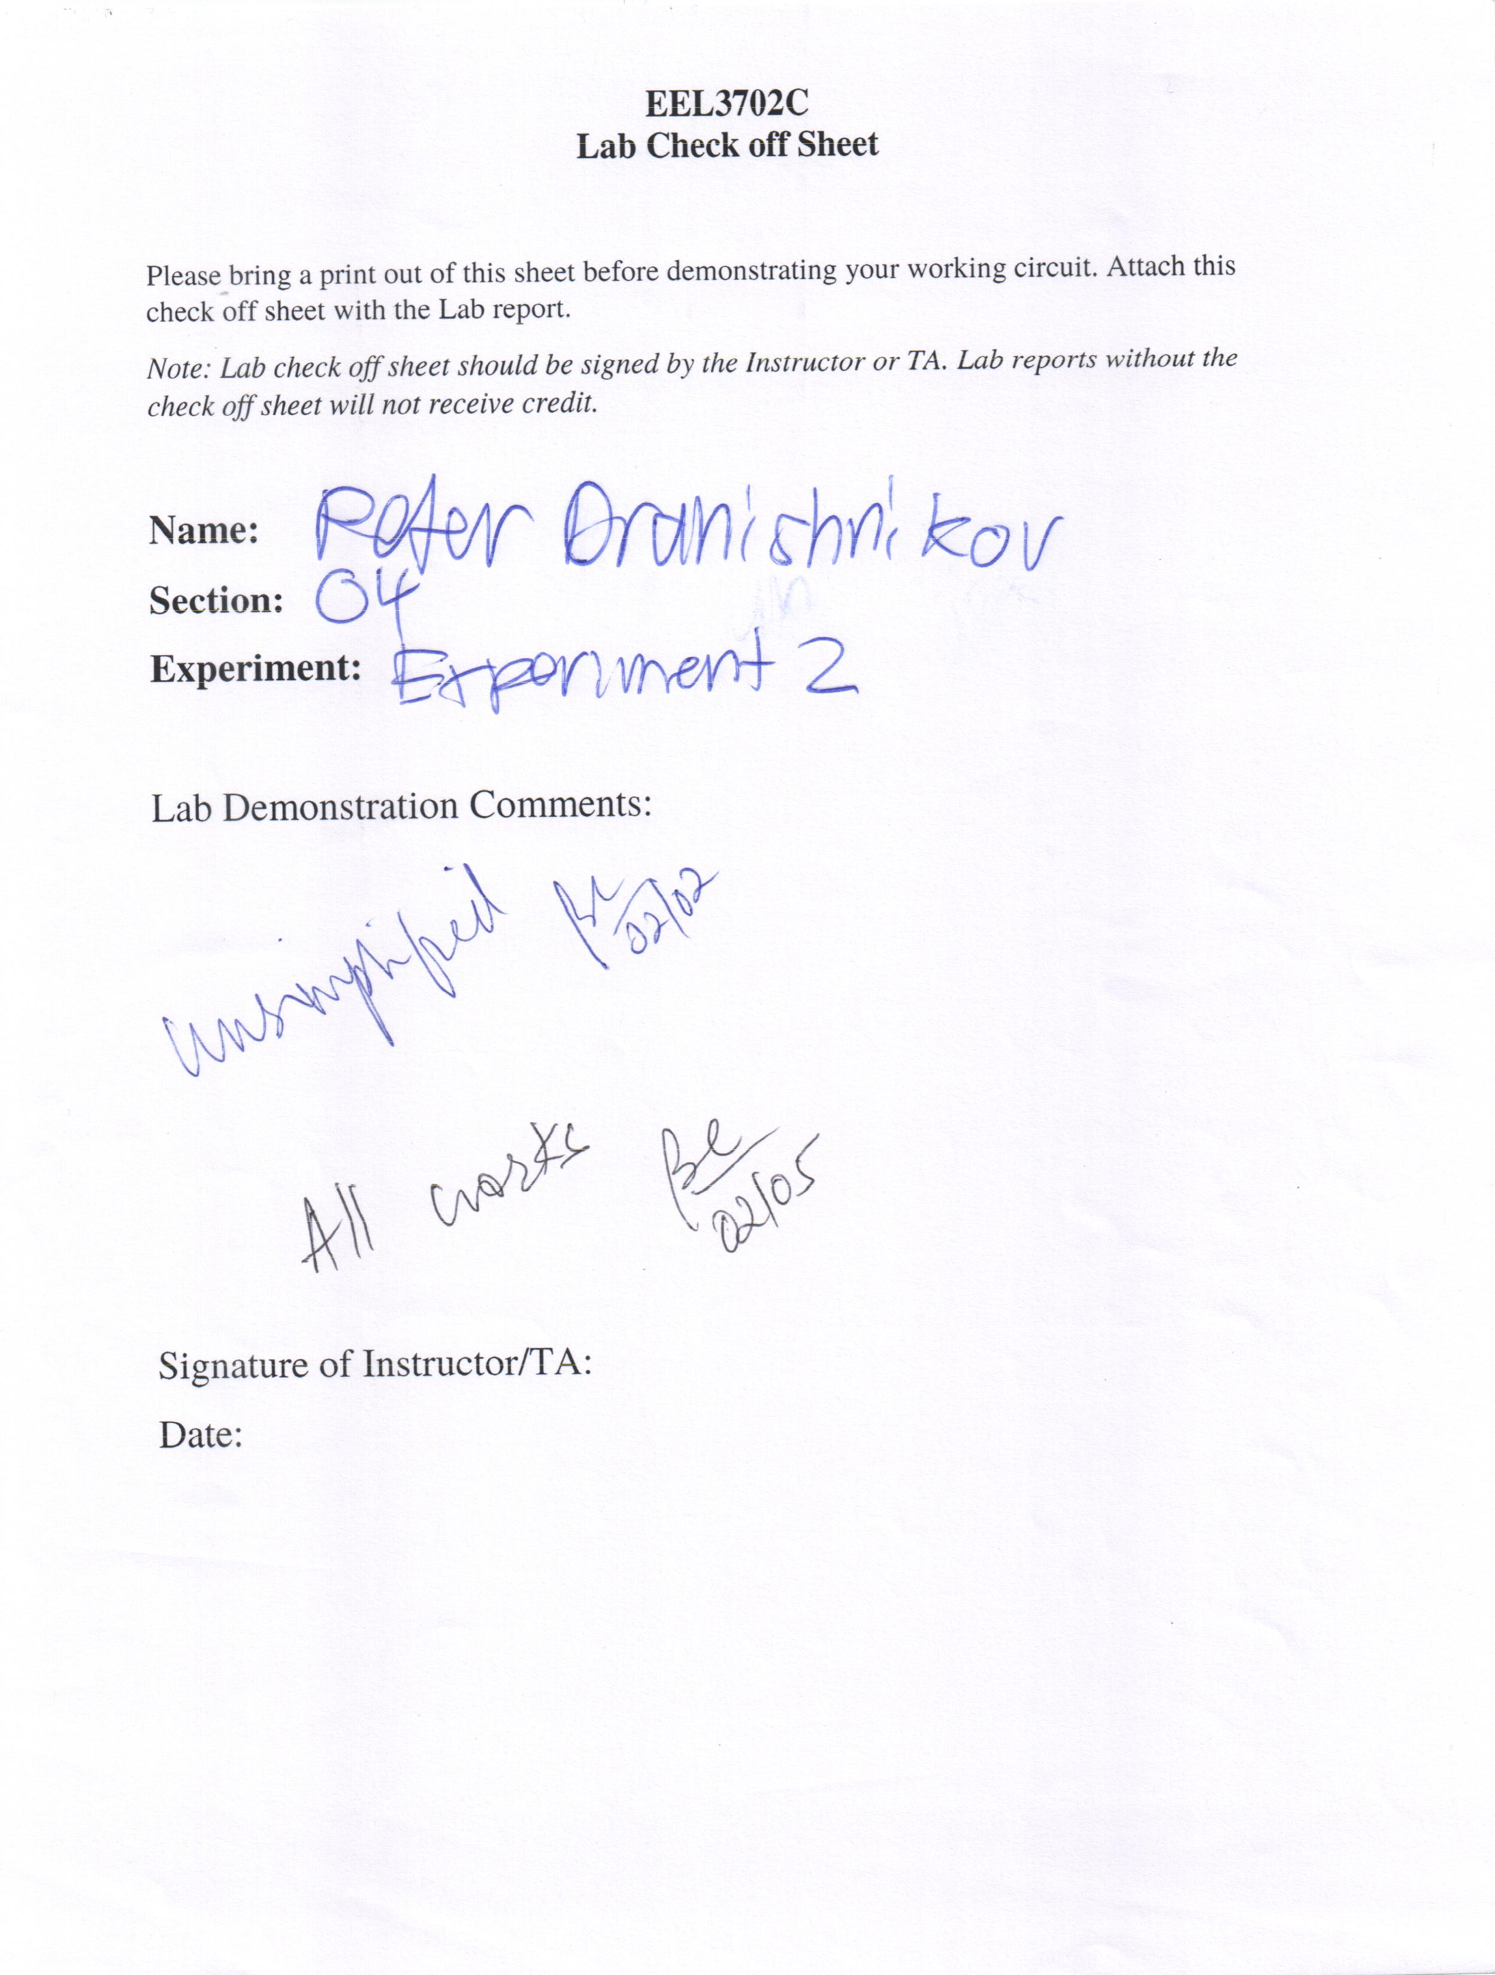

Results and Discussion:
The unsimplified circuit matched the truth table of the original unsimplified function exactly, although the circuit construction was very time-consuming. Two 74LS08 chips were required for the unsimplified circuit. The simplified circuit functioned correctly and exactly as the unsimplified function in the final demonstration (signed later than the laboratory session, see checkoff sheet for more information). The simplified circuit initially had connection problems, but were corrected before the final demonstration.

Conclusion:
Using the methods of boolean algebra, an initially large function may be simplified. The simplified function is usually easier to construct and simpler to debug than the unsimplified expression, saving significant development time and costs while achieving the same result of the initial function.

