Experiment 3
Applications of NAND and NOR Gates
Peter Dranishnikov
U0000005258
EEL3702C
Digital Logic Design
Section 04
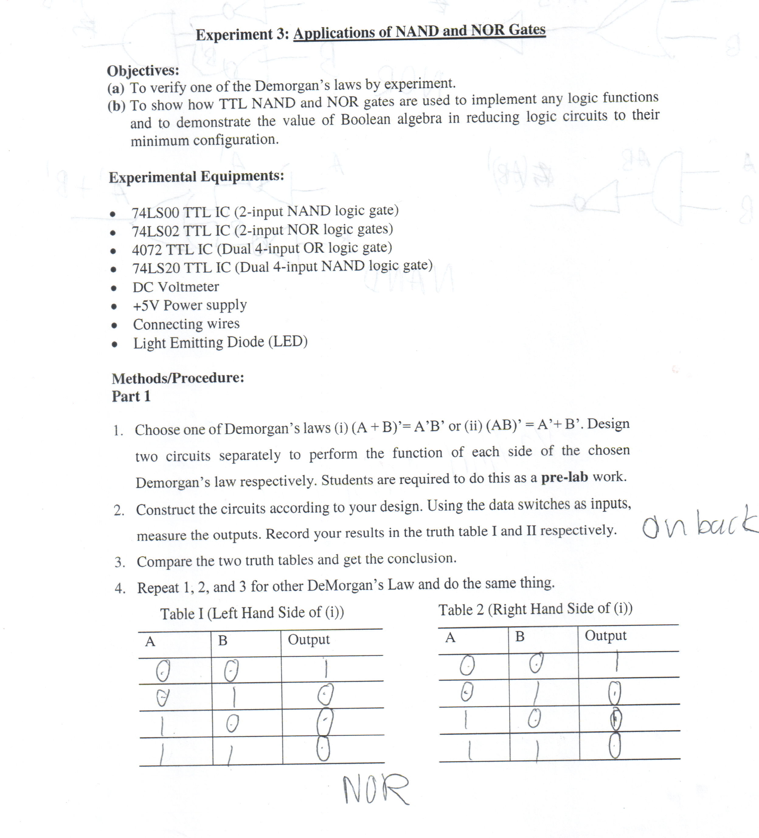
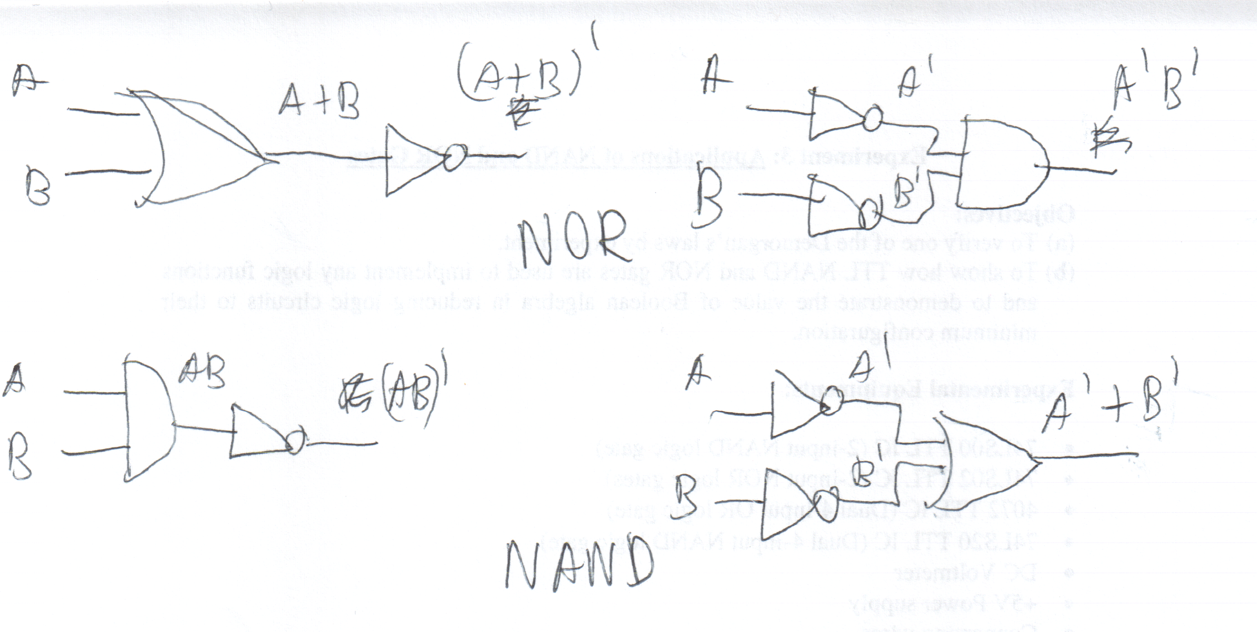
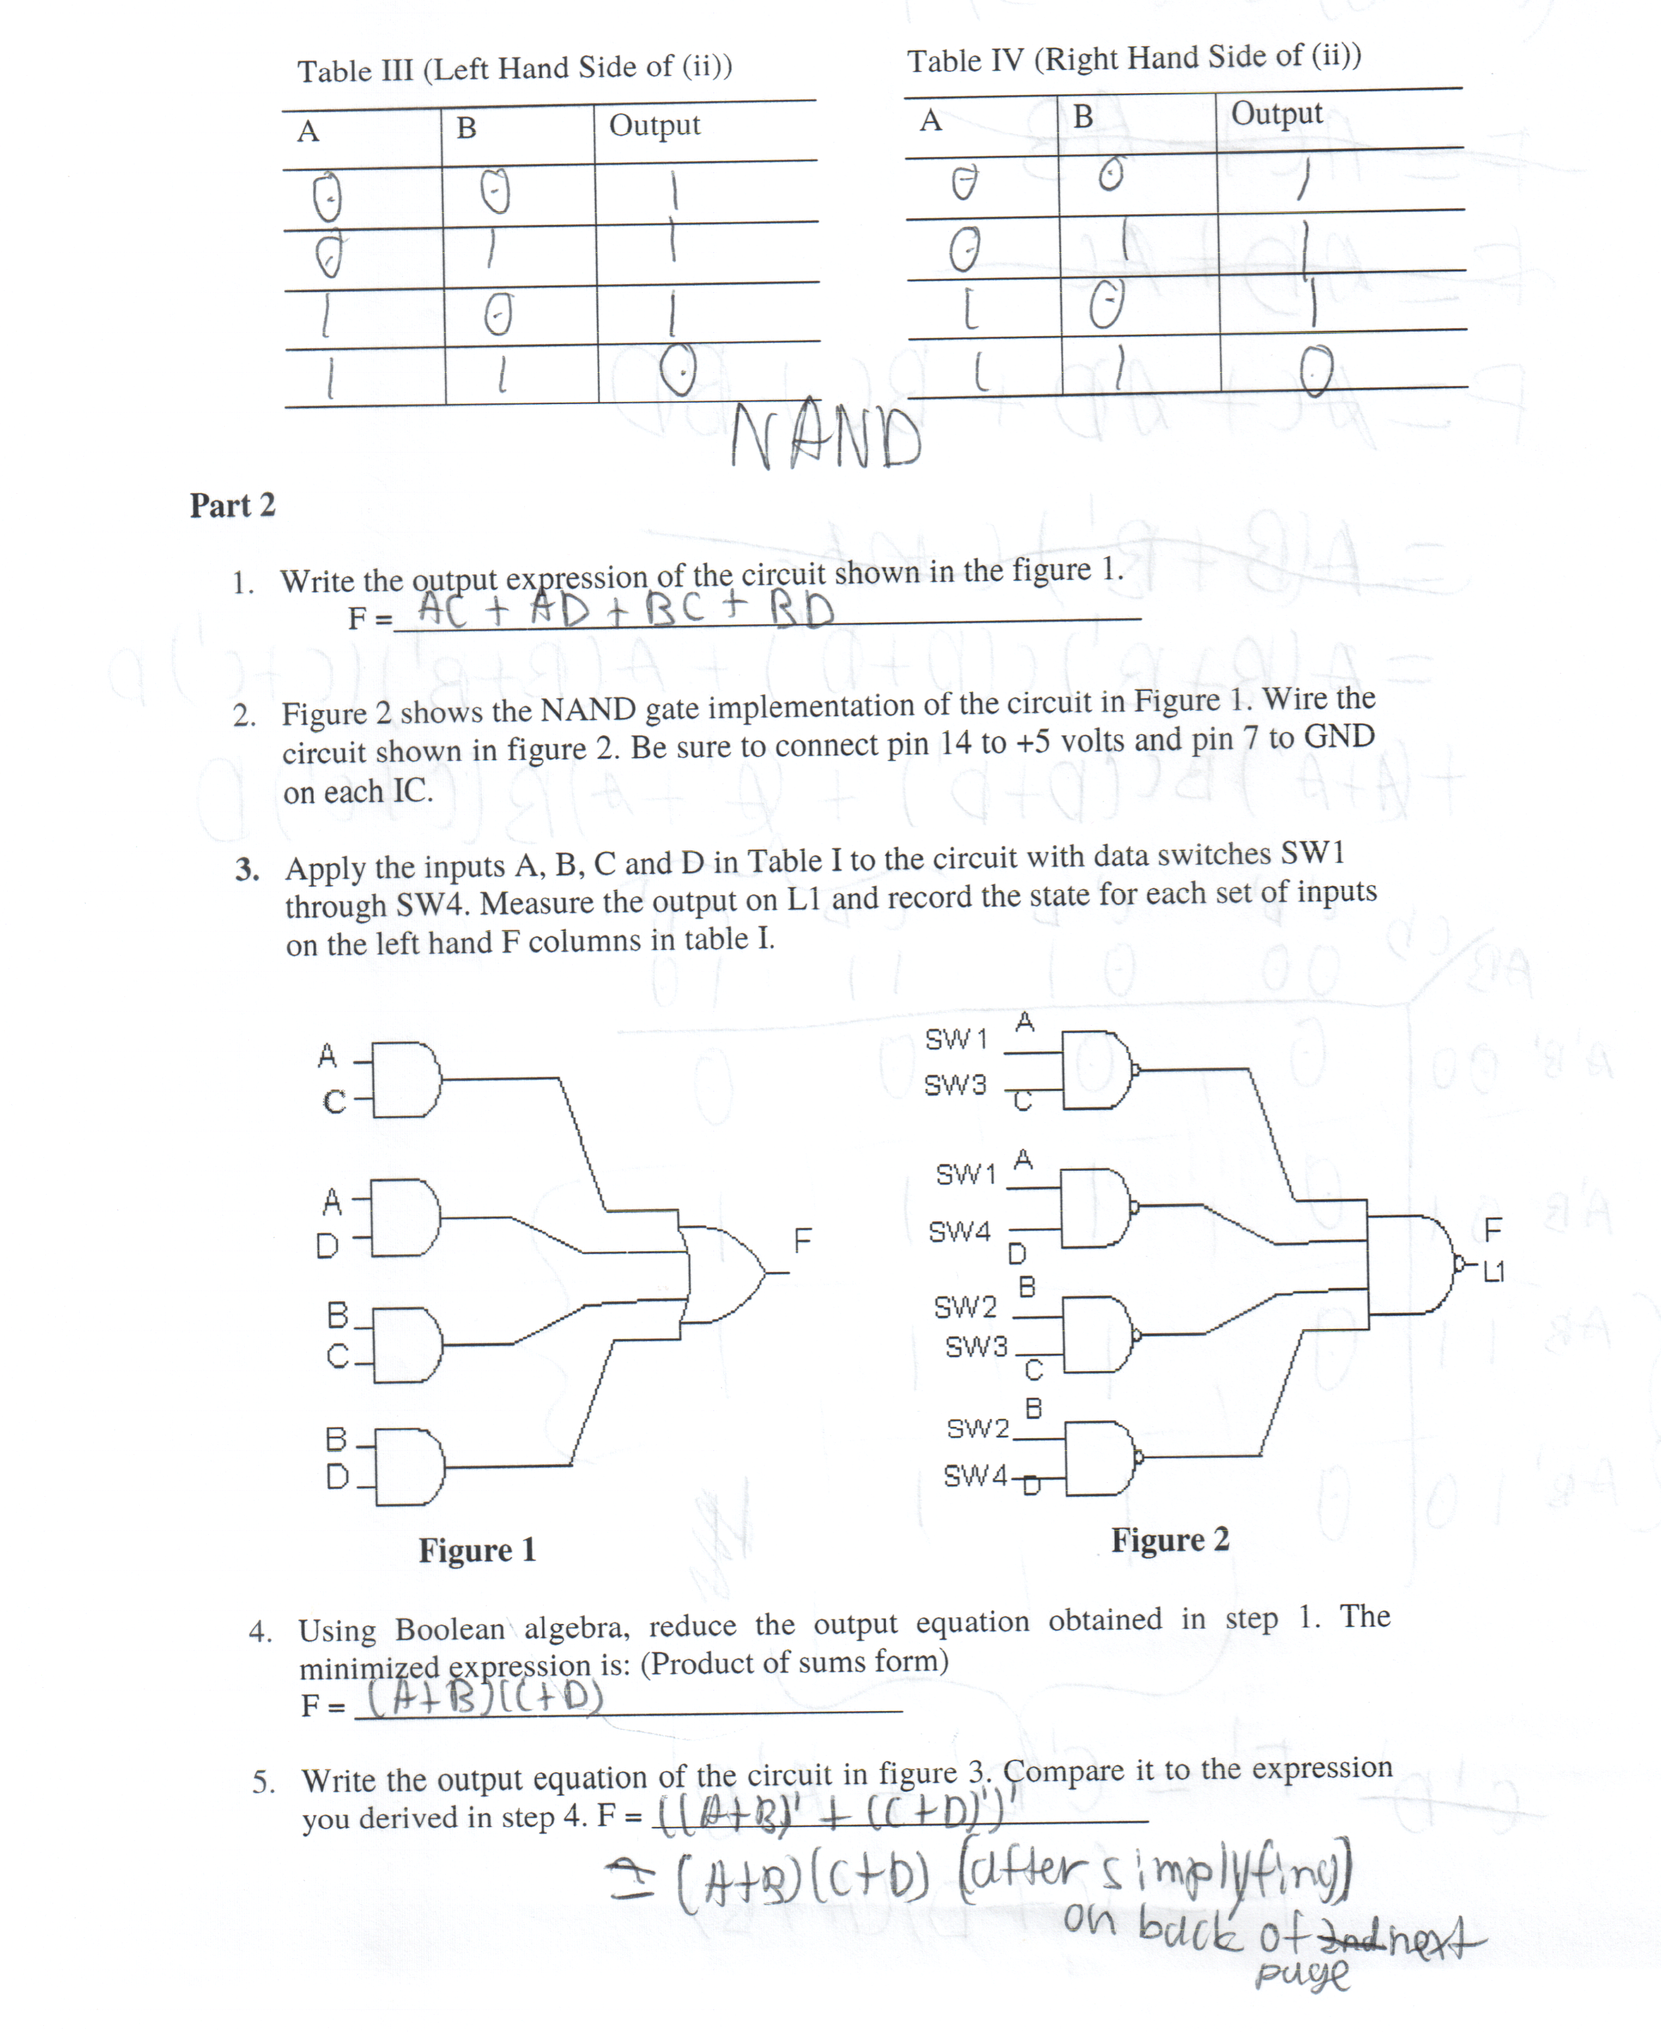
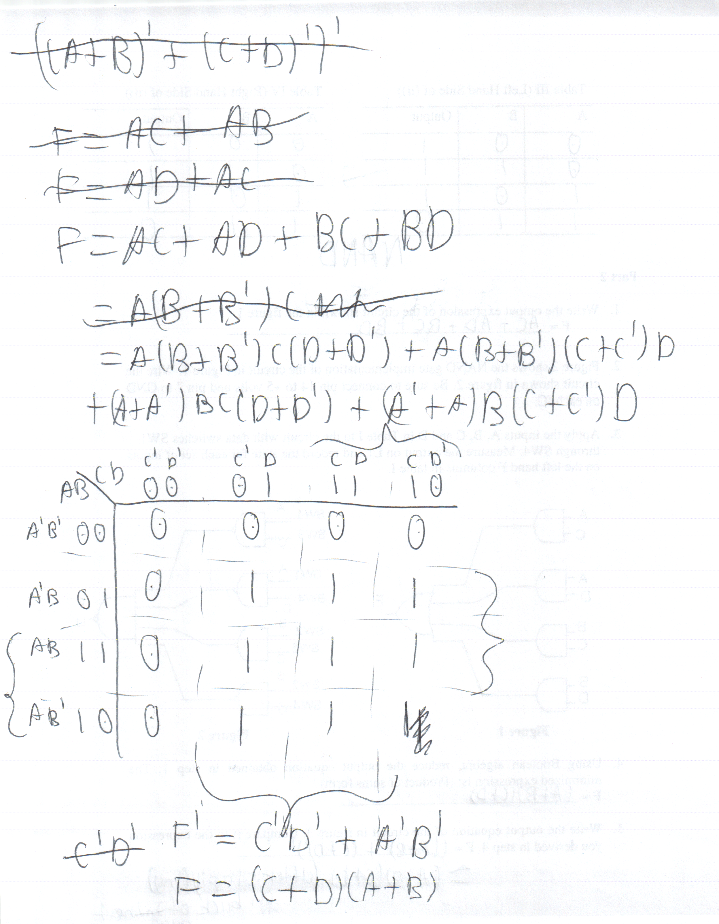
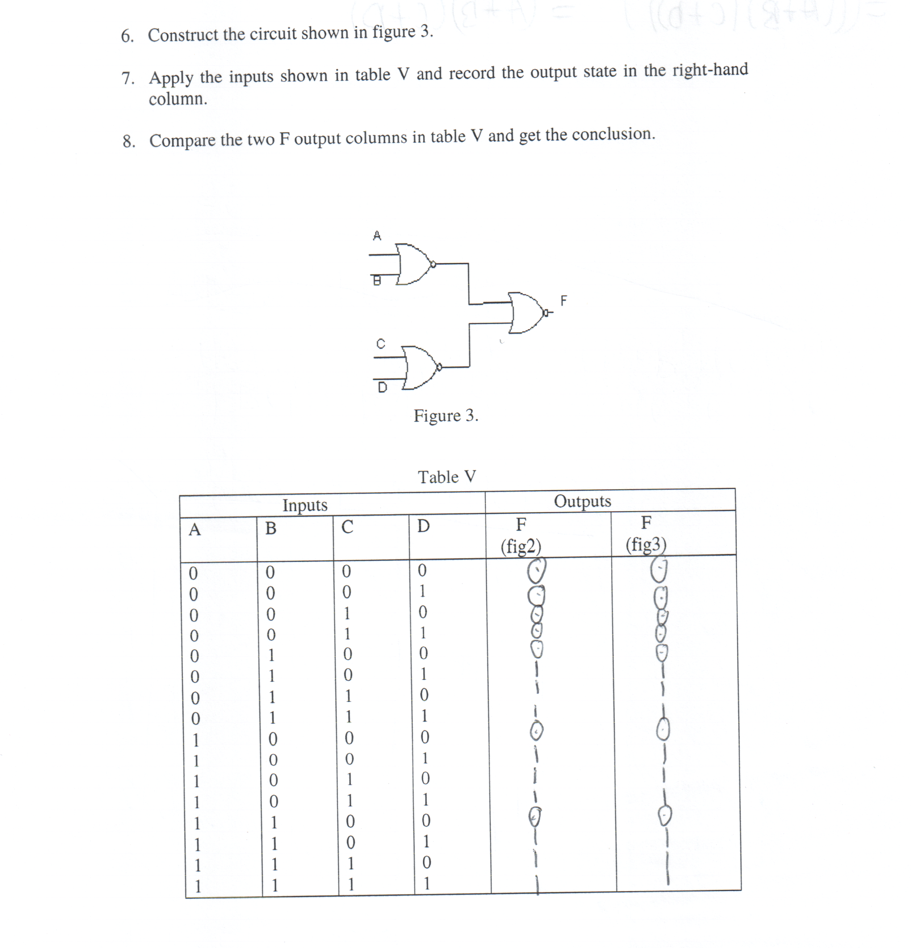
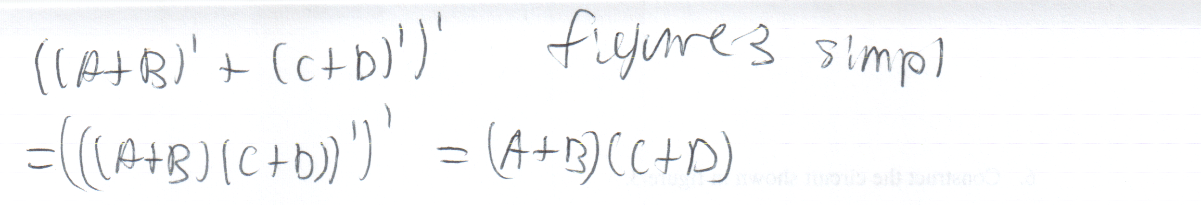
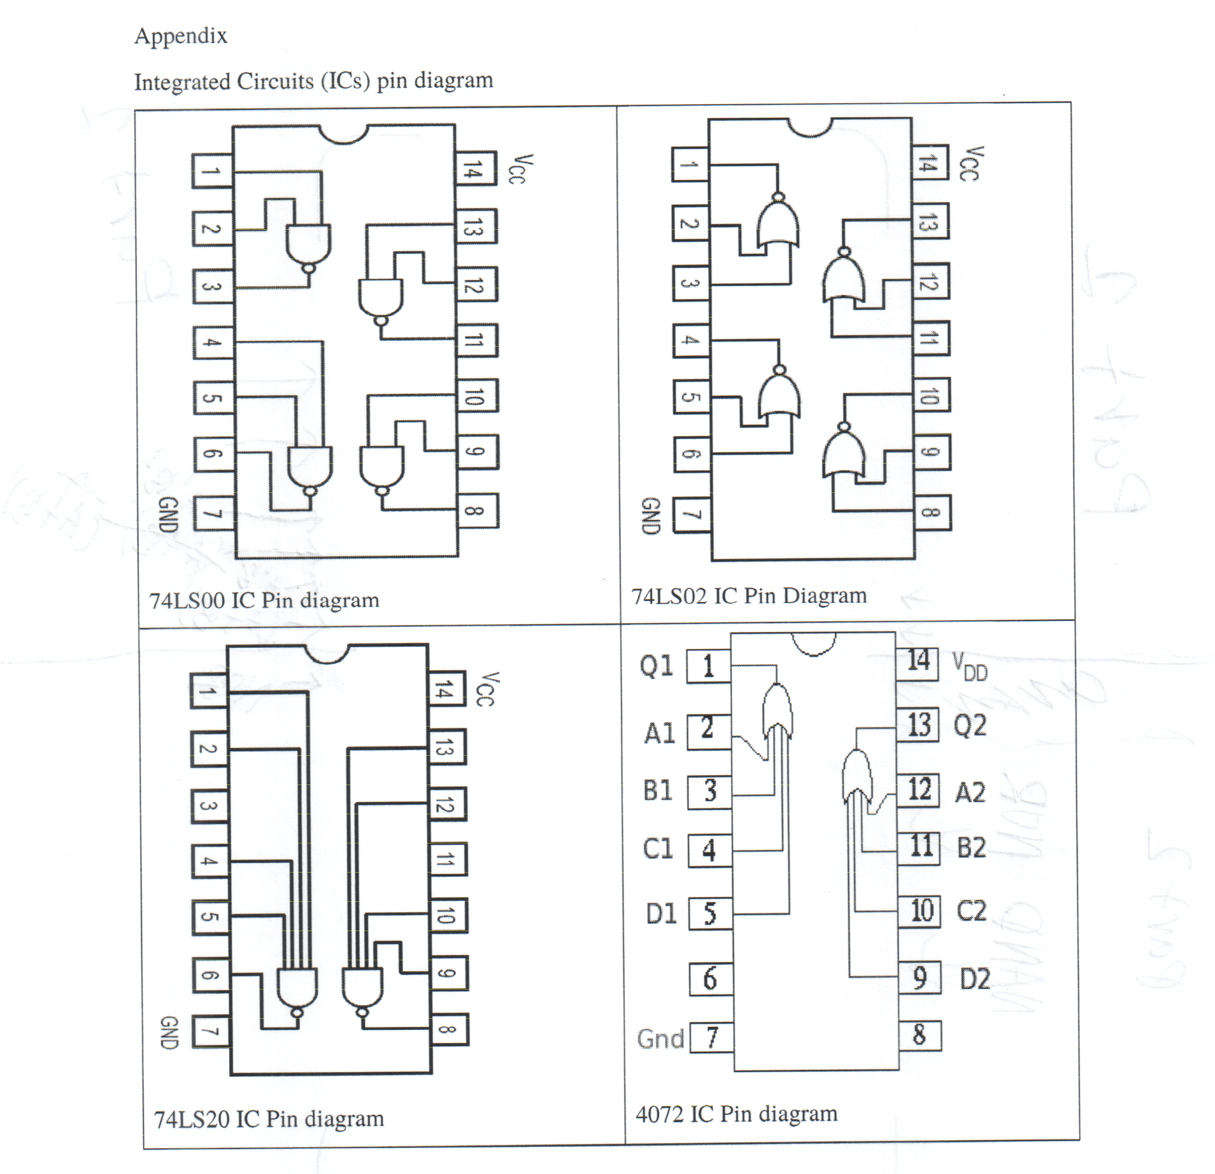
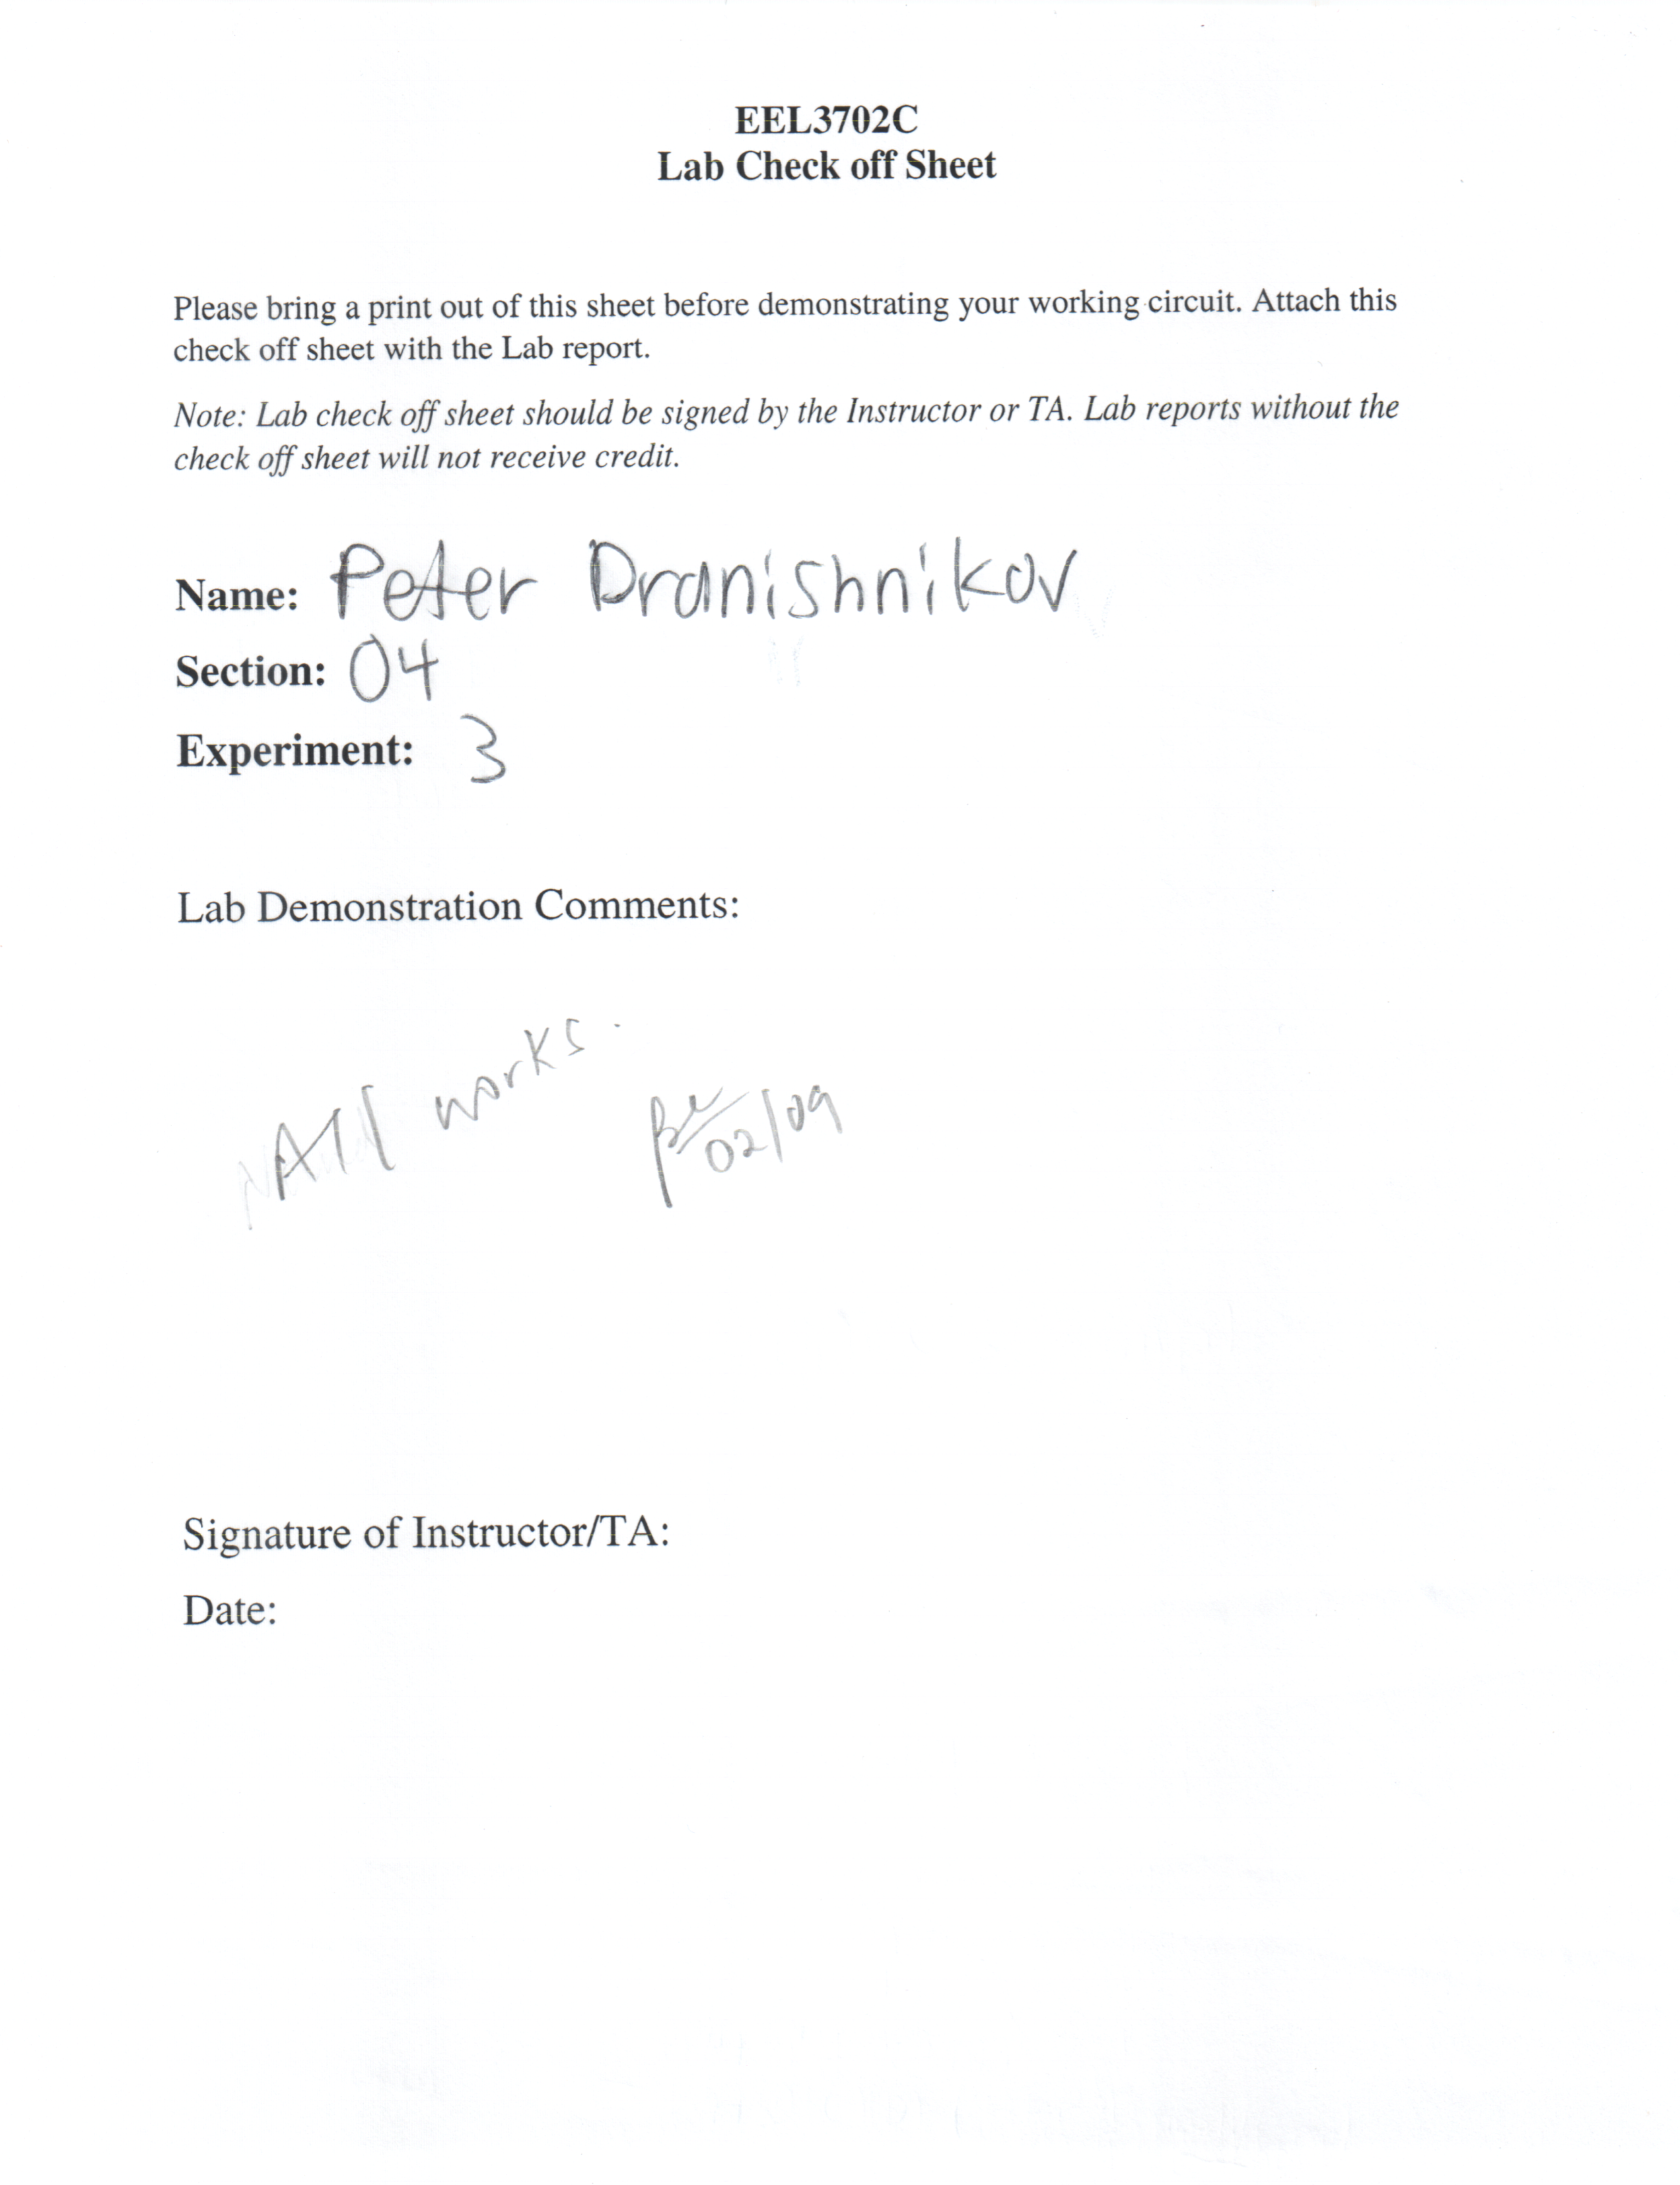

Results and Discussion:
In part 1, the first function represented the NOR gate, per the truth table, while the second function represented the NAND gate. In part 2, the function was implemented using NAND-only and NOR-only implementations. Both implementations matched the function’s truth table, thus being equivalent forms of the boolean function.

Conclusion:
Using DeMorgan’s law of boolean algebra, two universal gates exist. Any boolean function can be implemented exclusively using one of the universal gates. Additionally, the function exclusively implemented in one universal gate can be converted using DeMorgan’s law (or bubble pushing) to the other exclusive universal gate implementation. One implementation may be smaller than the other, thus determining which is smaller can be a cost-reducing method for digital logic function design.

