Experiment 4:
Design and Implementation of Circuits at Gate Level Minimization with Sum-of-Product and Product-of-Sum Simplification
Peter Dranishnikov
U0000005258
EEL3702C
Digital Logic Design
Section 04
Professor: Dr. Chandrasekaran
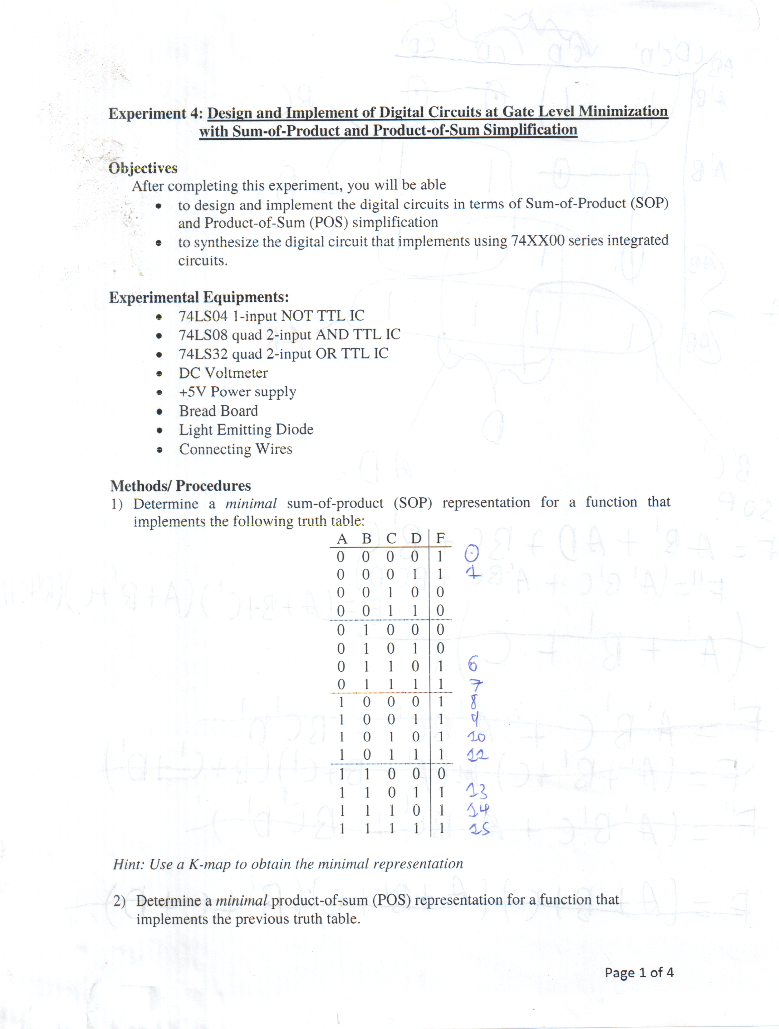
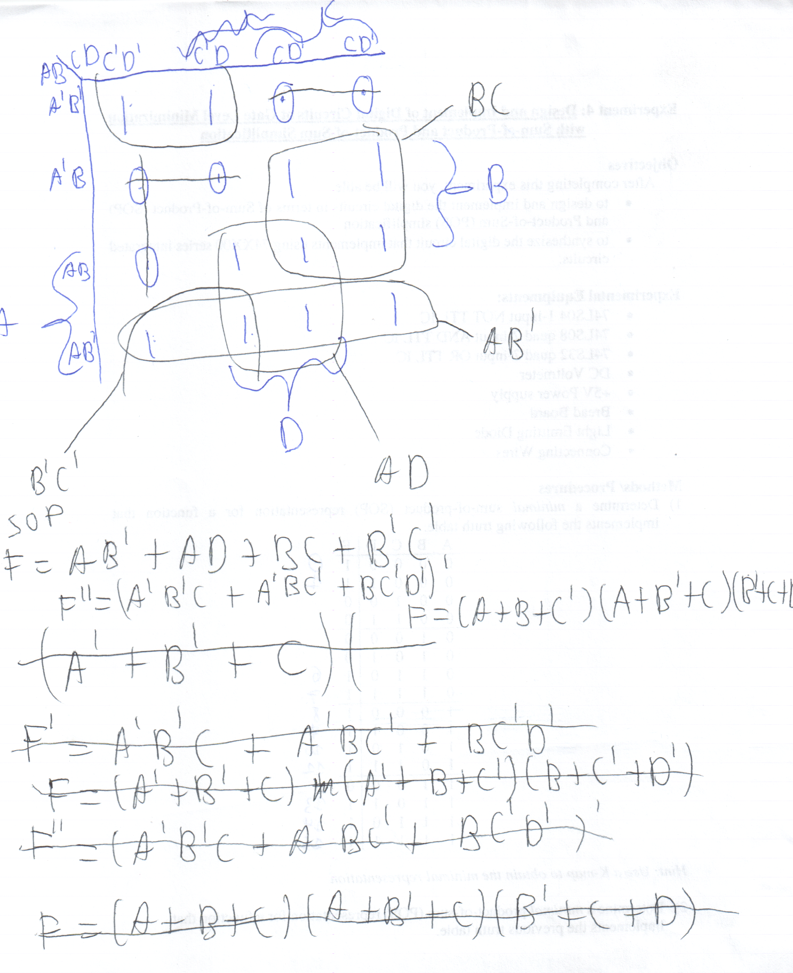
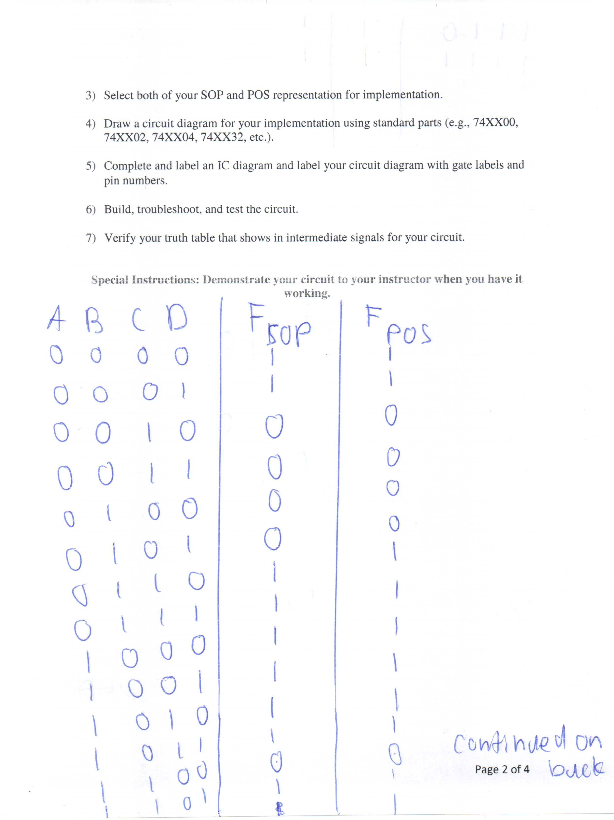
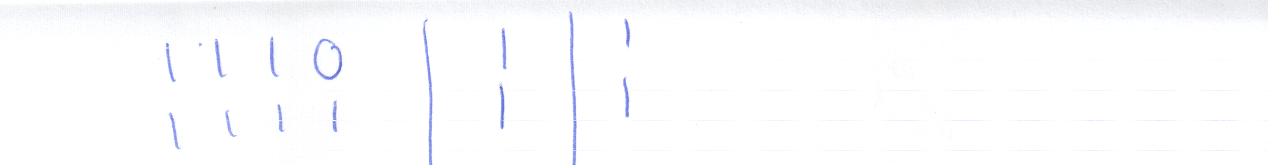
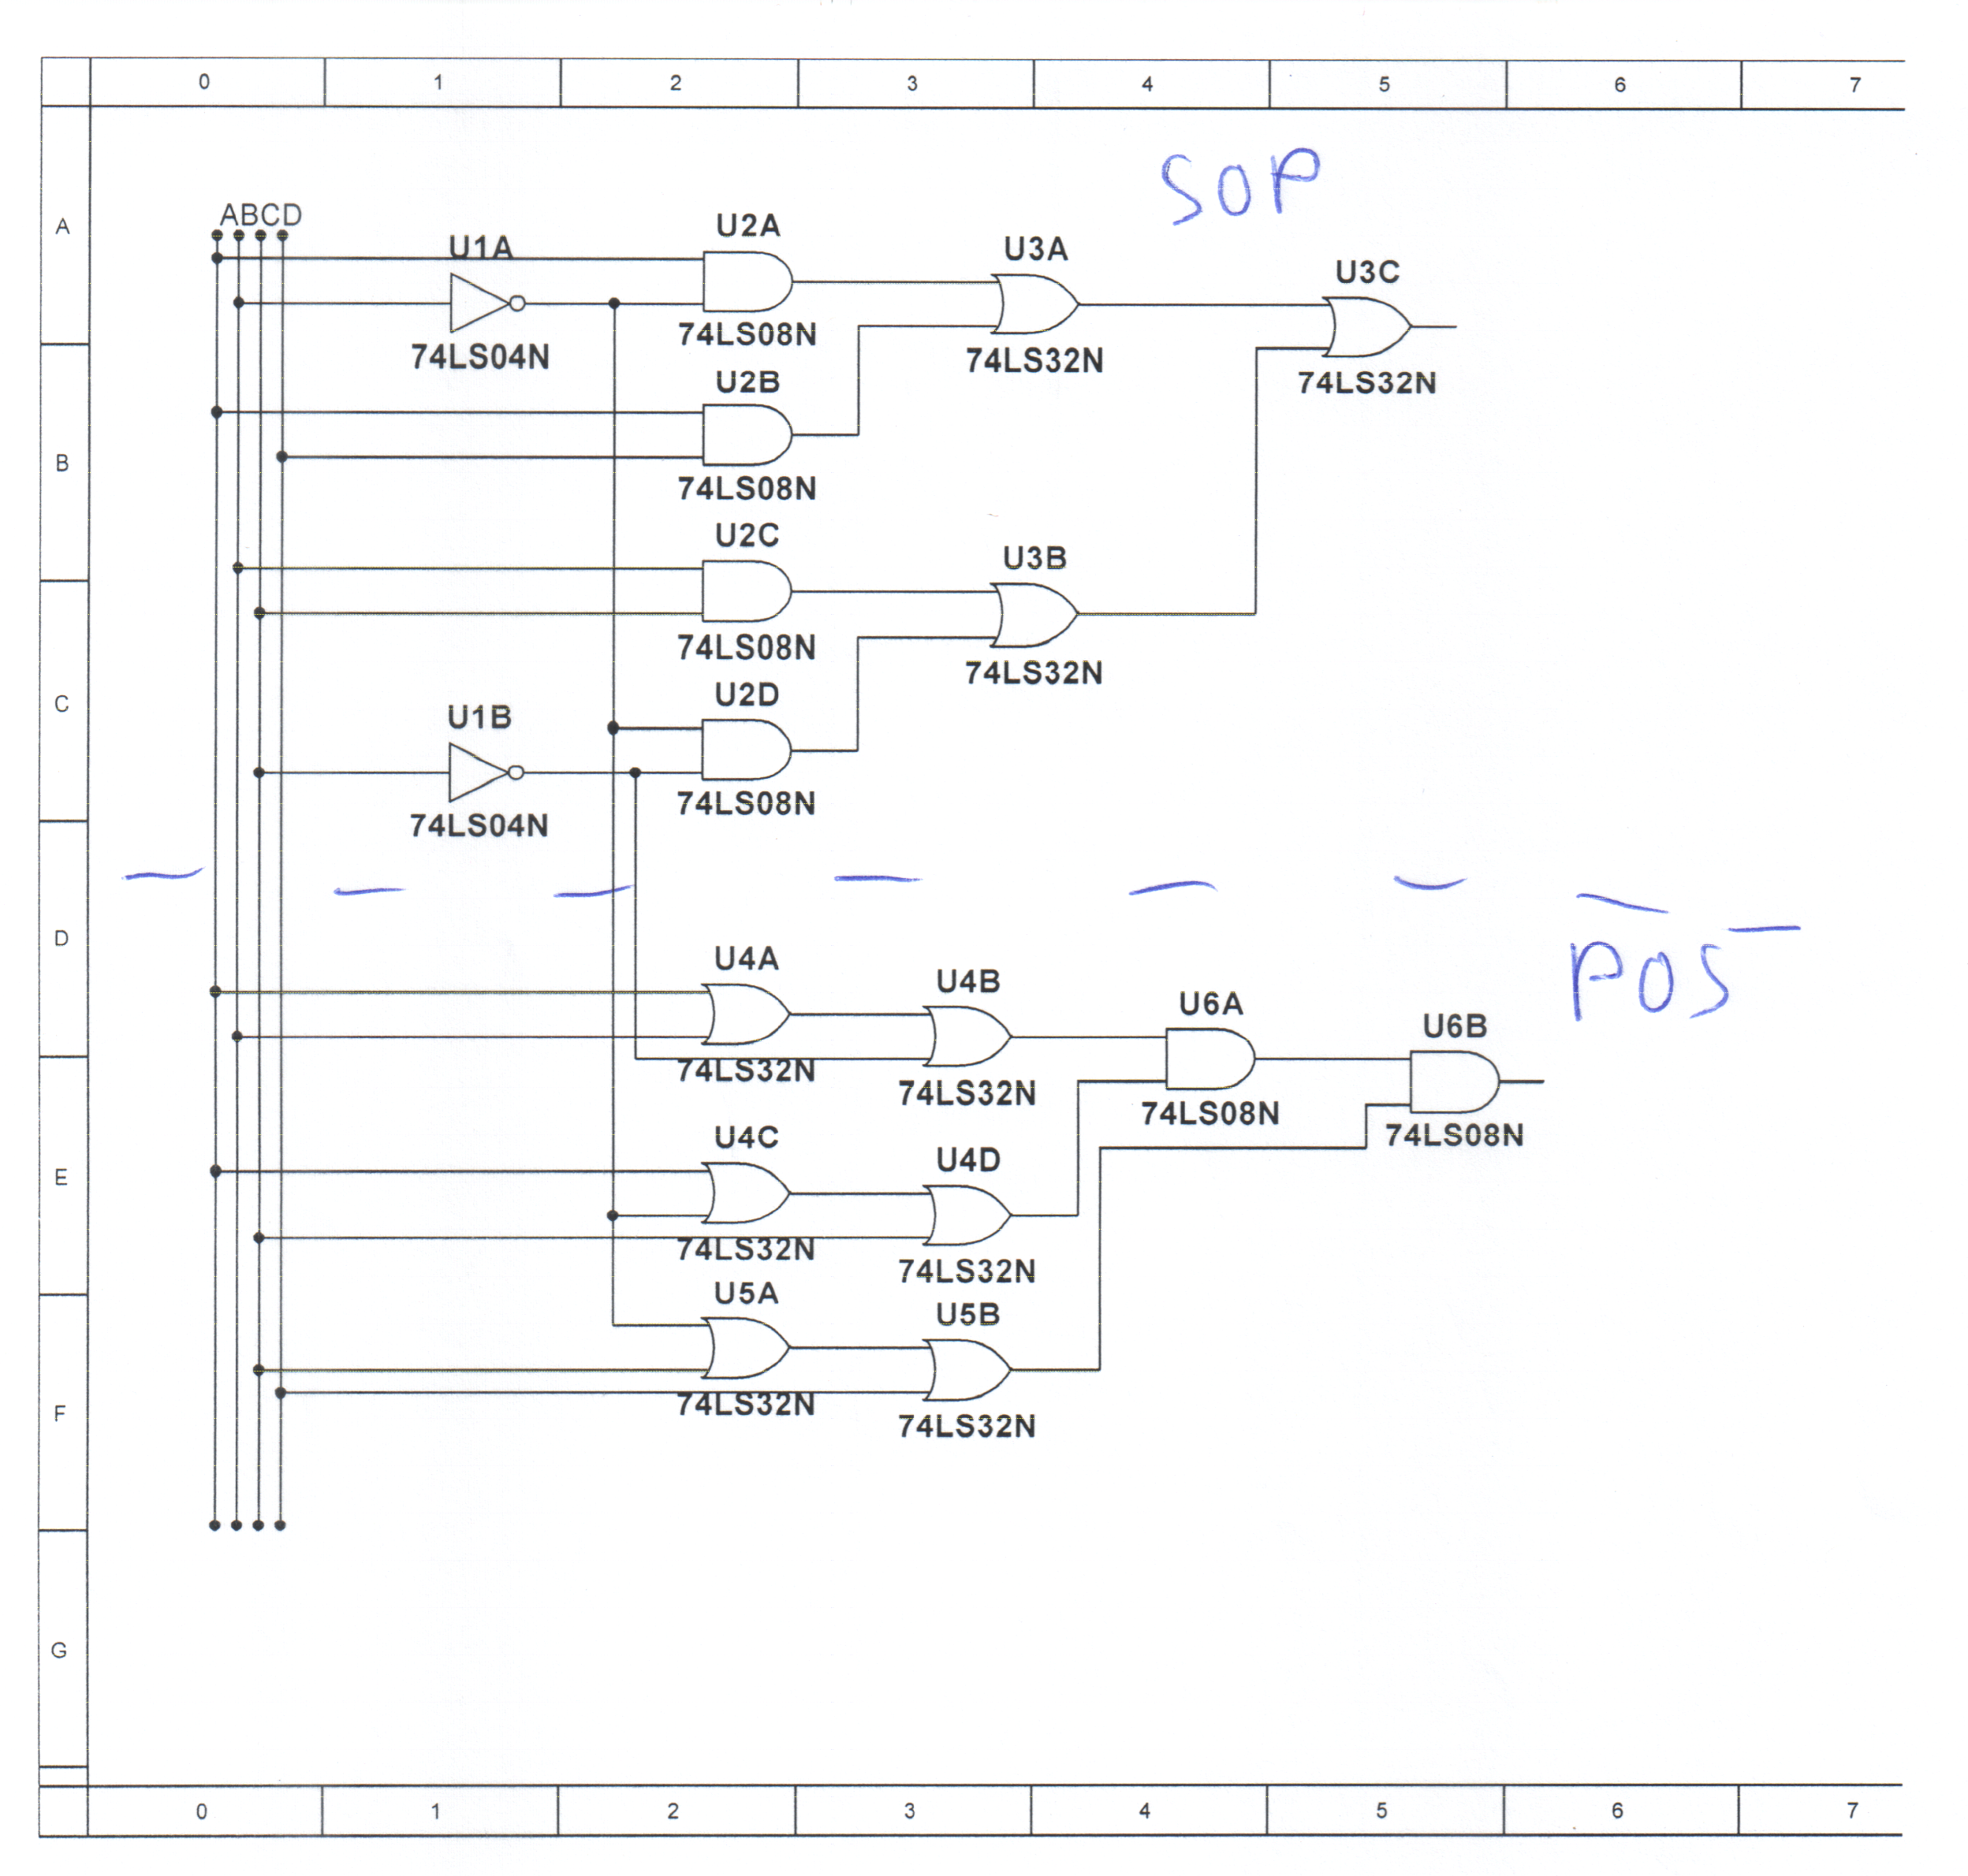
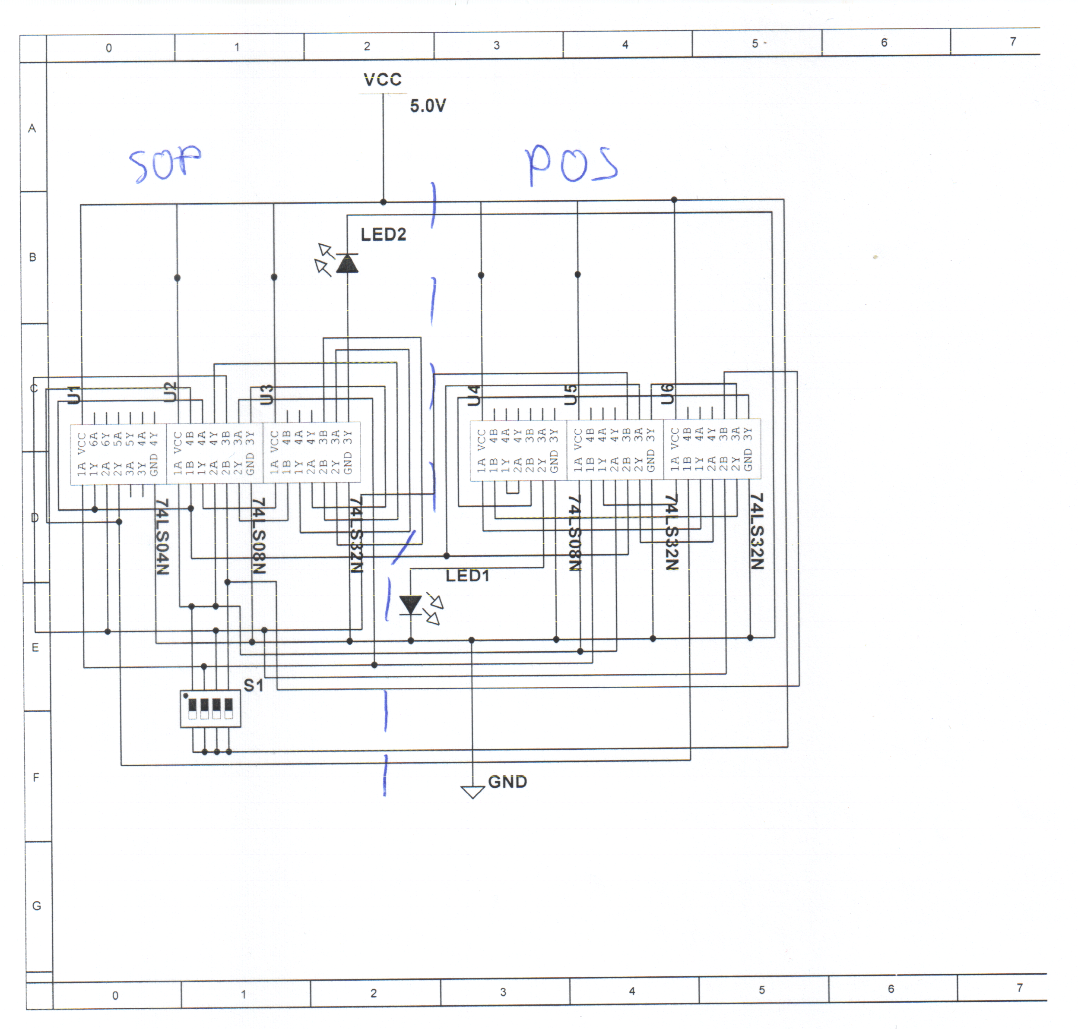
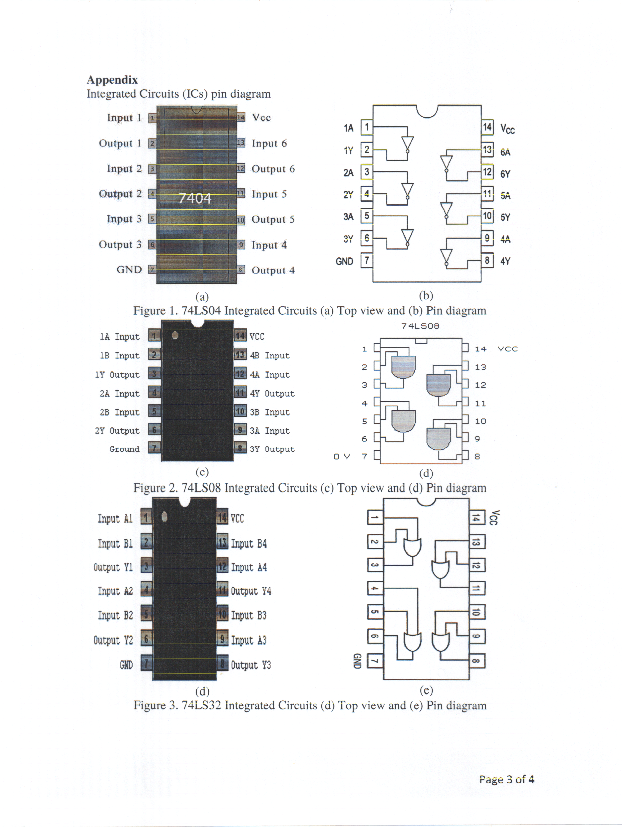
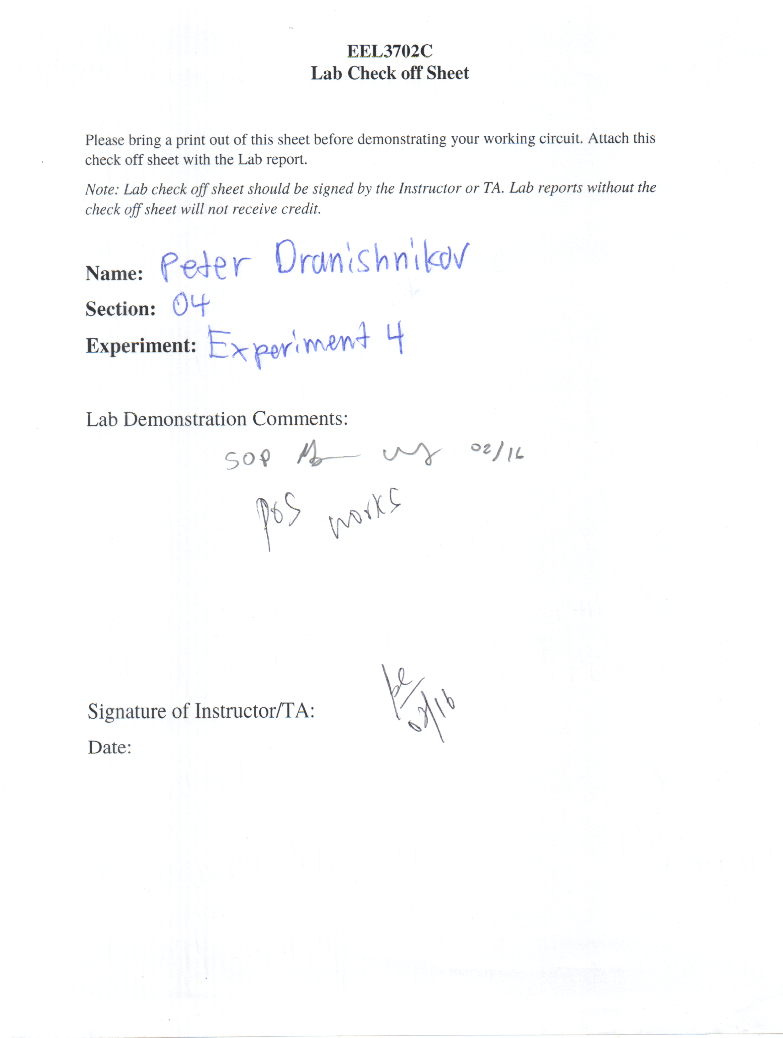

Results and Discussion:
Both the Product-of-Sum and Sum-of-Product implementations matched the initial truth table I/O values in operation both in Multisim and the breadboard implementation. The implementation cost is about the same in terms of number of gates and number of IC packages required.

Conclusion:
A Karhnaugh map simplifies the complexity and possible mistakes in conversion between POS and SOP forms of an expression. Additionally, simulation of a circuit in a SPICE-like simulator program (in this lab, Multisim), eases the design, testing, and troubleshooting phases of digital logic design with simulation-capable logic diagrams and IC circuit simulation.

