Experiment 5:
Design and Implementation of Half Adder and Full Adder Circuit(s)
Peter Dranishnikov
U0000005258
EEL3702C
Digital Logic Design
Section 04
Professor: Dr. Chandrasekaran

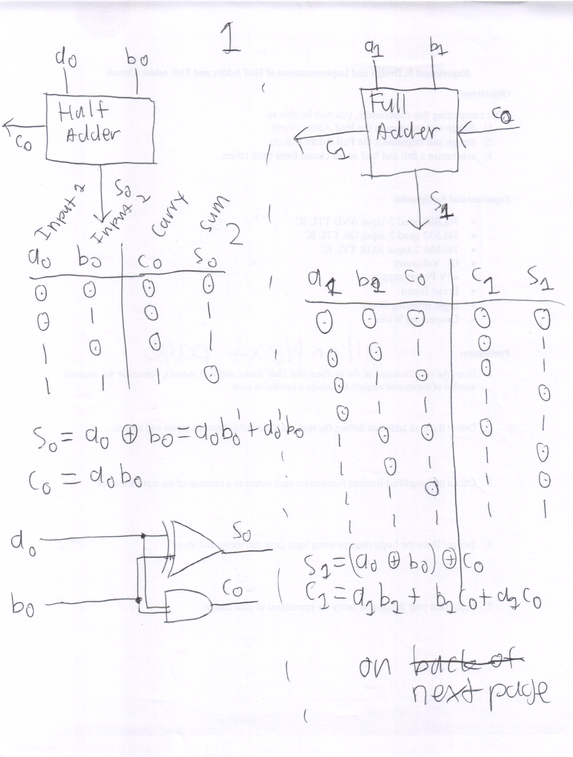
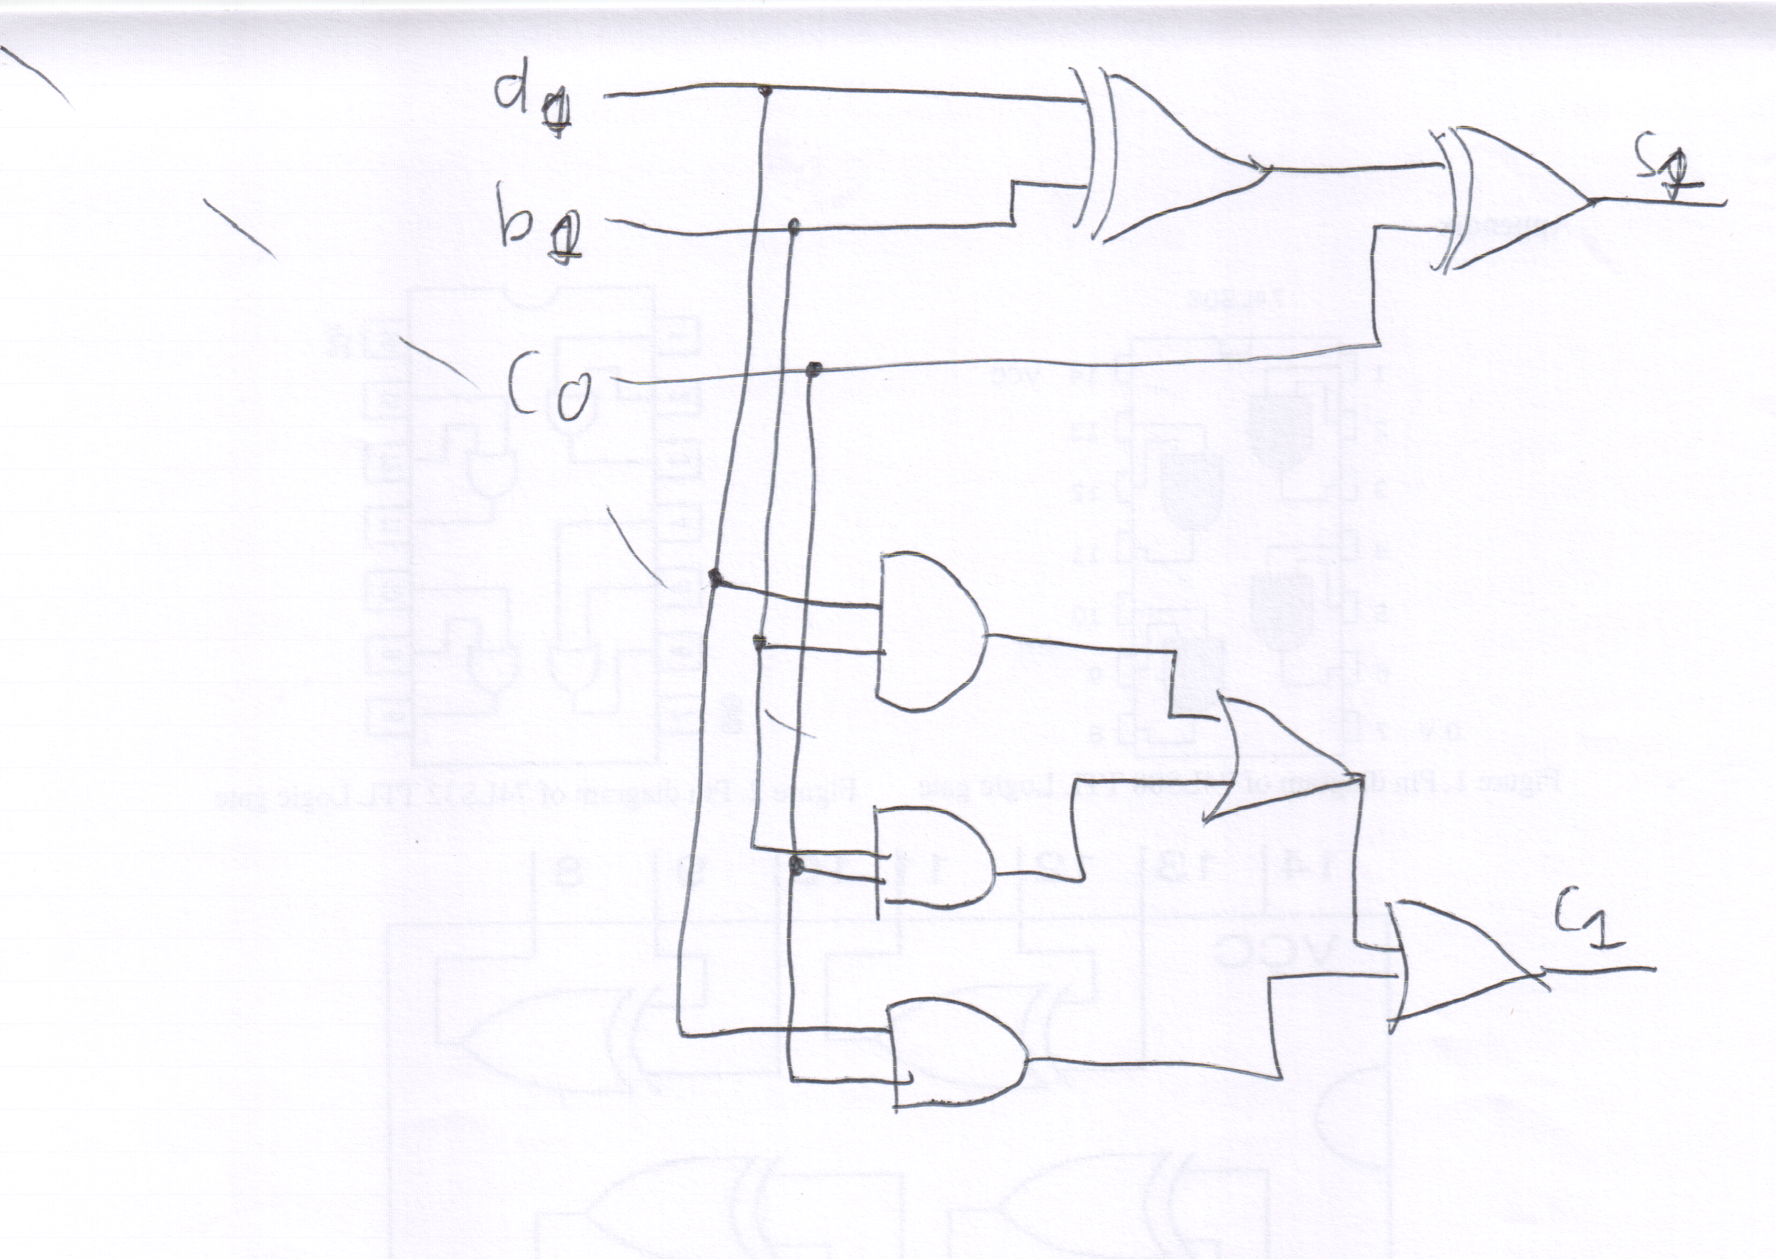
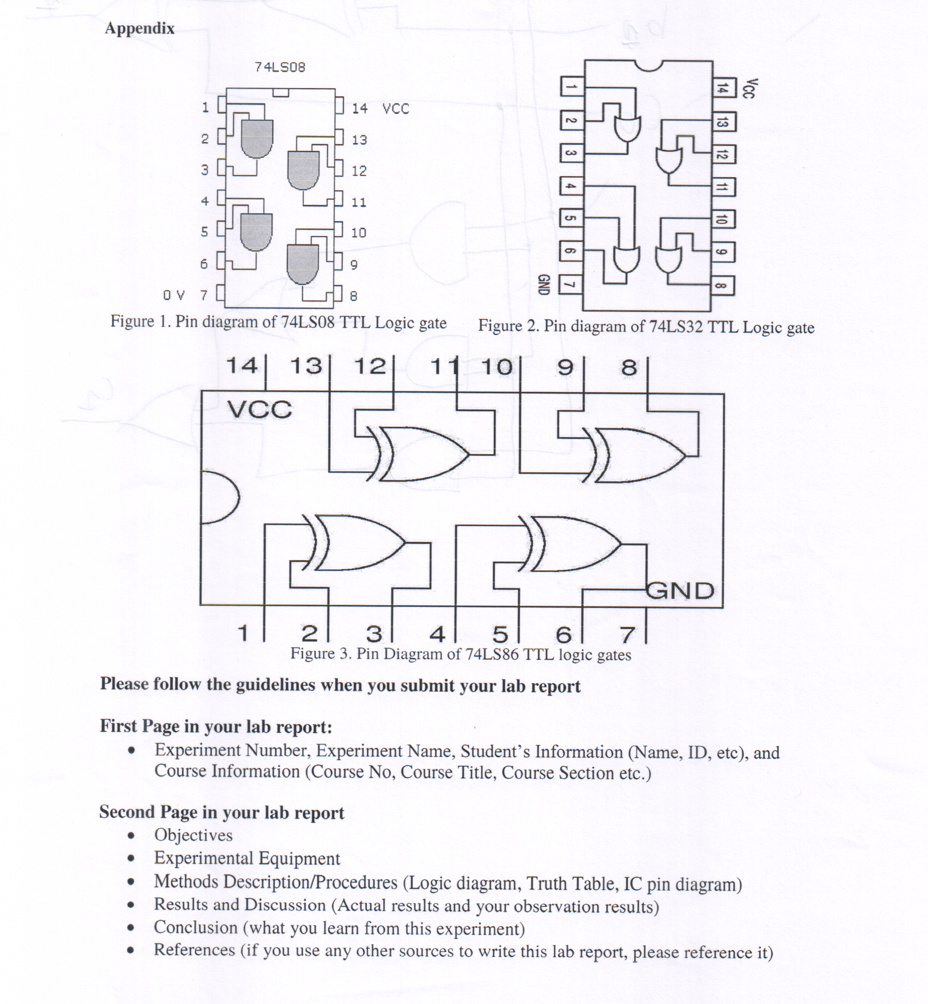
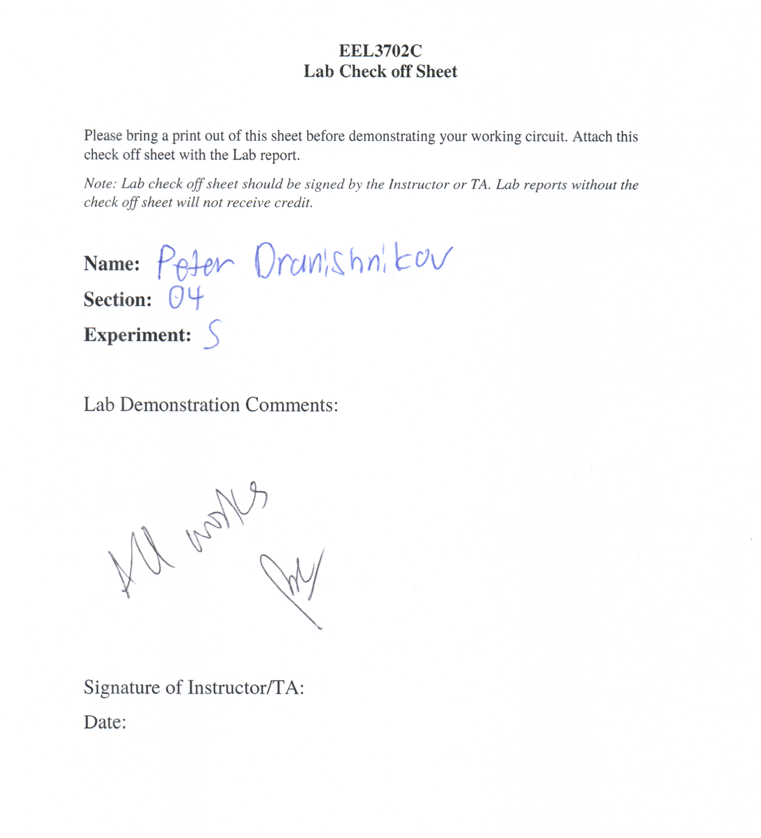

Results and Discussion:
The design, implementation, and verification of both a half adder and full adder circuit is experimentally verified using truth tables and the boolean functions derived. The implemented design meets the specifications of the original concept process.

Conclusion:
Any functioning digital logic circuit can be designed and implemented from an original concept by using the method as described in this report.

