Experiment 7:
Binary Coded Decimal (BCD) to Decimal Digit Conversion with Seven-Segment Display
Peter Dranishnikov
U0000005258
EEL3702C
Digital Logic Design
Section 04
Professor: Dr. Balasubramaniyan Chandrasekaran

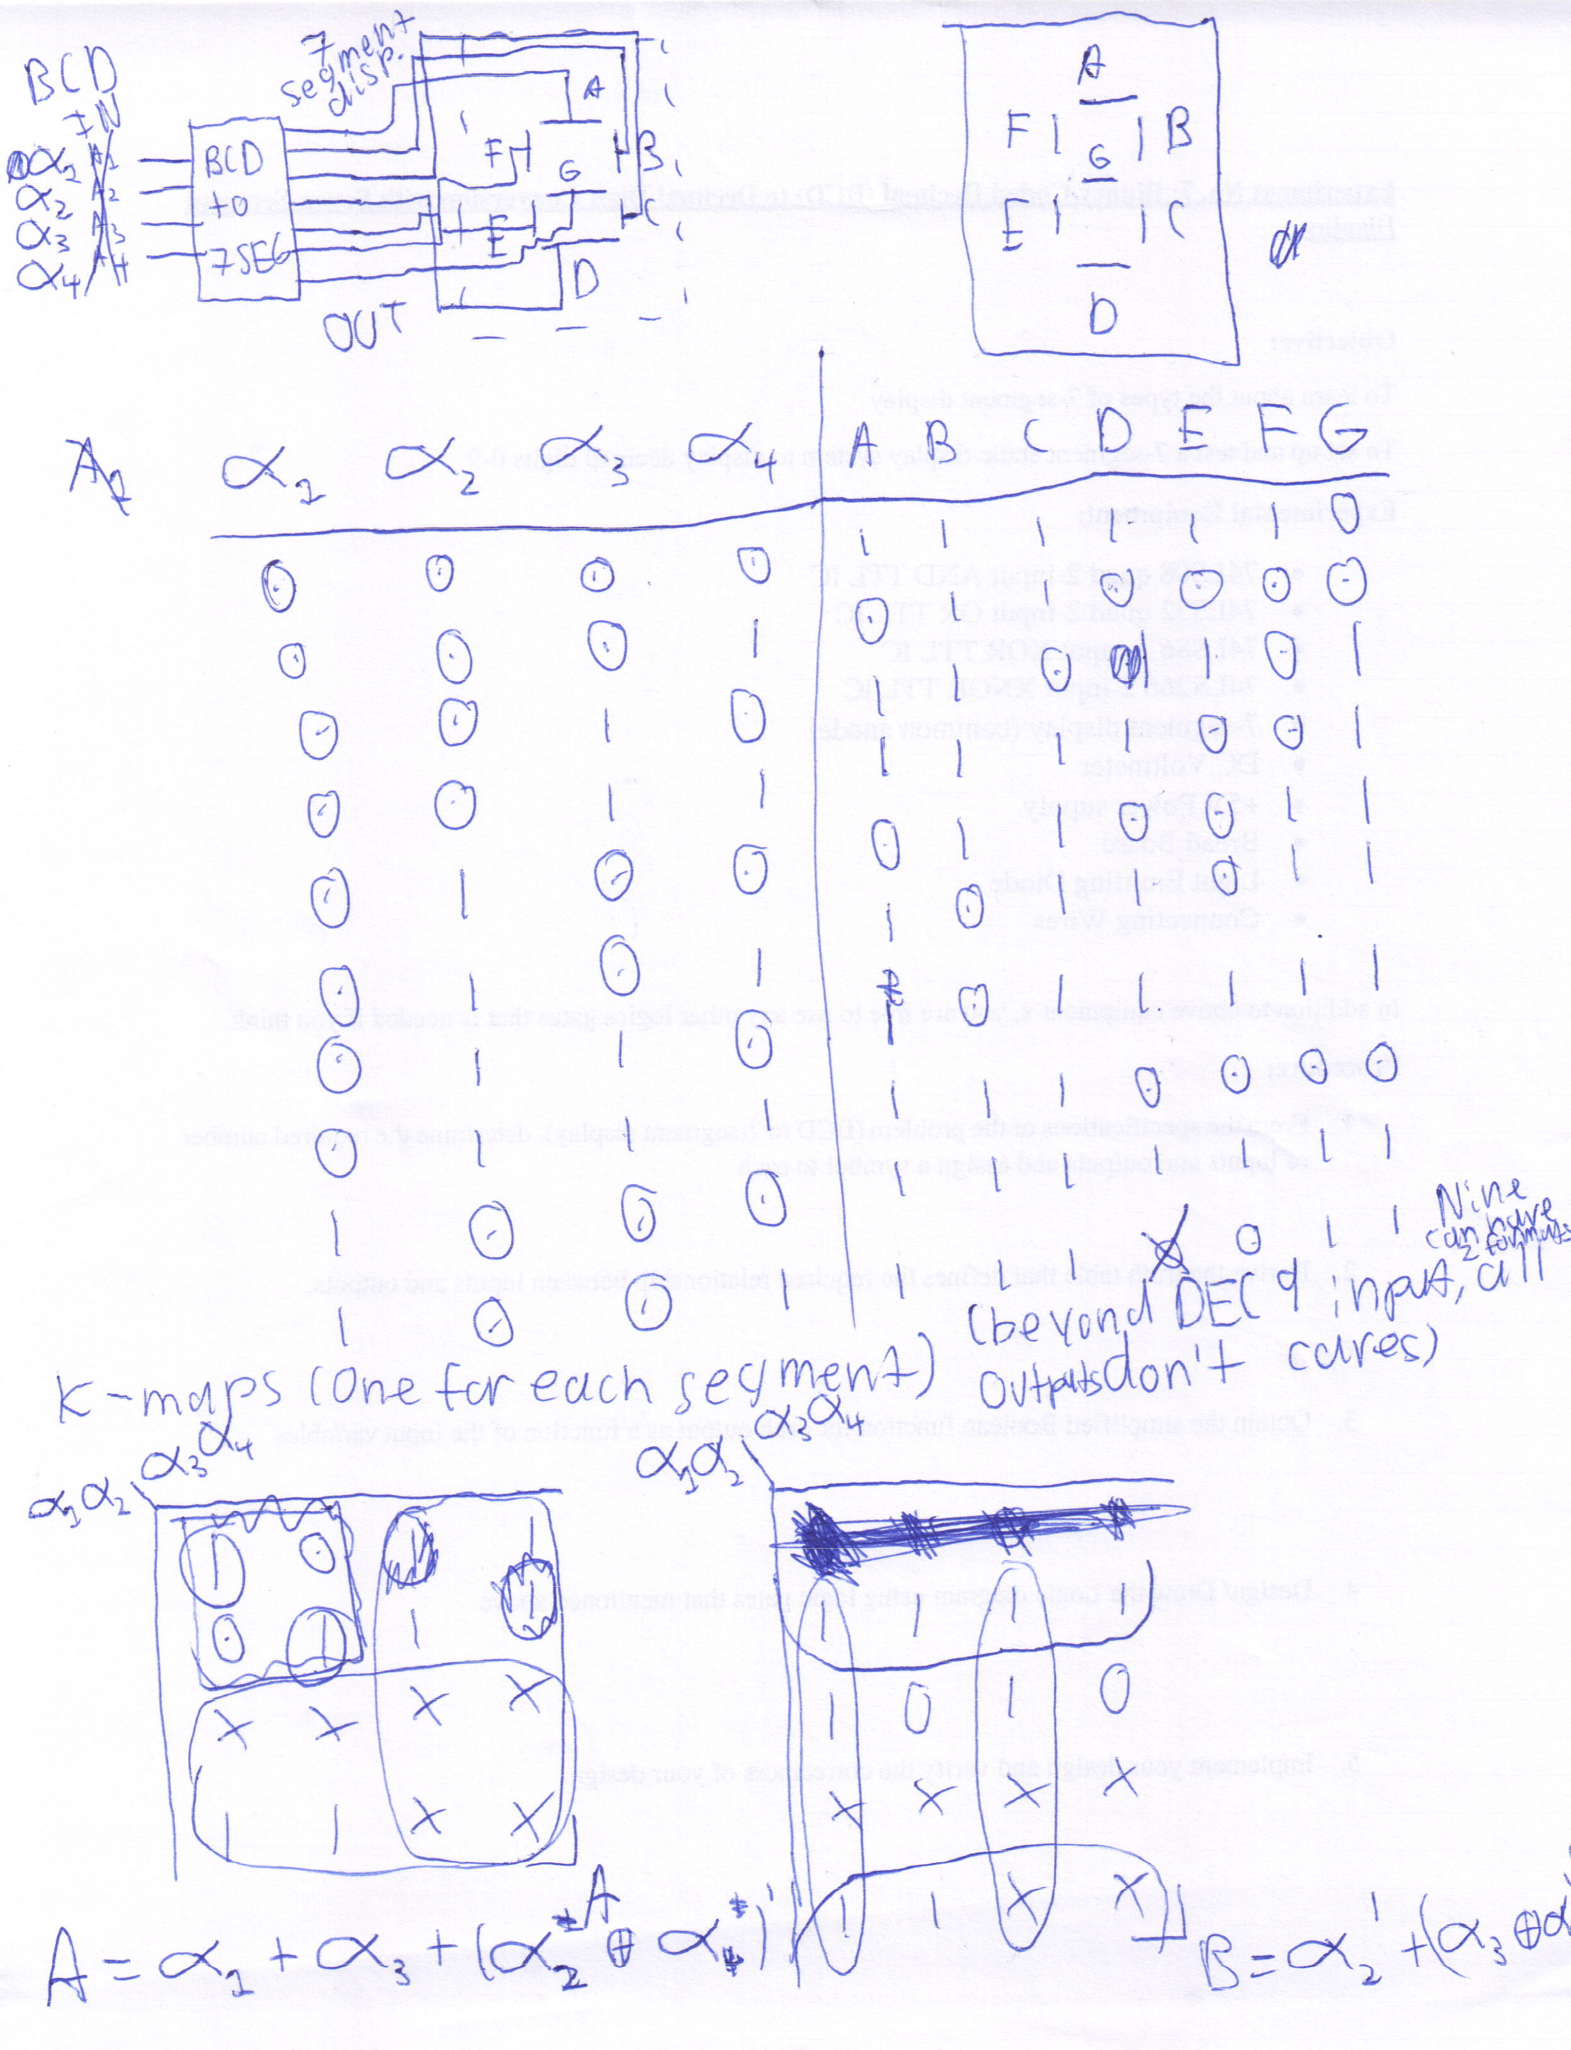

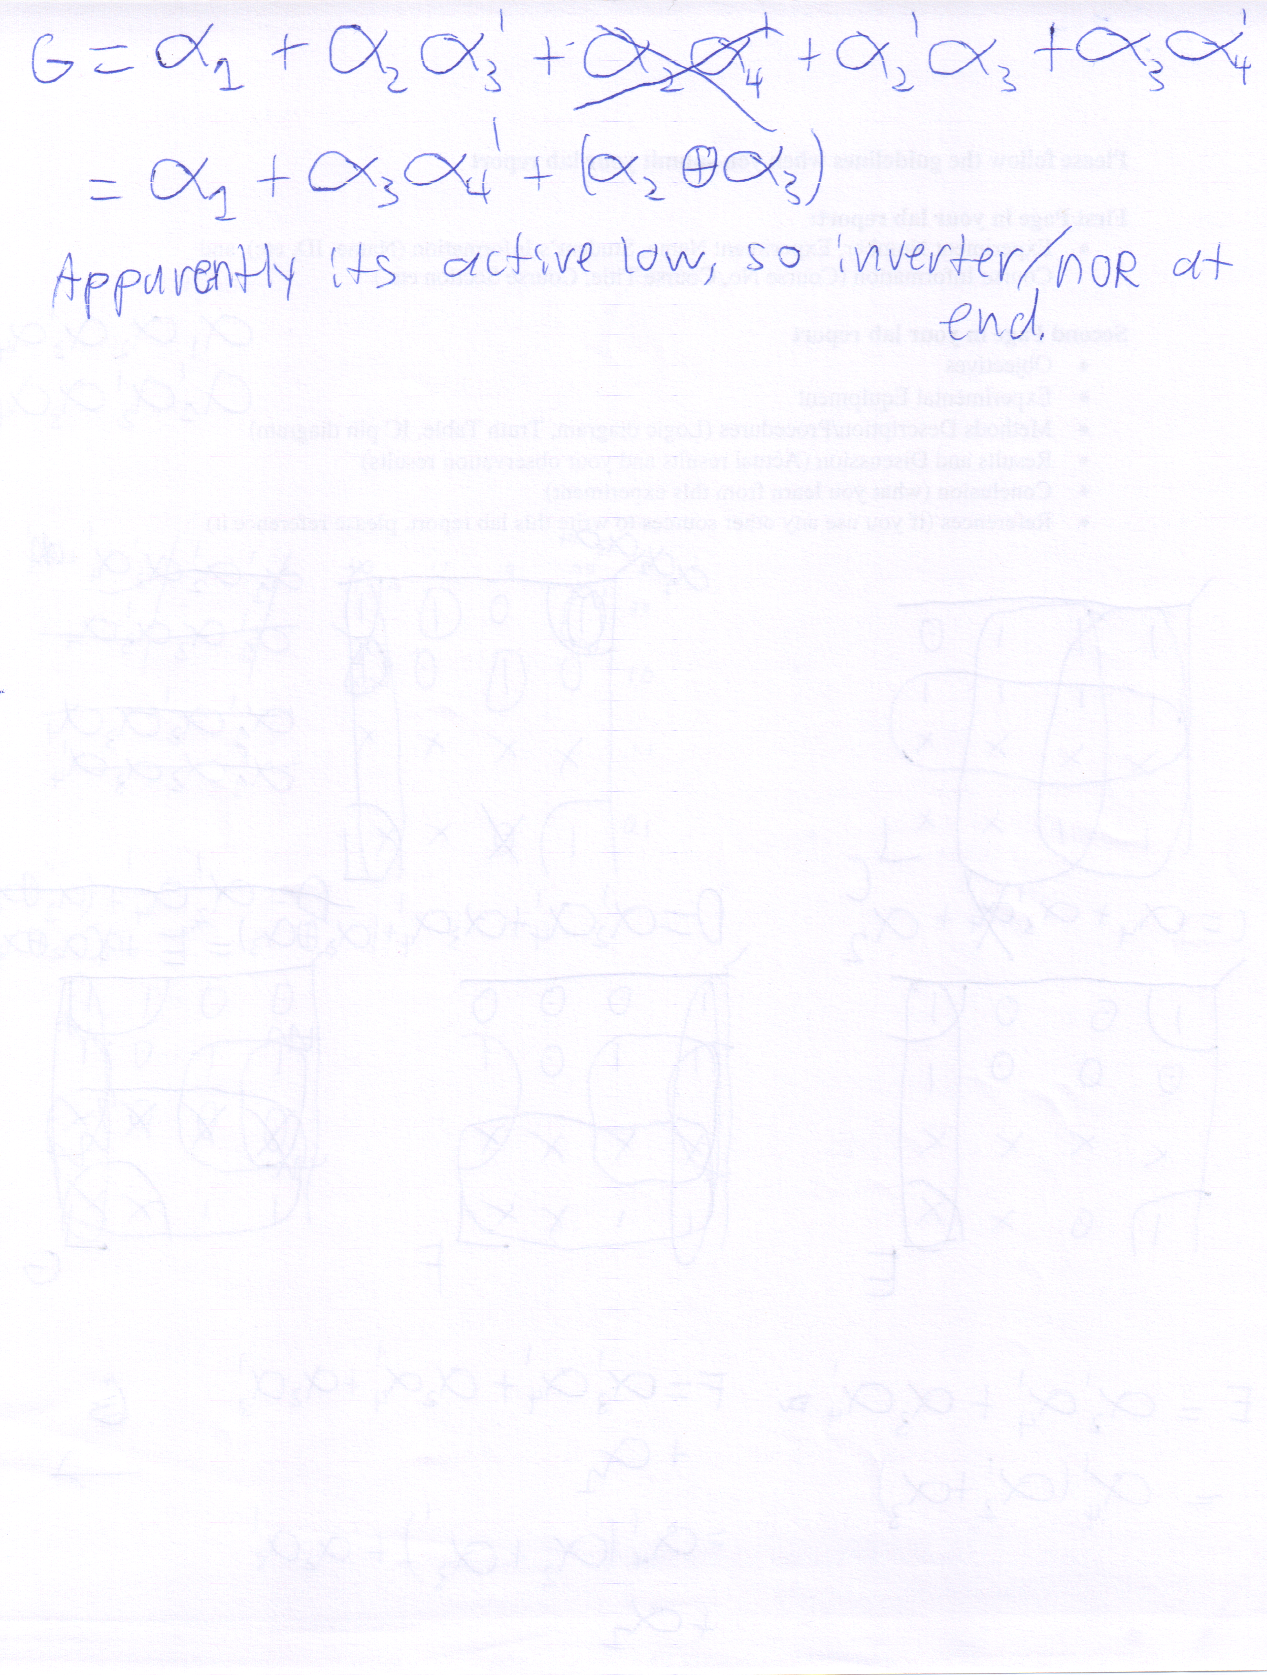
Note: Active low for simulation in Multisim.
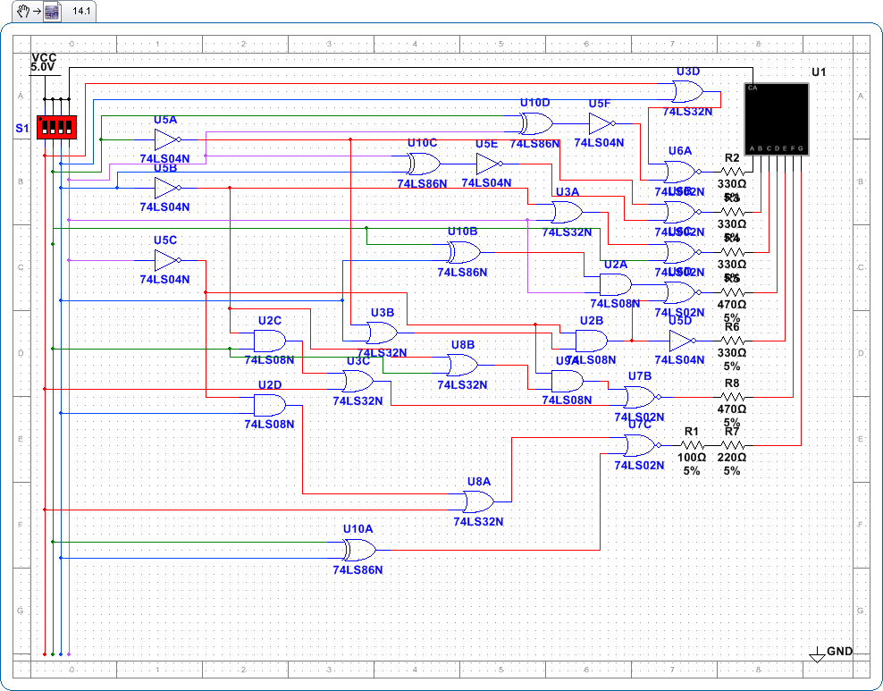
Note: Circuit design only used gates that were readily available.

Results/Discussion:
For the actual laboratory session, by the discretion of the professor, a single chip, the SN74LS47 BCD to 7-Segment decoder was used. The chip functioned and showed all 10 digits as per the specifications of its datasheet. The original circuit is still useful for questions outside of this laboratory assignment.

Conclusion:
Medium-scale integration circuits can be designed and constructed tediously using basic gates or by using a market solution (the MSI chip referenced).

References:
Texas Instruments, SN74LS47 Datasheet
Generic Datasheet (attached on subsequent pages), 1 Digit Seven Segments LED Display [sic]

