This lab uses data from an ODBII (on-board debugger v2) logger from the professor’s motor vehicle.
Images (in order per dataset):
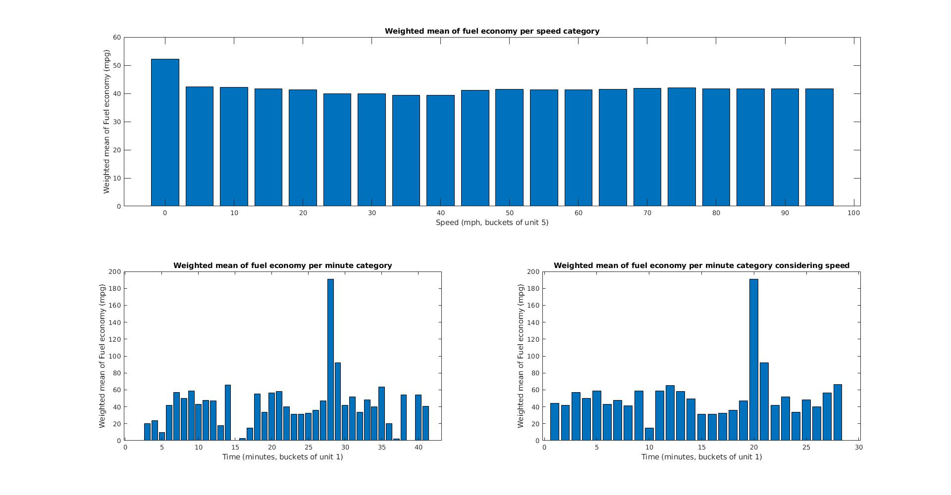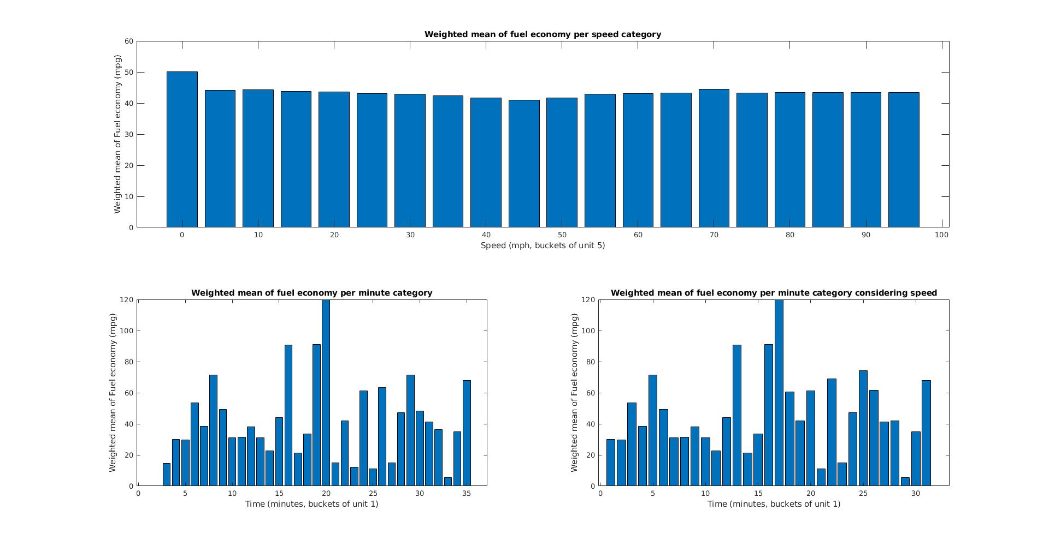
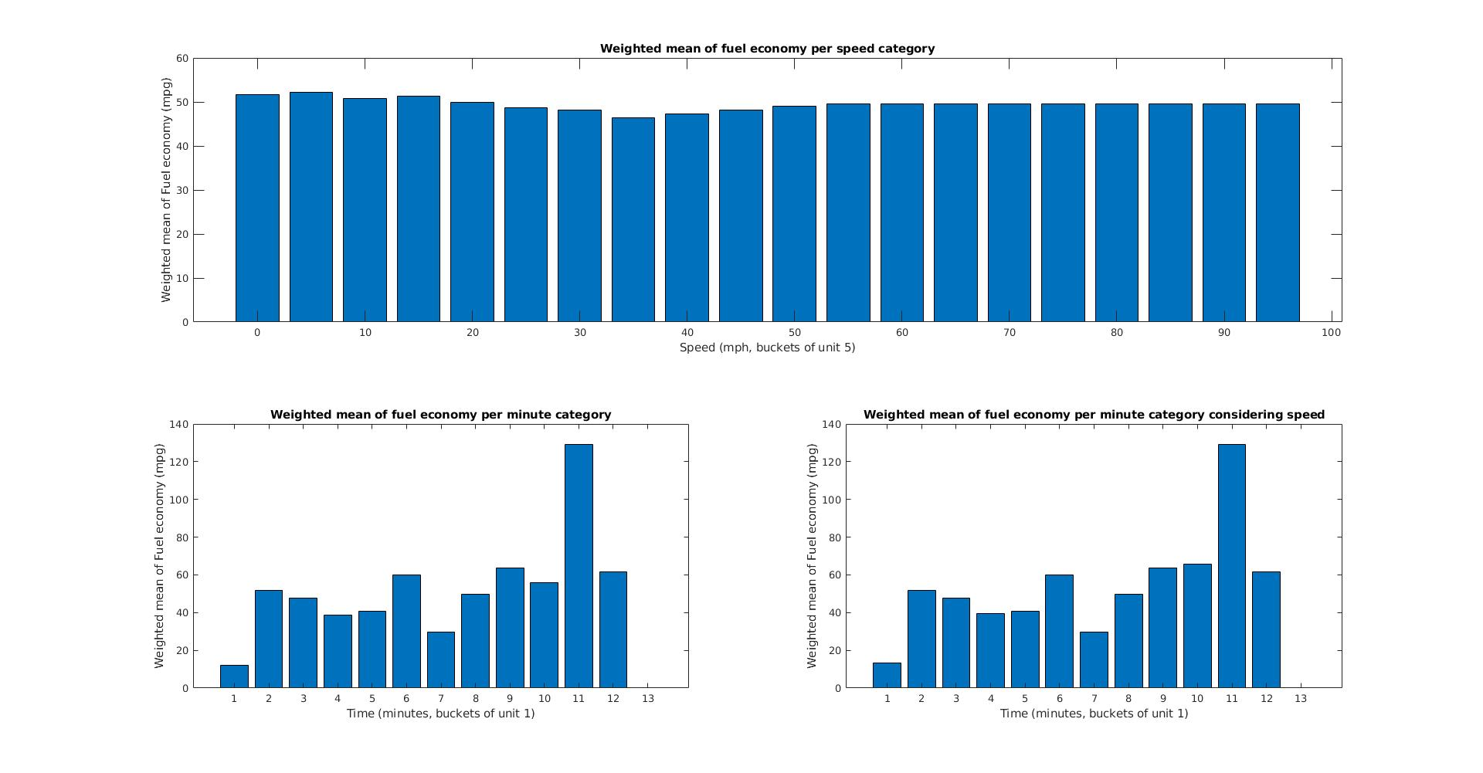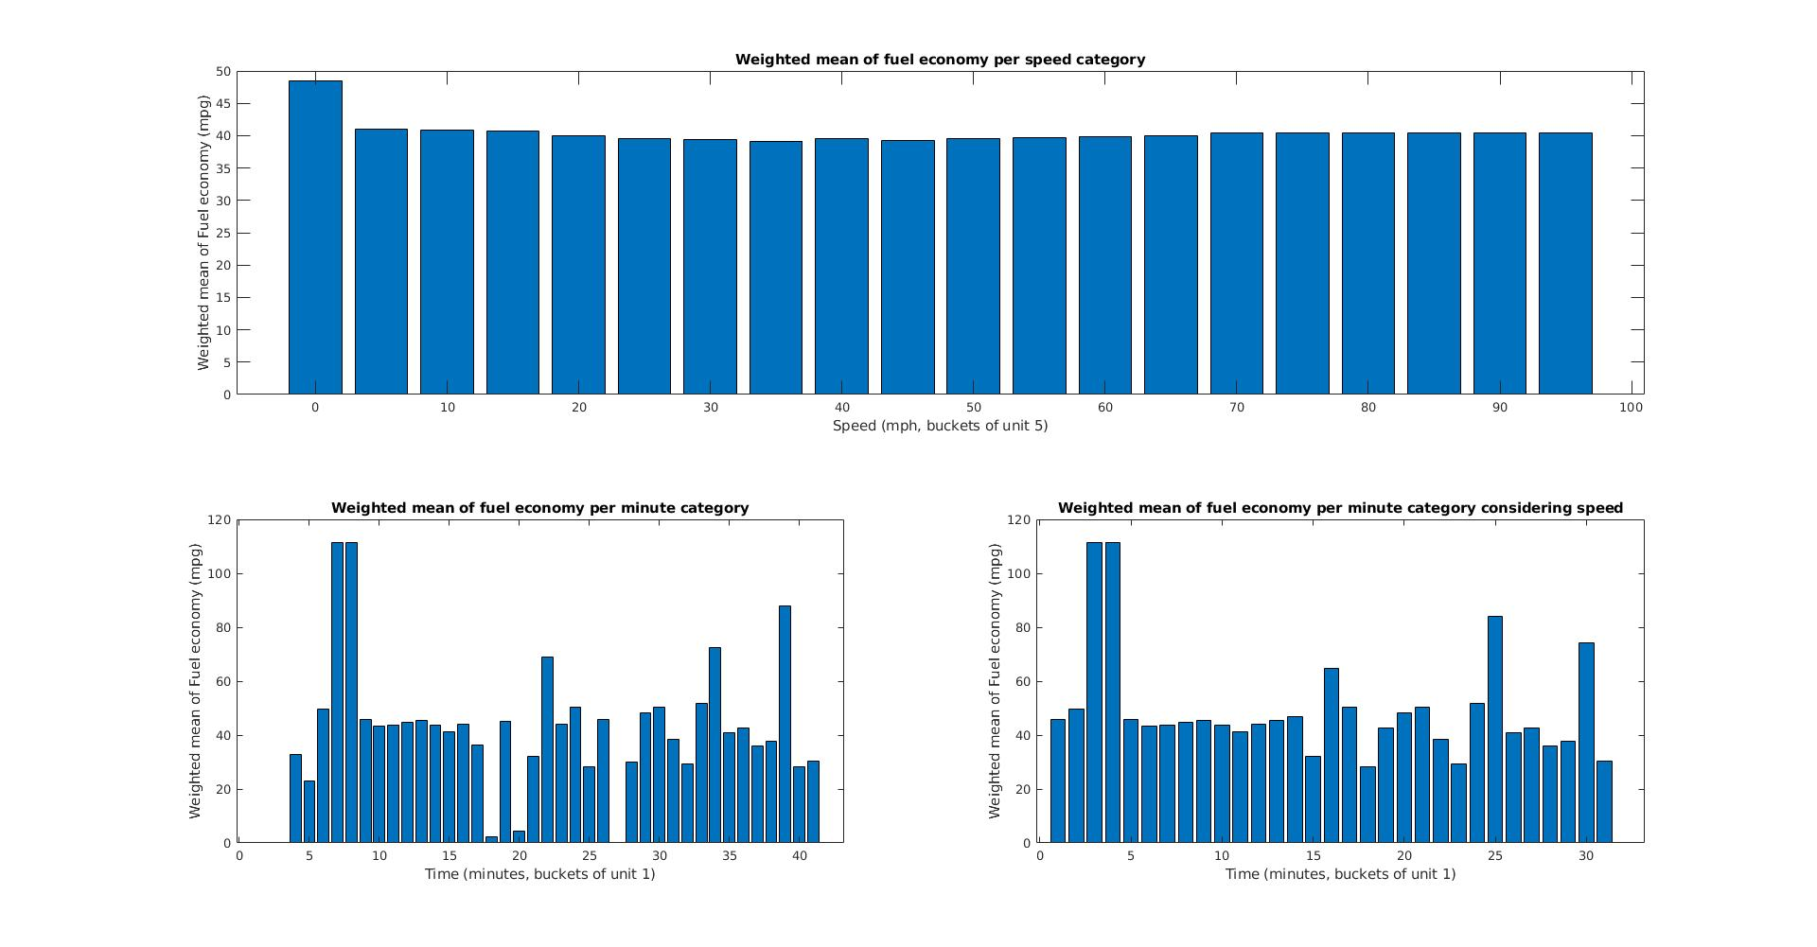
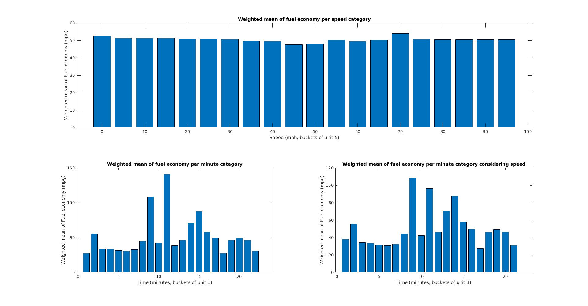
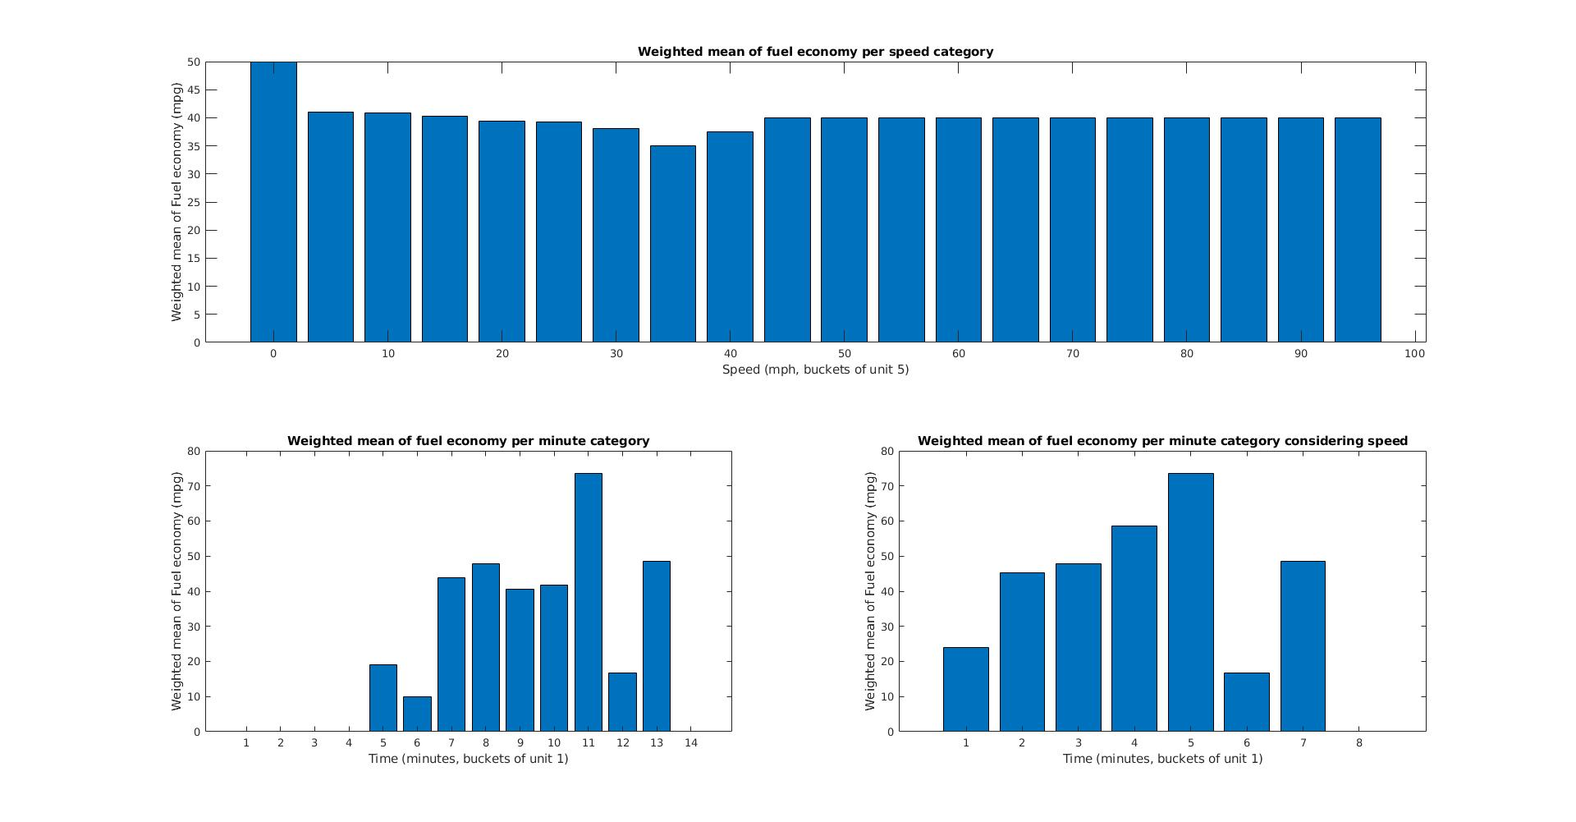
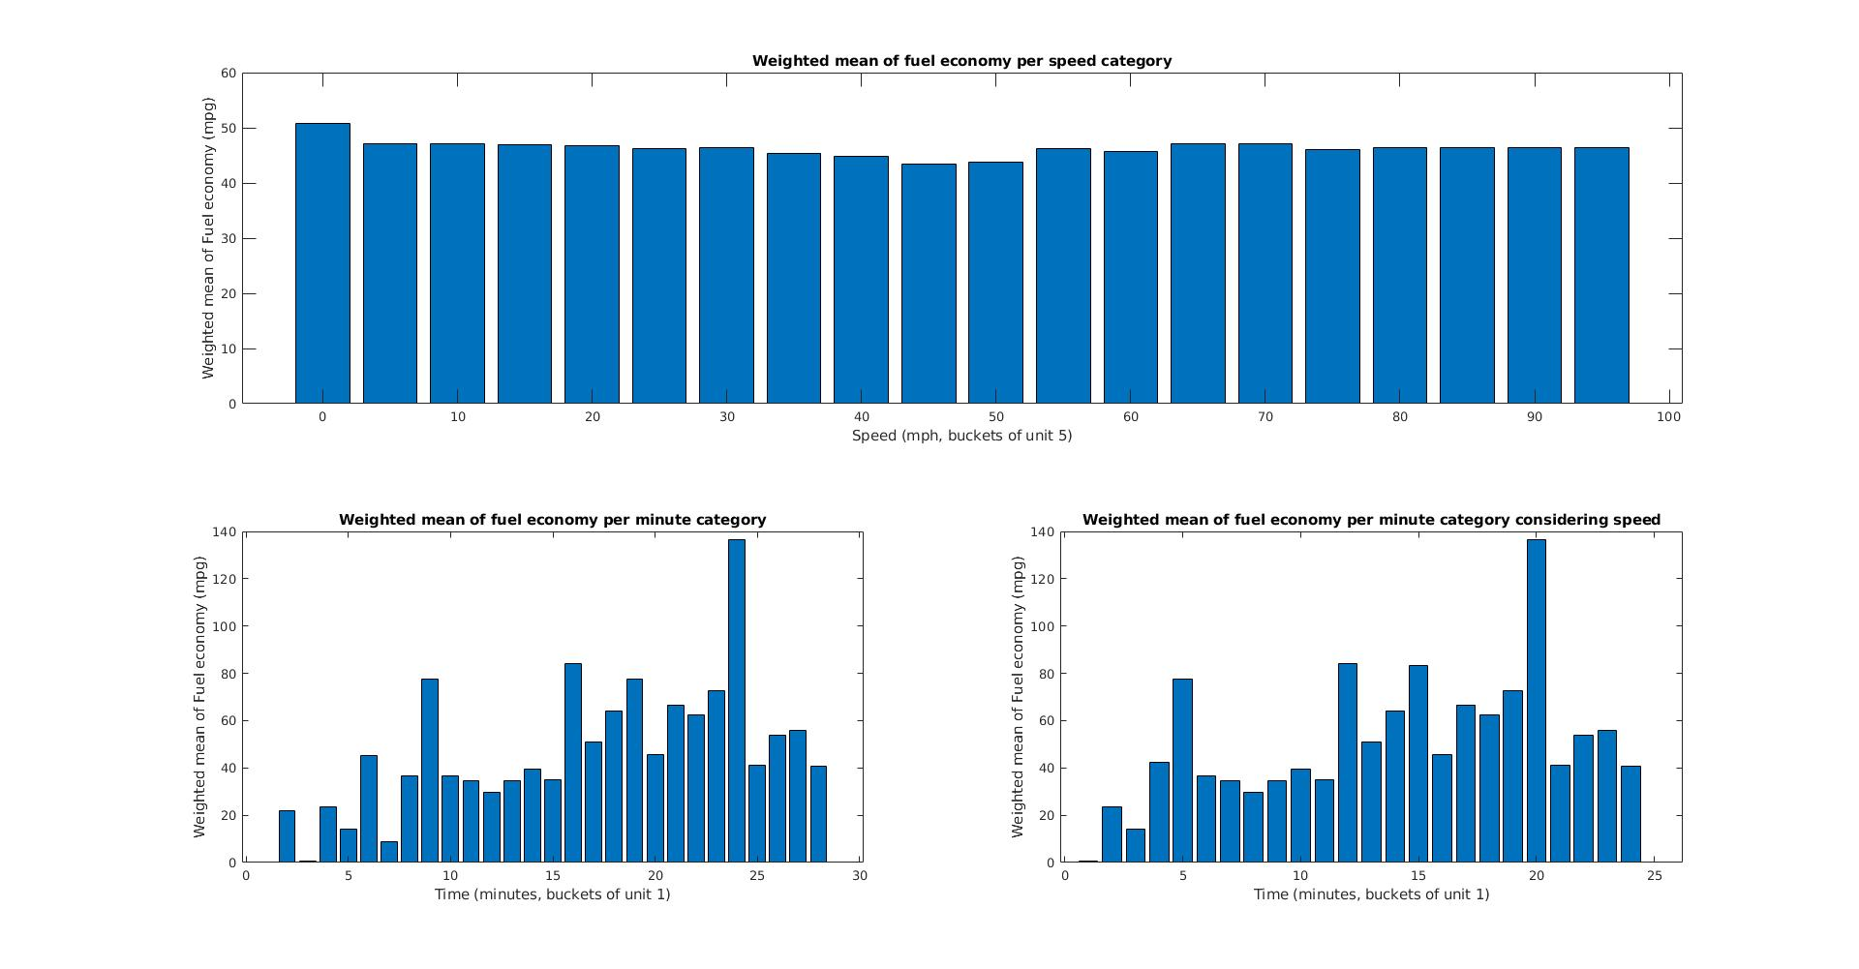
Scripts:
Part 1:
%Author: Peter A. Dranishnikov
%Lab number: 3
%Course number, section: EEL4685C, 01
%Due time, date, semester: February 12th, 17:20, Spring of 2019
%Function that accepts the log file's filename as argument
%returns an array containing the data in
%columns: timestamp, elapsed time from previous sample, average of
%continuous readings
%example usage: readdatalog('datalog1.csv')

function [result] = part1(filename)

TIME = 1;
GEAR = 5;
RPM = 7;

f = fopen(filename,'r');

junk = fgetl(f); % remove header line w/o worrying about contents
% Assume: Time (sec), Accel. Position (%), Boost (PSI), Fuel Economy (MPG), Gear Position (Gear), Engine RPM (RPM), Vehicle Speed (mph)
% read file, one data point per row
data = reshape(fscanf(f,'%f, %f, %f, %f, %d, %d, %d'), 7,[])';
disp(sprintf('%d data points read', size(data,1))); %report how many points were read from file
datalen = size(data, 1);
result = [data(2:datalen,1), data(2:datalen,1)-data(1:datalen-1,1), (data(2:datalen,2:4)+data(1:datalen-1,2:4))/2, data(2:datalen,5), (data(2:datalen,6:7)+data(1:datalen-1,6:7))/2];
fclose(f);
end

Part 2:
%Author: Peter A. Dranishnikov
%Lab number: 3
%Course number, section: EEL4685C, 01
%Due time, date, semester: February 12th, 17:20, Spring of 2019
%Function for weighted average of fuel econ and time difference
%returns a double of the resulting weighted average of the inputs
%also displays result to console
function [result] = part2(time_arr, fuel_econ)

result = sum(fuel_econ .* time_arr)/sum(time_arr);

disp(sprintf("The weighted mean of fuel economy is: %.2f mpg", result));
end

Part 3:
%Author: Peter A. Dranishnikov
%Lab number: 3
%Course number, section: EEL4685C, 01
%Due time, date, semester: February 12th, 17:20, Spring of 2019
%Function for weighted average excluding zero speed values
%Params: time_arr (values, vector), fuel_econ (weights, vector), speed
%(filter/mask, vector)
%Returns a double with the resulting weighted, filtered average
%also displays result to console
function [result] = part3(time_arr, fuel_econ, speed)

time_arr(speed == 0) = [];
fuel_econ(speed == 0) = [];

result = sum(fuel_econ .* time_arr)/sum(time_arr);

disp(sprintf("The weighted mean of fuel economy considering speed is: %.2f mpg", result));
end

Part 4a:
%Author: Peter A. Dranishnikov
%Lab number: 3
%Course number, section: EEL4685C, 01
%Due time, date, semester: February 12th, 17:20, Spring of 2019
%Function for bounded weighted average
%Params: values (vector), weights (vector), paramvals (filter, vector),
%bupper (upper bound, numeric), blower (lower bound, numeric)
%Returns a double with the resulting weighted average within the filtered bounds
function [result] = part4a(values, weights, paramvals, bupper, blower)

bool_arr = (paramvals >= bupper) & (paramvals < blower);
values(bool_arr) = [];
weights(bool_arr) = [];

result = sum(values .* weights)/sum(weights);
end

Part 4b:
%Author: Peter A. Dranishnikov
%Lab number: 3
%Course number, section: EEL4685C, 01
%Due time, date, semester: February 12th, 17:20, Spring of 2019
%Function for per minute averaging
%Params: values (vector), weights (vector), timestamp (decimal time, in seconds,
%sorted vector)
%Returns a vector of the weighted averages for each minute
%!!!!!!!!!!!!!!1
%NOTICE: if the input data does not have exact points that are evenly
%divisible by 60 or are floating point values, then the buckets may
%over or underextend by some amount of the error
function [result] = part4b(values, weights, timestamp)

min_divs = mod(timestamp, 60.0) < mean(weights);
time_vals = round(timestamp(min_divs));
loc_min_divs = find(min_divs == 1);

result = zeros(length(time_vals),1);
for i = 2:length(time_vals)
result(i-1) = sum(values(loc_min_divs(i-1):loc_min_divs(i)) .* weights(loc_min_divs(i-1):loc_min_divs(i))) / sum(weights(loc_min_divs(i-1):loc_min_divs(i)));
end

end

Part 4c:
%Author: Peter A. Dranishnikov
%Lab number: 3
%Course number, section: EEL4685C, 01
%Due time, date, semester: February 12th, 17:20, Spring of 2019
%Function for per minute averaging with a filter
%Params: values (vector), weights (vector), timestamp (decimal time, in seconds,
%sorted vector), elim_factor (filter, vector)
%Returns a vector of the filtered weighted averages for each minute
%!!!!!!!!!!!!!!1
%NOTICE: if the input data does not have exact points that are evenly
%divisible by 60 or are floating point values, then the buckets may
%over or underextend by some amount of the error
function [result] = part4c(values, weights, timestamp, elim_factor)
values(elim_factor == 0) = [];
weights(elim_factor == 0) = [];
timestamp(elim_factor == 0) = [];

min_divs = mod(timestamp, 60.0) < mean(weights);
time_vals = round(timestamp(min_divs));
loc_min_divs = find(min_divs == 1);

result = zeros(length(time_vals),1);
for i = 2:length(time_vals)
result(i-1) = sum(values(loc_min_divs(i-1):loc_min_divs(i)) .* weights(loc_min_divs(i-1):loc_min_divs(i))) / sum(weights(loc_min_divs(i-1):loc_min_divs(i)));
end
end

Combined script:
%Author: Peter A. Dranishnikov
%Lab number: 3
%Course number, section: EEL4685C, 01
%Due time, date, semester: February 12th, 17:20, Spring of 2019
%This script runs all parts of the lab assignment over all datalogs provided
for i = [1:7]
%Part 1-3
data = part1(sprintf('datalog%d.csv',i));
part2(data(:,2), data(:,5));
part3(data(:,2), data(:,5), data(:,8));
%Part 4 start here
%4a
figure;
subplot(2,1,1);
gen_arr = [0:5:100];
groups = zeros(length(gen_arr)-1,1);
for i = 1:length(gen_arr)-1
groups(i) = part4a(data(:,5), data(:,2), data(:,8), gen_arr(i), gen_arr(i+1));
end
gen_arr(gen_arr == 100) = [];%remove unused category (>=100 mph)
bar(gen_arr, groups);
title("Weighted mean of fuel economy per speed category");
xlabel("Speed (mph, buckets of unit 5)");
ylabel("Weighted mean of Fuel economy (mpg)");
%4b
subplot(2,2,3);
minutes = part4b(data(:,5), data(:,2), data(:,1));
bar(minutes);
title("Weighted mean of fuel economy per minute category");
xlabel("Time (minutes, buckets of unit 1)");
ylabel("Weighted mean of Fuel economy (mpg)");
%4c
subplot(2,2,4); %assignment says lower left, but so does the previous part, so lower right is what's left
speeding = part4c(data(:,5), data(:,2), data(:,1), data(:,8));
bar(speeding);
title("Weighted mean of fuel economy per minute category considering speed");
xlabel("Time (minutes, buckets of unit 1)");
ylabel("Weighted mean of Fuel economy (mpg)");
end

