This lab involved the continued use of the datalogs of the professor’s vehicle’s CAN bus.
Images:
Using datalog1.csv as input
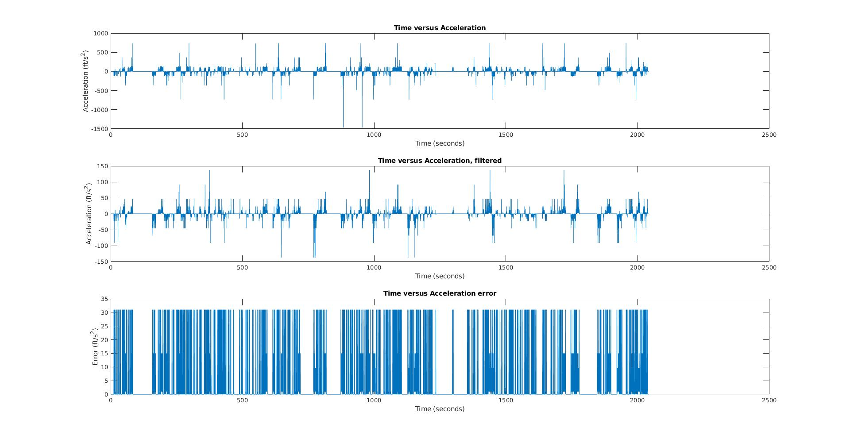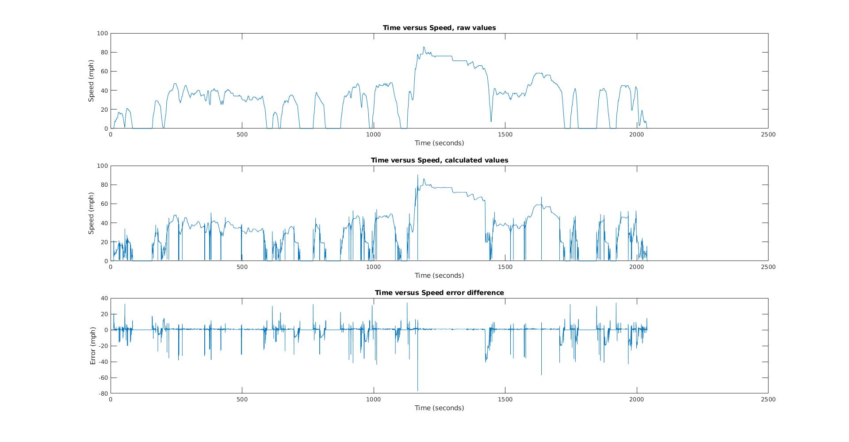
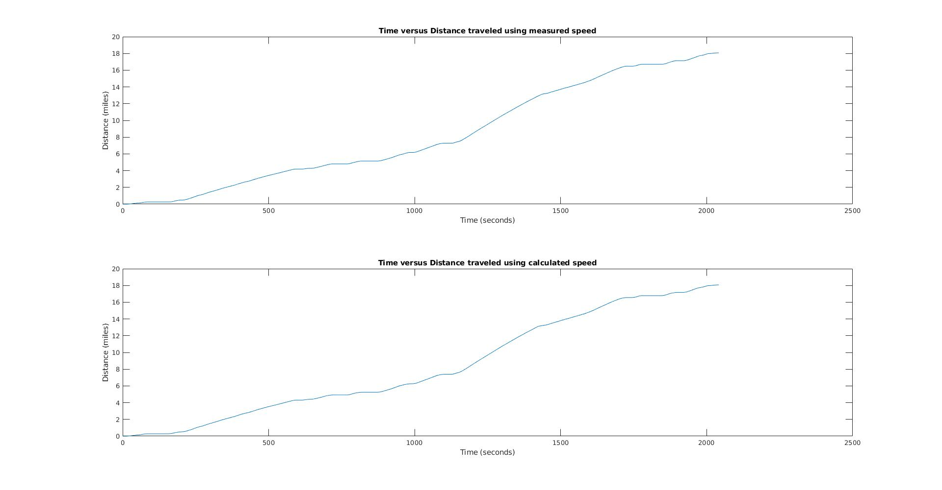

Using datalog4.csv as input:
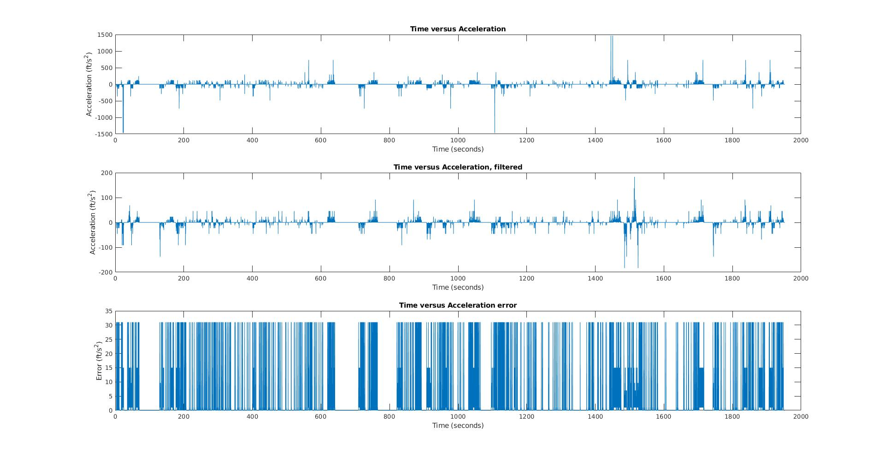
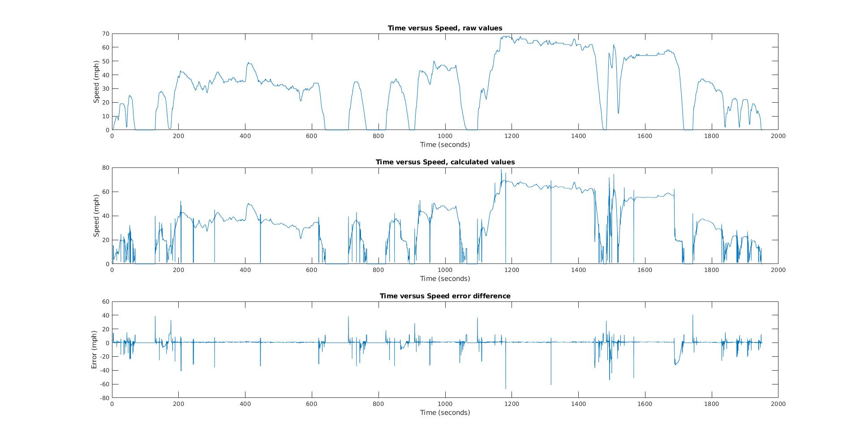
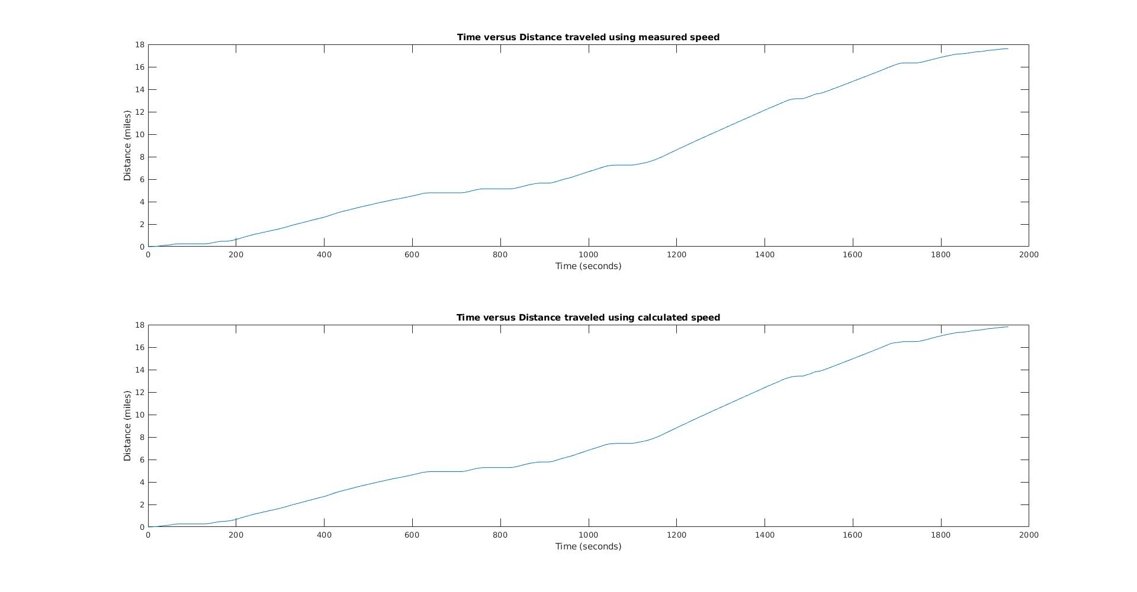

Matlab functions:
% Author: Peter Dranishnikov
% Lab 4
% EEL 4685c Section 01
% Due: February 26th, Spring 2019
%lab 4 part 1a-d
function [result, result_filter] = part1(filename)
f = fopen(filename,'r');

junk = fgetl(f); % remove header line w/o worrying about contents
% Assume: Time (sec), Accel. Position (%), Boost (PSI), Fuel Economy (MPG), Gear Position (Gear), Engine RPM (RPM), Vehicle Speed (mph)
% read file, one data point per row
data = reshape(fscanf(f,'%f, %f, %f, %f, %d, %d, %d'), 7,[])';
disp(sprintf('%d data points read', size(data,1))); %report how many points were read from file

dat_len = length(data);
spd = data(:,7);
time = data(:,1);
time_diff = data(2:dat_len,1)-data(1:dat_len-1,1);
%part a
acc = [0;(-22/15)*((spd(2:1:dat_len) - spd(1:1:dat_len-1)) ./ time_diff)];

subplot(3,1,1);
plot(time,acc);
title("Time versus Acceleration");
xlabel("Time (seconds)");
ylabel("Acceleration (ft/s^2)");

%part b
%i'm in dsp
avg = (1/32).*ones(1,32);
spd_window = filter(avg, 1, spd);
acc_filter = [0; (-22/15)*((spd_window(2:1:dat_len) - spd_window(1:1:dat_len-1)) ./ time_diff)];
subplot(3,1,2);
plot(time, acc_filter);
title("Time versus Acceleration, filtered");
xlabel("Time (seconds)");
ylabel("Acceleration (ft/s^2)");

%part c
subplot(3,1,3);
perdiff = abs((acc - acc_filter)./acc_filter);
perdiff(~isfinite(perdiff)) = 0;
plot(time, perdiff);
title("Time versus Acceleration error");
xlabel("Time (seconds)");
ylabel("Error (ft/s^2)");

%part d
result = acc;
result_filter = acc_filter;
end

% Author: Peter Dranishnikov
% Lab 4
% EEL 4685c Section 01
% Due: February 26th, Spring 2019
%lab 4 part 2
function [result] = part2(filename)
f = fopen(filename,'r');

junk = fgetl(f); % remove header line w/o worrying about contents
% Assume: Time (sec), Accel. Position (%), Boost (PSI), Fuel Economy (MPG), Gear Position (Gear), Engine RPM (RPM), Vehicle Speed (mph)
% read file, one data point per row
data = reshape(fscanf(f,'%f, %f, %f, %f, %d, %d, %d'), 7,[])';
disp(sprintf('%d data points read', size(data,1))); %report how many points were read from file

spd = data(:,7);
time = data(:,1);
gear_ratio = [0, 3.45, 1.95, 1.30, 0.97, 0.78, 0.67]; %add zero in front for easier concat
rpm = data(:,6);
gear = data(:,5) + 1;
filt_spd = spd;
filt_spd(gear > 1) = 0;

corrected_ratio = gear_ratio(gear)' + filt_spd;

spd_calc = (rpm .* (60 * pi * 25)) ./ ((5280 * 12 * 4.11) .* corrected_ratio);
spd_calc(~isfinite(spd_calc)) = 0;

spd_diff = spd_calc - spd;

subplot(3,1,1);
plot(time, spd);
title("Time versus Speed, raw values");
xlabel("Time (seconds)");
ylabel("Speed (mph)");

subplot(3,1,2);
plot(time, spd_calc);
title("Time versus Speed, calculated values");
xlabel("Time (seconds)");
ylabel("Speed (mph)");

subplot(3,1,3);
plot(time, spd_diff);
title("Time versus Speed error difference");
xlabel("Time (seconds)");
ylabel("Error (mph)");

result = spd_calc;
end

% Author: Peter Dranishnikov
% Lab 4
% EEL 4685c Section 01
% Due: February 26th, Spring 2019
%lab 4 part 3
function [result, result_2] = part3(filename)
f = fopen(filename,'r');

junk = fgetl(f); % remove header line w/o worrying about contents
% Assume: Time (sec), Accel. Position (%), Boost (PSI), Fuel Economy (MPG), Gear Position (Gear), Engine RPM (RPM), Vehicle Speed (mph)
% read file, one data point per row
data = reshape(fscanf(f,'%f, %f, %f, %f, %d, %d, %d'), 7,[])';
disp(sprintf('%d data points read', size(data,1))); %report how many points were read from file

dat_len = length(data);
spd = data(:,7);
time = data(:,1);
time_diff = data(2:dat_len,1)-data(1:dat_len-1,1);

dist_val = cumsum([0;(0.5 .* spd(2:dat_len) + 0.5 .* spd(1:dat_len-1)) .* (time_diff./3600)]);

subplot(2,1,1);
plot(time, dist_val);
title("Time versus Distance traveled using measured speed");
xlabel("Time (seconds)");
ylabel("Distance (miles)");

%copy and paste from part 2 to meet submission compliance
gear_ratio = [0, 3.45, 1.95, 1.30, 0.97, 0.78, 0.67]; %add zero in front for easier concat
rpm = data(:,6);
gear = data(:,5) + 1;
filt_spd = spd;
filt_spd(gear > 1) = 0;

corrected_ratio = gear_ratio(gear)' + filt_spd;
spd_calc = (rpm .* (60 * pi * 25)) ./ ((5280 * 12 * 4.11) .* corrected_ratio);
spd_calc(~isfinite(spd_calc)) = 0;

dist_calc = cumsum([0;(0.5 .* spd_calc(2:dat_len) + 0.5 .* spd_calc(1:dat_len-1)) .* (time_diff./3600)]);

subplot(2,1,2);
plot(time, dist_calc);
title("Time versus Distance traveled using calculated speed");
xlabel("Time (seconds)");
ylabel("Distance (miles)");

result = dist_val;
result_2 = dist_calc;
end

