Problem 1:
Define each of the following:
- Processor
A processor is a circuit that performs some task based on the input and produces output.
- CPU
Acronym for Central Processing Unit; The main processor of a (micro)computer. Contains the finite state machine elements, register file, ALU, and controllers to perform the fetch, decode, execute steps from a memory input and output connected to components such as memories and I/O (depending on architecture).
- Microprocessor
A microprocessor is a processor on an integrated circuit (IC, “chip”).
- Microcomputer
A microcomputer is a computer on an IC (“chip”)
- Microcontroller
A microcontroller is a microprocessor with control interfaces, ADCs, and DACs. Currently synonymous with microprocessor.

Problem 2:
A 4-bit processor X has:
1. 32 KiB address space.
2. Reset vector at the beginning of the address space, i.e., at address 0.
3. 4-bit data bus.
You are asked to build a basic computer with one 4 KiB×4 RAM and one 8 KiB×4 ROM. Show all calculations and the memory map when using the following strategies:
- Full-memory decoding
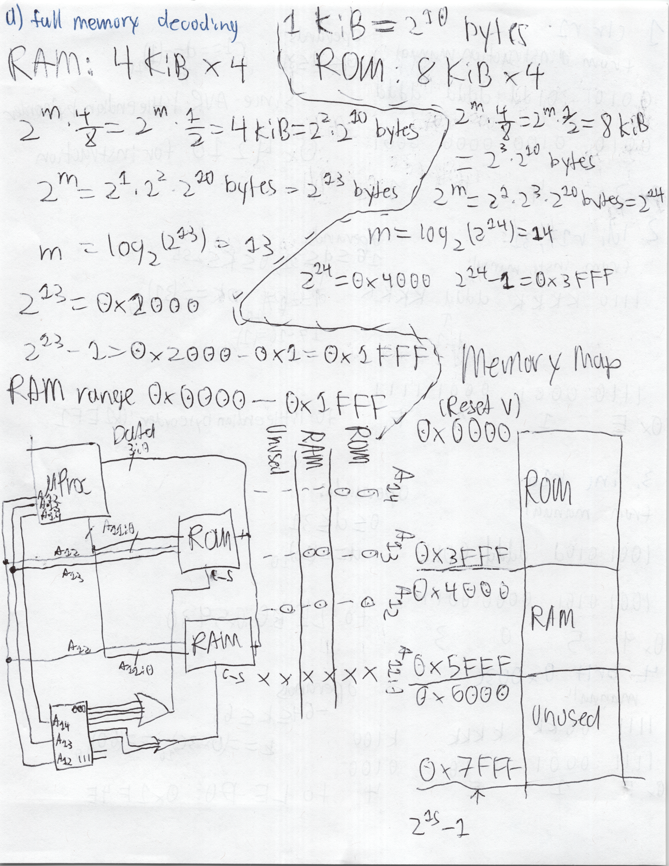
- Partial-memory decoding
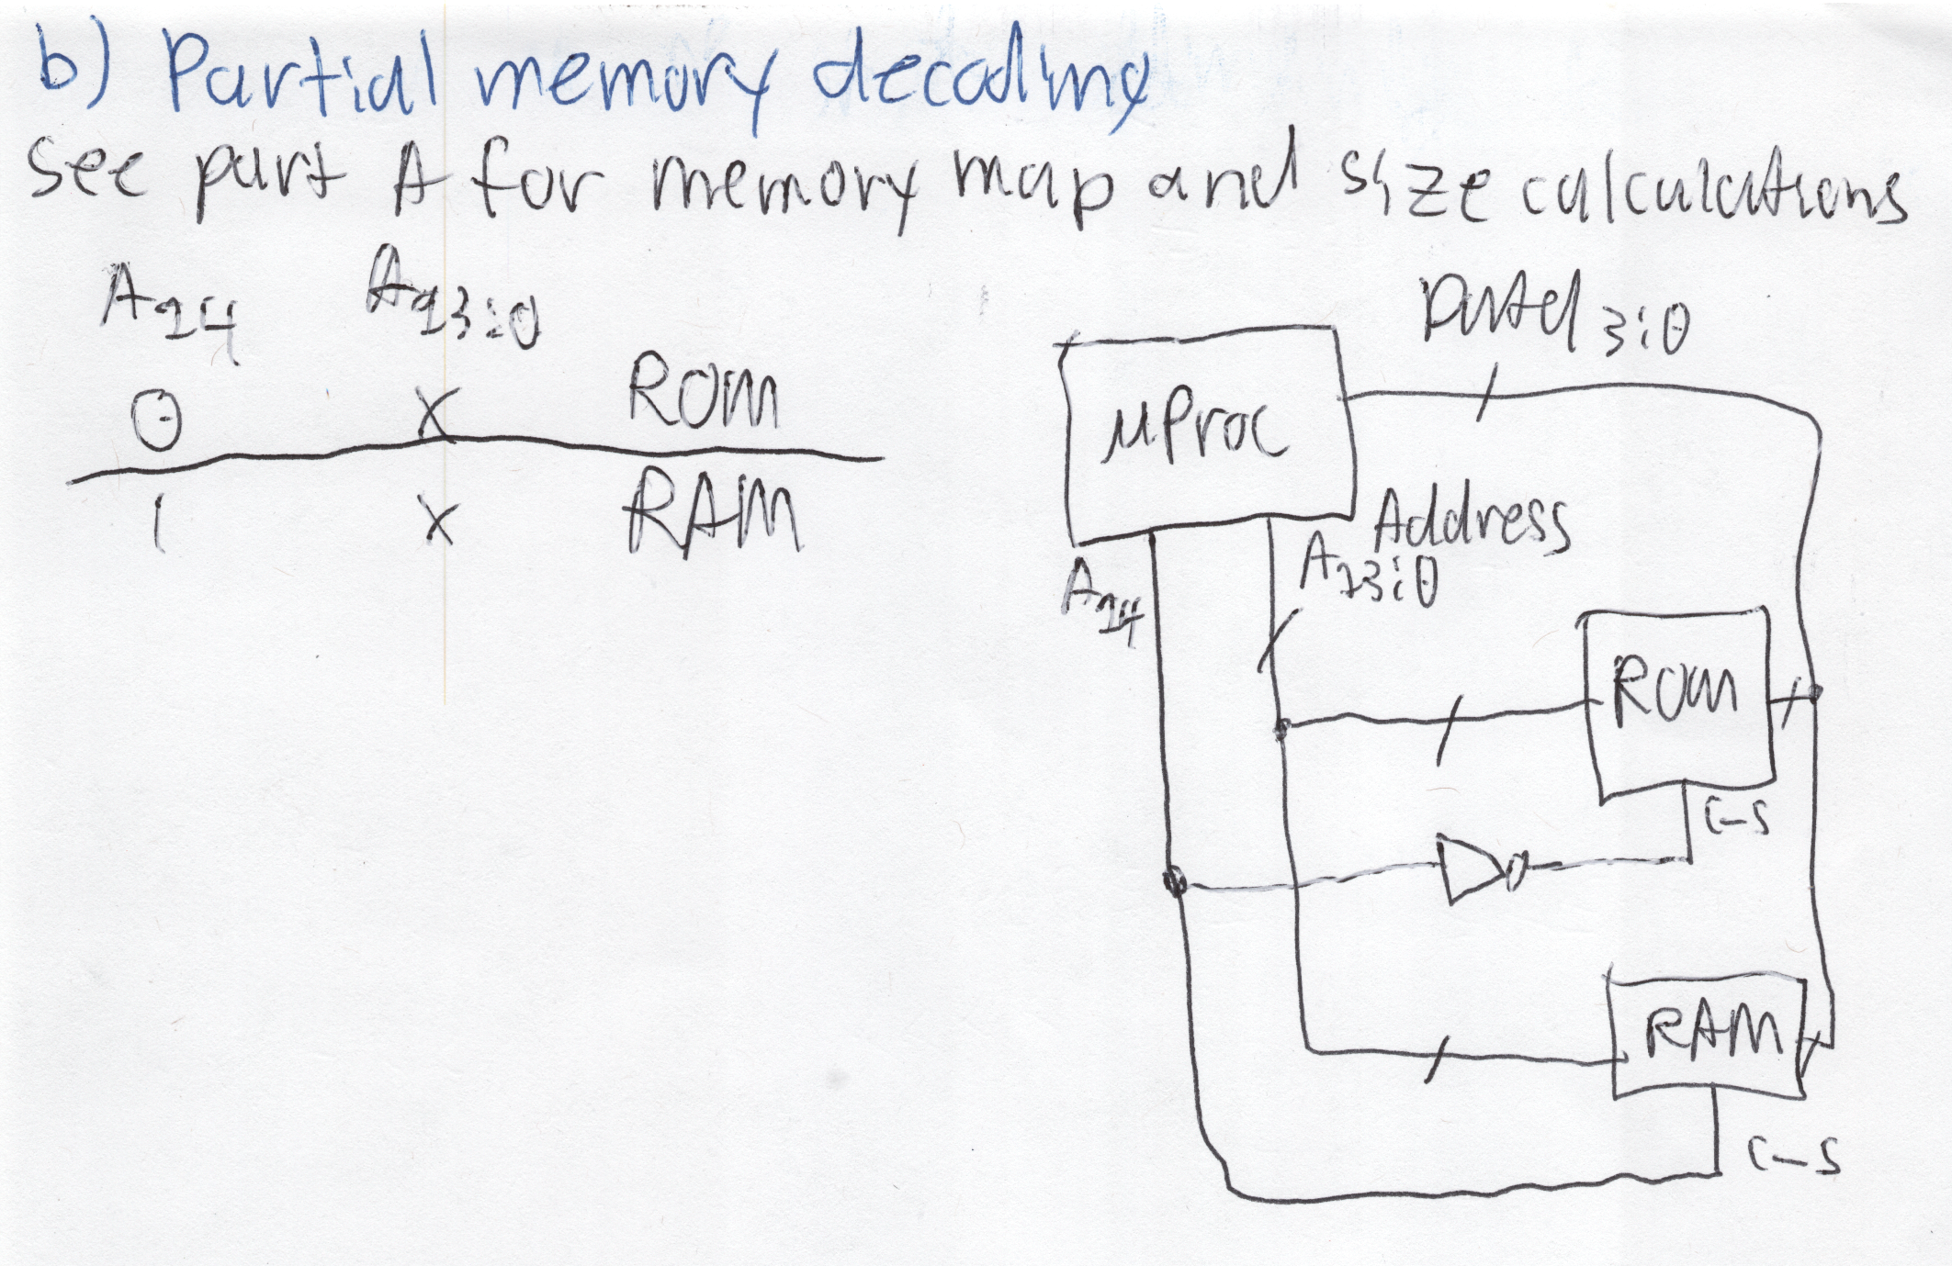

Problem 3:
Looking at the machine code of the instruction in the program memory location 0x0014, and it was found to be 0x5406. Answer the following:
- What is the instruction?
sbci r22, 80 ;subtract (from r22) immediate (decimal 80) with carry set bit in I/O register
- What are the used addressing modes?
Register direct, single register
- What are the operands?
Rd==0110_{2,} K==0101 0000₂

Problem 4:
By hand, convert each of the following AVR assembly instructions to its equivalent machine code. For each instruction assume that it is located at address 0x0050 in the program memory. Show all the steps.


