|  |
| --- |
|  |
| Cross-correlation and phase shift estimation for CW LiDAR |
| EEE 4510 Digital Signal Processing |

|  |
| --- |
| Dranishnikov, Peter  4/8/2019 |

**Introduction:**

A low-cost alternative to microwave-frequency sampling LiDAR system is by using a Continuous Wave (CW) system by driving a laser diode with a sine wave and DC bias and receive with a photo-receptive diode. In this report, several methods of cross correlation and peak location techniques are explored. The complete source code is in appendix A.

**Is it possible to use more cycles to make the cross-correlation curve smoother and reduce the ambiguity in the peak location?**

Yes, it is possible to use more cycles to increase the apparent smoothness of the cross-correlation curve in the aggregate and the correlation value of the peak. However, at the peak location, some noise is still present due to more data andnoise in the extra cycles, which only decreases the ambiguity range, not the ambiguity of the peak location itself. This portion of the MATLAB script takes six iterations, incrementing the cycle count by five each pass. The first figure shows the peak range graph for a cycle count of five. The second figure shows the peak range graph for a cycle count of 30. The apparent parabola of the peak shrank in width and increased in vertex value with increasing cycle count, with a more pronounced vertex shape. Obtaining a realistic value for the phase shift would be to match the current second graph to a parabolic function.

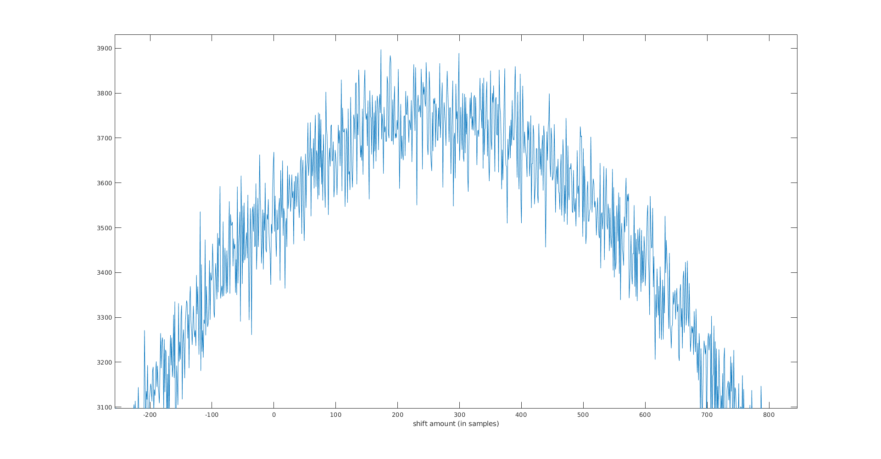

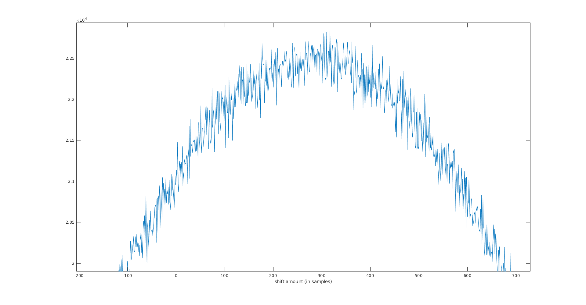

**Is it possible to do multiple measurements of the signals and average these measurements over time?**

Yes, it is possible to perform multiple measurements of the signal and average, as done below. However, the amount of time between measurements is important in considering the utility of the average obtained. For a LiDAR application, the duration of tens of minutes between measurements would not be of great utility for real-time scanning and computation. The average estimate of the sample difference obtained was 287 samples (rounded to the whole number). The average estimate of the phase shift obtained was 20.5104 degrees.

**Appendix A: MATLAB Source code**

%part 1

vals = [5:5:30];

est_sampleDiff = [];

est_phase = [];

for i = vals

% ADC speed

Fs=50e6;

Ts=1/Fs;

% sine freq

fo=10e3;

To=1/fo;

% number of cycles

Nc=i;

% time values

tv=[0:Ts:Nc*To];

% Measurement noise max

AN=1.0;

% RX signal ampl.

AR=0.3;

% Generate the first signal

x_Tx=sin(2*pi*fo*tv);

% add some extra zeros

x_Tx=[x_Tx zeros(1,length(x_Tx))];

% add some noise

n1=(AN)*(2*rand(1,length(x_Tx))-1);

x_Tx=x_Tx+n1;

% Plot

figure; clf; hold on;

plot(x_Tx);

xlabel('samples');

% phase shift (degrees)

diff_phase=20.3;

ph = diff_phase * pi/180; % deg to radians

% Generate the second signal

x_Rx=(AR)*sin(2*pi*fo*tv-ph);

% add some extra zeros

x_Rx=[x_Rx zeros(1,length(x_Rx))];

% add some noise

n2=(AN)*(2*rand(1,length(x_Rx))-1);

x_Rx=x_Rx+n2;

plot(x_Rx);

xlabel('samples');

% cross correlation

[cor,lags]=xcorr(x_Rx, x_Tx);

% Plot

figure; clf;

plot(lags,cor);

xlabel('shift amount (in samples)');

% find peak location and corresponding lag

[mx,ix]=max(cor);

est_sampleDiff = [est_sampleDiff, (lags(ix))];

est_phase = [est_phase, (est_sampleDiff * 360 / (Fs/fo))];

end

est_sampleDiff

mean(est_sampleDiff)

est_phase

mean(est_phase)

%part 2

vals = [1:1000:5000]; % a few hours in total

est_sampleDiff = [];

est_phase = [];

for i = vals

% ADC speed

Fs=50e6;

Ts=1/Fs;

% sine freq

fo=10e3;

To=1/fo;

% number of cycles

Nc=5;

% time values

tv=[0:Ts:Nc*To];

% Measurement noise max

AN=1.0;

% RX signal ampl.

AR=0.3;

% Generate the first signal

x_Tx=sin(2*pi*fo*tv);

% add some extra zeros

x_Tx=[x_Tx zeros(1,length(x_Tx))];

% add some noise

n1=(AN)*(2*rand(1,length(x_Tx))-1);

x_Tx=x_Tx+n1;

% Plot

figure; clf; hold on;

plot(x_Tx);

xlabel('samples');

% phase shift (degrees)

diff_phase=20.3;

ph = diff_phase * pi/180; % deg to radians

% Generate the second signal

x_Rx=(AR)*sin(2*pi*fo*tv-ph);

% add some extra zeros

x_Rx=[x_Rx zeros(1,length(x_Rx))];

% add some noise

n2=(AN)*(2*rand(1,length(x_Rx))-1);

x_Rx=x_Rx+n2;

plot(x_Rx);

xlabel('samples');

% cross correlation

[cor,lags]=xcorr(x_Rx, x_Tx);

% Plot

figure; clf;

plot(lags,cor);

xlabel('shift amount (in samples)');

% find peak location and corresponding lag

[mx,ix]=max(cor);

est_sampleDiff = [est_sampleDiff, (lags(ix))];

est_phase = [est_phase, (est_sampleDiff * 360 / (Fs/fo))];

pause(i);

end

est_sampleDiff

mean(est_sampleDiff)

est_phase

mean(est_phase)