|  |
| --- |
|  |
| Comparison of Direct Digital Synthesis of Integer and Floating-Point Decimal Generation |
| EEE 4510 Digital Signal Processing |

|  |
| --- |
| Dranishnikov, Peter  4/8/2019 |

**Introduction:**

|  |  |  |  |
| --- | --- | --- | --- |
| Original Frequency | Floating point frequency | Fixed point N = 10 | Fixed point  N = 20 |
| 20 | 20 | 21.5 | 20 |
| 400 | 400 | 409 | 400 |
| 1800 | 1800 | 1809 | 1800 |
| 5500 | 5500 | 5491 | 5500 |
| 10000 | 10000 | 9992 | 10001 |

Direct Digital Synthesis (DDS) is an inexpensive way to generate signals with only simple, digital hardware or software. However, DDS has some significant drawbacks for certain applications which require more “pure” signals than the ones generated by DDS. Since DDS outputs a signal of only zeros and ones (effectively a square wave), the harmonics produced by such a wave are much greater than that of a sine wave output of the same frequency. There are several techniques to suppress such “undesired” frequencies, each with their own drawback. In this project, the effect between resulting frequencies from the desired frequency for different measurement counts and target frequencies is described. The images shown in later pages are in increasing target frequency (Fo) in alternating between 10- and 20-bit resolutions (N). The MATLAB source code executed is in Appendix A.

**Results:**

**Discussion:**

For N = 10 measurements, there is a significant deviation of the resulting frequency for the fixed-point DDS generator equation, up to 9 Hz for higher frequencies compared to the floating-point DDS generator. For N = 20 measurements, the frequency deviation compared to the floating-point is negligible, but the amplitude differs for higher frequencies.

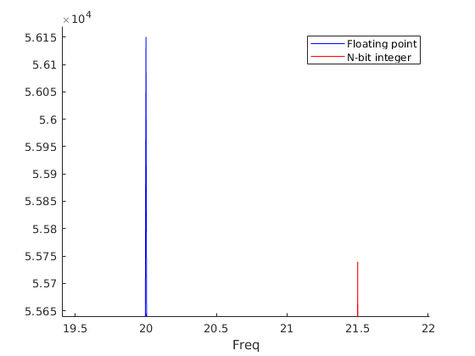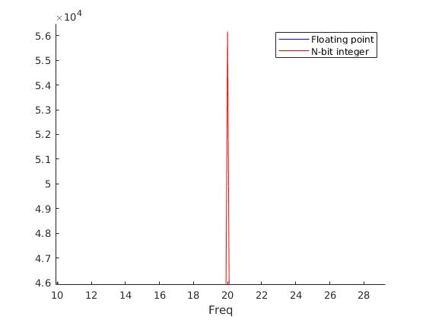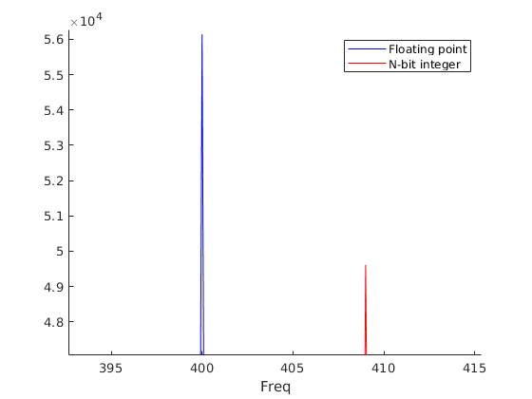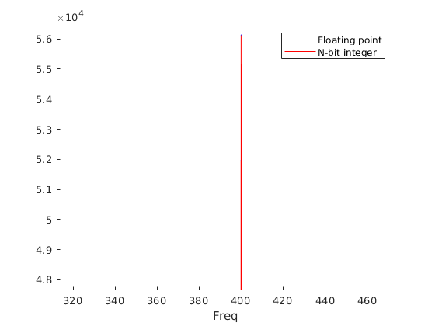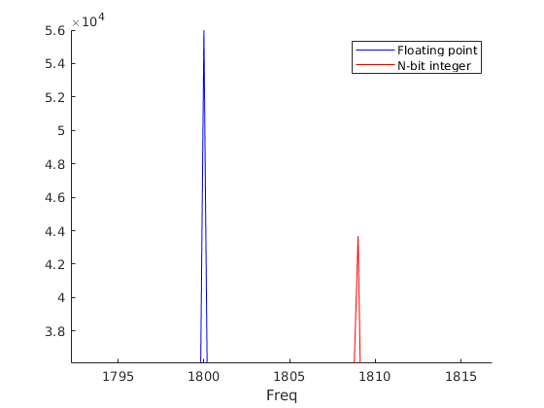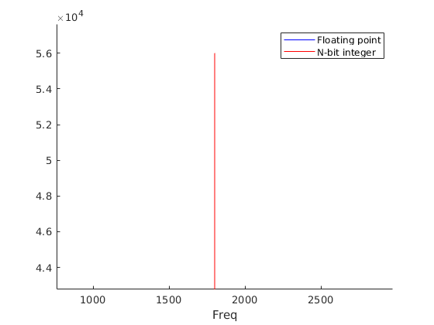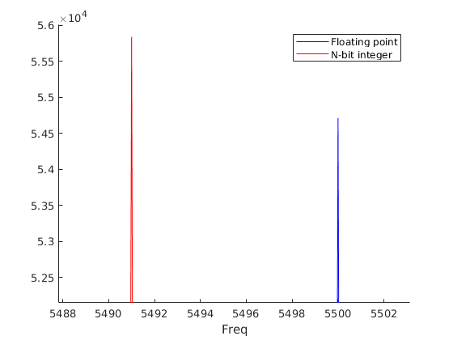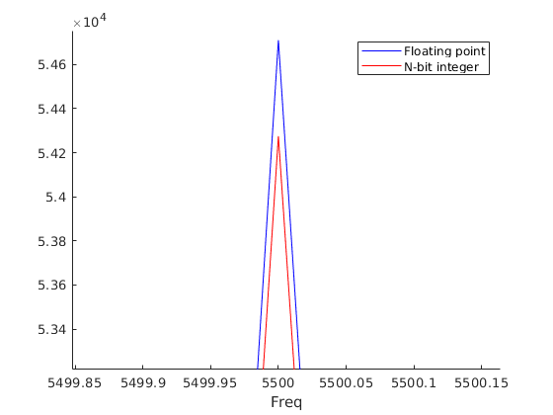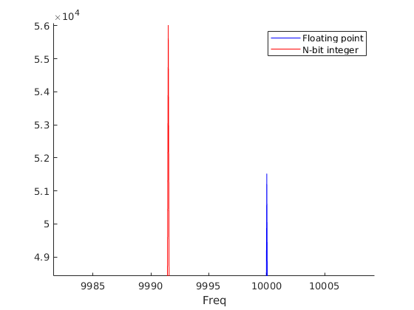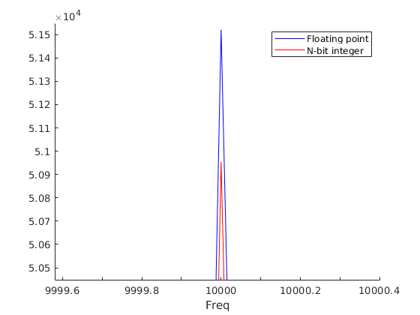

**Appendix A: MATLAB Source code**

fo_vals = [20, 400, 1800, 5500, 10000];

n_vals = [10, 20];

for i = fo_vals

% DDS project

fs=44100;

Ts=1/fs;

signal_duration=2;

kval=[0:signal_duration*fs];

tval=kval*Ts;

%fo=20001.8;

fo=i; %20, 400, 1800, 5500, 10000

% table

ta = [-1 1];

% alpha = fo/(fs/2)

alpha = fo/(fs/2);

% (-1)^POWER formula

xdds=(-1).^round(alpha*kval);

% Table/array based formula

xdds1=ta(1 + mod(round(alpha*kval),2));

% Integer arithmetic based formula

% alpha = M/2^N

for j = n_vals

N=j;

M=round(2^N*alpha);

xdds2=ta(1 + mod(round((M/2^N)*kval),2));

%sound(xdds, fs);

figure; clf; hold on;

xdds1=xdds1-mean(xdds1);

plot(linspace(-fs/2,fs/2,length(xdds1)),abs(fftshift(fft(xdds1))),'b-')

xdds2=xdds2-mean(xdds2);

plot(linspace(-fs/2,fs/2,length(xdds2)),abs(fftshift(fft(xdds2))),'r-')

xlabel('Freq');

legend('Floating point','N-bit integer');

end

end