Design and Implementation of a Passive High-Pass Filter

Peter Dranishnikov

12/06/2019

EEL3112C section 01

# Equipment used:

* Function Generator
  + Sweep mode was used, but a non-sweeping FG can be used
  + Any audio DAC can substitute an FG after calibration for differing impedances
* Oscilloscope
  + A 4-channel sampling oscilloscope with FFT was used, but only one channel was necessary for measurements
  + An audio ADC and averaging time-series plotting software can substitute an oscilloscope after calibration for differing impedances
* Multimeter
  + For measurement of the capacitor’s and resistor’s values
* Note: Ideally, a bode plotter would be used to measure the frequency response of the filter, but one was not readily available.

# Theoretical Results:

The primary equation for the selection of a resistor and capacitor network is the following:

$$2πf_{c}=\frac{1}{RC}$$

For fc = 4000, the following equation prevails:

$$8000π=\frac{1}{RC}$$

Thus, the resistor and capacitor values can be chosen freely or subject to other external constraints based on the above derived formula.

# Components:

For this design, resistors and capacitors were used due to the greater market variety of both resistors and capacitors comparted to alternate filter designs such as resistor-inductor passive filters. For the full selection matrix computation, see Appendix A

|  |  |  |  |
| --- | --- | --- | --- |
| Values | R (Ω) | C (F) | 3db attenuation freq (Hz) |
| Selected | 3900 | 1.00x10-8 | 4080.89598 |
| Actual | 3853.4 | 9.10x10-9 | 4538.73 |

The component pair above was selected due to having a small footprint and availability of parts.

# Simulation Schematic and Results:

The theoretical circuit schematic and simulated sinusoidal sweep response from 1 Hz to 10 kHz is shown in the figures below. The simulation was performed in MultiSim.

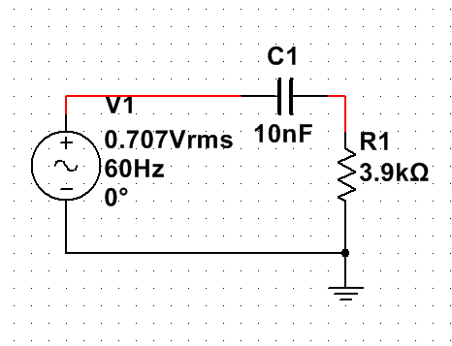

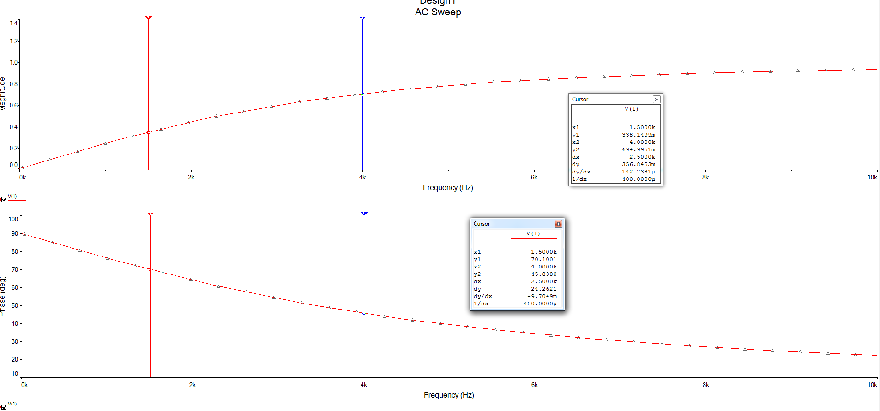

Likewise, the experimental circuit (with measured resistor and capacitor values) is displayed below with the simulated sinusoidal sweep response

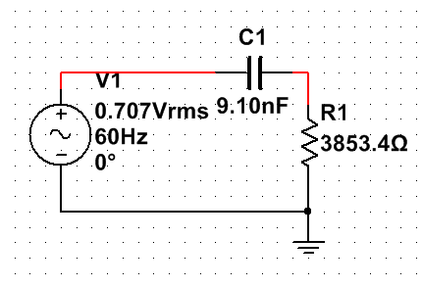

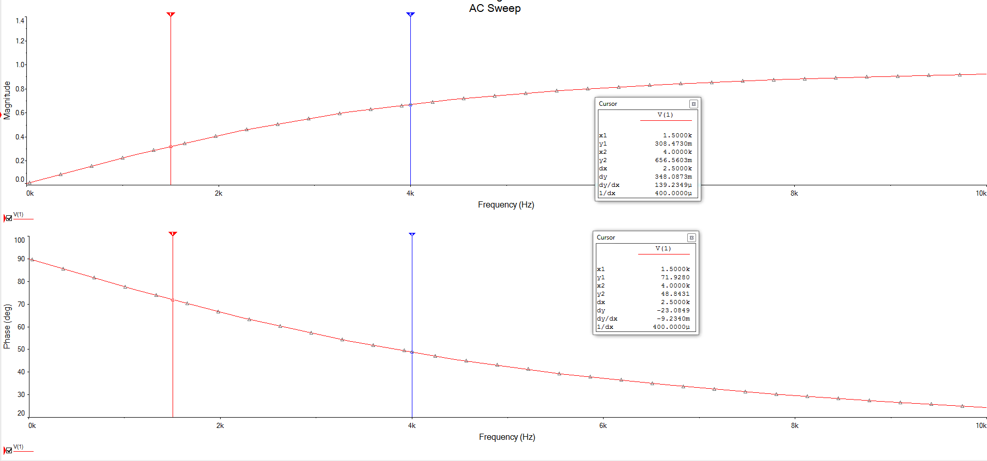

# Experimental Results:

The following values were produced using the function generator set to sweep mode from 1 Hz to 10kHz with a sweep period of 15 seconds. The long sweep period was set to ensure that the oscilloscope could capture images of the waveforms at the passband and stopband frequencies. The values are tabulated and plotted below.

|  |  |
| --- | --- |
| Frequency (Hz) | Vmag (V) |
| 625* | 0.12 |
| 1111* | 0.2 |
| 2948 | 0.26 |
| 3259 | 0.54 |
| 3492 | 0.46 |
| 5028 | 0.66 |
| 7143 | 0.78 |

*these frequencies were computed by manual counting of the period due to measurement noise

The oscilloscope screenshots below are in ascending order of frequency. The red graph displayed is the oscilloscope’s built-in Fast Fourier Transform (FFT) function. However, the FFT graph is for reference purposes only, as the smallest resolution available is 5kHz per division, which is higher than the cutoff frequency.

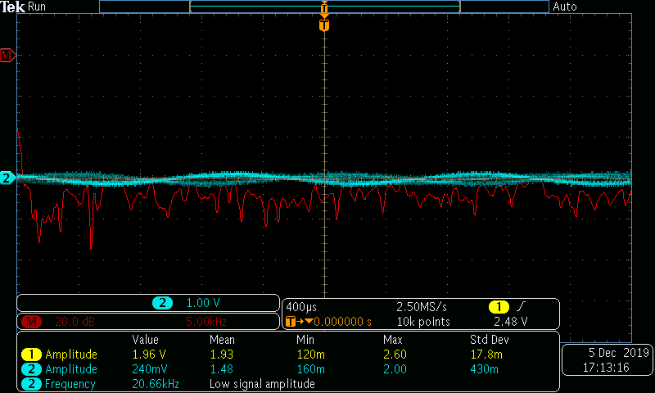

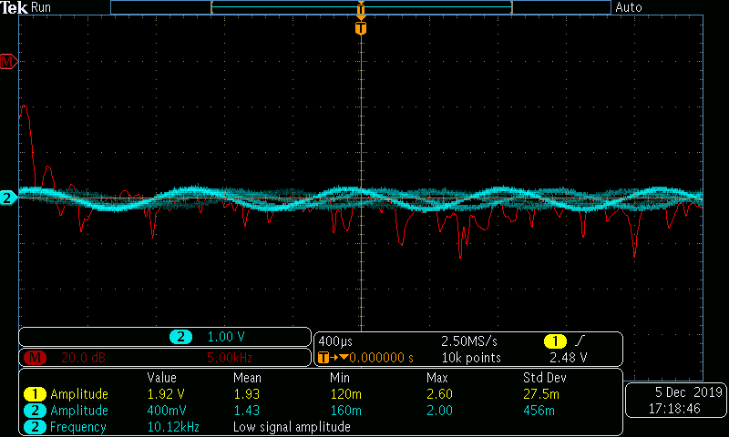

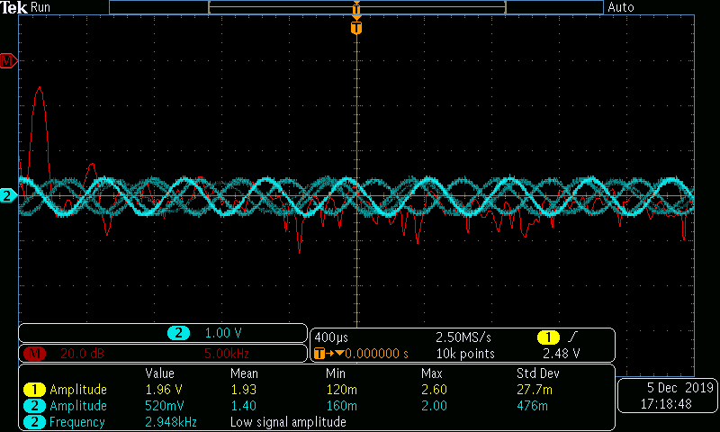

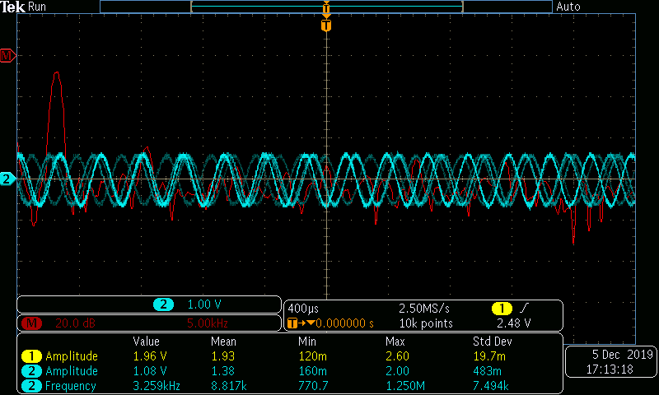

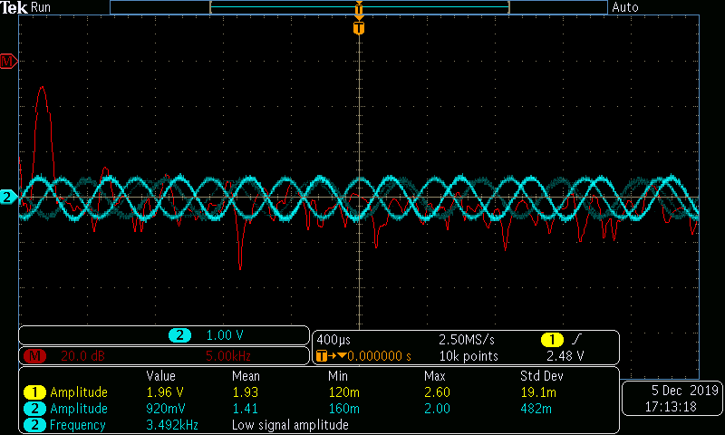

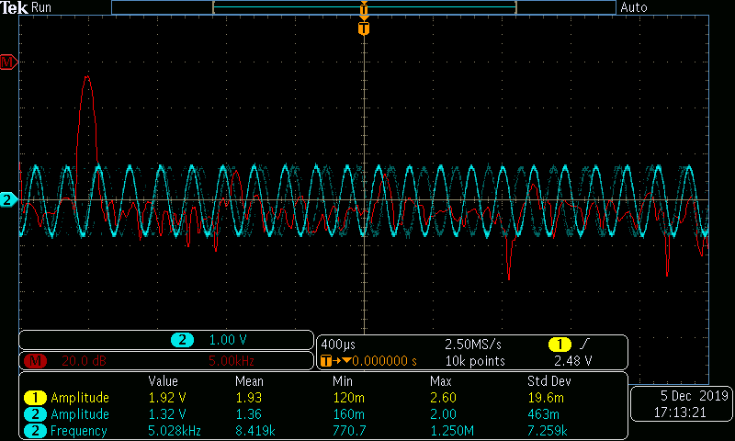

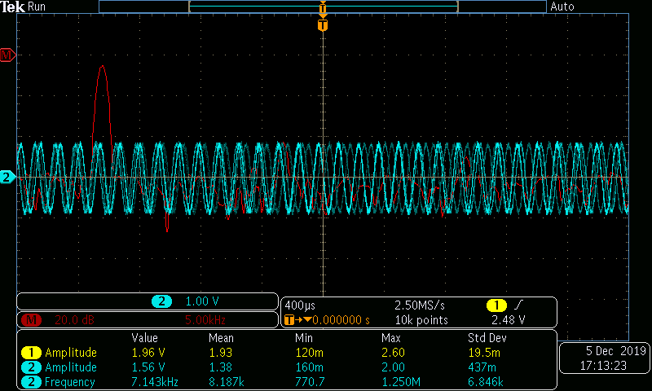

Results: The filter performs close to expectations, with a shift in the cutoff frequency due to component tolerance deviations.

# Appendix A: Full Resistor-Capacitor Matching Matrix

The green highlights correspond to the frequency values within 15% of the nominal cutoff frequency of 4 kHz. The purple highlighted value represents the selected pair in the components section. Computations were performed in bulk by Excel and compatible spreadsheet programs.

|  |  |  |  |  |  |  |  |  |  |  |  |  |  |  |  |  |  |  |  |  |  |  |  |  |  |
| --- | --- | --- | --- | --- | --- | --- | --- | --- | --- | --- | --- | --- | --- | --- | --- | --- | --- | --- | --- | --- | --- | --- | --- | --- | --- |
| combined table | |  |  |  |  | Src of edge | values | Nilsson, Riedel: Electric Circuits (10e), p. 761 | | | |  |  |  |  |  |  |  |  |  |  |  |  |  |  |
| R ↓ | C → | 1E-11 | 2.2E-11 | 4.7E-11 | 1E-10 | 2.2E-10 | 4.7E-10 | 1E-09 | 2.2E-09 | 4.7E-09 | 1.00E-08 | 2.2E-08 | 4.7E-08 | 1.00E-07 | 0.00000022 | 0.00000047 | 0.000001 | 0.0000022 | 0.0000047 | 0.00001 | 0.000022 | 0.000047 | 0.0001 | 0.00022 | 0.00047 | F |
| 10 | 1591549431 | 723431560 | 338627538 | 159154943 | 72343156 | 33862753.8 | 15915494.3 | 7234315.6 | 3386275.38 | 1591549.43 | 723431.56 | 338627.538 | 159154.943 | 72343.156 | 33862.7538 | 15915.4943 | 7234.3156 | 3386.27538 | 1591.54943 | 723.43156 | 338.627538 | 159.154943 | 72.343156 | 33.8627538 |  |
| 15 | 1061032954 | 482287706 | 225751692 | 106103295 | 48228770.6 | 22575169.2 | 10610329.5 | 4822877.06 | 2257516.92 | 1061032.95 | 482287.706 | 225751.692 | 106103.295 | 48228.7706 | 22575.1692 | 10610.3295 | 4822.87706 | 2257.51692 | 1061.03295 | 482.287706 | 225.751692 | 106.103295 | 48.2287706 | 22.5751692 |  |
| 22 | 723431560 | 328832527 | 153921608 | 72343156 | 32883252.7 | 15392160.8 | 7234315.6 | 3288325.27 | 1539216.08 | 723431.56 | 328832.527 | 153921.608 | 72343.156 | 32883.2527 | 15392.1608 | 7234.3156 | 3288.32527 | 1539.21608 | 723.43156 | 328.832527 | 153.921608 | 72.343156 | 32.8832527 | 15.3921608 |  |
| 33 | 482287706 | 219221685 | 102614406 | 48228770.6 | 21922168.5 | 10261440.6 | 4822877.06 | 2192216.85 | 1026144.06 | 482287.706 | 219221.685 | 102614.406 | 48228.7706 | 21922.1685 | 10261.4406 | 4822.87706 | 2192.21685 | 1026.14406 | 482.287706 | 219.221685 | 102.614406 | 48.2287706 | 21.9221685 | 10.2614406 |  |
| 47 | 338627538 | 153921608 | 72048412.4 | 33862753.8 | 15392160.8 | 7204841.24 | 3386275.38 | 1539216.08 | 720484.124 | 338627.538 | 153921.608 | 72048.4124 | 33862.7538 | 15392.1608 | 7204.84124 | 3386.27538 | 1539.21608 | 720.484124 | 338.627538 | 153.921608 | 72.0484124 | 33.8627538 | 15.3921608 | 7.20484124 |  |
| 68 | 234051387 | 106386994 | 49798167.4 | 23405138.7 | 10638699.4 | 4979816.74 | 2340513.87 | 1063869.94 | 497981.674 | 234051.387 | 106386.994 | 49798.1674 | 23405.1387 | 10638.6994 | 4979.81674 | 2340.51387 | 1063.86994 | 497.981674 | 234.051387 | 106.386994 | 49.7981674 | 23.4051387 | 10.6386994 | 4.97981674 |  |
| 100 | 159154943 | 72343156 | 33862753.8 | 15915494.3 | 7234315.6 | 3386275.38 | 1591549.43 | 723431.56 | 338627.538 | 159154.943 | 72343.156 | 33862.7538 | 15915.4943 | 7234.3156 | 3386.27538 | 1591.54943 | 723.43156 | 338.627538 | 159.154943 | 72.343156 | 33.8627538 | 15.9154943 | 7.2343156 | 3.38627538 |  |
| 120 | 132629119 | 60285963.3 | 28218961.5 | 13262911.9 | 6028596.33 | 2821896.15 | 1326291.19 | 602859.633 | 282189.615 | 132629.119 | 60285.9633 | 28218.9615 | 13262.9119 | 6028.59633 | 2821.89615 | 1326.29119 | 602.859633 | 282.189615 | 132.629119 | 60.2859633 | 28.2189615 | 13.2629119 | 6.02859633 | 2.82189615 |  |
| 150 | 106103295 | 48228770.6 | 22575169.2 | 10610329.5 | 4822877.06 | 2257516.92 | 1061032.95 | 482287.706 | 225751.692 | 106103.295 | 48228.7706 | 22575.1692 | 10610.3295 | 4822.87706 | 2257.51692 | 1061.03295 | 482.287706 | 225.751692 | 106.103295 | 48.2287706 | 22.5751692 | 10.6103295 | 4.82287706 | 2.25751692 |  |
| 180 | 88419412.8 | 40190642.2 | 18812641 | 8841941.28 | 4019064.22 | 1881264.1 | 884194.128 | 401906.422 | 188126.41 | 88419.4128 | 40190.6422 | 18812.641 | 8841.94128 | 4019.06422 | 1881.2641 | 884.194128 | 401.906422 | 188.12641 | 88.4194128 | 40.1906422 | 18.812641 | 8.84194128 | 4.01906422 | 1.8812641 |  |
| 220 | 72343156 | 32883252.7 | 15392160.8 | 7234315.6 | 3288325.27 | 1539216.08 | 723431.56 | 328832.527 | 153921.608 | 72343.156 | 32883.2527 | 15392.1608 | 7234.3156 | 3288.32527 | 1539.21608 | 723.43156 | 328.832527 | 153.921608 | 72.343156 | 32.8832527 | 15.3921608 | 7.2343156 | 3.28832527 | 1.53921608 |  |
| 270 | 58946275.2 | 26793761.5 | 12541760.7 | 5894627.52 | 2679376.15 | 1254176.07 | 589462.752 | 267937.615 | 125417.607 | 58946.2752 | 26793.7615 | 12541.7607 | 5894.62752 | 2679.37615 | 1254.17607 | 589.462752 | 267.937615 | 125.417607 | 58.9462752 | 26.7937615 | 12.5417607 | 5.89462752 | 2.67937615 | 1.25417607 |  |
| 330 | 48228770.6 | 21922168.5 | 10261440.6 | 4822877.06 | 2192216.85 | 1026144.06 | 482287.706 | 219221.685 | 102614.406 | 48228.7706 | 21922.1685 | 10261.4406 | 4822.87706 | 2192.21685 | 1026.14406 | 482.287706 | 219.221685 | 102.614406 | 48.2287706 | 21.9221685 | 10.2614406 | 4.82287706 | 2.19221685 | 1.02614406 |  |
| 390 | 40808959.8 | 18549527.2 | 8682757.4 | 4080895.98 | 1854952.72 | 868275.74 | 408089.598 | 185495.272 | 86827.574 | 40808.9598 | 18549.5272 | 8682.7574 | 4080.89598 | 1854.95272 | 868.27574 | 408.089598 | 185.495272 | 86.827574 | 40.8089598 | 18.5495272 | 8.6827574 | 4.08089598 | 1.85495272 | 0.86827574 |  |
| 470 | 33862753.8 | 15392160.8 | 7204841.24 | 3386275.38 | 1539216.08 | 720484.124 | 338627.538 | 153921.608 | 72048.4124 | 33862.7538 | 15392.1608 | 7204.84124 | 3386.27538 | 1539.21608 | 720.484124 | 338.627538 | 153.921608 | 72.0484124 | 33.8627538 | 15.3921608 | 7.20484124 | 3.38627538 | 1.53921608 | 0.72048412 |  |
| 560 | 28420525.6 | 12918420.7 | 6046920.33 | 2842052.56 | 1291842.07 | 604692.033 | 284205.256 | 129184.207 | 60469.2033 | 28420.5256 | 12918.4207 | 6046.92033 | 2842.05256 | 1291.84207 | 604.692033 | 284.205256 | 129.184207 | 60.4692033 | 28.4205256 | 12.9184207 | 6.04692033 | 2.84205256 | 1.29184207 | 0.60469203 |  |
| 680 | 23405138.7 | 10638699.4 | 4979816.74 | 2340513.87 | 1063869.94 | 497981.674 | 234051.387 | 106386.994 | 49798.1674 | 23405.1387 | 10638.6994 | 4979.81674 | 2340.51387 | 1063.86994 | 497.981674 | 234.051387 | 106.386994 | 49.7981674 | 23.4051387 | 10.6386994 | 4.97981674 | 2.34051387 | 1.06386994 | 0.49798167 |  |
| 1000 | 15915494.3 | 7234315.6 | 3386275.38 | 1591549.43 | 723431.56 | 338627.538 | 159154.943 | 72343.156 | 33862.7538 | 15915.4943 | 7234.3156 | 3386.27538 | 1591.54943 | 723.43156 | 338.627538 | 159.154943 | 72.343156 | 33.8627538 | 15.9154943 | 7.2343156 | 3.38627538 | 1.59154943 | 0.72343156 | 0.33862754 |  |
| 1200 | 13262911.9 | 6028596.33 | 2821896.15 | 1326291.19 | 602859.633 | 282189.615 | 132629.119 | 60285.9633 | 28218.9615 | 13262.9119 | 6028.59633 | 2821.89615 | 1326.29119 | 602.859633 | 282.189615 | 132.629119 | 60.2859633 | 28.2189615 | 13.2629119 | 6.02859633 | 2.82189615 | 1.32629119 | 0.60285963 | 0.28218962 |  |
| 1500 | 10610329.5 | 4822877.06 | 2257516.92 | 1061032.95 | 482287.706 | 225751.692 | 106103.295 | 48228.7706 | 22575.1692 | 10610.3295 | 4822.87706 | 2257.51692 | 1061.03295 | 482.287706 | 225.751692 | 106.103295 | 48.2287706 | 22.5751692 | 10.6103295 | 4.82287706 | 2.25751692 | 1.06103295 | 0.48228771 | 0.22575169 |  |
| 1800 | 8841941.28 | 4019064.22 | 1881264.1 | 884194.128 | 401906.422 | 188126.41 | 88419.4128 | 40190.6422 | 18812.641 | 8841.94128 | 4019.06422 | 1881.2641 | 884.194128 | 401.906422 | 188.12641 | 88.4194128 | 40.1906422 | 18.812641 | 8.84194128 | 4.01906422 | 1.8812641 | 0.88419413 | 0.40190642 | 0.18812641 |  |
| 2200 | 7234315.6 | 3288325.27 | 1539216.08 | 723431.56 | 328832.527 | 153921.608 | 72343.156 | 32883.2527 | 15392.1608 | 7234.3156 | 3288.32527 | 1539.21608 | 723.43156 | 328.832527 | 153.921608 | 72.343156 | 32.8832527 | 15.3921608 | 7.2343156 | 3.28832527 | 1.53921608 | 0.72343156 | 0.32883253 | 0.15392161 |  |
| 2700 | 5894627.52 | 2679376.15 | 1254176.07 | 589462.752 | 267937.615 | 125417.607 | 58946.2752 | 26793.7615 | 12541.7607 | 5894.62752 | 2679.37615 | 1254.17607 | 589.462752 | 267.937615 | 125.417607 | 58.9462752 | 26.7937615 | 12.5417607 | 5.89462752 | 2.67937615 | 1.25417607 | 0.58946275 | 0.26793761 | 0.12541761 |  |
| 3300 | 4822877.06 | 2192216.85 | 1026144.06 | 482287.706 | 219221.685 | 102614.406 | 48228.7706 | 21922.1685 | 10261.4406 | 4822.87706 | 2192.21685 | 1026.14406 | 482.287706 | 219.221685 | 102.614406 | 48.2287706 | 21.9221685 | 10.2614406 | 4.82287706 | 2.19221685 | 1.02614406 | 0.48228771 | 0.21922168 | 0.10261441 |  |
| 3900 | 4080895.98 | 1854952.72 | 868275.74 | 408089.598 | 185495.272 | 86827.574 | 40808.9598 | 18549.5272 | 8682.7574 | 4080.89598 | 1854.95272 | 868.27574 | 408.089598 | 185.495272 | 86.827574 | 40.8089598 | 18.5495272 | 8.6827574 | 4.08089598 | 1.85495272 | 0.86827574 | 0.4080896 | 0.18549527 | 0.08682757 |  |
| 4700 | 3386275.38 | 1539216.08 | 720484.124 | 338627.538 | 153921.608 | 72048.4124 | 33862.7538 | 15392.1608 | 7204.84124 | 3386.27538 | 1539.21608 | 720.484124 | 338.627538 | 153.921608 | 72.0484124 | 33.8627538 | 15.3921608 | 7.20484124 | 3.38627538 | 1.53921608 | 0.72048412 | 0.33862754 | 0.15392161 | 0.07204841 |  |
| 5600 | 2842052.56 | 1291842.07 | 604692.033 | 284205.256 | 129184.207 | 60469.2033 | 28420.5256 | 12918.4207 | 6046.92033 | 2842.05256 | 1291.84207 | 604.692033 | 284.205256 | 129.184207 | 60.4692033 | 28.4205256 | 12.9184207 | 6.04692033 | 2.84205256 | 1.29184207 | 0.60469203 | 0.28420526 | 0.12918421 | 0.0604692 |  |
| 6800 | 2340513.87 | 1063869.94 | 497981.674 | 234051.387 | 106386.994 | 49798.1674 | 23405.1387 | 10638.6994 | 4979.81674 | 2340.51387 | 1063.86994 | 497.981674 | 234.051387 | 106.386994 | 49.7981674 | 23.4051387 | 10.6386994 | 4.97981674 | 2.34051387 | 1.06386994 | 0.49798167 | 0.23405139 | 0.10638699 | 0.04979817 |  |
| 10000 | 1591549.43 | 723431.56 | 338627.538 | 159154.943 | 72343.156 | 33862.7538 | 15915.4943 | 7234.3156 | 3386.27538 | 1591.54943 | 723.43156 | 338.627538 | 159.154943 | 72.343156 | 33.8627538 | 15.9154943 | 7.2343156 | 3.38627538 | 1.59154943 | 0.72343156 | 0.33862754 | 0.15915494 | 0.07234316 | 0.03386275 |  |
| 12000 | 1326291.19 | 602859.633 | 282189.615 | 132629.119 | 60285.9633 | 28218.9615 | 13262.9119 | 6028.59633 | 2821.89615 | 1326.29119 | 602.859633 | 282.189615 | 132.629119 | 60.2859633 | 28.2189615 | 13.2629119 | 6.02859633 | 2.82189615 | 1.32629119 | 0.60285963 | 0.28218962 | 0.13262912 | 0.06028596 | 0.02821896 |  |
| 15000 | 1061032.95 | 482287.706 | 225751.692 | 106103.295 | 48228.7706 | 22575.1692 | 10610.3295 | 4822.87706 | 2257.51692 | 1061.03295 | 482.287706 | 225.751692 | 106.103295 | 48.2287706 | 22.5751692 | 10.6103295 | 4.82287706 | 2.25751692 | 1.06103295 | 0.48228771 | 0.22575169 | 0.1061033 | 0.04822877 | 0.02257517 |  |
| 18000 | 884194.128 | 401906.422 | 188126.41 | 88419.4128 | 40190.6422 | 18812.641 | 8841.94128 | 4019.06422 | 1881.2641 | 884.194128 | 401.906422 | 188.12641 | 88.4194128 | 40.1906422 | 18.812641 | 8.84194128 | 4.01906422 | 1.8812641 | 0.88419413 | 0.40190642 | 0.18812641 | 0.08841941 | 0.04019064 | 0.01881264 |  |
| 22000 | 723431.56 | 328832.527 | 153921.608 | 72343.156 | 32883.2527 | 15392.1608 | 7234.3156 | 3288.32527 | 1539.21608 | 723.43156 | 328.832527 | 153.921608 | 72.343156 | 32.8832527 | 15.3921608 | 7.2343156 | 3.28832527 | 1.53921608 | 0.72343156 | 0.32883253 | 0.15392161 | 0.07234316 | 0.03288325 | 0.01539216 |  |
| 27000 | 589462.752 | 267937.615 | 125417.607 | 58946.2752 | 26793.7615 | 12541.7607 | 5894.62752 | 2679.37615 | 1254.17607 | 589.462752 | 267.937615 | 125.417607 | 58.9462752 | 26.7937615 | 12.5417607 | 5.89462752 | 2.67937615 | 1.25417607 | 0.58946275 | 0.26793761 | 0.12541761 | 0.05894628 | 0.02679376 | 0.01254176 |  |
| 33000 | 482287.706 | 219221.685 | 102614.406 | 48228.7706 | 21922.1685 | 10261.4406 | 4822.87706 | 2192.21685 | 1026.14406 | 482.287706 | 219.221685 | 102.614406 | 48.2287706 | 21.9221685 | 10.2614406 | 4.82287706 | 2.19221685 | 1.02614406 | 0.48228771 | 0.21922168 | 0.10261441 | 0.04822877 | 0.02192217 | 0.01026144 |  |
| 39000 | 408089.598 | 185495.272 | 86827.574 | 40808.9598 | 18549.5272 | 8682.7574 | 4080.89598 | 1854.95272 | 868.27574 | 408.089598 | 185.495272 | 86.827574 | 40.8089598 | 18.5495272 | 8.6827574 | 4.08089598 | 1.85495272 | 0.86827574 | 0.4080896 | 0.18549527 | 0.08682757 | 0.04080896 | 0.01854953 | 0.00868276 |  |
| 47000 | 338627.538 | 153921.608 | 72048.4124 | 33862.7538 | 15392.1608 | 7204.84124 | 3386.27538 | 1539.21608 | 720.484124 | 338.627538 | 153.921608 | 72.0484124 | 33.8627538 | 15.3921608 | 7.20484124 | 3.38627538 | 1.53921608 | 0.72048412 | 0.33862754 | 0.15392161 | 0.07204841 | 0.03386275 | 0.01539216 | 0.00720484 |  |
| 56000 | 284205.256 | 129184.207 | 60469.2033 | 28420.5256 | 12918.4207 | 6046.92033 | 2842.05256 | 1291.84207 | 604.692033 | 284.205256 | 129.184207 | 60.4692033 | 28.4205256 | 12.9184207 | 6.04692033 | 2.84205256 | 1.29184207 | 0.60469203 | 0.28420526 | 0.12918421 | 0.0604692 | 0.02842053 | 0.01291842 | 0.00604692 |  |
| 68000 | 234051.387 | 106386.994 | 49798.1674 | 23405.1387 | 10638.6994 | 4979.81674 | 2340.51387 | 1063.86994 | 497.981674 | 234.051387 | 106.386994 | 49.7981674 | 23.4051387 | 10.6386994 | 4.97981674 | 2.34051387 | 1.06386994 | 0.49798167 | 0.23405139 | 0.10638699 | 0.04979817 | 0.02340514 | 0.0106387 | 0.00497982 |  |
| 100000 | 159154.943 | 72343.156 | 33862.7538 | 15915.4943 | 7234.3156 | 3386.27538 | 1591.54943 | 723.43156 | 338.627538 | 159.154943 | 72.343156 | 33.8627538 | 15.9154943 | 7.2343156 | 3.38627538 | 1.59154943 | 0.72343156 | 0.33862754 | 0.15915494 | 0.07234316 | 0.03386275 | 0.01591549 | 0.00723432 | 0.00338628 |  |
| 120000 | 132629.119 | 60285.9633 | 28218.9615 | 13262.9119 | 6028.59633 | 2821.89615 | 1326.29119 | 602.859633 | 282.189615 | 132.629119 | 60.2859633 | 28.2189615 | 13.2629119 | 6.02859633 | 2.82189615 | 1.32629119 | 0.60285963 | 0.28218962 | 0.13262912 | 0.06028596 | 0.02821896 | 0.01326291 | 0.0060286 | 0.0028219 |  |
| 150000 | 106103.295 | 48228.7706 | 22575.1692 | 10610.3295 | 4822.87706 | 2257.51692 | 1061.03295 | 482.287706 | 225.751692 | 106.103295 | 48.2287706 | 22.5751692 | 10.6103295 | 4.82287706 | 2.25751692 | 1.06103295 | 0.48228771 | 0.22575169 | 0.1061033 | 0.04822877 | 0.02257517 | 0.01061033 | 0.00482288 | 0.00225752 |  |
| 180000 | 88419.4128 | 40190.6422 | 18812.641 | 8841.94128 | 4019.06422 | 1881.2641 | 884.194128 | 401.906422 | 188.12641 | 88.4194128 | 40.1906422 | 18.812641 | 8.84194128 | 4.01906422 | 1.8812641 | 0.88419413 | 0.40190642 | 0.18812641 | 0.08841941 | 0.04019064 | 0.01881264 | 0.00884194 | 0.00401906 | 0.00188126 |  |
| 220000 | 72343.156 | 32883.2527 | 15392.1608 | 7234.3156 | 3288.32527 | 1539.21608 | 723.43156 | 328.832527 | 153.921608 | 72.343156 | 32.8832527 | 15.3921608 | 7.2343156 | 3.28832527 | 1.53921608 | 0.72343156 | 0.32883253 | 0.15392161 | 0.07234316 | 0.03288325 | 0.01539216 | 0.00723432 | 0.00328833 | 0.00153922 |  |
| 270000 | 58946.2752 | 26793.7615 | 12541.7607 | 5894.62752 | 2679.37615 | 1254.17607 | 589.462752 | 267.937615 | 125.417607 | 58.9462752 | 26.7937615 | 12.5417607 | 5.89462752 | 2.67937615 | 1.25417607 | 0.58946275 | 0.26793761 | 0.12541761 | 0.05894628 | 0.02679376 | 0.01254176 | 0.00589463 | 0.00267938 | 0.00125418 |  |
| 330000 | 48228.7706 | 21922.1685 | 10261.4406 | 4822.87706 | 2192.21685 | 1026.14406 | 482.287706 | 219.221685 | 102.614406 | 48.2287706 | 21.9221685 | 10.2614406 | 4.82287706 | 2.19221685 | 1.02614406 | 0.48228771 | 0.21922168 | 0.10261441 | 0.04822877 | 0.02192217 | 0.01026144 | 0.00482288 | 0.00219222 | 0.00102614 |  |
| 390000 | 40808.9598 | 18549.5272 | 8682.7574 | 4080.89598 | 1854.95272 | 868.27574 | 408.089598 | 185.495272 | 86.827574 | 40.8089598 | 18.5495272 | 8.6827574 | 4.08089598 | 1.85495272 | 0.86827574 | 0.4080896 | 0.18549527 | 0.08682757 | 0.04080896 | 0.01854953 | 0.00868276 | 0.0040809 | 0.00185495 | 0.00086828 |  |
| 470000 | 33862.7538 | 15392.1608 | 7204.84124 | 3386.27538 | 1539.21608 | 720.484124 | 338.627538 | 153.921608 | 72.0484124 | 33.8627538 | 15.3921608 | 7.20484124 | 3.38627538 | 1.53921608 | 0.72048412 | 0.33862754 | 0.15392161 | 0.07204841 | 0.03386275 | 0.01539216 | 0.00720484 | 0.00338628 | 0.00153922 | 0.00072048 |  |
| 560000 | 28420.5256 | 12918.4207 | 6046.92033 | 2842.05256 | 1291.84207 | 604.692033 | 284.205256 | 129.184207 | 60.4692033 | 28.4205256 | 12.9184207 | 6.04692033 | 2.84205256 | 1.29184207 | 0.60469203 | 0.28420526 | 0.12918421 | 0.0604692 | 0.02842053 | 0.01291842 | 0.00604692 | 0.00284205 | 0.00129184 | 0.00060469 |  |
| 680000 | 23405.1387 | 10638.6994 | 4979.81674 | 2340.51387 | 1063.86994 | 497.981674 | 234.051387 | 106.386994 | 49.7981674 | 23.4051387 | 10.6386994 | 4.97981674 | 2.34051387 | 1.06386994 | 0.49798167 | 0.23405139 | 0.10638699 | 0.04979817 | 0.02340514 | 0.0106387 | 0.00497982 | 0.00234051 | 0.00106387 | 0.00049798 |  |
| 1000000 | 15915.4943 | 7234.3156 | 3386.27538 | 1591.54943 | 723.43156 | 338.627538 | 159.154943 | 72.343156 | 33.8627538 | 15.9154943 | 7.2343156 | 3.38627538 | 1.59154943 | 0.72343156 | 0.33862754 | 0.15915494 | 0.07234316 | 0.03386275 | 0.01591549 | 0.00723432 | 0.00338628 | 0.00159155 | 0.00072343 | 0.00033863 |  |
| 1500000 | 10610.3295 | 4822.87706 | 2257.51692 | 1061.03295 | 482.287706 | 225.751692 | 106.103295 | 48.2287706 | 22.5751692 | 10.6103295 | 4.82287706 | 2.25751692 | 1.06103295 | 0.48228771 | 0.22575169 | 0.1061033 | 0.04822877 | 0.02257517 | 0.01061033 | 0.00482288 | 0.00225752 | 0.00106103 | 0.00048229 | 0.00022575 |  |
| 2200000 | 7234.3156 | 3288.32527 | 1539.21608 | 723.43156 | 328.832527 | 153.921608 | 72.343156 | 32.8832527 | 15.3921608 | 7.2343156 | 3.28832527 | 1.53921608 | 0.72343156 | 0.32883253 | 0.15392161 | 0.07234316 | 0.03288325 | 0.01539216 | 0.00723432 | 0.00328833 | 0.00153922 | 0.00072343 | 0.00032883 | 0.00015392 |  |
| 3300000 | 4822.87706 | 2192.21685 | 1026.14406 | 482.287706 | 219.221685 | 102.614406 | 48.2287706 | 21.9221685 | 10.2614406 | 4.82287706 | 2.19221685 | 1.02614406 | 0.48228771 | 0.21922168 | 0.10261441 | 0.04822877 | 0.02192217 | 0.01026144 | 0.00482288 | 0.00219222 | 0.00102614 | 0.00048229 | 0.00021922 | 0.00010261 |  |
| 4700000 | 3386.27538 | 1539.21608 | 720.484124 | 338.627538 | 153.921608 | 72.0484124 | 33.8627538 | 15.3921608 | 7.20484124 | 3.38627538 | 1.53921608 | 0.72048412 | 0.33862754 | 0.15392161 | 0.07204841 | 0.03386275 | 0.01539216 | 0.00720484 | 0.00338628 | 0.00153922 | 0.00072048 | 0.00033863 | 0.00015392 | 7.2048E-05 |  |
| 6800000 | 2340.51387 | 1063.86994 | 497.981674 | 234.051387 | 106.386994 | 49.7981674 | 23.4051387 | 10.6386994 | 4.97981674 | 2.34051387 | 1.06386994 | 0.49798167 | 0.23405139 | 0.10638699 | 0.04979817 | 0.02340514 | 0.0106387 | 0.00497982 | 0.00234051 | 0.00106387 | 0.00049798 | 0.00023405 | 0.00010639 | 4.9798E-05 |  |
| Ω |  |  |  |  |  |  |  |  |  |  |  |  |  |  |  |  |  |  |  |  |  |  |  |  |  |