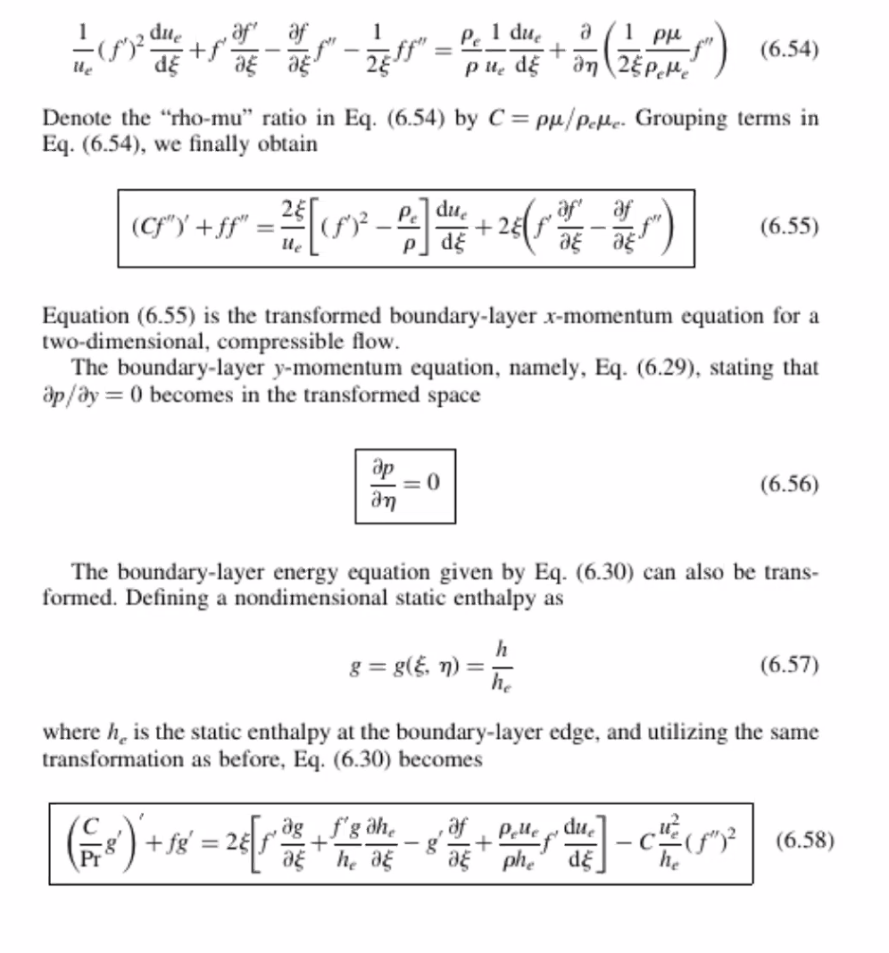

Wall

$$f=f^{'}=0$$

For fixed wall temp:

$$g=g_{w}$$

For adiabatic wall:

$$g^{'}=0$$

At BL edge:

$f^{'}=1$, $g=1$