Evaluation

Customer Requirements
In this section I will compare the final project to the original specification outlined by my client in the analysis section and evaluate the final project in it's effectiveness in fulfilling those objectives, and should it fail to fulfil one or more objective, I will explain why not.

General Objectives

1 – A simple and clear layout for viewing recorded meetings

Fulfilled?
Yes, as is evident from my communications with the user after they completed a one-week trial use of the system, the user found that the planner section was organised in a way that is logical and easy to use, even without training.

Evidence
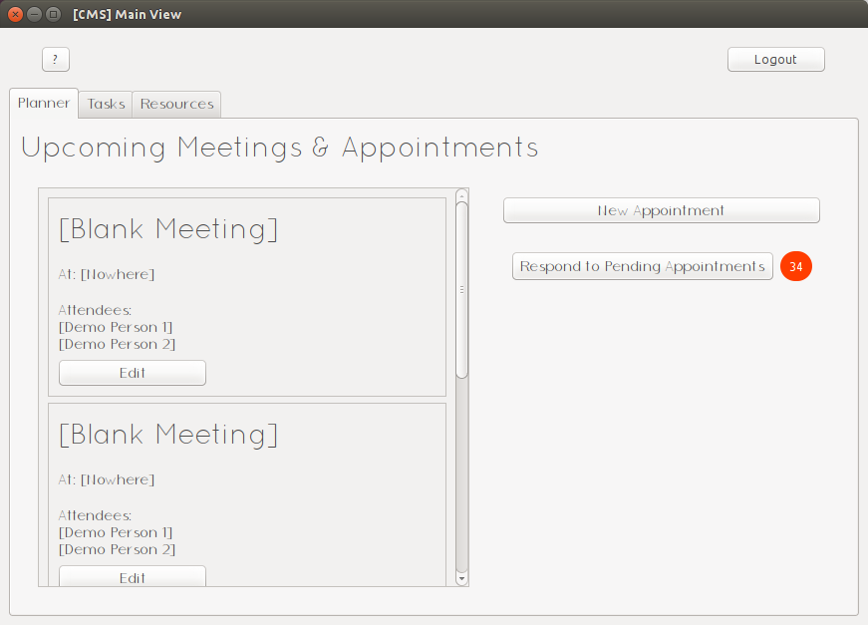
The meetings are shown, prioritized by date to ensure that the user always sees the most urgent parts of their agenda first

2 – A simple and clear layout for adding new meetings

Fulfilled?
Yes, when designing this part of the interface, I ensured there was no uncertainty in what each part of the system does, I made sure the design was simple, yet effective. All the entry points are clearly labelled in a way which cannot be misinterpreted. I chose to model the UI similarly to mobile interfaces, with which all of the staff team is familiar.

Evidence
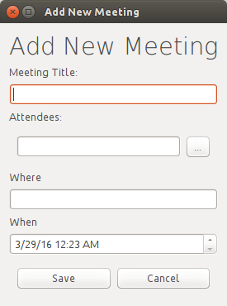
All of the entry points are labelled clearly

3 – A simple and clear layout for adding and viewing a to-do list of tasks

Fulfilled?
Yes, the list interface is designed to mirror a traditional paper checklist (which is something the client commented on in the appraisal), each task can be ticked as done and new tasks can be added using a simple form following the same principles as the forms for adding meetings

Evidence
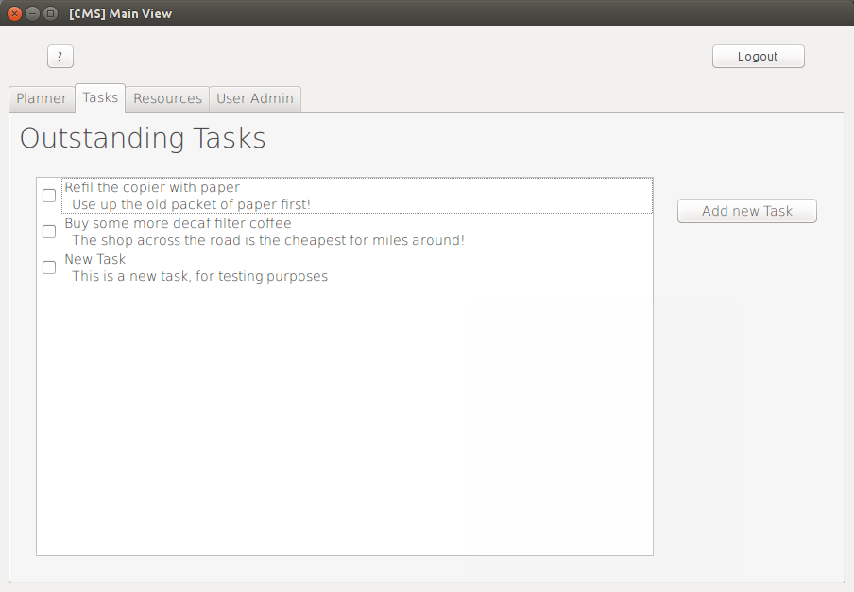
It's really simple, you literally can't go wrong
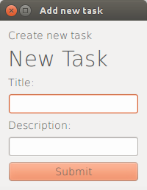
Once again, the core mantra of this design scheme is simplicity, which seems to work with the client's requirements

4 – A Clear and effective way of monitoring stock levels of various resources

Fulfilled?
Partially, initially, the user was unsure of how to use this part of the system at first, but with the aid of the supplied manual they managed to work around the difficulties. The client also commented that there was no notification of when there was a resource running low, so they did not know when to click on the “View urgent requirements” button. However, the user commented later on that once they had added a few resources, and familiarised themselves with this part of the system they found they became more accustomed to it.

Evidence:
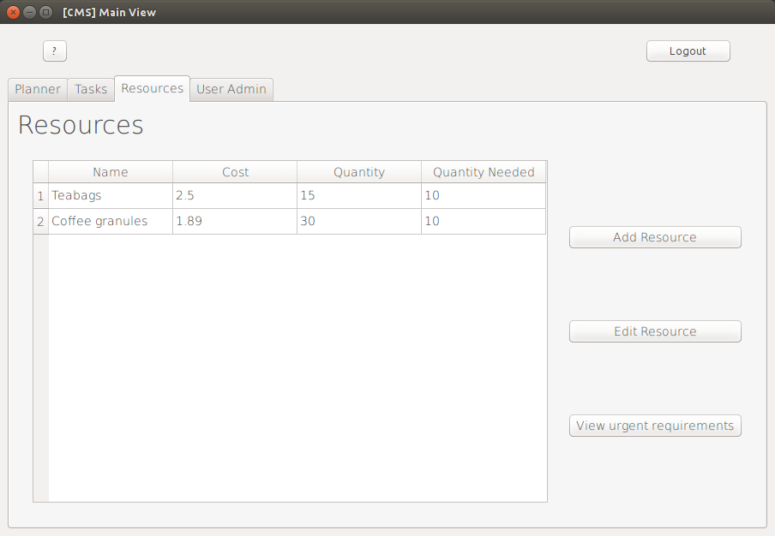
It's not clear when this button needs to be checked, like the 'pending appointment requests' section
It would be good if the urgent items were highlighted in the table view.

5 – A way to edit the user information

Fulfilled?
Partially, after liaisons with the client, we decided that it was only necessary for the user to be able to change their password, and no other information. So, with the updated objective, A way for users to change their passwords, is fulfilled.

Evidence:
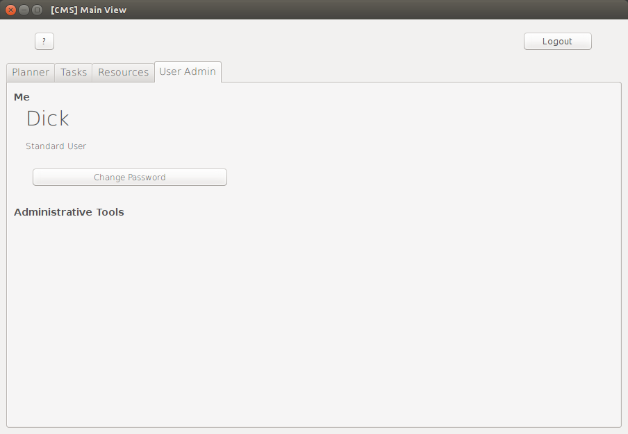
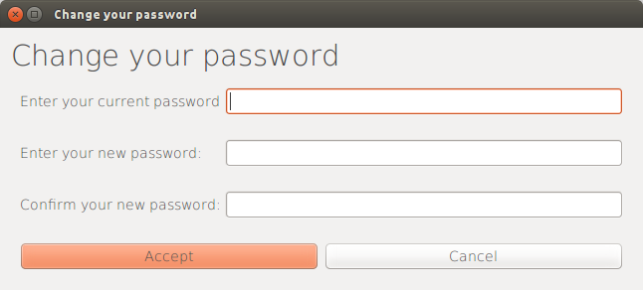
The form for updating a password is self explanatory, as required by the client.

Specific Objectives

1.1 – A clear and consistent structure used for displaying meeting objects

Fulfilled?
Yes, I created a customized Qt widget in the style of a business card, or a diary entry to use for displaying meetings throughout the system. The client commented on how helpful the consistency was in clarifying and distinguishing the various elements of the system.

Evidence:
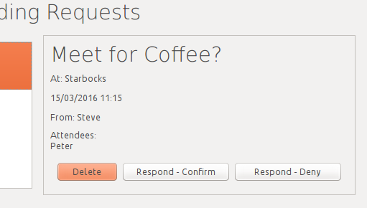
Here you can see an example of a meeting 'card'.

1.2 - Minimal controls to ensure accessibility and to reduce the necessity for training.

Fulfilled?
Yes, throughout the interface design process, I made sure that the controls were kept to a minimum and there were no unnecessary buttons so the interface can be as simple as possible to make it easy to learn. I also made sure the labels for the controls were both descriptive and to-the-point so that the interface is self-explanatory.

Evidence
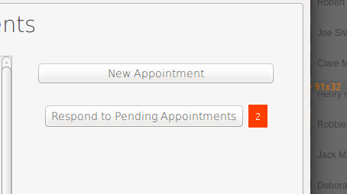

1.3 - Only essential information shown

Fulfilled?
Yes, my client and I decided what would constitute essential information and we concluded that a brief title, the date and time, the location and a list of other attendees was all the information that is strictly needed to record a meeting. Which is why in this system, that is the only information that's stored about the meetings, and that's the only information that is shown about the meetings.

Evidence
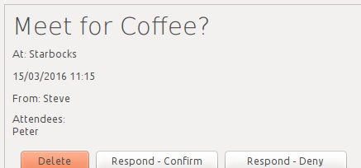

2.1 - An input structure that follows a pattern similar to how the meetings are displayed.

Fulfilled?
Yes, this is fulfilled, by the meetings input structure following a simple, clutter-free order, in the same way that the meetings are displayed.

Evidence
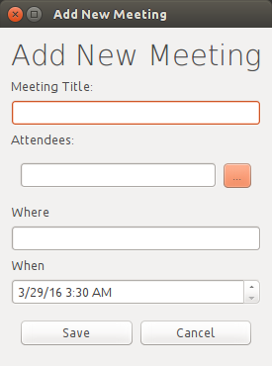

Notice the same, vertical layout used for displaying and inputting information in both the input and output parts of the system

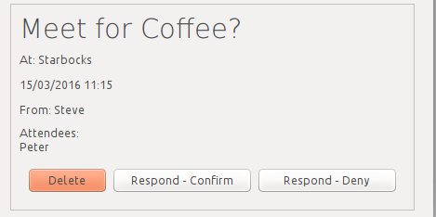

2.2 - Easy selection of attendees from a pool of available users.

Fulfilled?
Yes, I included a 'select' username function in the 'add meeting' window, it performs this task.

Evidence
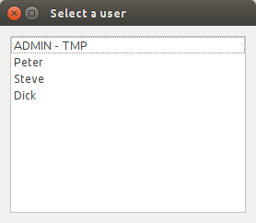

2.3 - Validation of the user's input

Fulfilled?
Yes, the user's input is validated to the standards defined in the system design section

Evidence
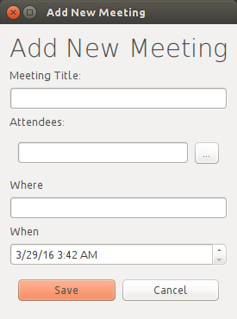
Before

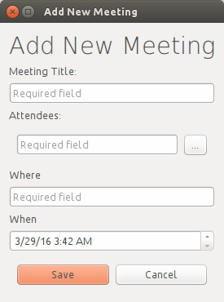
(after)

3.1 - A clear, prioritized list of tasks

Fulfilled?
Partially, the list of tasks is not prioritized as the individual tasks to not have a time, or due date associated with them. However, there is a clear list of tasks, which is the main part of what the client wanted.

Evidence
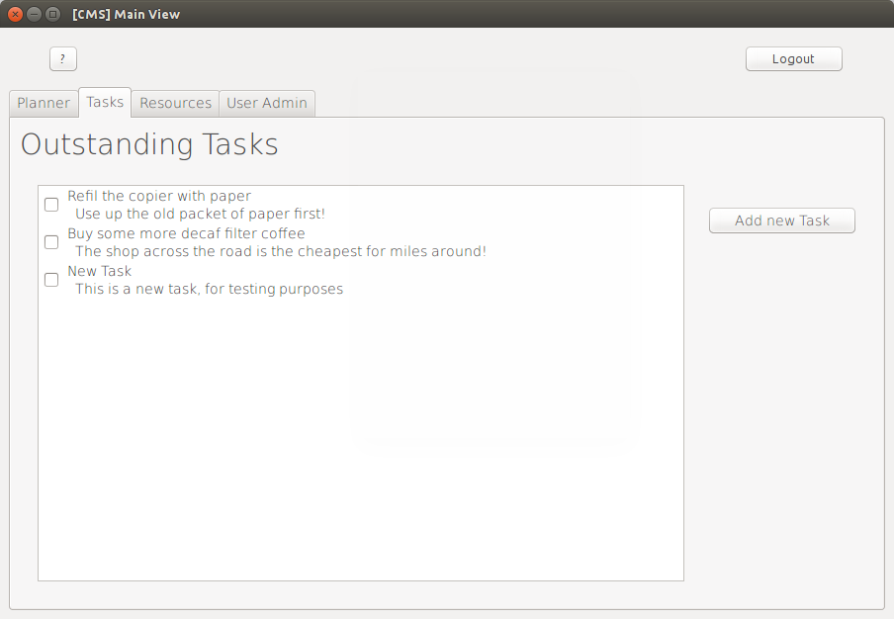
The list of tasks is in reverse chronological order – oldest first.

3.2 - The option to mark tasks as “Done”

Fulfilled?
Partially, the user has the ability to mark a task as done, but this is not stored in the database. So a user can mark a task as completed but when they logout of that session, the tasks are all reset.

Evidence
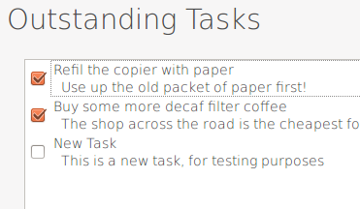
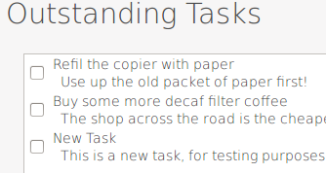
After restarting the software…

4.1 - An ordered table of information for all the recorded resources

Fulfilled?
Partially, the table is not ordered, but it is complete, so the essential functions of the table operate. During the original brief, the client stated that the resources management subsystem was not as important as the meetings or the tasks subsystems.

Evidence
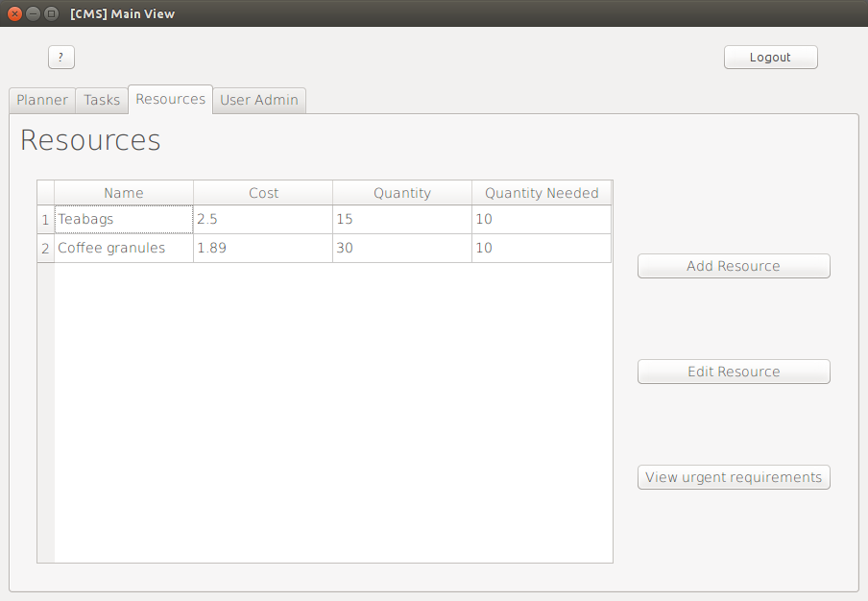
The resources are not ordered but they're all there!

4.2 – The ability to add additional resources at any time

Fulfilled?
No, I ran out of time, so I was not able to fully develop the forms and database interactions for this part of the subsystem.

4.3 - The ability to update the quantity of resources available.

Fulfilled?
As with section 4.2, I did not have sufficient time to complete this part of the subsystem.

4.4 - A way to quickly view a list of resources that are below the required level.

Fulfilled?
As with sections 4.2 and 4.3, there was insufficient time for me to implement this part of the subsystem.

5.1 - A way to change the user's password

Fulfilled?
Yes, there is support for password changing.

Evidence
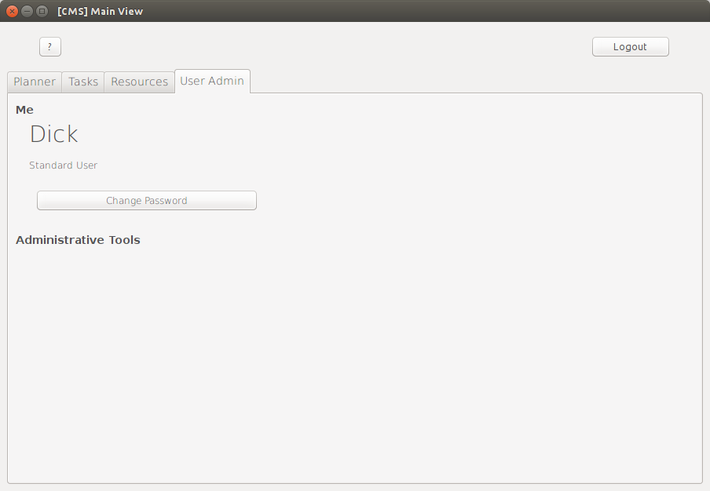
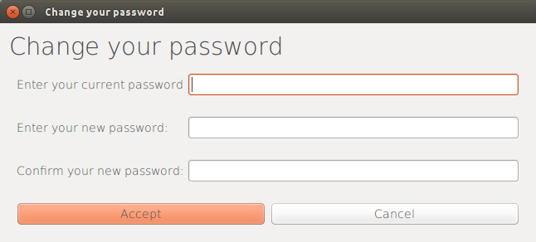

Effectiveness Summary
Out of 5 general objectives, the system I produced 3 fully and 2 partially. Of the 13 specific objectives, this system fulfils 7, partially fulfils 3 and fails to fulfil 3.
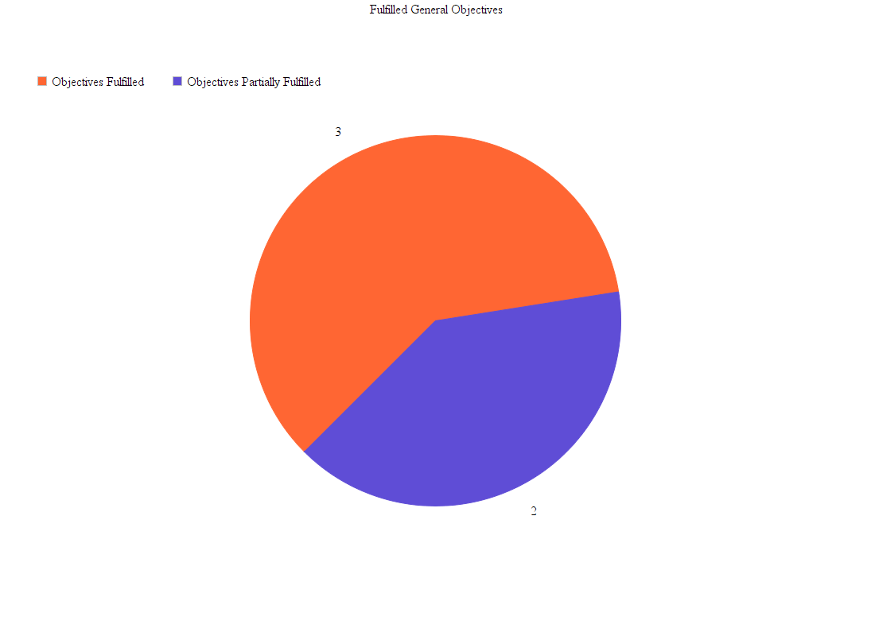
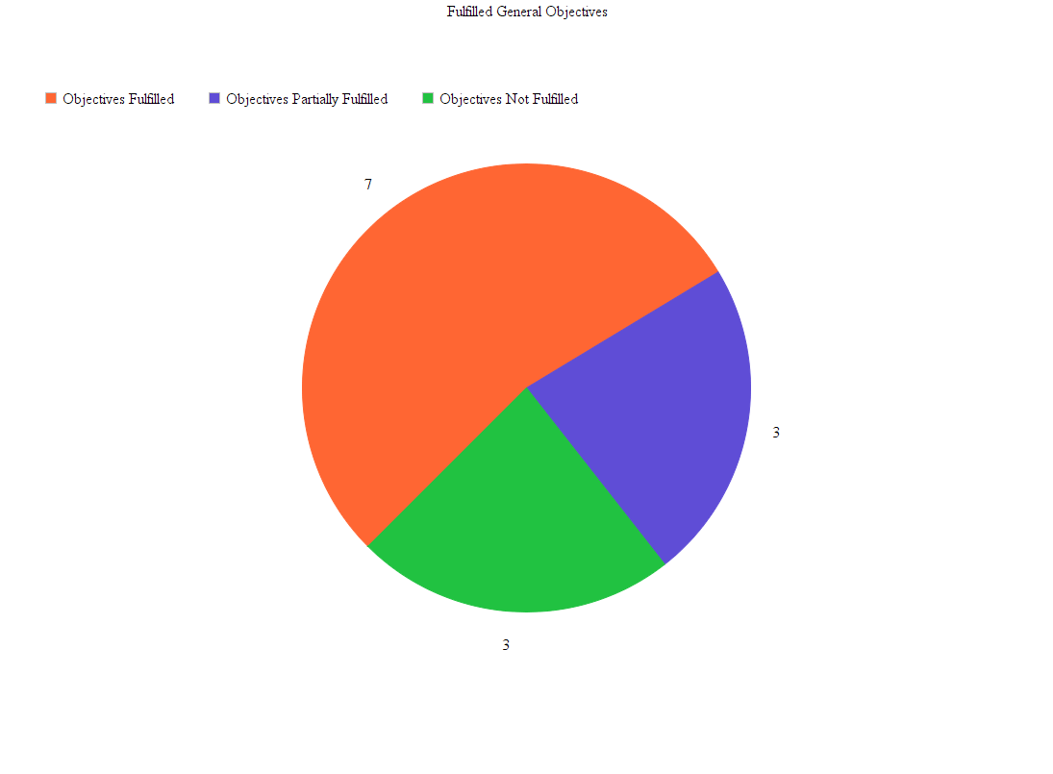
Objectives Fulfilled
Objectives Partially Fulfilled
Objectives Fulfilled
Objectives Partially Fulfilled
Objectives Not Fulfilled
General objectives
Specific Objectives

From this data and these charts, it is clear to see that the majority of the objectives have been met to some extent, however a significant proportion of objectives have not been met fully. During development of the system, I prioritized the subsystems that the client prioritizes in their daily operations (as defined in the initial discussion with them about which objectives are most important to them) therefore I can conclude that the system is effective in achieving it's general objectives.

Learn-ability
One of the key parts of the organisation that I developed this system for is that the structure of the staff team changes at least twice per year, so it's important that the system is easy to learn so no time is wasted in training. Because of the range of ages of the people who will be using this system, it is fair to assume no knowledge of computers.
Because of this, I ensured the following was in place as part of my system:
- First I ensured the layouts were similar to the only point of reference many of the users would have – mobile and tablet interfaces. This is to give the system a familiar feel and to use logical ways of interacting with an interface which have already been practised.
- Next I carefully chose simple, descriptive and clear words and phrases to label the various control elements throughout the system.
- Finally, I provided a complete user manual for each and every function within the system, in case the interface isn't self explanatory enough.

Usability
This section is to determine and evaluate the technical effectiveness of the user interface, this will be evaluate by several areas of the code:
- Clarity of the UI elements – basically how long it takes the user to notice where a button or a link is
- Efficiency of rendering – basically how long it takes for the computer to draw the GUI components onto the screen.
- Readability – how clear all the text is and how easy it is to read
- Navigability – if all the buttons and links work!
First of all, all of the UI elements are slightly larger than the operating system's standard size, this aids in differentiating between the various buttons and controls for navigating between the various screens and windows that make up the system. Also all of the screens and layouts follow a common design principle of information on the left and controls on the right, this uniformity throughout the system helps the users to anticipate where the various controls are going to be.
Because the GUI doesn't use any elements which require additional rendering, the drawing of the GUI is practically instantaneous, even on the lowest spec computer that was used for testing so the system is very usable in this respect.
Due to the fact that one of the main things that the client wanted was for everything to be clear and concise, there is not an occasion where there's a huge amount of text, however this doesn't make readability any less important, to ensure readability, I used a clear and regular sans-serif font that was designed specifically with readability in mind. For any dialogue boxes, windows or sections which have a 'key message', this is put as a title in a large font to emphasise that message. This also means that the user can understand exactly what's going on at a glance.
During the first part of the system testing (see testing section 1), I tested the navigation between sections, windows and dialogue boxes, and the system passed all of the tests.
In summary, I will conclude that my system is very usable, as it has passed the four tests of usability. I think the most important factors in usability are that everything works (navigability) and that everything is obvious (clarity of UI elements), the system I produced is successful in both of these, as well as having good standards of readability and efficient rendering, hence the system has a good level of usability.

Maintainability

Fixing Bugs
Although the testing phase of the system did not reveal any bugs, it is possible that a bug may arise during normal usage of the software, if this happens, it is possible for another developer to maintain the code and fix the bug for the following reasons:
- Most of the code is self-documented so it should be easy to identify and rectify errors in the code (See the section on system maintenance)
- All of the data from the database is converted into python objects and then key-value python dictionaries so it should be easy to isolate the processing of erroneous data.
- Complicated sections of code are well documented in the System Maintenance section
- Explanations of the SQL queries can be found as part of the Design sections

Responding to New Requirements
The system is designed to be modular (as necessitated by the support for user permissions) so new modules can be written and added without much programming effort. The various factors involved with adding new features are listed below:
- The software is built on top of Python's object orientated programming (OOP) model, which allows for elements to be defined as classes, which means it'll be easy to find the various parts of the code, as well as making it possible to add large amounts of code without changing existing code.
- The majority of the code is self-documenting, with logically chosen variable, method and class names to further clarify the purpose of each variable.
Overall, I feel as though I have designed and implemented the system in such a way that it is easy to extend and maintain. However there are a few potential problems, as the documentation for the code is not fully exhaustive, for an experienced programmer, it shouldn't prove too much of a challenge.

Suggestions for Improvement
As part of their appraisal, the client mentioned several parts of the system which were not quite to the specification they had defined, for example, the resources management section is currently incomplete and does not meet some of the objectives.

Complete the Resources section
It's obvious that completing the system, as per specified in the original brief should be the first stage of improving the system, this would make the system the complete package that the client requested.

Complete the Tasks Section
Ensuring that the parts of the tasks section which do not fully meet the objectives specified in the analysis are completed to meet those objectives should also be a priority for future updates to the system.

Add Availability Cross-Referencing to the Meetings bookings
In the current rendition of the system, there is no mechanism to check if users are available for meeting at a particular time, and there is currently no way to keep track of how long a meeting is planned to be, which would be a logical next step.

Cloud storage
Services such as Microsoft Azure or AmazonWebServices offer hosted MySQL databases on remote servers which would mean that the system would be more secure, have all the benefits of a multimillion dollar datacentre such as daily backups, 99.99% uptime and the ability to access the database from anywhere in the world. The system would use all the same SQL queries, all the same GUI code, all apart from the code to execute the SQL queries.

End User Appendix
Here is part of an email conversation between me and my client
