System Maintenance

Environment

Software
During the development of this system I used various software tools to create the system, the names and versions of these are listed below:
- Python 3.4
- Atom 1.4.1
- PyQt 4
- Sqlite 3
- DB Browser for SQLite
- git 2.5.0 & GitHub
- LibreOffice 5.0.5.2

Usage Explanation
Below are the explanations for the software I have used, all of the software I have used is either open sourced and/or freely available at no cost for developer or client.
Software | Usage
Python 3.4 | Python is the underlying language that the software is written in. Version 3.4 is the latest stable version and contains the best balance of security, features and stability of all currently available versions.
Atom 1.4.1 | Atom by GitHub is the text editor that I chose to use throughout the project because of it's customizable syntax highlighting and the various extensions that it includes to make writing code easier.
PyQt 4 | The software library for defining graphical user interfaces and converting python into an event driven language.
Sqlite 3 | Support for this standard is included with the python language and is used for all the database interactions in this project.
DB Browser for SQLite | This is not required for the client's system but it is required for testing the validity of the data held in the database.
Git 2.5.0 & GitHub | These are not strictly required by the user, I use them for version control and synchronisation of code and resources however they could be used as a way to distribute updates.
LibreOffice 5.0.5.2 | For the production of the documentation

System Overview

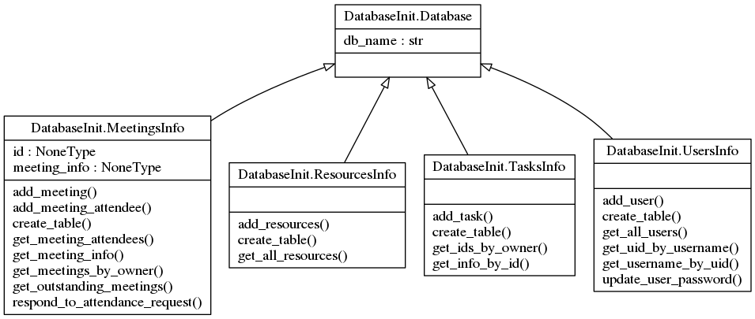
Class Diagrams

System Navigation

Code Structure
The class shown below is the 'Database' class which is the derivative class for all the database interactions from the file “DatabaseInit.py”.
#This tidies all of the SQL queries into another namespace.
import SqlDictionary
import random
import hashlib
import sqlite3

def gen_pw_hash(password):
phash = hashlib.md5()
phash.update(bytes(password, "UTF-8"))
return phash.hexdigest()

class Database:
"""This is the general database wrapper that I'll use throughout the system"""
def __init__(self, child, database_name="cmsdb.db"):
#print("[INFO] Created database object")

self.db_name = database_name

def _connect_and_execute(self, sql="", database_name=None):
#print(sql)
if database_name == None:
database_name = self.db_name

with sqlite3.connect(self.db_name) as dbcon:
cursor = dbcon.cursor()
cursor.execute(sql)
results = cursor.fetchall()
return results
This code is structured as a class so the more specific classes within the code can inherit it's properties. This prevents the duplication of code across the classes as well as reduces the risk of errors. This code provides all of it's child classes with a routine to access the database.
Below is the code for the interaction with the table 'Users' within the database:
class UsersInfo(Database):
def __init__(self, uid = 0):
super().__init__(self)
self.create_table()

# NB: all input MUST be sanitized at this point.
def create_table(self):
self._connect_and_execute(SqlDictionary.CREATE_USERS)
self._create_initial_admin_user()

def _create_initial_admin_user(self):
# This is to create an initial administrative user in case something happens to the database
pwd = "".join([chr(random.choice(range(ord('A'), ord('z')))) for c in range(10)])

new_user_info = {"Name":"ADMIN - TMP", "Username":"default_admin", "Password": gen_pw_hash(pwd), "Permissions": 29}

if len(self.get_all_users("WHERE(Username = 'default_admin')")) == 0:
print("[INFO] Empty users table detected, adding default user...")
self.add_user(new_user_info)
print("[INFO] Default user added,\n\tUsername: 'default_admin'\n\tPassword: '{0}'".format(pwd))

def get_all_users(self, condition = ""): # Add a SQL condition? maybe? TODO: refactor this bit
return self._connect_and_execute(SqlDictionary.GET_ALL_USERS.format(condition))

def get_uid_by_username(self, username=""):
return self._connect_and_execute((SqlDictionary.GET_USER_ID.format(username)))[0][0]

def get_username_by_uid(self, uid=None):
return self._connect_and_execute(SqlDictionary.GET_USERNAME_BY_UID.format(uid))[0][0]

def add_user(self, info):
#info follows the format {"SQL value":Data value}
values = "'{0}', '{1}', '{2}', {3}".format(info["Name"], info["Username"], info["Password"], info["Permissions"])

return self._connect_and_execute(SqlDictionary.ADD_USER.format(values))

def update_user_password(self, password, uid):
sql = SqlDictionary.UPDATE_PASSWORD.format("'{0}'".format(password), uid)
return self._connect_and_execute(sql)

I wrote this code as a class so it could inherit propeties from a parent class, in this case, “Database”. This class containas all the functions required for passing data in and out of the table “Users” in the database, as well as some of the management and administrative functions such as 'create_table' and '_create_initial_admin_user'.

System Structure

Log in
This part of the system controls overall access to the system and prevents unauthorised users from accessing some or all of the system. When the user inputs a username and password combination, a hash is generated of the inputted password and the username is used to lookup the hash of the password stored in the database, the two hashes are compared. If the hashes match then the system prepares the GUI based on the permissons associated with the user.

Graphical User Interface
This part of the system provides the user with a graphical way of interacting with the software. It is designed to be easy and intuative for users to use without or with minimal training. Command buttons and the various input components and positioned around the interface in an appropriately logical structure. The interface also includes various labels and hints to provide guidance to the user and to assist in their operation of the system.

Meetings Overview
The meetings overview tab contains all the controls and output regarding the meetings subsystem.

add meeting

respond

Tasks Overview

new task

Resources Overview

new resources

Admin Area

change password

Variable Listing

Explaination of detailed Algorithms

LoginAction.py
import hashlib

from DatabaseInit import *
import SqlDictionary

class User:
def __init__(self, uid=0):
self.info = {} # info to be retrieved from the database
self.permissions = {}
self.user_id = uid

self.dbinterface = UsersInfo()

self.update_user_info()

def gen_pw_hash(self, password):
# Create a md5 hash of the password
phash = hashlib.md5()
# (Encode the password - the python md5 implementation only accepts binary data.)
phash.update(bytes(password, "UTF-8"))
# return a hexadecimal representation of the md5 hash.
return phash.hexdigest()

def password_hash_cmp(self, password_input):
currenthash = self.info["Password"]
return currenthash == self.gen_pw_hash(password_input)
In this code I have used Python's builtin hashing library to secure the passwords with one-way encryption so that if the user or someone else accesses the database containing the usernames and passwords, they will not be able to use that information to gain access to the system. In this instance, I have used the md5 algorithm.

Permissions Array
def gen_permissions(self):
# Get the denary integer value for the user's permissions
perm = self.info["Permissions"]

# Create a list of the default values for the user's permissions
blist = [False, False, False, False, False]

# For each item in a list of the individual binary digits
# The python `bin` function outputs a string in the format '0b10101'
# which is why we need to get rid of the first two characters
for index, digit in enumerate(bin(int(perm))[2:]):
# set each item in the b(inary)list as a python Bool so it can easily
# be used in selection statements
blist[index] = (bool(int(digit)))
permissions = {}
permissions["Meetings"] = blist[0]
permissions["Tasks"] = blist[1]
permissions["Resources"] = blist[2]
permissions["ChangeOwnData"] = blist[3]
permissions["Admin"] = blist[4]

# Overwrite the existing permissions number with a dictionary.
self.permissions = permissions
return permissions
For this code I have used the python integer-to-binary conversion as well as python dictionaries (a basic key-value database system that is stored in memory). This algorithm converts an integer value taken from the global database into a binary string (taking the format 0b10101) and then converting that into a list of boolean data (taking the format [True, False, True, False, True]) which can then easily be used elsewhere in the system.

Username Parsing
def _add_attendees(self, meeting):
valid = True
raw_attendee_list = self.attendees_entry.text()
#Parse this into a list of attendees, seperated by eiter semicolons or commas.
pattern = re.compile("([a-zA-Z]+;?)")
# Iterate through the list of attendees
print(pattern.findall(raw_attendee_list))

for string in pattern.findall(raw_attendee_list):

if string[-1] == ";":
string = string[0:-1]
try:
attendeeID = UsersInfo().get_uid_by_username(string)
except IndexError:
print("[WARN] Username '{0}' not recognised".format(string))
attendeeID = 0
valid = False
# Show a warning dialog and prevent the form from completing.
if attendeeID:
meeting.add_meeting_attendee(attendeeID)
return valid
From the file “NewMeetingDialog.py” in the class “NewMeetingDialog”. I used python's built in support for regular expressions, in this instance, I wanted the usernames input as text and separated by any non-alphabet character, for this I used the regex ([a-zA-Z]+;?) which is designed to separate strings based on any characters which are not in the alphabet (a-Z) and are either upper or lower case. It then checks each of the strings it finds against the database. Because of the way the database code is written, if it can't find a user with a matching username, it raises an IndexError, which is caught by the “except IndexError” and processed appropriately.

https://docs.python.org/3.4/library/stdtypes.html?highlight=dict#dict

